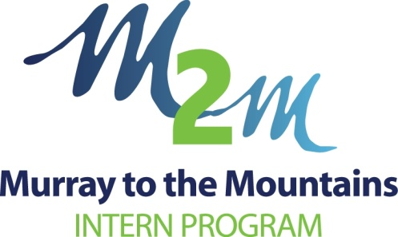**Testimonials**



**Dr Mahmoud Youssef** - **Murray to the Mountains Intern 2017**

I was an intern in the M2M program in 2017. Internship is a very interesting and exciting experience but can also be stressful. When I got accepted into the M2M program, I did not know anything about the program except that it was a rural program. Reflecting back on this year, I would have to say that I am glad that I got into this internship program. The learning curve is steep in internship generally, but **being an M2M intern gave me the opportunity to have more responsibility, gain practical experience (opportunities to perform procedures independently and under supervision), and learn about topics that are usually covered superficially in medical schools but are relevant in real life practice** There is a lot of support for interns that come from the health service that they work in as well as the M2M program administrative staff.



**Dr Shannon Welsh**  - **Murray to the Mountains Intern 2016**

Not only was the rotation mix perfect but from the very beginning M2M staff were instantly available to provide assistance and tailor my intern experience to be the best it possibly could.

The hospital-based rotations were also fantastic and offered a very broad mix of presentations. The physicians and surgeons at Northeast Health Wangaratta have wide-ranging skillsets and are always eager to pass on their knowledge and wisdom. The education that M2M provides on a regular basis is also excellent. I found the training days extremely engaging and relevant – often covering areas that were not covered well at medical school.

If all of the above wasn’t enough, then the region itself is an absolute gem as well – whether you love the food and wine of Rutherglen, the snow-fields of Mt Beauty or the numerous scattered rail-trail bike rides, there is something for everyone!

**I highly recommend the M2M intern program to anyone wishing to experience how rewarding medicine can be from the very beginning – you won’t be disappointed!**





**Dr Chris Brown** - **Murray to the Mountains Intern 2015**

**I couldn't have asked for a better intern year**. M2M have put together an excellent combination of workshops, general practice and rural hospital rotations which provide a broad and challenging clinical experience.

The staff are exceptionally helpful and are dedicated to making the year the best it can be**. I believe the hospital rotations expose you to higher levels of autonomy and responsibility than metropolitan hospitals.**

While challenging, this encourages self-education and innovation. Personally, my general practice experience played a huge role in determining my career aspirations**. I can't recommend this program enough, and would encourage anyone who is interested in a varied and engaging year to seriously consider it.**



**Dr Bre Irving**  - **Murray to the Mountains Intern 2014**

What a true privilege it was to have undertaken an internship with the Murray to Mountains program. Having had the opportunity to work in different areas of medicine, from surgery & general medicine, to emergency and general practice, enabled me to not only discover my passion for general practice, but also provided me with an excellent foundation of clinical knowledge and procedural skills.

I will be forever grateful for the training I received and experience I gained through the Murray to Mountains intern program, and **I cannot imagine having a better way to have commenced my medical career**

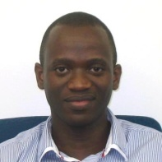

**Dr Tiro Othomile** - **Murray to the Mountains Intern 2014**

 It was a wonderful experience in a relaxed environment, great program with lots of support for interns from clinical staff and M2M administrators. There's great learning opportunities with well suited workshops. Great opportunity to explore general practice while still keeping your options open.  **I give it a big thumbs up!**

**Testimonials**



**Dr Lauren Tanzen** - **Murray to the Mountains Intern 2013**

I have increasingly recognised how privileged I am to be in the M2M program**. I am grateful for every opportunity afforded along the way that other programs don't come close to offering**, particularly with regard to the specialist domain of rural health.

Many thanks again. Much appreciated for the great grounding and leg up for my future career.



**Dr Alison Mahony** - **Murray to the Mountains Intern 2012**

Through M2M I believe I have had a really solid introduction to medicine. I have completed rotations in Medicine and Orthpaedics (Surgery) at Wangaratta base hospital, and Emergency med at Albury Wodonga now doing my GP rotations in two small country towns.

**The advantage of GP in your intern year cannot be over emphasised especially if you think this may be a pathway you would like to pursue.** In my GP rotation there has been time for teaching. GP's have been training registrars for decades. It is a natural progression for them to now teach interns. And who benefits? We all do. The patients are happy with the extended consults and they say they learn also if the GP explains things to the intern. It can help to have fresh eyes approach a chronic case too. My colleagues and I had no trouble arranging HMO2 positions for next year.

Good luck with securing your future pathway in medicine

**M2M Recruitment Process**

**Important Dates**

|  |  |
| --- | --- |
| Medical Expo | 28 April 2018 |
| Intern Registration opens | 1 May 2018 |
| Intern Applications close | 1 June 2018 |
| Computer Match | 3-6 July 2018 |

**M2M Application Requirements**

**For a copy of the Position Descriptions contact:**

Shane Boyer, M2M Manager

email: shane.boyer@unimelb.edu.au

**Applicants must provide:**

* A cover letter addressing selection criteria
* Curriculum Vitae (standardised CV via Computer Matching website) Academic Transcripts (Non Victorian students only)
* Passport photo: on standardised CV
* Two clinical referee reports via Computer Matching website
* Non Clinical Reference

**Interviews**

* Shortlisted candidates only
* Phone interviews will be available.
* Interviews will be conducted on Tuesday 19th June in Wangaratta, Victoria.
* The interview panel will include representatives from M2M, Northeast Health Wangaratta and Albury Wodonga Health.

**WEBSITE:** [www.m2m.asn.au](http://www.m2m.asn.au)