[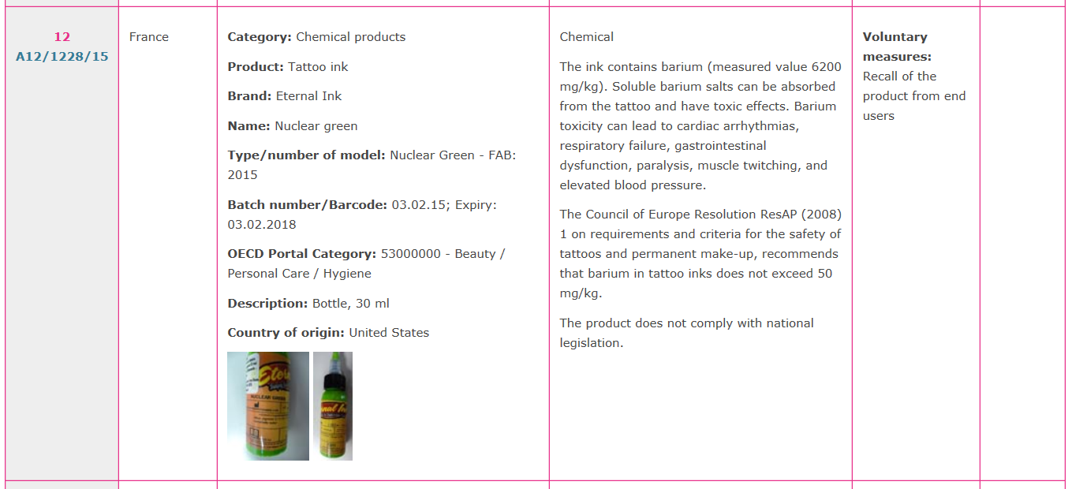](http://ec.europa.eu/consumers/consumers_safety/safety_products/rapex/index_en.htm)

