**Prawn fishers and farmers share the love at national awards.**

The Australian Council of Prawn Fisheries and the Australian Prawn Farmers Association shared the award for best seafood promotion at the National Seafood Awards held at the Crown Convention Centre in Perth last night.

The campaign, now in its third year is the first united and voluntarily funded marketing program for an entire seafood category - Australian Prawns.

“As a nation, we love our Australian Prawns, but we tend to love them only twice a year - Christmas and Easter. This campaign was developed to change those long held perceptions.” said ACPF chair Stephen Murphy.

The campaign won the WA and QLD state awards for promotion and was also a finalist in the SA awards.

“We’re thrilled to see years of effort recognised. Uniting the wild catch and aquaculture sector behind the campaign was not simple or easy, but the effort has been worth it, with both prawn farmers and fishers now enjoying more robust and predictable demand for their p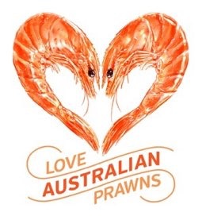roduct. What this national campaign achieved on a modest budget is something we, as an industry, are very proud of.”, he said.

“We’re sustainable, we’re delicious, we’re Australian and we’re loved - and we’re so happy to be recognised for the hard work the industry has put into marketing its product with a united voice.”, said campaign co-ordinator, Ben Hale.

The Love Australian Prawns campaign was delivered at point of sale through 825 Woolworths Supermarkets, 440 independent seafood retailers, as well as online and through social media.

“Professional marketing makes a difference and we saw that through higher demand and a better result for the producers. It’s not easy, it’s not simple, but done well, it works.” said Warren Lewis, from the Australian Prawn Farmer’s Association.

RELEASE ENDS

For further information and images please contact Ben Hale, Campaign Co-ordinator on 0407752622 [ben.hale@australianprawnmarketing.net](mailto:ben.hale@australianprawnmarketing.net)

For a detailed overview of the campaign a PDF can be downloaded at [this link](https://www.dropbox.com/s/eqryn6kp1rzll5z/Love%20Australian%20Prawns%20-%20campaign%20detail%20and%20entry.pdf?dl=0)

Or copy and paste this URL into your browser

<https://www.dropbox.com/s/eqryn6kp1rzll5z/Love%20Australian%20Prawns%20-%20campaign%20detail%20and%20entry.pdf?dl=0>