**Synthesis of Australian Prawn Farmers research for extension to industry and relevant stakeholders**

**Professor Meredith Lawley**

**Project No. 2014/728**



**March 2015**



**This project was conducted by:**

**Professor Meredith Lawley,**

**University of the Sunshine Coast**

Sippy Downs Drive

Maroochydore DC Qld 4558

Tel: +61 5430 1223

Email: mlawley1@usc.edu.au

**Copyright, 2012**: The Seafood CRC Company Ltd, the Fisheries Research and Development Corporation and the University of the Sunshine Coast.

This work is copyright. Except as permitted under the Copyright Act 1968 (Cth), no part of this publication may be reproduced by any process, electronic or otherwise, without the specific written permission of the copyright owners. Neither may information be stored electronically in any form whatsoever without such permission.

*The Australian Seafood CRC is established and supported under the Australian Government’s Cooperative Research Centres Program. Other investors in the CRC are the Fisheries Research and Development Corporation, Seafood CRC company members, and supporting participants.*

Office Mark Oliphant Building, Laffer Drive, Bedford Park SA 5042

Postal Box 26, Mark Oliphant Building, Laffer Drive, Bedford Park SA 5042

Tollfree 1300 732 213 Phone 08 8201 7650 Facsimile 08 8201 7659

Website [www.seafoodcrc.com](http://www.seafoodcrc.com) ABN 51 126 074 048

|  |
| --- |
| **Important Notice**  Although the Australian Seafood CRC has taken all reasonable care in preparing this report, neither the Seafood CRC nor its officers accept any liability from the interpretation or use of the information set out in this document. Information contained in this document is subject to change without notice. |

** **

# Non-Technical Summary

**PROJECT NUMBER:** 2014/728

**PROJECT TITLE:**

**‘Synthesis of Australian Prawn Farmers research for extension to industry and relevant stakeholders’**

**PRINCIPAL INVESTIGATOR**: Professor Meredith Lawley

**ADDRESS:**

University of the Sunshine Coast

Sippy Downs Drive

Maroochydore DC Qld 4558

Tel: +61 5430 1223

Email: [mlawley1@usc.edu.au](mailto:mlawley1@usc.edu.au)

**PROJECT OBJECTIVE:** The objective of the project was to develop a single consolidated summary of all available research, by auditing all key research and reports (both academic and non-academic) relevant to Australian prawn farming published since 2000.

The audit was required to note any issues on the current ease of accessing information and include recommendations to improve information access to ensure industry can find information quickly.

**NON TECHNICAL SUMMARY**

The purpose of this project was to develop a single consolidated summary of all available research relevant to Australian prawn farming, by auditing all key research and reports (both academic and non-academic) published since 2000. The audit was required to note any issues on the current ease of accessing information and include recommendations to improve information access to ensure industry can find information quickly.

In brief, 198 unique reports were identified (from APFA, FRDC, ASCRC, CSIRO, DAFF both federal and Qld, and USC) and consolidated into a single summary document – including full details of authors, dates, titles, sponsoring organisation and where possible an electronic copy of the document. The papers were classified into five themes of: Disease and Biosecurity (n = 57); Farm Operations (n = 28); Genetics (n = 31); Industry Development (n = 71) and Marketing (n = 35). Some reports appear in multiple themes, hence the numbers noted previously add to more than 198. Brief summaries were developed for each of these themes highlighting sponsoring organisations, trends over time and key streams addressed in each theme.

While compiling the summary, areas of duplication and ease of searching were noted. Very little duplication of reports was found. This indicates that APFA members searching for information prior to the summary would need to check each individual source to identify information relevant to a particular topic. In terms of ease of navigation, while most sites were relatively easy to search, some lacked advanced search facilities and issues were also identified with inconsistent naming of reports and reports being located in incorrect places (i.e. not where they were supposed to be).

Recommendations include encouraging the APFA to maintain the currency of the summary and source organisations to consider the issues raised in relation to searching for articles.

|  |
| --- |
| **OUTCOMES ACHIEVED:**  The project has delivered the following outcomes:   * Audit of key research and reports relevant to Australian prawn farming published since 2000. * Identification of issues arising around searching for research and reports on key websites including ASCRC, FRDC, CSIRO, DAFF Federal, DAFF Qld, FRDC and USC. * Briefing of APFA Research subcommittee on audit.   **LIST OF OUTPUTS PRODUCED:**  The project has delivered the following outputs:   * A searchable and updatable summary of 198 key research and reports relevant to Australian prawn farming published since 2000 (as at end January 2015). The summary has been categorised into 5 major themes (Disease & Biosecurity, Marketing, Industry Development, Genetics and Farm Operations). * A brief one to two page summary describing the state of research to date for each of the five main themes (Disease & Biosecurity, Marketing, Industry Development, Genetics, and Farm Operations). * Recommendations for improving ease of information access to extant research and reports. |

**KEYWORDS:**

Prawn farming research

Prawn farming reports

# Acknowledgements

The author would like to thank the Australian Seafood CRC and the Australian Prawn Farmers Association (APFA) for the opportunity to undertake this project. In particular Helen Jenkins (APFA) and Emily Mantilla (ASCRC) – were both a pleasure and a delight to work with.

At USC, the research support provided by Judy Watson and Jan Macalister ensured this project happened in a timely manner.

Table of Contents

Non-Technical Summary - ii -

Acknowledgements - iv -

1. Introduction and Background - 1 -

1.1 Need - 1 -

1.2 Objectives - 1 -

2. Methods - 1 -

3. Results - 2 -

4. Discussion - 7 -

5. Benefits and Adoption - 8 -

6. Further Development - 8 -

7. Planned Outcomes - 9 -

7.1 Public Benefit Outcomes - 9 -

7.2 Private Benefit Outcomes - 10 -

7.3 Linkages with CRC Milestone Outcomes - 10 -

8. Conclusion - 10 -

References - 11 -

Appendices - 12 -

**Appendix 1**: Summary of APFA Research Literature - 12 -

**Appendix 2**: Summary of APFA Research Literature - Disease and Biosecurity - 13 -

**Appendix 3**: Summary of APFA Research Literature – Farm Operations - 14 -

**Appendix 4**: Summary of APFA Research Literature – Genetics - 15 -

**Appendix 5**: Summary of APFA Research Literature – Industry Development - 16 -

**Appendix 6**: Summary of APFA Research Literature – Marketing - 18 -

**Appendix 7**: Staff engaged on project - 20 -

**List of Tables**

**Table 1**: Research and reports initially provided by the APFA - 3 -

**Table 2**: Additional research and reports drawn from websites between mid-December 2014 and mid-January 2015 - 3 -

**Table 3**: Source and availability of articles/reports - 4 -

**Table 4**: Reports sourced from the APFA duplicated on other websites - 4 -

**Table 5**: Reports sourced from the ASCRC duplicated on other websites - 4 -

**Table 6**: Papers by sources and theme - 6 -

**Table 7**: General trends in amount of research in each theme over time - 7 -

# 1. Introduction and Background

## 1.1 Need

The Australian Prawn Farmers Association (APFA) has been part of the Australian Seafood CRC since inception. During that time, numerous research projects have been undertaken. While every effort has been made by the APFA to capture final reports, the Association lacks a consolidated summary of not only the CRC research, but research undertaken via the Fisheries Research and Development Corporation (FRDC), as well as other papers, commission reports and research relevant to Australian prawn farming. A one stop “house” for all these materials, in the form of a single summary of all APFA relevant research over the last 14 years, was needed.

## 1.2 Objectives

While the overall purpose of the project was to develop a single consolidated summary of all key research and reports relevant to Australian prawn farming published since 2000, the specific objectives of the project were:

* To develop a searchable and updatable summary of key research and reports relevant to Australian prawn farming published since 2000;
* Categorise the research and reports into 5 major themes (Disease & Biosecurity, Marketing, Industry Development, Genetics and Farm Operations);
* Develop a brief one to two page summary describing the state of research to date for each of the five main themes (Disease & Biosecurity, Marketing, Industry Development, Genetics, and Farm Operations);
* Identify issues arising around searching for research and reports on key websites including ASCRC, CSIRO, DAFF Federal, DAFF Qld, FRDC and USC as a basis for recommending possible improvements to ensure fast and easy access; and
* Brief the APFA Board on the outcomes of the above.

# 2. Methods

To address the above objectives the project adopted the following approach:

**Step 1**: Identify all research and reports currently held by the APFA.

**Step 2**: Search FRDC, ASCRC, CSIRO, DAFF Fed, DAFF Qld, and USC for additional research and reports not currently held by APFA.

**Step 3**: While undertaking steps 1 and 2, concurrently evaluate ease of searching and comprehensiveness of research and reports on each site.

**Step 4:** Record the following details for each report gathered:

* Author(s);
* Date;
* Funding/sponsoring organisation;
* Title;
* Key words;
* Abstract;
* Focus area (from the five main streams);
* Method used; and
* A copy of, or a link to the full article or report.

**Step 5:** Categorise research and reports into the five predetermined themes as identified by the APFA. This was done in conjunction with Helen Jenkins (APFA) to ensure reports were correctly categorised.

* Disease and Biosecurity,
* Marketing,
* Industry Development,
* Genetics, and
* Farm Operations

**Step 6:** Develop summaries for each of the 5 theme areas including:

* Details of the number of reports in that area,
* A profile by publication year,
* The methodology utilised, and
* The key streams of the research undertaken between 2000 and 2015.

**Step 7:** Communicate findings to APFA and ensure APFA can maintain and update summary as required.

# 3. Results

The research resulted in a total of 198 unique reports being added to the summary (as of end January 2015). Several issues regarding ease of searching and accessibility were identified throughout the process of compiling the summary, both within the APFA and with the external bodies identified. These results will be reported following the steps outlined in the methods above.

**Step 1: Identify all research and reports currently held by the APFA**

Initially, the APFA provided 71 existing research items and reports in a variety of forms including hard copy, electronic copy and in some cases web links as summarised in Table 1.

***Table 1: Research and reports initially provided by the APFA***

|  |  |
| --- | --- |
|  | **Number of items** |
| Web Links | 29 |
| Electronic copy | 22 |
| Hard copy | 13 |
| Reference only | 7 |
| **Total** | 71 |

From the Summary (provided in hard copy at Appendix 1 and also available electronically from the APFA) it can be seen that the documents sourced from the APFA covered a diverse range of sources – including reports from international organisations such as the FAO, journal articles, reports commissioned specifically by the APFA, as well as groups like Agrifood Skills Australia. Some documents appear to be generated by larger CRC projects (e.g. Colquhoun, E., 2013, Funding Options for the Australian Wild-Catch Prawn Industry.) or are conference papers presented at the APFA conference with data derived from CRC projects (e.g. Danenberg, 2010).

**Step 2: Search FRDC, ASCRC, CSIRO, DAFF Fed, DAFF Qld, and USC for additional research and reports not currently held by APFA.**

In order to identify any relevant research and reports not currently held by the APFA, the following sites were searched between mid-December 2014 and mid-January 2015: the Australian Seafood Cooperative Research Centre (ASCRC), Fisheries Research and Development Corporation (FRDC), the Commonwealth Scientific and Industrial Research Organisation (CSIRO), the Department of Agriculture, Forestry and Fisheries (DAFF) (both Federal and for the state of Queensland), and the University of the Sunshine Coast (USC) resulting in the identification of 47 additional items, as summarised in Table 2.

***Table 2: Additional research and reports drawn from websites between mid-December 2014 and mid-January 2015***

|  |  |
| --- | --- |
|  | **Number of items** |
| FRDC | 18 |
| DAFF - Federal | 12 |
| DAFF - Qld | 10 |
| ASCRC | 5 |
| CSIRO | 2 |
| **Total** | 47 |

Whilst the search was ongoing, in mid-January, the APFA provided one further report (electronic copy) and a list of items of interest held by the ASCRC (n = 51) and FRDC (n = 11). The ASCRC and FRDC sites were then searched for all reports nominated on these lists.

A further 33 reports were obtained from the ASCRC, and two reports from the FRDC. The discrepancy in the numbers provided by the APFA compared to what could be actually found on these sites related to a variety of issues including hyperlinks not working, some reports not being available electronically, and possible inconsistencies in the naming of reports.

The APFA then provided a further 30 electronic reports. The University of the Sunshine Coast (USC) website was searched for relevant reports, with a further 14 items added to the summary, predominantly academic journal articles. All of these were identified through USC Research bank, a publically accessible summary of all research done by USC academics.

This resulted in a total of 198 unique articles/reports in the summary. These articles were sourced from the APFA and six other websites as detailed in Table 3.

***Table 3: Source and availability of articles/reports***

|  |  |
| --- | --- |
|  | **Number of items sourced from:** |
| APFA | 102 |
| ASCRC | 38 |
| FRDC | 20 |
| USC | 14 |
| DAFF Federal | 12 |
| DAFF Queensland | 10 |
| CSIRO | 2 |

**Step 3: While undertaking steps 1 and 2 concurrently evaluate ease of searching and comprehensiveness of research and reports on each site.**

Concurrently, throughout the process, each site was searched for duplication of reports across the websites. An assessment of the ease of navigation and identification of the research and reports was also made.

**Duplication of reports.** There was limited duplication of reports across the websites. Of the 102 reports provided by the APFA, 16 were also available on other searched websites (Table 4).

***Table 4: Reports sourced from the APFA duplicated on other websites***

|  |  |
| --- | --- |
|  | **Number of items available from:** |
| DAFF Federal | 10 |
| FRDC | 6 |

Of the documents sourced from the ASCRC only two were duplicated on other sites (Table 5).

***Table 5: Reports sourced from the ASCRC duplicated on other websites***

|  |  |
| --- | --- |
|  | **Number of items available from:** |
| DAFF Qld | 1 |
| FRDC | 1 |

One document sourced from the FRDC (Project No. 2003/417) was duplicated in summary format on the DAFF Queensland website, another from the FRDC (Project No. 2008/019) could be accessed from a link on the DAFF Queensland website. There was no duplication of the reports sourced from the CSIRO, DAFF Federal, DAFF Qld and USC.

This result appears surprising as it was expected that there would be significant duplication of reports across the sites (particularly the APFA, CRC and FRDC), however, closer investigation of the actual reports highlighted that some of the reports provided by the APFA were actually reports generated by larger CRC projects (e.g. the Colquhoun 2013 report on funding options for a prawn marketing campaign was part of the larger CRC Prawn Marketing Project).

**Ease of navigation and searching for reports.** In general, the websites were easy to navigate with the publication section and search option straightforward to find, however, advanced search functionality was limited, with only the FRDC site having this level of search.

When searching for nominated documents from lists that detailed where the reports should be found, locating copies of each identified report was not always possible (11 such reports could not be found). The following issues were experienced during the searches:

* Where a research final report was listed, neither an online copy nor a downloadable copy of a report was available (n = 10).
* One hyperlink to a report returned a completely different report unrelated to prawn farming.
* The name given to a specific report/article was inconsistent across websites – the actual title of the report varied (n = 2), further in one of these cases an identical project title was related to another project number within the same website.
* Naming conventions were not always used on/across reports; for example, final report code numbers were not consistently included in the report title, making it more difficult to assess if the correct report had been found.
* Occurrences where no reference to a report was found through the search function, even though that report should have been available via the specific website. In some cases, reports had been archived.

**Step 4: Record the following details for each report gathered:**

* Author(s);
* Date;
* Funding/sponsoring organisation;
* Title;
* Key words;
* Abstract;
* Focus area (from the five main streams);
* Method used.
* A copy of or a link to the full article or report.

This summary is included at Appendix 1.

**Step 5: Categorise research and reports into the five predetermined themes as identified by the APFA:**

* Disease and Biosecurity,
* Marketing,
* Industry Development,
* Genetics, and
* Farm Operations

This categorisation has been included in the full summary in Appendix 1.

**Step 6: Develop summaries for each of the 5 theme areas including:**

* Details of the number of reports in that area,
* The profile of publication year,
* The methodology utilised, and
* The key themes of the research undertaken between 2000 and 2015.

While summaries of each research theme are contained in Appendices 2 to 6, the following tables summarise across the five streams to provide an overview of sources, timings and patterns.

***Table 6: Papers by sources and theme***

|  |  |  |  |  |  |  |
| --- | --- | --- | --- | --- | --- | --- |
|  | **Total\*\*** | **Other* incl APFA** | **FRDC** | **ASCRC** | **DAFF** | **CSIRO** |
| Disease and Biosecurity | 52 | 35 | 4 | 2 | **11** | 0 |
| Farm Operations | 28 | **21** | 3 | 3 | 0 | 1 |
| Genetics | 29 | **17** | 3 | **9** | 0 | 0 |
| Industry Development | 71 | 42 | 9 | 8 | 11 | 1 |
| Marketing | 33 | 11 | 6 | **15** | 1 | 0 |

*\* Other includes all sources apart from those specified sources such as journal articles, consultants and other organisations*

*\*\* Note – some papers were available through more than one source*

As expected, Table 6 highlights the focus of the organisations conducting the research, so DAFF is the single largest sources of articles in the Disease and Biosecurity theme, while the ASCRC has been the major source of research in the marketing theme.

***Table 7: General trends in amount of research in each theme over time***

|  |  |
| --- | --- |
| Theme | **Timing** |
| Disease and Biosecurity | Peaks 2006 – 2007 |
| Farm Operations | Consistent |
| Genetics | 2012 – 2014 |
| Industry Development | General increase since 2000 |
| Marketing | Minimal before 2006 then upward |

Table 7 highlights the increasing work being undertaken in the area of industry development and marketing, with farm operations a consistent area of research.

**Step 7: Communicate findings to APFA and ensure APFA can maintain and update summary as required.**

On February 20th, 2015, Judy Watson attended the APFA Research meeting in Brisbane and presented the summary and sought feedback (as noted below). Judy also spent time with Helen Jenkins through the project and Helen has since advised that she has already made an update to the summary.

As highlighted by Helen Jenkins (APFA Executive Officer):

“*Industry associations like APFA, who have spent millions of dollars over years on research, become custodians of results. At times, a change of the guard may mean that these valuable resource tools are not all housed in the one spot or easy to locate. Therefore, a library where all research is kept, easy to access and updated regularly, and made available to members is a valuable reference tool for current and future members and industry personnel as a ‘one stop shop’ for industry.”*

Further, Helen noted:

*“The APFA were very satisfied with the results, the amount of research that was available was astounding and the ease of access – brilliant.”*

# 4. Discussion

The results outlined above highlight the importance of the APFA creating and maintaining an independent research summary to allow quick and easy access to reports of importance and relevance to them. The summary that has been developed has the advantage of keeping electronic copies of all reports to allow quick, simple and consistent access. Aggregating all the research into a single consistent summary has the advantage of making searching easier, as APFA members only have to search one source rather than multiple sources (each of which has a different layout), where research is kept in different areas and accessed through different search capabilities and approaches.

A further advantage to the APFA summary is that it allows the APFA to break down large projects (which may incorporate several smaller projects) into the specific smaller projects that are then more easily identified when searching. Further, the APFA can bring in research from any source that has relevance to them.

# 5. Benefits and Adoption

In the short and medium term, the outputs from this project offer a number of benefits.

As the summary document is to be made available to all APFA members and non-members who have contributed to R&D funding, there will be increased awareness of the available research literature. It is easily updatable, which should assist in maintaining its currency. The summary also offers a unified pathway, allowing access to relevant research literature. Further, the body of literature can be searched for specific information, as it can be easily accessible through multiple devices at any internet enabled location – giving speed of access and assisting the timeliness of information delivery. Overall, there is the opportunity for both increased knowledge and easier access to knowledge across the industry.

In the longer term, in addition to the points raised above, access to such a body of literature will aid in the planning of further research and development, and may be useful to hand to regulators and policy makers to inform them of the comprehensive research that has been undertaken.

# 6. Further Development

It is planned that the APFA will extend and update the summary document on a regular basis, thus providing members with access to up-to-date research literature through a one stop source. Issues the APFA are still considering are security of the summary (for example ensuring that documents cannot be deleted or altered) and developing a process to control additions to the summary. At present, these will be done centrally by the APFA. The APFA have also restricted access to APFA members – with non-members directed to contact the APFA for access.

Key recommendations to other source organisations to facilitate ease of access for industry to research are:

* Ensuring all research reports are actually available
* Ensuring report titles are unique
* Ensuring report titles are consistent within and across websites
* Ensuring project numbers (where applicable) are included in report titles
* Ensuring hyperlinks are active and working correctly
* Incorporating advanced search options into website functionality where possible.

# 7. Planned Outcomes

The identified need was the lack of a summary of all research that had been undertaken by the APFA since the inception of the ASCRC. In addition, there was a need for research undertaken via the FRDC, as well as other papers, commission reports and research relevant to Australian prawn farming to be added to the summary, creating a one stop “house” for research undertaken since 2000 for the APFA.

The planned outcome was a document providing a summary of key research and reports relevant to Australian prawn farming and published since the year 2000. The summary was to be categorised into five major sections as follows:

1. **Biosecurity and Disease**: New and emerging diseases/increased surveillance/antibiotic resistance/aquatic animal health
2. **Marketing**: Quality/value adding/Kakadu plum/Love Australian Prawns
3. **Industry Development**: Regulations/social licence to operate/access to land/submissions/inquires/GBRMPA/lobbying State and federal governments
4. **Genetics**: P/l survival/broodstock & access/domestication/disease resistant animals/hatchery techniques
5. **Farm Operations**: Energy efficiency/new technology (such as aeration or solar)/APFA communications/feed nutrition

As required in the project approval, a full copy of the summary will be forwarded to the FRDC upon approval of the project report. The APFA will also include a link on their new webpage as required.

The outcome from this project offers benefits in areas of economic, educational and social impact.

* **Economic impact**: By offering easy access to the most recent research, stakeholders have the opportunity to utilise the research to improve prawn husbandry and marketing practices.
* **Educational impact**: There is potential for increased knowledge across all APFA stakeholders through improved access to current research reports. This in turn may lead to more targeted research projects and more informed regulators and policy makers.
* **Social impact**: The opportunity to improve prawn husbandry and marketing practices through the acquisition of knowledge allows a flow on of the benefit to the wider public as they achieve access to a better and more sustainably produced and marketed product, which itself has the potential to benefit people’s lives through improved health and well-being.

The aim was to collate and improve access to current research literature. This aim has been met through the compilation of the summary document.

## 7.1 Public Benefit Outcomes

Public benefit outcomes are indicated in the area of social impact – access to a better and more sustainably produced and marketed product which itself has the potential to benefit people’s lives through improved health and well-being.

## 7.2 Private Benefit Outcomes

Private benefits are indicated in all three of the above impact areas: increased knowledge leading to improved prawn husbandry and marketing practices, more targeted research, better informed regulators and policy makers, and the potential for the wider public through the positive impact on health and well-being.

## 7.3 Linkages with CRC Milestone Outcomes

The project ‘Synthesis of Australian Prawn Farmers research for extension to industry and relevant stakeholders’ has successfully contributed to the following CRC Milestone Outcomes:

* **CRC Outcome: 4.3** – Communication tools developed and delivered.
* **CRC Milestone: 4.3.3** – Communication tools, including media products, developed.
* **CRC Outcome: 4.4** – Technology transfer leading to successful commercialisation and utilisation of CRC outputs.
* **CRC Milestone: 4.4.4** – Implementation plan to ensure rapid industry adoption completed for the selected research outputs.
* **CRC Outcome: 4.6** – Communication tools developed and delivered.
* **CRC Milestone: 4.6.3** – Communication tools, including media products, developed.

# 8. Conclusion

In brief, this project has developed a research summary that is easily accessible, searchable, and easily updated. The audit, conducted in conjunction with compiling the summary, has highlighted the importance of the APFA maintaining such a summary to provide their members with up to date research from multiple sources and of relevance to all facets of the Australian Prawn Farming industry.

# References

Given the nature of the project, that is, compiling a summary of research, the Summary at Appendix 1 contains full bibliographic details of all research.

# Appendices

## Appendix 1: Summary of APFA Research Literature

(See attached Excel file)

## Appendix 2: Summary of APFA Research Literature - Disease and Biosecurity

**Number of articles/reports** 52

**Sourced from** ASCRC 2  
 FRDC 4  
 CSIRO 0  
 DAFF 11  
 Other (inc APFA) 35

**Year published**

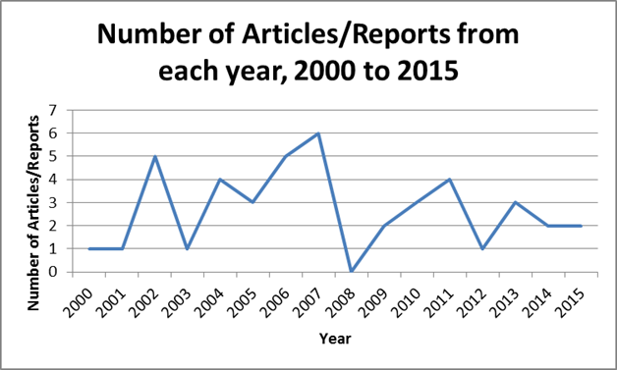

**Method** Desktop Research 2  
 Experiment 6  
 Literature Review 6  
 Sampling 4  
 Survey/Questionnaire/Interviews 5  
 Workshops 3

**Key Themes**

Antibiotic resistance

Antimicrobial resistance in bacteria

Codes of practice

Environmental impact of antibiotics

Import and transport protocols

Import risks

Manufacture of prawn feed

Prawn diseases/viruses

Use of antibiotics and their residue limits

Water quality

## Appendix 3: Summary of APFA Research Literature – Farm Operations

**Number of articles/reports** 28

**Sourced from** ASCRC 3  
 FRDC 3  
 CSIRO 1  
 DAFF 0  
 Other (inc APFA) 21

**Year published**

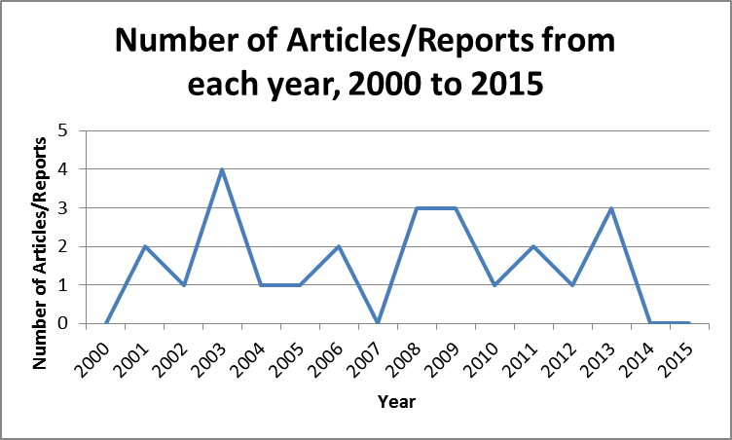

**Method** Case Study 1  
 Desktop Research 2  
 Experiment 3  
 Sampling 4  
 Survey/Questionnaire/Interviews 2

**Key Themes**

Best practice framework

Biofouling of pond aerators

Energy use, efficiency and management

Health management

Impact of climate change

Impact of prawn effluent on the environment

Manufacture of prawn feed

Nutrient requirements, diet validation and feeding strategies

Prawn breeding and genetic selection

Recirculation prawn farming

Saline aquaculture

## Appendix 4: Summary of APFA Research Literature – Genetics

**Number of articles/reports** 29

**Sourced from** ASCRC 9  
 FRDC 3  
 CSIRO 0  
 DAFF 0  
 Other (inc APFA) 17

**Year published**

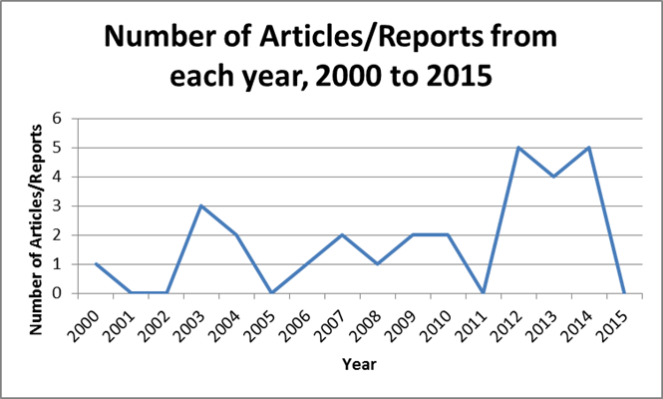

**Method** Desktop Research 2  
 Experiment 23  
 Sampling 1  
 Survey/Questionnaire/Interviews 1  
 Workshops 1

**Key Themes**

Biological tagging

Body colour

Broodstock production

Downstream environmental impact of shrimp farm discharge

Genetic improvement of breeding stock

Heritability and genetic correlations of growth and survival

Prawn cell culture, cell lines

Reproductive behaviour and dysfunction

Selective breeding of domestic stock

Sustainable production

Viral infection reduction

## Appendix 5: Summary of APFA Research Literature – Industry Development

**Number of articles/reports** 71

**Sourced from** ASCRC 8  
 FRDC 9  
 CSIRO 1  
 DAFF 11  
 Other (inc APFA) 42

**Year published**

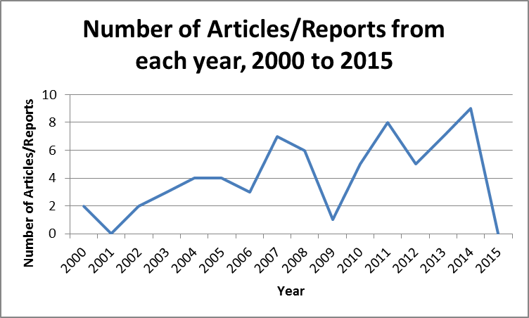

**Method** Case Study 1  
 Desktop Research 11  
 Experiment 4  
 Focus Groups 1  
 Literature review 2  
 Sampling 1  
 Survey/Questionnaire/Interviews 11  
 Workshops 4

**Key Themes**

Aquaculture innovation hub

Aquaculture management

Aquaculture statistics

Australian marine pests

Codes of practice in aquaculture

Collaborative processing project

Commonwealth fisheries management legislation

Consumer profiling

Demonstration farm feasibility study

Domestic prawn breeding

Eastern King Prawn Fishery

Economic and environmental sustainability

Environmental regulatory arrangements for aquaculture

Environmental scan of the agrifood industries

Food safety

Funding options

Great Barrier Reef

Guthalungra project

Import risk analysis

Levies

Northern Prawn Fishery

Queensland production surveys

Recirculation prawn farming

Research and development plans

Saline aquaculture

Site identification

Strategic plans for aquatic animal health

Supply chain

Waste water management trials

White spot disease

## Appendix 6: Summary of APFA Research Literature – Marketing

**Number of articles/reports** 33

**Sourced from** ASCRC 15  
 FRDC 6  
 CSIRO 0  
 DAFF 1  
 Other (inc APFA) 11

**Year published**

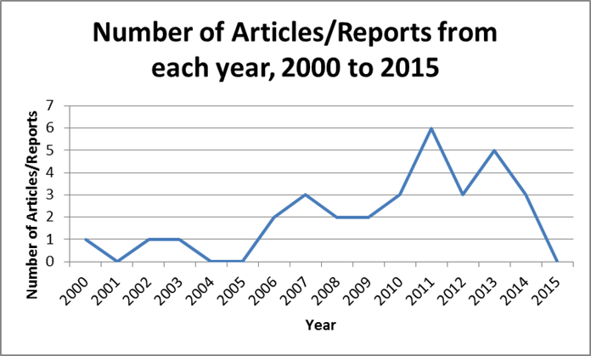

**Method** Desktop Research 9  
 Experiment 6  
 Focus Groups 3  
 Literature review 1  
 Sampling 1  
 Survey/Questionnaire/Interviews 10  
 Workshops 3

**Key Themes**

Aquaculture statistics

Consumer acceptance of innovation

Distribution outsourcing alliances

Drivers and barriers of seafood consumption

Factors contributing to export propensity

Factors influencing consumer purchase intention

Food safety

Funding options

National prawn marketing campaign

Nutritional elements of seafood

Prawn colour including dealing with blackspot

Prawn quality and quality standards

Preferences of younger consumers

Seafood consumption patterns

Seafood supply chain

Stakeholder perceptions of aquaculture

## Appendix 7: Staff engaged on project

|  |  |  |
| --- | --- | --- |
| **Name** | **Institution** | **Role** |
| Professor Meredith Lawley | School of Business  University of the Sunshine Coast | Principal Investigator |
| Ms Judy Watson | School of Business  University of the Sunshine Coast | Research Assistant |
| Ms Jan MacAlister | School of Business  University of the Sunshine Coast | Research Assistant |

## 