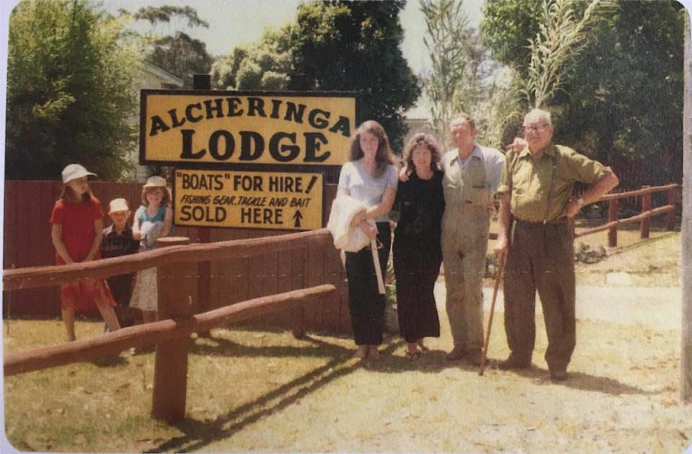**Gunsser Family History of Bemm River**

BEMM RIVER THE WAY IT WAS  
  IN CELEBRATION OF FIVE GENERATIONS   
  OF THE GUNSSER FAMILY

It was Grahams grandfather who first brought him to Bemm  
It was the year 1948 and he was just ten.  
It took them two days to get here, it was such a long way,  
Unmade roads left them weary, after a hot tiring day.  
The first night was at Lakes Entrance, where sand crabs invaded the park,  
They crossed over the Princes Highway, making their way in the dark.  
The roads were narrow with pot holes and treacherous bends,  
There was little traffic, but they were relieved when the journey came to an end.  
Only rough bush with no clearing, no space to put up a tent  
By the time they hacked out the scrub, they were both truly spent.  
They didn’t have a shop, no electricity, no phone,   
Yet there was the beauty of Bemm, a man could be all alone.  
There weren't any township roads, that we would recognise today  
The Bemm was only green bush land , it was too far away.  
Close by the Lake was a pump that had this vile putrid smell  
Here you could get water for washing, from the underground well  
Do I mention the two old honey pots, that stood on top of the hill  
Of course, one was for Jack, the other one for Jill.  
You had to cart your own water, see by the hurricane lamp,  
No ice for fresh food, your clothes would always hang damp.  
Graham remembers they would get covered with tiny bush flies   
They would crawl over your food, get on your face, and be in your eyes.  
But you see for a man, Bemm had its own special charms  
For here they were free, to meet all their mates, and tell fishing yarns.  
They would drink in the old pub, the one that was eventually burnt down.  
Lifetime friendships were formed in that small Bemm River town.  
When you think of the caravan park, there was a sort of a kind  
But not the type of caravan park, that we have in mind.  
There were no modern conveniences, there were no hot showers,  
Just plenty of lazy time, to while away the hours.  
JACK FELLOWS supplied fresh water to the campers, from his own tank  
The country roads board filled it up , when his water level sank.  
JACK HANSEN from the country roads board would collect the camping fees  
For you still had to pay for the privilege of sleeping under the trees.  
One of Grahams favourite grandpa stories , that he just loves to tell,  
Was how his grandpa would drink neat gin, like it was water from a well.  
You have to remember, it was just after the war, alcohol was a luxury   
And spirits was the nectar of kings  
But his grandpa worked as a cooper in a brewery, so he had bottles of the stuff, and it just wasn’t a worry for him.  
The local park ranger nearly had a heart attack, with a look of horror on his face,  
For there was his grandpa priming the Primus stove with gin, wasting this liquid gold, like an alien out of space.  
When a working man could hardly afford a pint, it was such a sacrilege, and a total criminal waste.  
But to Grahams grandpa, it was like water off a ducks back, for he had an endless supply to taste.  
So you can imagine how popular the GUNSSER camp was, to all the local fishermen at Bemm,   
For his Pa had a veritable gold mine, and this precious liquid was shared by each and every one  of them.

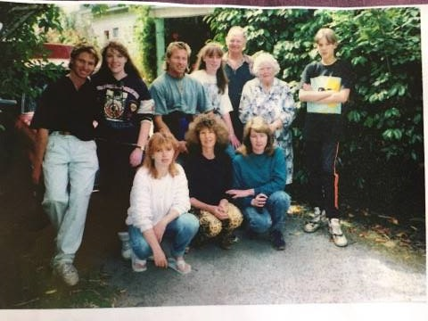

Many fishing yarns were spun, a young boys education had begun.  
Strong bonds were formed that tied you to the place  
So, for year after year, the same fishermen returned, for part of the attraction, was to meet a friendly face.  
At Christmas time there was always a couple who sold bait, charging a shilling to fill up a jam tin.  
But there was a catch! If you didn’t happen to bring your own jam tin, you never got your bait, for you just didn’t get a look in  
Fishing skills were only learnt with practice, not something you could read in a book.  
There were no lures in those days, they would trawl for skipjack using a coloured rag on the end of a hook.  
Cane rods and side Wacker reels were the cause of many a tangled line  
Compared to the modern gear of today, fishing was simple and basic, knots and rigging could be taught in a short space of time.  
Let us discuss the heritage Clinkers and Carvils which were affectionately known as PUT PUTS with their single cylinder inboard motor, for those were the kind Jack Fellows used for his hire boats.  
The hotel also had this type, the hulls which were built from timber were heavy  and solid, but very safe to float  
The cavils were joined with a smooth finish, the clinkers timber was overlapped   
To those collectors dedicated to restoring their pride, history owes you a pat on the back.  
The Bemm River Hotel provided an excellent, first class silver service for their paying guests, catering for the elite, for they were the ones with the money.  
But I would bet on my life, Graham and his grandpa had the most fun in their camping tent with the outside dunny.  
We have all heard the legendary stories about Dinny, and I just have to mention the Bluey and Curly Cartoon Strip,  
But Bluey and Curly is a blast from the past, so only us oldies would get the satire of his humorous wit.  
Dinny leaning over the tiny pub bar, not wanting to move an inch  
Dinny leaning over the fishing jetty, and the hotel front picket fence.  
His unique laid back character made Dinny, the butt of many a  Bemm River joke,  
But I am going to step up and bat one for Dinny, to tell another side of a very different type of bloke.

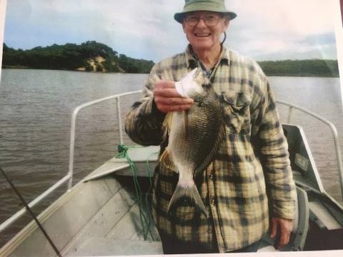

The Bemm River hotel was run by Dinny and his sister Beatrice, who became mates with Grahams grandpa,  
So , to a shy, freckled faced red head, it was a big deal to go to Dinnys tiny bar  
Dinny was a larger than life character, and Graham was a little scared and over awed by this strange and powerful man  
Until one day, while fishing on the jetty, Dinny stopped, leaned over the rail, he started to chat and hold out a friendly hand.  
We will never know why he bothered to reach out to our budding young fisherman  
Perhaps Graham reminded him of his own childhood, when he was a little boy of ten.  
For as every time Dinny leaned over the rails, he took an interest in everything Graham did.  
So this fear of Dinny, turned into respect and appreciation, which was to help influence and shape our Bemm River kid.  
Graham never did forget Dinnys kindness, as he constantly spoilt him with raspberry lemonade.  
That very shy young boy, is now a grown man, but that touching Bemm River memory will never fade.  
Graham had achieved a milestone, his social status had risen, from being a cub ,to a dedicated Boy Scout.  
That uniform went fishing all over the Bemm, and with that Aussie sense of humour, the men couldn't help but notice, when he was about.  
He was so proud of his Boy Scout uniform, he didn’t want to take it off.  
And to this very serious Bemm River Boy Scout, Dinny was never a man to scoff.  
So Dinnys legacy of life, taught a valuable lesson, to never judge a book by its cover  
And so to all of those crazy legends about our one of a kind Dinny we have just added another.  
Children grow up, boys become men, but those happy memories have lingered on forever.  
Grahams love was to be shared by five generations, who enjoyed the total magic of our Bemm River  
How can you explain to a stranger the pull of the past, the deep passion that binds us together .  
Around the burning glow of the campfires embers, we relive the joy of our "DO YOU REMEMBERS "