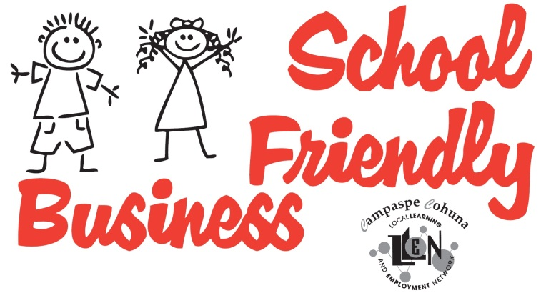**Becoming a School Friendly Business**

*Tick at least 6 of the following boxes:*

Our Business is aware of important school dates

We will consider flexi time for parent/guardian employees to attend significant school events

We will welcome authorised school and parenting promotional literature in our staff room

We are prepared to host workplace learning (work experience, work placements and/or school based apprentices) and tours of our worksite

We would consider mentoring students

Our business engages with the Beacon Foundation

We would like to be invited to important school events

We are keen to help train potential employees

We want to be part of the ‘village that raises a child’

Other involvement (please describe) ­

**Yes, I / We are interested in becoming a School Friendly Business**

Name of Business or Organisation:

Manager / Executive Officer / Director:

**Contact Details**

Telephone:

Mobile:

Email:

Web Address:

Fill in and mail back to CCLLEN, PO Box 273, Echuca VIC 3564

OR- Call 03 5482 6055 or email [admin@ccllen.com.au](mailto:admin@ccllen.com.au) for a form to be sent out or delivered to you