Prices exclude GST and are in Australian Dollars

Local freight costs are shown at the end of this information or, for overseas customers, these can be viewed under “Postage Rates” on our web site.

Notes: All colours are the same price including Clear

We make a Standard for $100 (made from 3mm material in a wide of colours)

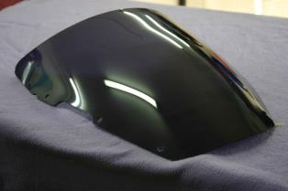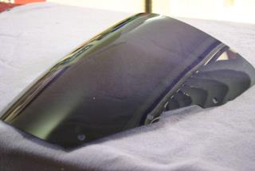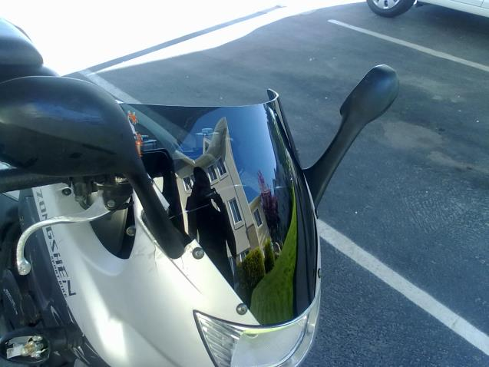

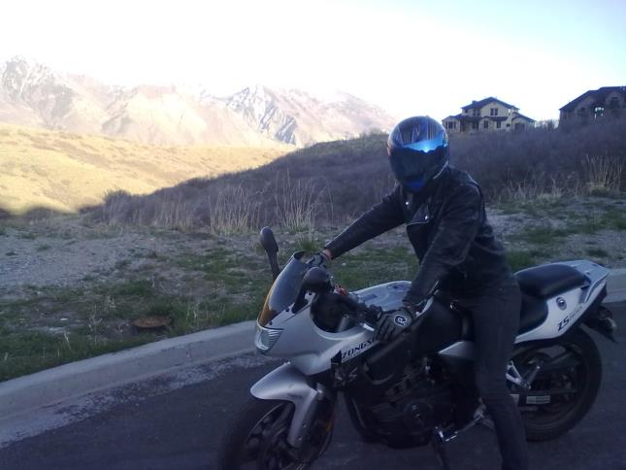  
Windlip for $120 (No photos available)

and Double Bubble/High Contour for $130 (No photos available…see sketch below for details)

and Touring for $140 (No photos available…see sketch below for details)

That's for any colour Tint or Clear that you like although Dark Tint often looks the best.

Once made, Perth close metro area delivery is only $12. Elsewhere in Australia, delivery is $25.

Overseas postage rates are detailed on our web site under “Postage rates” (4th Item down Top RH corner)

(These weigh around 0.75kg when packed and depending on the style chosen)

Ordering is via Email, Fax or from our Web Site.

Local payments can be made by Cash, Credit Card (surcharge applies), Direct Deposit or PayPal (Surcharge applies).  
Overseas payments are only by Visa, Mastercard and PayPal (surcharge applies)  
All consultancy and technical information is answered as quickly as possible by email.  
Please note that this quote will remain current for 24 hours.

Thanks for your enquiry.   
EAGLE SCREENS AUSTRALIA

"In our 33rd year of manufacturing screens ....and exporting to the world"

You can use your existing fittings to fit our screens, but if you wanted an all-round new look, here are the fittings we have available …..

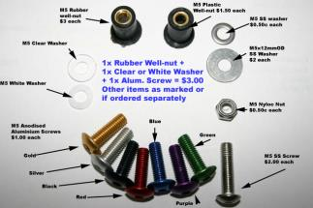

Please use the attached sketch to check for correct model identification. Return fees apply if the incorrect screen is ordered. (Z-01)

