***DUAL PURPOSE* - CEILING SCREWS COLLATED AND LOOSE**

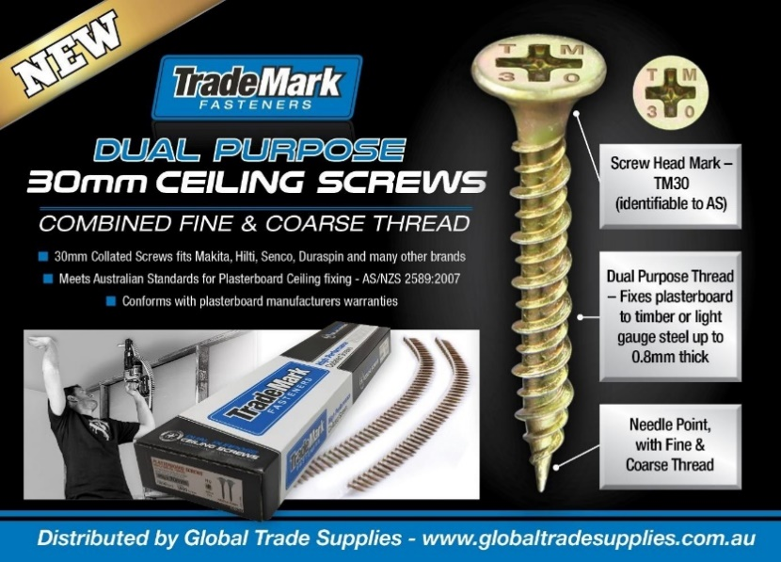

**Features**

• Dual Purpose Thread – Fixes plasterboard to timber or light gauge steel up to 0.8mm thick

• Needle Point, with Fine & Coarse Thread

• Meets Australian Standard for Plasterboard Ceiling fixing.

• Conforms to plasterboard manufacturers warranties.

• Screw Head Mark – TM30 (Easily identifiable to meet Australian Standards)

|  |  |  |  |  |
| --- | --- | --- | --- | --- |
| **Short Code** | **Description** | **Product Code** | **Barcode** | **Preferred Order Qty** |
| CS30 | COLLATED SCREWS PLASTER #6 X 30MM  DUAL PURPOSE THREAD NP PH2 YZ 1000 PCS | TMCPDP30YZ | 9350149002894 | **10** |
| LS130 | LOOSE SCREWS PLASTER #6 X 30MM  DUAL PURPOSE THREAD NP PH2 YZ 1000 PCS | TMLPDP30YZ | 9350149003631 | **12** |