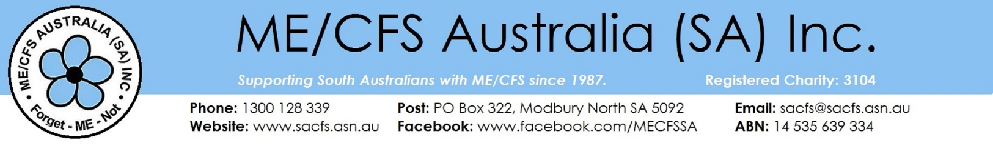

**Membership Form**

The membership year is from 1st July to 30th June and the membership fee is $5.

Please fill out ALL the details below and either email ([memberships@sacfs.asn.au](mailto:memberships@sacfs.asn.au)) or post (Membership ME/CFS SA, PO Box 322, Modbury North 5096) this signed form with payment or payment receipt attached.

**Title:** Choose an item. **Given Name:** Click here to enter text. **Surname:** Click here to enter text.

**Postal Address:** Click here to enter text.

**Suburb:** Click here to enter text. **Postcode:** Click here to enter text.

**Preferred Ph:** Click here to enter text. **Email:** Click here to enter text.

Please indicate your age range:  Under 30  30 - 49  50- 64  65+

I would prefer to receive *Talking Point* magazine by post.

Please send me SMS Seminar reminders.

I hereby  **Apply for  Renew** my membership of ME/CFS South Australia

I consent to the Society collecting, storing and using my information in accordance with its Privacy Policy.

I agree to uphold and abide by itsconstitution.

Date Click here to enter a date.

I have been diagnosed with:  ME/CFS  Fibromyalgia  MCS

I am a Carer Relative Health Practitioner  Other Click here to enter text.

I would like to volunteer to help. My skills & interests are Click here to enter text.

**How To Pay**

**Direct Deposit: Acct Name**: ME/CFS Australia (SA) Inc  **BSB:** 105-900 **Acct No**: 954470240

Reference: Use your last name & initial. Please send a copy of your payment receipt with this form.

**Cheque/Money Order:** make payable to ME/CFS Australia (SA) Inc

**Cash**

**Membership Fee $**Click or tap here to enter text.

**Donation $**Click or tap here to enter text.

**Total Payment $** Click or tap here to enter text.

**Administration only:** Payment Confirmed ……/..…./..…. Receipt No. Data entered ……/..…./..…