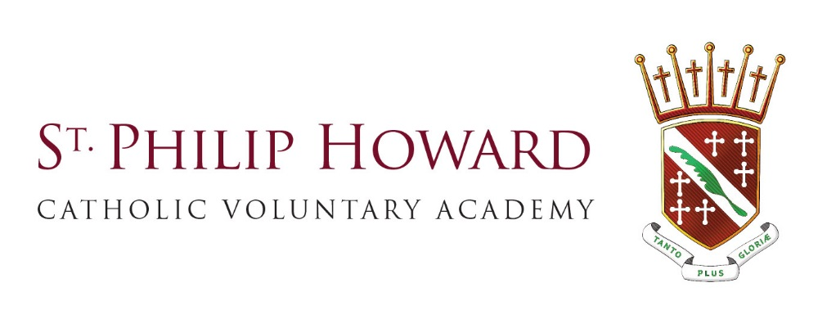

**School Holidays**

**2017/2018 Academic Year**

Autumn Term

INSET – 4th and 5th September

School opens to students Wednesday 6th September – Friday 20th October 2017

Half term – Monday 23rd October 2017 – Friday 27th October 2017

Monday 30th October 2017 – Tuesday 19th December 2017

School closed for long weekend - Friday 24th November 2017

Last day of term Tuesday 19th December 2017 – school closes at 12.15pm

Christmas Holidays Wednesday 20th December – Tuesday 2nd January 2018

Spring Term

INSET – Wednesday 3rd January 2018

School opens to students Thursday 4th January 2018 – Friday 16th February 2018

Half term - Monday 19th February 2018 – Friday 23rd February 2018

Monday 26th February 2018 – Friday 23rd March 2018

Last day of term Friday 23rd March 2018

Easter Holidays Monday 26th March – Friday 6th April 2018

Summer Term

Monday 9th April 2018 – Friday 25th May 2018

Monday 28th May 2018 – Friday 1st June 2018

Monday 4th June 2018 – Friday 20th July 2018

Last Day of term Friday 20th July 2018 – school closes at 12.15pm

INSET Days

Monday 4th September 2017

Tuesday 5th September 2017

Wednesday 3rd January 2018

Bank Holidays

25 and 26 December 2017

1 January 2018

30 March 2018 (Good Friday)

2 April 2018 (Easter Monday)

7 May 2018

28 May 2018 (Spring Bank Holiday)

27 August 2018 (Summer Bank Holiday).