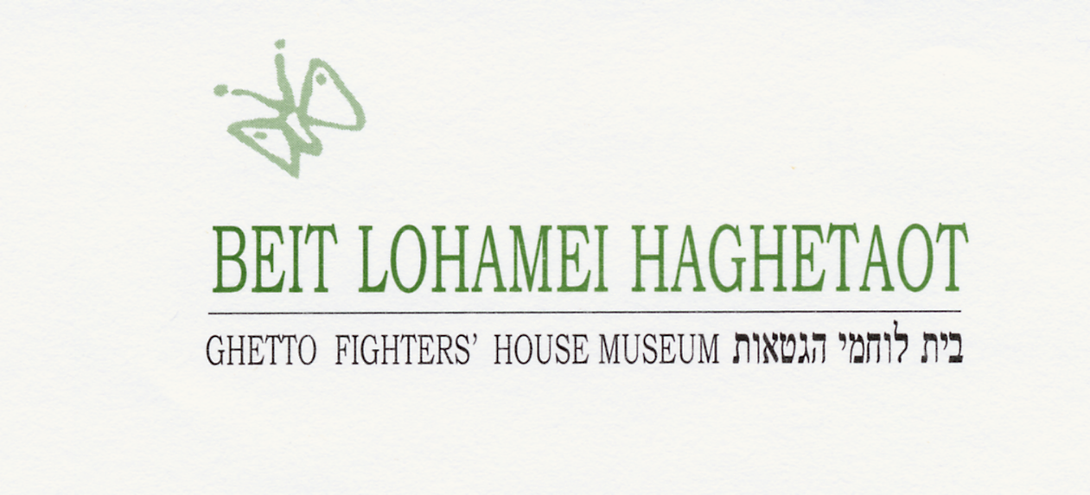

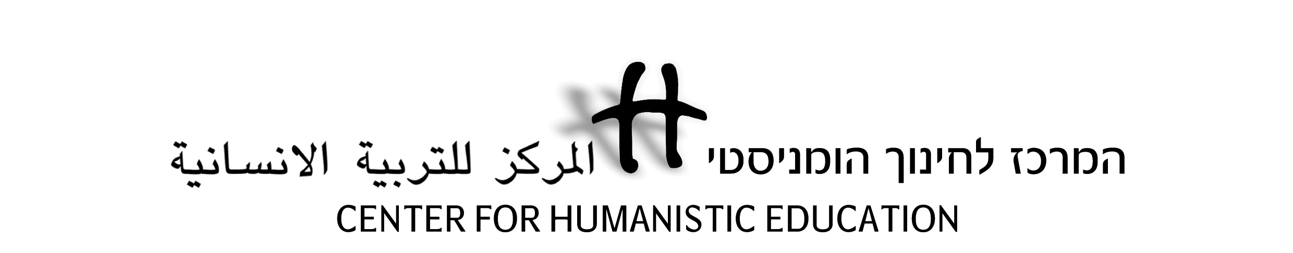

**Holocaust Education for Democratic Values**

**CHE-Erinnern.at Seminar at Ghetto Fighters House, July 2016**

**Day 1, 17/7: Introducing Ghetto Fighters House Museum**

|  |  |  |  |
| --- | --- | --- | --- |
| **Time** | **Subject and Activity Description** | **Goals** | **Comments** |
| **9.00-9.30** | **Seminar opening, introduction** |  | At the Center |
| **9.30-12.00** | **Lochamei Hagetaot (the Ghetto Fighters):** The story of the kibbutz and the museum.  With: Tali Shner, a scholar, pedagogue, daughter of Kibbbutz founders. | Acquaintance with the place and its unique story. | a guided tour through the kibbutz, concluding in the Witness Hall at the museum. |
| **12.00-13.00** | **Lunch** |  |  |
| **13.00-15.00** | Educational work at the museum - pedagogical and practical problems and solutions**.** | Acquaintance with issues of museum-based pedagogy | Discussion combined with demonstrations on the museum floor |
| **15.00-17.00** | **Personal museum time** | Equipped with personal audioguides and assisted by the staff, an opportunity to visit the museum. | Educational kits will be on display in the library (sorry – only in English…) |

**Day 2, 18/7: Holocaust Education and Democratic Values**

|  |  |  |  |
| --- | --- | --- | --- |
| **Time** | **Subject and Activity Description** | **Goals** | **Comments** |
| **8.30-10.00** | **Materials of Memory:** Acquaintance with the GFH Archive | Presentation and active research | Yizkor Hall,  study-room |
| **10.00-10.15** | **Break** |  |  |
| **10.15-12.00** | **1) Lessons of the Holocaust:**  A text-based activity on meanings and implications of the Holocaust for us today.  **2) Presentation on CHE** | The activity encourages a personal and social reflective discussion on the Holocaust.  Description of the work of CHE and its particular features. |  |
| **12.00-13.00** | **Lunch** |  |  |
| **13.00-14.00** | **"Brainland":** A workshop about social discrimination | A simulation dealing with the ethical premise of human equality, in association with the Nazi racial theory. |  |
| **14.00-15.30** | **Exclusion of those who are 'different'**  A workshop depicting the Nazi policy towards 'unwanted elements' in society. | The social and political concept of Ingroup and Outgroup: do we identify it in our own society? How can we deal with it? | Activity followed by reflective discussion |
| **15.30-**  **16.00** | **"Wasted Lives":** genocide in the 20th century | A short film and follow-up discussion on connecting Holocaust to other genocides |  |
| **16.00-16.30** | **Day's closure discussion** |  |  |

**Day 3, 19/7: Jewish-Arab Dialogue at CHE**

|  |  |  |  |
| --- | --- | --- | --- |
| **Time** | **Subject and Activity Description** | **Goals** | **Comments** |
| **8.30 –**  **10.00** | **Workshop: Majority-Minority Relations** | Examination of various patterns of group-relations – from alienation to dialogue, connected to concrete contexts. | Activity followed by reflective discussion |
| **10.00-10.15** | Break |  |  |
| **10.15 –**  **11.30** | **Local Context: Historical and sociopolitical background of Jewish-Arab dialogue at CHE** | Deepen understanding of the major issues dividing Jews and Arabs. | Hands-on and informal confrontation with local past and present |
| **11.30-11.45** | **Break** |  |  |
| **11.45-12.30** | **Presenting the Narrative-based Dialogue** | Exposure to the particular approach to inter-group dialogue practiced at CHE |  |
| **12.30 –**  **13.30** | **Lunch** |  |  |
| **13.30 –**  **15.30** | **CHE's educational operation: from theory to practice** | Free discussion with CHE graduates about their experience and insights |  |
| **15.30-15.45** | **Break** |  |  |
| **15.45 –**  **17.00** | **Conclusions.**  **Farewell!!!** | 1) Comments and recommendations for next seminars.  2) What do I take with me from here? |  |