

### ­­

### Recon V3

### MODEL FSV1132-03

### USER MANUAL

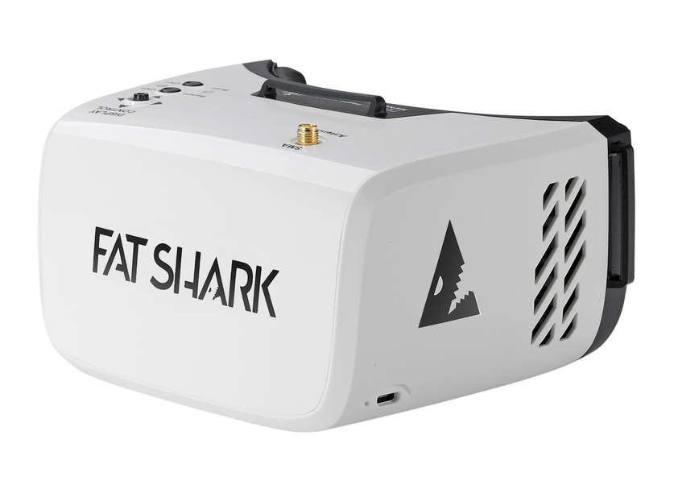

### Revision A 05/24/2019

### For more product information, please visit: [www.fatshark.com](http://www.fatshark.com) All Rights Reserved

# Headset Operation

* **Battery Charging:** The battery in the headset is a standard 18650 2600mAh Li-ion cell, and can be charged with built-in charger by connecting a micro USB power supply to the headset.
* **Brightness and Contrast:** Slide the 5-way button left and right or forward and back for contrast and brightness adjustment.
* **Channel Selection:** Short press channel Up(CH+)/ Down(CH-) button to incrementally increase/decrease the channels. Long press and release the Up(CH+) button to change band; long press and release the Up(CH-) button to do auto scan active channel.
* **DVR Recording:** Vertically depress the 5-way button and listen for the short beep to start and stop recording video from the live feed. Long-press the 5-way button to enter the DVR menu and browse/play content. This DVR has no auto save recording file function, need to manually stop recording to save file.
* **Control Diagram:**

 