**Summit Station Weekly Science Report**

**Reporting Period:**  February 25– March 3, 2019

**Completed by:** Mara Menahan and Nathan Bowker

**Comments:** After much effort both on and off-site, the ICECAPS Dataman computer is back online and functioning normally. Additionally, technicians completed an ICESat traverse on 2019-02-26.

Wind speeds at Summit ranged from 0.7 m/s, recorded on 2019-02-28, to 14.7 m/s recorded on 2019-03-02. The average wind speed for the week was 7.27 m/s. Temperatures ranged from a low of -48.99˚C on 2019-02-28 to a high of -18.88˚C on 2019-03-01. The weekly average temperature was -28.99˚C.

Summit experienced low winds on 2019-02-26 at 13:44Z, and on 2019-02-17 from 00:45-00:49Z. Summit did not experience any north winds this week.

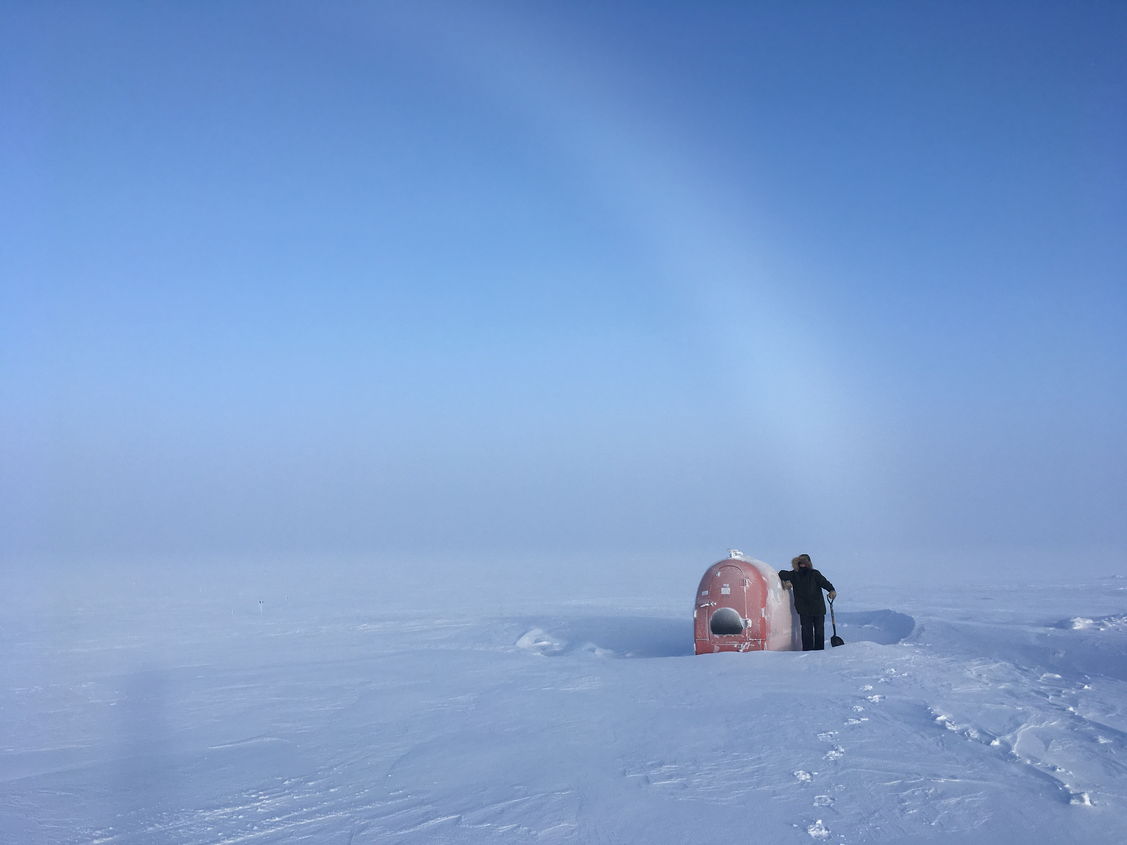

Mara frees the Polypod from a snowdrift in preparation for an ICESat traverse.

Photo: Kathy Schroeder

**Please visit the clean air log at ftp://isr.sri.com/pub/summit/ftp/science/clean_air_traffic/**

|  |  |
| --- | --- |
| **Facilities** | **Comment** |
| TAWO |  |
| MSF |  |
| Green House |  |
| **Experiment** | **Notes** |
| NOAA CCGG flasks | Comment:  Date performed: 2019-03-01 |
| NOAA HATS flasks | Comment: twice per month  Date performed: 2019-02-23 |
| NOAA Surface Ozone | Comment: Calibrated on 2019-02-26.  % of time operating: 100% |
| NOAA Aethelometer | Comment: Instrument offsite for service.  % of time operating: 0% |
| NOAA Meteorology | Comment:  % of time operating: 100% |
| NOAA CLAP & Neph | Comment: Span check last occurred on 2019-02-19.  % of time operating: 100% |
| Radionuclide Filter | Comment: Changed every other day.  % of time operating: 100% |
| Aerosol DRUM Sampler | Comment:  % of time operating: 100% |
| Bamboo Forest | Comment:  Date performed: 2019-02-27 |
| SnowFox | Comment:  Date performed: 2019-02-27 |
| ICESat Accumulation | Comment:  Date performed: 2019-02-26 |
| GFZ Potsdam Seismometer | Comment:  % of time operating: 100% |
| DTU Magnetometer | Comment:  % of time operating: 100% |
| UNAVCO | Comment: |
| Helmig CUGC | Comment:  % of time operating: 100% |
| Steffen Tower Instruments | Comment:  % of time operating: 100% |
| Steffen Solar Instruments | Comment: Communicating with PI’s to restore power and comms to the CR23x data logger on the solar tracker.  % of time operating: 50% |
| ICECAPS-ACE Total Sky Imager | Comment: Offline for the winter.  % of time operating: 0% |
| ICECAPS-ACE Radiosonde | Comment: 2019-03-02: 0000Z sonde data collected but did not transmit to DMI.  Dates performed: Twice daily. |
| ICECAPS-ACE MWR | Comment: Restarted on 2019-03-01 due to Slave elevation mirror error.  % of time operating: 100% |
| ICECAPS-ACE SODAR | Comment:  % of time operating: 100% |
| ICECAPS-ACE POSS | Comment: Restarted on 2019-03-02 at 0000Z. Operating normally.  % of time operating: 30% |
| ICECAPS-ACE MASC | Comment: Instrument offsite for service; expected return 2019-06.  % of time operating: 0% |
| ICECAPS-ACE MMCR | Comment:  % of time operating: 100% |
| ICECAPS-ACE CAPABL | Comment: Instrument offline awaiting service.  % of time operating: 0% |
| ICECAPS-ACE MPL | Comment:  % of time operating: 100% |
| ICECAPS-ACE Ceilometer | Comment:  % of time operating: 100% |
| ICECAPS-ACE PAERI | Comment:  % of time operating: 100% |
| ICECAPS-ACE IcePIC | Comment:  Date(s) performed: 2019-02-25, 2019-03-03 |
| ICECAPS-ACE CLASP | Comment: Instrument offsite for service.  % of time operating: 0% |
| ICECAPS-ACE CPC | Comment: 2019-02-27: CPC data now plotting to quicklooks.  % of time operating: 100% |
| ICECAPS-ACE OPC | Comment:  % of time operating: 100% |
|  |  |  |
|  |  |  |