**Summit Station Weekly Science Report**

**Reporting Period:**  March 04 – March 10, 2019

**Completed by:** Mara Menahan and Nathan Bowker

**Comments:** The backlog of ICECAPS data that had amassed while the dataman computer was down is now fully caught up, and nightly ICECAPS data transfers are once again occurring normally.

Note: While daylight savings time for 2019 began in the United States on Sunday, March 10th, Greenland and Europe will not make this change until Sunday, March 31st. In the interim our clocks will be one hour closer together than the normal time difference.

Wind speeds at Summit ranged from 0.1 m/s, recorded on 2019-03-10, to 9.3 m/s recorded on 2019-03-04. The average wind speed for the week was 5.49 m/s. Temperatures ranged from a low of -51.92˚C recorded on 2019-03-10 to a high of -31.10˚C on 2019-03-07. The weekly average temperature was -43.97˚C.

Summit experienced low winds on 2019-03-08 from 07:02-07:14Z and on 2019-03-10 from 20:13-23:45Z. Summit experienced north winds on 2019-03-05 from 00:58-21:19Z, on 2019-03-08 from 03:29-16:02Z, and on 2019-03-10 from 23:21-23:38Z.

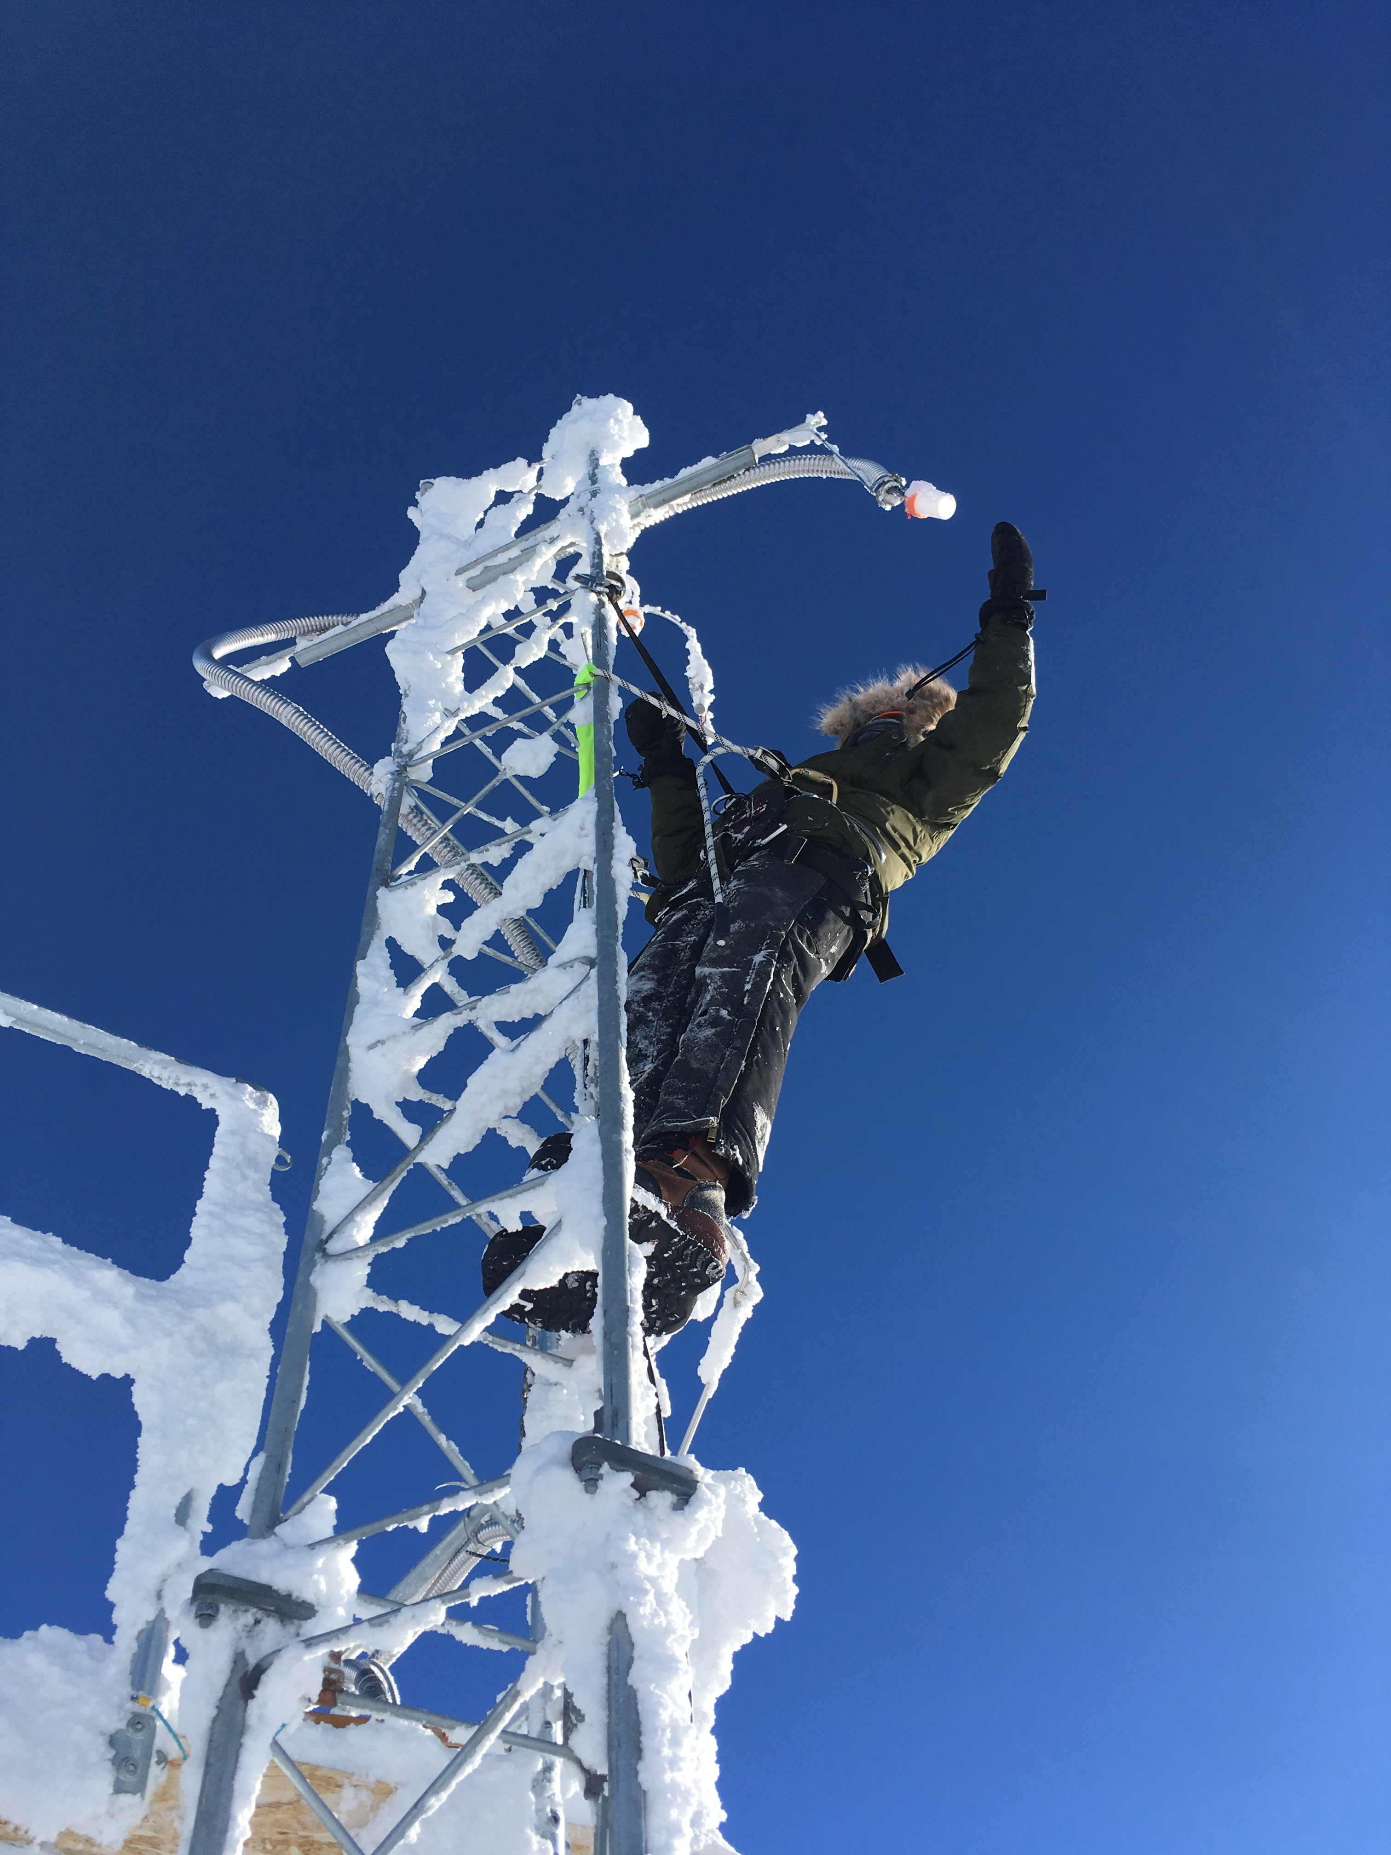

Mara repairs a damaged wire on the CUGC inlet.

Photo: Nate Bowker

**Please visit the clean air log at ftp://isr.sri.com/pub/summit/ftp/science/clean_air_traffic/**

|  |  |
| --- | --- |
| **Facilities** | **Comment** |
| TAWO | Repaired damaged wire on the CUGC inlet on 2019-03-09. |
| MSF |  |
| Green House |  |
| **Experiment** | **Notes** |
| NOAA CCGG flasks | Comment:  Date performed: 2019-03-07 |
| NOAA HATS flasks | Comment: twice per month  Date performed: 2019-03-08 |
| NOAA Surface Ozone | Comment: Calibrated on 2019-03-05.  % of time operating: 100% |
| NOAA Aethelometer | Comment: Instrument offsite for service.  % of time operating: 0% |
| NOAA Meteorology | Comment:  % of time operating: 100% |
| NOAA CLAP & Neph | Comment: Span check last occurred on 2019-03-05.  % of time operating: 100% |
| Radionuclide Filter | Comment: Changed every other day.  % of time operating: 100% |
| Aerosol DRUM Sampler | Comment:  % of time operating: 100% |
| Bamboo Forest | Comment:  Date performed: 2019-03-07 |
| SnowFox | Comment:  Date performed: 2019-03-06 |
| ICESat Accumulation | Comment:  Date performed: 2019-02-26 |
| GFZ Potsdam Seismometer | Comment: PI’s performed a remote re-center on 2019-03-05  % of time operating: 80% |
| DTU Magnetometer | Comment:  % of time operating: 100% |
| UNAVCO | Comment: |
| Helmig CUGC | Comment: Repaired damaged wire on inlet from 1422-1443 on 2019-03-09  % of time operating: 100% |
| Steffen Tower Instruments | Comment:  % of time operating: 100% |
| Steffen Solar Instruments | Comment: Communicating with PI’s to restore power and comms to the CR23x data logger on the solar tracker.  % of time operating: 50% |
| ICECAPS-ACE Total Sky Imager | Comment: Offline for the winter.  % of time operating: 0% |
| ICECAPS-ACE Radiosonde | Comment: 2019-03-05: Replaced plastic on balloon table.  Dates performed: Twice daily. |
| ICECAPS-ACE MWR | Comment: Restarted system on 2019-03-04 to correct Master/Slave COM port reversal.  % of time operating: 99.9% |
| ICECAPS-ACE SODAR | Comment:  % of time operating: 100% |
| ICECAPS-ACE POSS | Comment:  % of time operating: 100% |
| ICECAPS-ACE MASC | Comment: Instrument offsite for service; expected return 2019-06.  % of time operating: 0% |
| ICECAPS-ACE MMCR | Comment: Restarted on 2019-03-07 to correct LabVIEW error.  % of time operating: 99.9% |
| ICECAPS-ACE CAPABL | Comment: Instrument offline awaiting service.  % of time operating: 0% |
| ICECAPS-ACE MPL | Comment:  % of time operating: 100% |
| ICECAPS-ACE Ceilometer | Comment:  % of time operating: 100% |
| ICECAPS-ACE PAERI | Comment:  % of time operating: 100% |
| ICECAPS-ACE IcePIC | Comment: Backlog of IcePICs staged for transfer  Date(s) performed: |
| ICECAPS-ACE CLASP | Comment: Instrument offsite for service.  % of time operating: 0% |
| ICECAPS-ACE CPC | Comment: Received “Liquid Level” error on 2019-03-06, which cleared upon venting the reservoir.  % of time operating: 99% |
| ICECAPS-ACE OPC | Comment:  % of time operating: 100% |
|  |  |  |
|  |  |  |