**Summit Station Weekly Science Report**

**Reporting Period:**  April 08 – April 14, 2019

**Completed by:** Mara Menahan and Nathan Bowker

**Comments:** Technicians took advantage of the warm temperatures this week to raise science flag lines. This effort included replacing damaged bamboo poles and raising the length of the seismometer cable line. In addition, technician modified the solar tracker stand to allow for unrestricted cable movement throughout the instrument’s daily rotations.

Wind speeds at Summit ranged from 0.8 m/s, recorded on 2019-04-08, to 23.3 m/s recorded on 2019-04-13. The average wind speed for the week was 7.21 m/s. Temperatures ranged from a low of -36.96˚C recorded on 2019-04-08 to a high of -10.97˚C on 2019-04-13. The weekly average temperature was -24.96˚C.

Summit experienced low winds on 2019-04-08 from 15:26-15:32Z. Summit experienced no north winds this week.

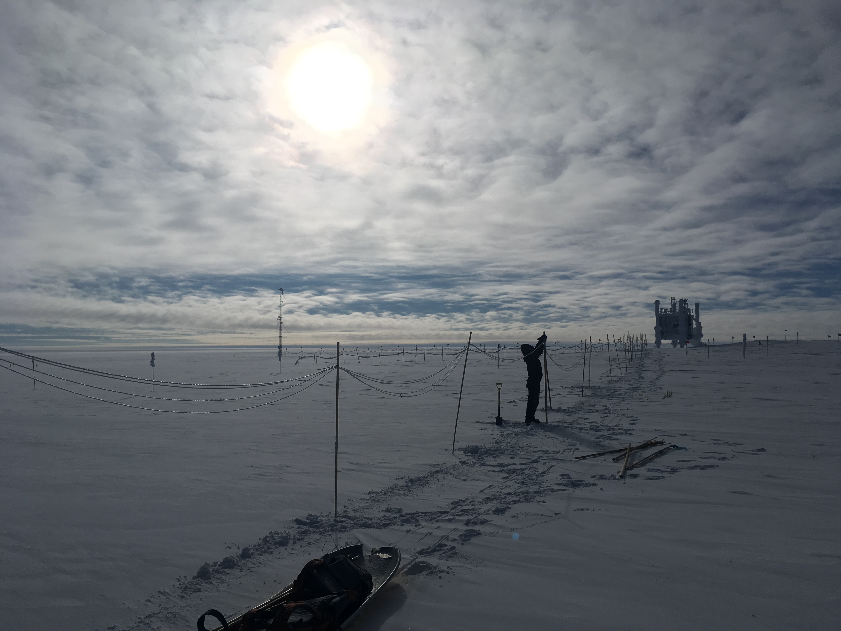Raising the seismometer flag line. Photo: Nate Bowker

**Please visit the clean air log at ftp://isr.sri.com/pub/summit/ftp/science/clean_air_traffic/**

|  |  |
| --- | --- |
| **Facilities** | **Comment** |
| TAWO | Raised and replaced bamboo poles along the seismometer cable line. Modified the solar tracker stand to allow for unrestricted cable movement. |
| MSF |  |
| Green House |  |
| **Experiment** | **Notes** |
| NOAA CCGG flasks | Comment: Prepared a sampled flask crate for retro and replaced with an unsampled crate at TAWO on 2019-04-11  Date performed: 2019-04-11 |
| NOAA HATS flasks | Comment: Performed twice per month  Date performed: 2019-03-08 |
| NOAA Surface Ozone | Comment: Calibrated on 2019-04-09.  % of time operating: 100% |
| NOAA Meteorology | Comment:  % of time operating: 100% |
| NOAA CLAP & Neph | Comment: Span check last occurred on 2019-04-02.  % of time operating: 100% |
| Radionuclide Filter | Comment: Changed every other day.  % of time operating: 100% |
| Aerosol DRUM Sampler | Comment:  % of time operating: 100% |
| Bamboo Forest | Comment:  Date performed: 2019-04-12 |
| SnowFox | Comment:  Date performed: 2019-04-10 |
| ICESat Accumulation | Comment:  Date performed: 2019-03-31 |
| GFZ Potsdam Seismometer | Comment: Raised and replaced bamboo poles along the seismometer cable line on 2019-04-10 from 1600-1930z and on 2019-04-11 from 1700-1800z.  % of time operating: 100% |
| DTU Magnetometer | Comment:  % of time operating: 100% |
| UNAVCO | Comment: |
| Helmig CUGC | Comment:  % of time operating: 100% |
| Steffen Tower Instruments | Comment:  % of time operating: 100% |
| Steffen Solar Instruments | Comment: Modified the solar tracker stand to allow for unrestricted cable movement on 2019-04-12.  % of time operating: 98% |
| ICECAPS-ACE Total Sky Imager | Comment: Offline for the winter.  % of time operating: 0% |
| ICECAPS-ACE Radiosonde | Comment: A software update for the MW41 sounding system was installed on 2019-04-08, correcting the issues caused by the GPS week number rollover on 2019-04-06.  Dates performed: Twice daily. |
| ICECAPS-ACE MWR | Comment:  % of time operating: 100% |
| ICECAPS-ACE SODAR | Comment:  % of time operating: 100% |
| ICECAPS-ACE POSS | Comment:  % of time operating: 100% |
| ICECAPS-ACE MASC | Comment: Instrument offsite for service; expected return 2019-06.  % of time operating: 0% |
| ICECAPS-ACE MMCR | Comment:  % of time operating: 100% |
| ICECAPS-ACE CAPABL | Comment: Instrument offline awaiting service.  % of time operating: 0% |
| ICECAPS-ACE MPL | Comment:  % of time operating: 100% |
| ICECAPS-ACE Ceilometer | Comment:  % of time operating: 100% |
| ICECAPS-ACE PAERI | Comment:  % of time operating: 100% |
| ICECAPS-ACE IcePIC | Comment: Three sampling sessions photographed and uploaded.  Date(s) performed: 2019-04-11, 2019-04-12 |
| ICECAPS-ACE CLASP | Comment: Instrument offsite for service.  % of time operating: 0% |
| ICECAPS-ACE CPC | Comment: Instrument lost power due to a loose power connection to the PDU and was restarted on 2019-04-13 at 1225Z.  % of time operating: 95% |
| ICECAPS-ACE OPC | Comment:  % of time operating: 100% |
|  |  |  |
|  |  |  |