**Summit Station Weekly Science Report**

**Reporting Period:**  December 31, 2018 – January 6, 2019

**Completed by:** Gus Allen, Troy Nave

**Comments:** The summit techs rolled a non-trivial number of logs and documents over to 2019 this week.

Wind speeds at Summit ranged from 0.1 m/s, recorded on 2019-1-5, to 18.5 m/s on 2019-1-2. The average wind speed for the week was 7.6 m/s. Temperatures ranged from a low of -50.0˚C on 2019-1-6 to a high of -17.9˚C on 2019-1-4. The average temperature was -32.4˚C.

Summit experienced North wins from 1926 Z on 2019-1-5 to 1210 Z on 2019-1-6. Low winds were experienced at Summit from 1927 to 2103 Z on 2019-1-5.

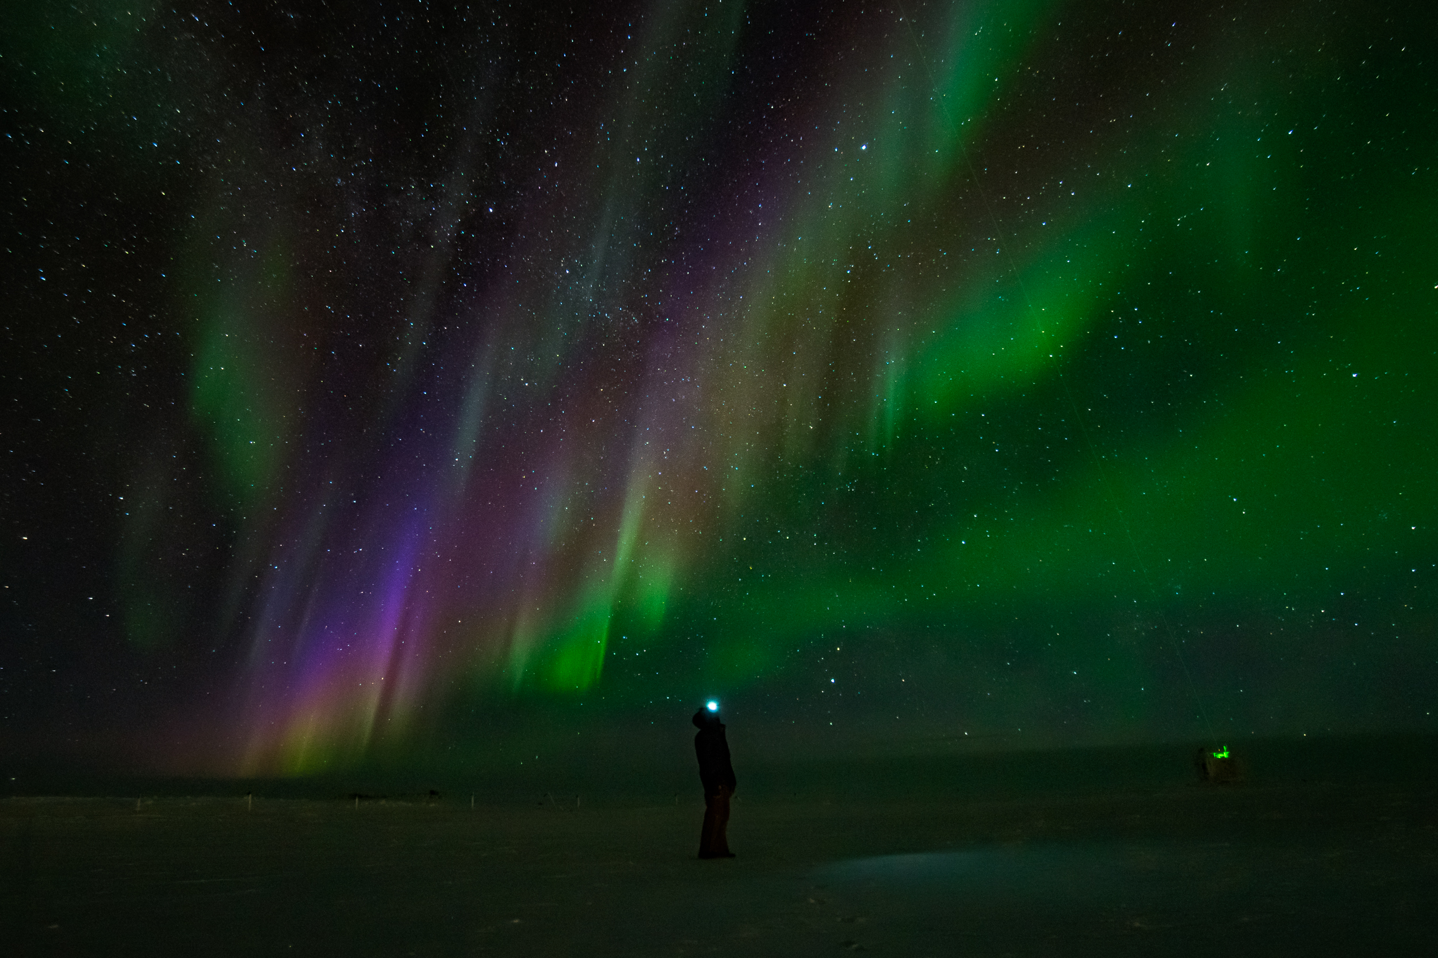

The ICECAPS tech inspects Aurora Borealis for hue and brightness on the morning January 5

**Please visit the clean air log at ftp://isr.sri.com/pub/summit/ftp/science/clean_air_traffic/**

|  |  |
| --- | --- |
| **Facilities** | **Comment** |
| TAWO | Minor temp control issue addressed and resolved. |
| MSF | MMCR level 0.11 pitch 0.00 roll |
| Green House |  |
| **Experiment** | **Notes** |
| NOAA CCGG flasks | Comment:  Date performed: 2019-1-3 |
| NOAA HATS flasks | Comment:  Date performed: none last week |
| NOAA Surface Ozone | Comment: Calibrated on 2019-1-1.  % of time operating: 100% |
| NOAA Aethelometer | Comment: Instrument offsite for service.  % of time operating: 0% |
| NOAA Meteorology | Comment:  % of time operating: 100% |
| NOAA CLAP & Neph | Comment: .  % of time operating: 100% |
| Radionuclide Filter | Comment: Changed every other day  % of time operating: 100% |
| Aerosol DRUM Sampler | Comment:  % of time operating: 100% |
| Bamboo Forest | Comment:  Date performed: 2019-1-4 |
| SnowFox | Comment:  Date performed: 2019-1-2 |
| ICESat Accumulation | Comment:  Date performed: 2018-12-15 |
| GFZ Potsdam Seismometer | Comment:  % of time operating: 100% |
| DTU Magnetometer | Comment:  % of time operating: 100% |
| UNAVCO | Comment: |
| Helmig CUGC | Comment:  % of time operating: 100% |
| Steffen Tower Instruments | Comment:  % of time operating: 100% |
| Steffen Solar Instruments | Comment:  % of time operating: 100% |
| ICECAPS-ACE Total Sky Imager | Comment: Offline for the winter.  % of time operating: 0% |
| ICECAPS-ACE Radiosonde | Comment:  Dates performed: Twice daily. |
| ICECAPS-ACE MWR | Comment:  % of time operating: 100% |
| ICECAPS-ACE SODAR | Comment:  % of time operating: 100% |
| ICECAPS-ACE POSS | Comment:  % of time operating: 100% |
| ICECAPS-ACE MASC | Comment: Instrument offsite for service; expected return 2019-06.  % of time operating: 0% |
| ICECAPS-ACE MMCR | Comment: Replaced dessicant filters on 1-2  % of time operating: 100% |
| ICECAPS-ACE CAPABL | Comment: Instrument is presently operating normally using laser 2.  % of time operating: 100% |
| ICECAPS-ACE MPL | Comment:  % of time operating: 100% |
| ICECAPS-ACE Ceilometer | Comment:  % of time operating: 100% |
| ICECAPS-ACE PAERI | Comment:  % of time operating: 100% |
| ICECAPS-ACE IcePIC | Comment: No images captured this week.  Date(s) performed: |
| ICECAPS-ACE CLASP | Comment: Instrument offsite for service; expected return 2019-02.  % of time operating: 0% |
| ICECAPS-ACE CPC | Comment: Instrument offsite for service; expected return 2019-02.  % of time operating: 0% |
| ICECAPS-ACE OPC | Comment: Progress has been made restoring the ACE laptop, but the OPC status remains ambiguous.  % of time operating: Unknown. |
|  |  |  |
|  |  |  |