**Summit Station Weekly Science Report**

**Reporting Period:**  July 30, 2018 – August 5, 2018

**Completed by:** Mara Menahan and Hannah James

**Comments:**

Good weather afforded us the opportunity to complete an ICESat survey on July 30th. We were also able to raise bamboo markers for both ICESat and the Bamboo Forest.

On Monday, July 30, Summit switched to the Emergency Generator so vault work could continue in the garage area, resulting in brief station-wide power outages. Later in the week, Summit experienced several prolonged outages in order for the construction team to successfully raise the electrical distribution shack. On Thursday, August 2, the MSF was powered by the 70kW generator which ran on the north side of the MSF from 13:32-17:00Z. TAWO experienced an outage from 14:58-16:46Z with most instruments supported by the UPS. During the D-Shack lift on Friday, August 3, the generator ran from 13:26- 19:55Z at the MSF and TAWO experienced an outage from 14:58-17:40z, during which the UPS overheated. On Saturday, August 4, the generator ran from 10:02-14:18Z and TAWO instruments were powered down with the help of PIs in order to place a minimum load on the UPS from 10:30-14:02Z.

Wind speeds at Summit ranged from 0.0 m/s recorded on 2018-08-04 and up to 17.5 m/s on 2018-07-30. Temperatures ranged from -26.44˚C on 2018-07-31 to -1.76˚C on 2018-07-31.

Summit experienced low winds on 2018-07-31 from 20:54-23:02Z, and on 2018-08-04 from 15:00-21:42Z. Summit experienced north winds on 2018-07-31 from 22:49-23:59Z, on 2018-08-01 intermittently from 00:02-23:59Z, on 2018-08-02 from 00:02-01:04Z, on 2018-08-04 from 19:02-21:28Z.

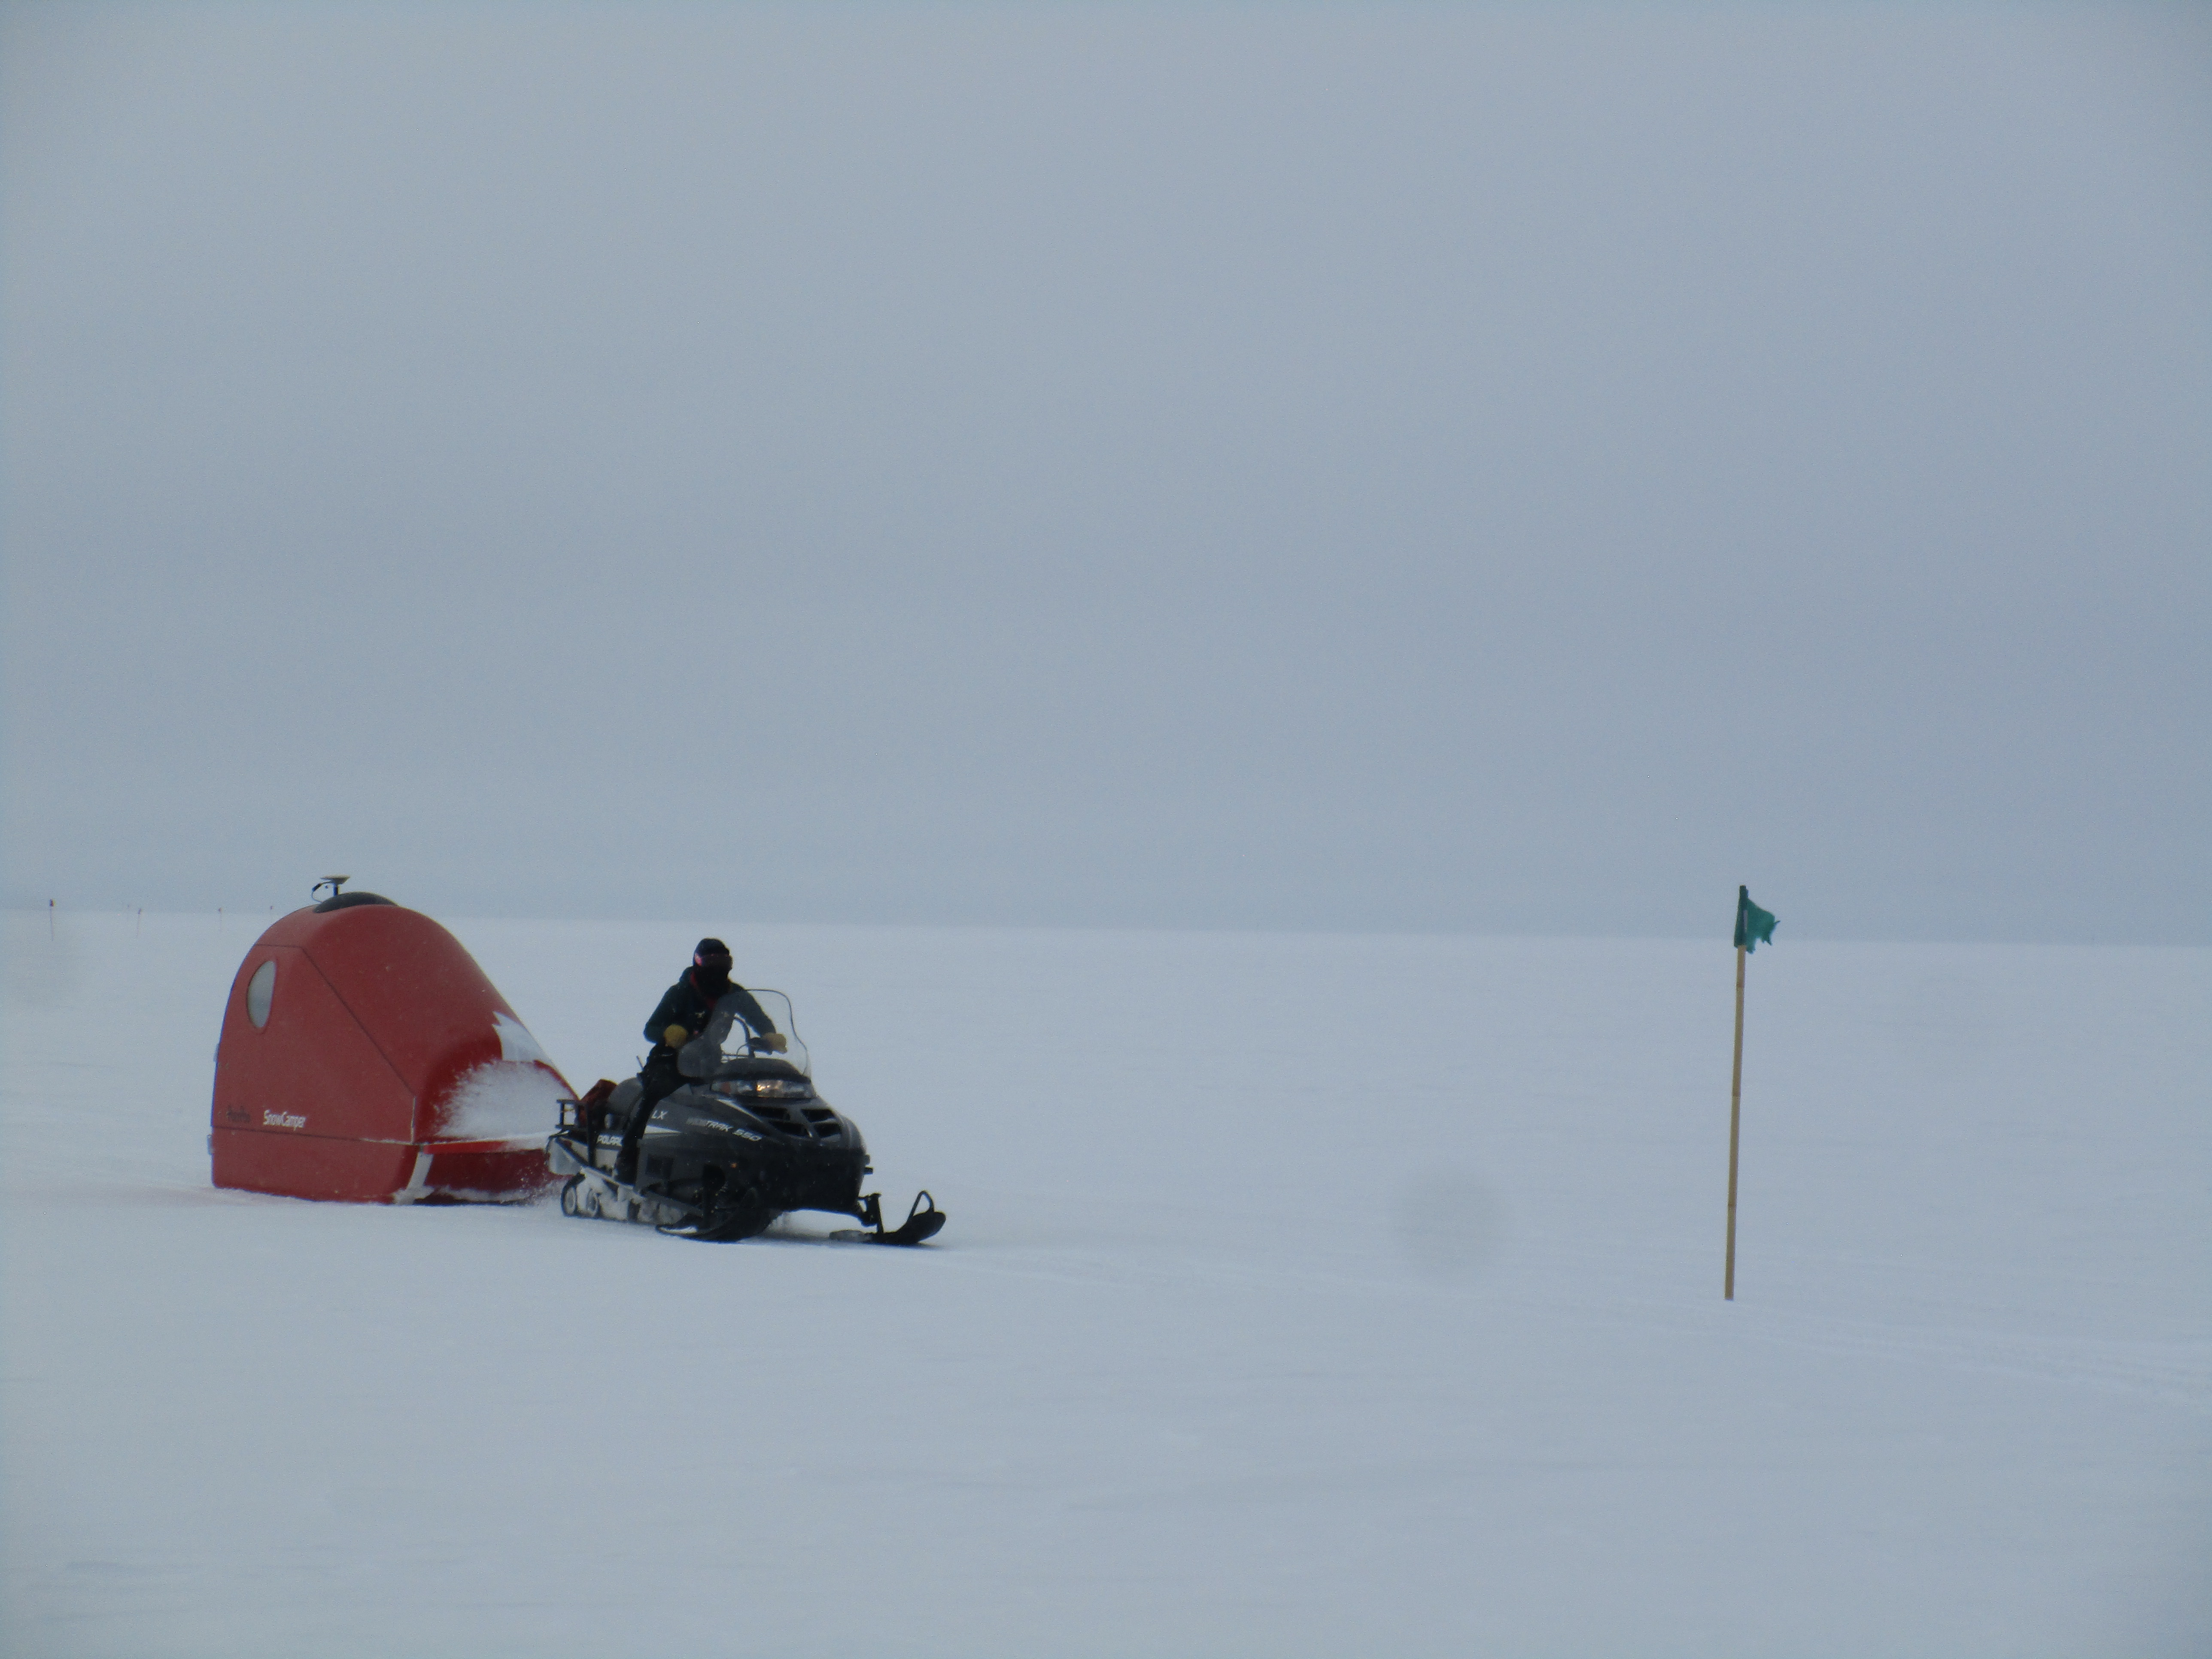

Science tech Mara Menahan driving the PolyPod, equipped with GPS equipment along the ICESat traverse.

Photo: Hannah James

**Please visit the clean air log at ftp://isr.sri.com/pub/summit/ftp/science/clean_air_traffic/**

|  |  |
| --- | --- |
| **Facilities** | **Comment** |
| TAWO | In order to allow the construction team enough time to complete the D-Shack lift, some instruments were completely powered down to place a minimum load on the UPS and extend its run time. |
| MSF | MSF ran on the 70kW generator during station outages due to insufficient UPS run time. See above for generator run times. |
| Green House |  |
| **Experiment** | **Notes** |
| NOAA CCGG flasks | Comment:  Date performed: 2018-08-02 |
| NOAA HATS flasks | Comment:  Date performed: 2018-08-02 |
| NOAA Surface Ozone | Comment: Calibration was performed on 2018-07-25. Instrument was off during all power outages.  % of time operating: 95% |
| NOAA Aethelometer | Comment: Offline since 2018-01-10. Instrument offsite for repair.  % of time operating: 0% |
| NOAA Meteorology | Comment: MET system was off during the power outage on 2018-08-04.  % of time operating: 97.5% |
| NOAA CLAP & Neph | Comment: Nephelometer span check was performed on 2018-07-25. Instruments and computer were completely off during all power outages.  % of time operating: 95% |
| Radionuclide Filter | Comment: Filter was off during all power outages.  % of time operating: 90% |
| Aerosol DRUM Sampler | Comment: Instrument was off during the power outages on 2018-08-03 and 2018-07-04.  % of time operating: 97.5% |
| Bamboo Forest | Comment: Raised on 2018-07-31  Date performed: 2018-07-31 |
| SnowFox | Comment: SnowFox was unplugged during planned power outage times. PIs were notified of these times.  Date performed: 2018-08-01 |
| ICESat Accumulation | Comment: Raised on 2018-07-30  Date performed: 2018-07-30 |
| GFZ Potsdam Seismometer | Comment: Powered by UPS during the outages.  % of time operating: 100% |
| DTU Magnetometer | Comment: Powered by UPS during the outages.  % of time operating: 100% |
| UNAVCO | Comment: |
| Helmig CUGC | Comment: H2 generator stayed powered during outages while the CUGC was placed into standby mode or shut off during the outages.  % of time operating: 75% |
| Steffen Tower Instruments | Comment:  % of time operating: 100% |
| Steffen Solar Instruments | Comment: Radio connection to the tracker continues to be unsuccessful. Power source investigation occurred throughout the week.  % of time operating: Unknown |
| ICECAPS Total Sky Imager | Comment: 2018-08-01: 12:37-16:45Z- TSI off during relocation to the North side of the MSF. New location allows room for incoming ACE experiments.  % of time operating: 95% |
| ICECAPS Radiosonde | Comment: Due to a power outage, the morning balloon on 2018-08-04 did not complete or transmit data.  Dates performed: Twice daily, with above exception. |
| ICECAPS MWR | Comment: The HATPRO is offsite for repair; the 150-90 radiometer continues to collect measurements.  % of time operating: 100% |
| ICECAPS SODAR | Comment: Heavy equipment operating around the MSF in preparation for the building move throughout the week, times recorded in the SODAR log.  % of time operating: 100% |
| ICECAPS POSS | Comment:  % of time operating: 100% |
| ICECAPS Hotplate | Comment: PIs reported that the Hotplate will not return to Summit Station.  % of time operating: 0% |
| ICECAPS MASC | Comment: Instrument is offsite for repair and is due to return Summer 2019.  % of time operating: 0% |
| ICECAPS MMCR | Comment:  % of time operating: 100% |
| ICECAPS CAPABL | Comment:  % of time operating: 100% |
| ICECAPS MPL | Comment:  % of time operating: 100% |
| ICECAPS Ceilometer | Comment: 2018-08-03: 13:05Z- Updated time, computer 18 seconds ahead of GPS server.  % of time operating: 100% |
| ICECAPS PAERI | Comment:  % of time operating: 100% |
| ICECAPS IcePIC | Comment: No images captured this week.  Date(s) performed: |