MEDSDN2CFPOINT 1.0.9

USER MANUAL

seventh_framework_programme

Project Acronym :SeaDataNet II

Project Full Title :SeaDataNet II: Pan-European infrastructure for ocean and marine data management

Grant Agreement Number :283607

PAN-EUROPEAN INFRASTRUCTURE FOR OCEAN & MARINE DATA MANAGEMENT

|  |  |
| --- | --- |
| Deliverable number | Short Title |
|  | MedSDN2CFPOINT User Manual |
| Long title | |
| User Manual of MedSDN2CFPOINT | |
| Short description | |
| User Manual of MedSDN2CFPOINT software delivered in the frame of SeaDataNet European project. This software is used to convertSeaDataNet MEDATLAS files of vertical profiles, time-series and trajectories to SeaDataNetNetCDF (CFPoint) | |
| Author | **Working group** |
| Fichaut M., Brégent S., Capitaine D. |  |

***History***

|  |  |  |  |
| --- | --- | --- | --- |
| Version | Authors | Date | Comments |
| 1.0.3 | Capitaine D. | 18/12/2013 | Creation |
| 1.0.3 | Fichaut M. | 20/12/2013 | Edits |
| 1.0.4 | Bregent S. | 24/02/2014 | Change version to match application version number |
| 1.0.5 | Bregent S. | 06/06/2014 | Change version to match application version number |
| 1.0.6 | Bregent S. | 25/02/2015 | §1.1 MedSDN2CFPOINT compliance with the “SeaDataNet Datafile Formats” D8.5, version 1.6.  §3.2.2.1: MedSDN2CFPOINT generates CDI SDN references  §1.2: java >=1.7 is required |
| 1.0.7 | Bregent S. | 15/06/2015 | §1.1 MedSDN2CFPOINT compliance with the “SeaDataNet Datafile Formats” D8.5, version 1.16. |
| 1.0.8 | Bregent S. | 23/06/2015 | Update version number to fit with Software version. No change in documentation |
| 1.0.9 | Bregent S. | 24/06/2015 | Update version number to fit with Software version. No change in documentation |

***Table of illustrations***

[Figure 1 - Check Java version installed on your computer 6](#_Toc375236913)

[Figure 2 - Installation of MedSDN2CFPOINT – definition of shortcuts. 7](#_Toc375236914)

[Figure 3 - Last screen of MedSDN2CFPOINT installation 8](#_Toc375236915)

[Figure 4 - error uninstaller message 8](#_Toc375236916)

[Figure 5 - uninstallation screen 9](#_Toc375236917)

[Figure 6 - Settings screen 10](#_Toc375236918)

[Figure 7 – Result while updating vocabulary list 11](#_Toc375236919)

[Figure 8 - About MedSDN2CFPOINT 11](#_Toc375236920)

[Figure 9 - Main screen of MedSDN2CFPOINT 12](#_Toc375236921)

[Figure 10 - Directory conversion 13](#_Toc375236922)

[Figure 11 - Name of the coupling file 14](#_Toc375236923)

[Figure 12 - Input of the Output directory prefix 14](#_Toc375236924)

[Figure 13 - Error message on EDMO Code 15](#_Toc375236925)

[Figure 14 - Progress bar while conversion is running 16](#_Toc375236926)

[Figure 15 - Log file for errors 17](#_Toc375236927)

***Table of contents***

[1. Introduction 5](#_Toc375321180)

[1.1. Main principles 5](#_Toc375321181)

[1.2. Technical characteristics 5](#_Toc375321182)

[1.3. Links with others entities 6](#_Toc375321183)

[2. MedSDN2CFPOINT installation and uninstallation 7](#_Toc375321184)

[2.1. MedSDN2CFPOINT installation 7](#_Toc375321185)

[2.2. MedSDN2CFPOINT uninstallation 8](#_Toc375321186)

[3. RUNNING MedSDN2CFPOINT 10](#_Toc375321187)

[3.1. Main Menu 10](#_Toc375321188)

[3.1.1. Settings 10](#_Toc375321189)

[3.1.2. Vocabulary update 10](#_Toc375321190)

[3.1.3. About MedSDN2CFPOINT 11](#_Toc375321191)

[3.2. Main screen 12](#_Toc375321192)

[3.2.1. User Interface 12](#_Toc375321193)

[3.2.2. Processing 16](#_Toc375321194)

[3.3. Batch mode 23](#_Toc375321195)

# Introduction

The CF metadata conventions (http://cf-pcmdi.llnl.gov/) are designed to promote the processing and sharing of files created with the NetCDF API. The conventions define metadata that provide a definitive description of what the data in each variable represents, and the spatial and temporal properties of the data. This enables users of data from different sources to decide which quantities are comparable, and facilitates building applications with powerful extraction, regridding, and display capabilities.

The approach taken with the development of the SeaDataNet profile based on CF 1.6 was to classify data on the basis of feature types and produce a SeaDataNet specification for storage of each of the following:

* Profile (x, y, t fixed; z variable). The specification given is for storage of a single profile such as a CTD cast or bottle profile. However, the design is such that very little change is required to facilitate the storage of multiple profiles in a single netCDF file.
* TimeSeries (x, y, z fixed; t variable). The specification given is for storage of a single time series, such as a current meter record. However, the design is such that very little change is required to facilitate the storage of multiple time series in a single netCDF file.
* Trajectory (x, y, z, t all variable). The specification given is for storage of a single trajectory, but this may be easily modified to store several trajectories in a single file.

The specification was then developed through discussions on a collaborative e-mail list involving participants in SeaDataNet, MyOcean, USNODC, NCAR and AODN. The working objective focussed on producing profiles with the following properties:

* CF 1.6 conformant
* Have maximum interoperability with CF 1.6 implementations in use by MyOcean (OceanSITES conventions), USNODC (USNODC NetCDF templates) and two contributors to AODN (IMOS and METOC)
* Include storage for all labels, metadata and standardised semantic markup that were included in the SeaDataNet ODV format files for the equivalent feature type.

Significant list discussion focussed on the version of NetCDF that should be used for SeaDataNet. The conclusion was that NetCDF 4 should be used wherever possible, but that NetCDF 3, although strongly discouraged, should not be totally forbidden.

## Main principles

MedSDN2CFPOINT converts SeaDataNet MEDATLAS (SDN MEDATLAS) file(s) of vertical profiles, time series or trajectories to SeaDataNet NetCDF (CFPOINT).

MedSDN2CFPOINT is compliant with the “SeaDataNet Datafile Formats” D8.5, version 1.16.

User can convert one MEDATLAS file or one directory with one to n MEDATLAS files.

MedSDN2CFPOINT is bilingual (English – French).

## Technical characteristics

MedSDN2CFPOINT is portable software that can be downloaded from the SeaDataNet website <http://www.seadatanet.org>, free of charge, with its user manual.

It iswritten in Java Language (Version >= 1.7) and it is available under Microsoft 32/64 bits (tested with Windows XP, Sevenand ), Linux 32/64 bits and Solaris (not tested). Log4j is used for error management.

MedSDN2CFPOINT works offline; however as it uses the SeaDataNet common vocabularies web services to update its lists of values, network connection is needed only when update of these lists is necessary.

* To know if Java is available on your computer, in the right version, follow these steps:
  + - Open 'Start' menu, then 'Execute'
    - On the displayed window, enter: 'cmd', then click on 'OK' button
    - Enter 'java -version'
* Check if command has been executed:
  + - If not, download the last java version at

<http://java.com/en/download/index.jsp>.

* + - Else, check the version displayed. The version should be greater than or equal to 1.6.

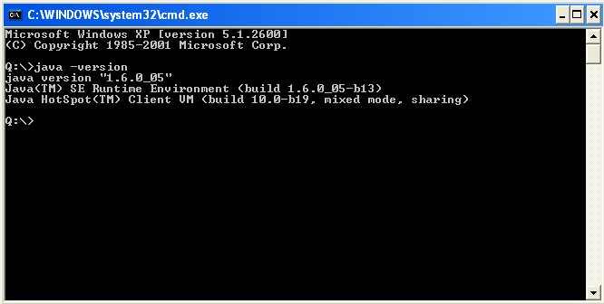

Figure 1 - Check Java version installed on your computer

## Links with others entities

MedSDN2CFPOINT uses SeaDataNet vocabularies and EDMO for the data file conversion.

The following lists are used by MedSDN2CFPOINT:

|  |  |
| --- | --- |
| List Code | List Name |
| Mapping P09-P01 | Mapping between P09 (MEDATLAS Parameter Usage Vocabulary) and P01 (BODC Parameter Usage Vocabulary) |
| Mapping P09-P06 | Mapping between P09 (MEDATLAS Parameter Usage Vocabulary) and P06 (BODC data storage units) |
| EDMO | European Directory of Marine Organizations |

These lists are available at:

<http://seadatanet.maris2.nl/v_bodc_vocab_v2/welcome.asp>

Up-to-date version of the vocabulary lists can be downloaded with MedSDN2CFPOINT.

# MedSDN2CFPOINT installation and uninstallation

## MedSDN2CFPOINT installation

Get MedSDN2CFPOINT software from SeaDataNet Web site:

<http://www.seadatanet.org/Standards-Software/Software/MedSDN2CFPOINT>

Copy the zip file on your computer, and unzip it.

You will get 2 files: install\_ MedSDN2CFPOINT.jar and launcher\_MedSDN2CFPOINT.bat

(launcher\_MedSDN2CFPOINT.sh for Linux)

To install MedSDN2CFPOINT double click on the file

launcher\_MedSDN2CFPOINT.bat(launcher\_MedSDN2CFPOINT.sh for Linux).

Then select your language and run the installation:

1. Accept the terms of the license agreement.
2. Select the installation path (default is C:\Program Files\MedSDN2CFPOINT for windows), target directory is created if not exists.
3. If you want a shortcut on your Desktop check the box circled in red on the image below. You can create a shortcut for the current user or for all users of the computer (circled in blue); by default “all users” is checked.

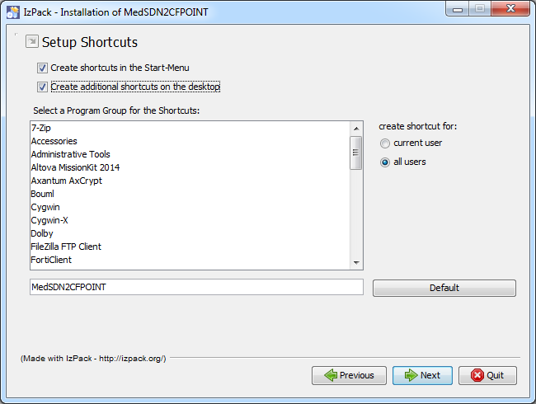

Figure 2 - Installation of MedSDN2CFPOINT – definition of shortcuts.

The shortcuts are created in the desktop and in the Start menu of the computer with the following icon:

on the desktop or  in the start menu under the group define in the circled in green field in Figure 2 - Installation of MedSDN2CFPOINT – definition of shortcuts..

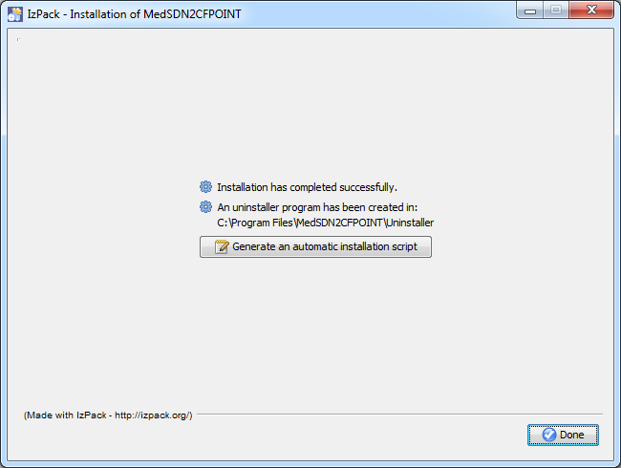

Figure 3 - Last screen of MedSDN2CFPOINT installation

If MedSDN2CFPOINT needs to be installed on several computers it is possible to “Generate an automatic installation script, by clicking on the appropriate button on the last screen of MedSDN2CFPOINT installation (Figure 3 - Last screen of MedSDN2CFPOINT installation).

## MedSDN2CFPOINT uninstallation

If you want to remove MedSDN2CFPOINT from your computer, run the uninstaller by selecting MedSDN2CFPOINT Uninstaller in the start menu of your computer (cf. MedSDN2CFPOINT installation).

If running the uninstaller generates the following message:

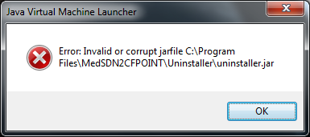

Figure 4 - error uninstaller message

Please run: <MedSDN2CFPOINT\_*Installation\_directory>*\Uninstaller\launcher\_uninstaller.bat(launcher\_uninstaller.sh for Linux).

The following window opens:

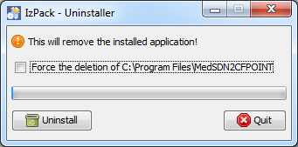

Figure 5 - uninstallation screen

Click on Force the deletion of C:\<MedSDN2CFPOINT\_Installation\_directory> and then click on Uninstall.

# RUNNING MedSDN2CFPOINT

## Main Menu

The main menu of MedSDN2CFPOINT has 3 choices:

* Options/Settings
* Options/Vocabulary update
* ?/About MedSDN2CFPOINT

### Settings

This screen is to:

* Choose the language of MedSDN2CFPOINT. To take into account language change, user must exit and restart the software.
* Define a manual PROXY configuration: if box “Use manual Proxy configuration” is checked, HTTP Proxy address and Port are mandatory.

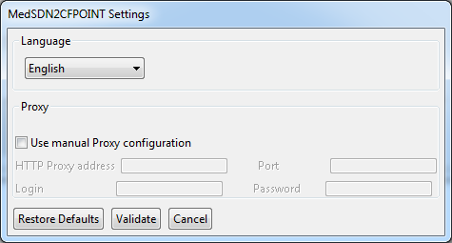

Figure 6 - Settings screen

The “Restore defaults” button restores the default values for all the fields of this screen. This action cannot be cancelled.

### Vocabulary update

This function is to update the vocabulary lists described in paragraph Links with others entities; it needs an internet connection and makes use of the Web services defined in the settings of MedSDN2CFPOINT

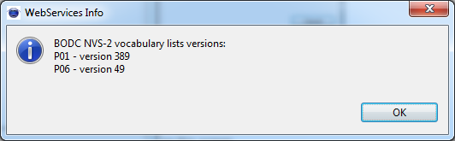

Figure 7–Result while updating vocabulary list

### About MedSDN2CFPOINT

The version of the software is available on this screen.

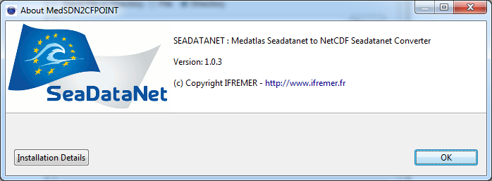

Figure 8 - About MedSDN2CFPOINT

## Main screen

This screen is to input information necessary to data conversion, and also to run data conversion

### User Interface

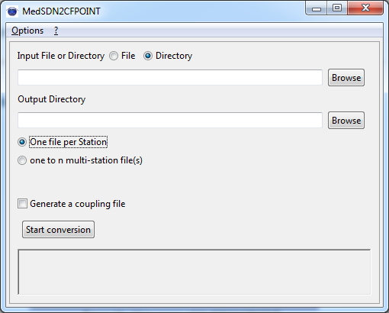

Figure 9 - Main screen of MedSDN2CFPOINT

#### Input file or directory

User must tell MedSDN2CFPOINT if he wants to convert one file or one directory (default value is directory).

Then the name of the file or of the directory has to be selected through the “Browse” button.

If a directory is selected, MedSDN2CFPOINT converts only the files in this directory, **not in the sub-directories if there are some.**

#### Output directory

This output directory, where converted files will be written,can be input manually or selected through the “Browse” button.

If this directory does not exist, MedSDN2CFPOINT will create it.

The output directory must be different from the input one.

#### Mono or Multi Stations

User must tell MedSDN2CFPOINT if he wants to convert in monostation (One file per Station) or in multistation (one to n multi-station file(s))

**In multistationmode** : the ouput file contains each Station of One input file.

Output filename is the same as input filename.

**In monstationmode** : the ouput file contains one Station of One input file.

Output filename is the LOCAL\_CDI\_ID +.nc

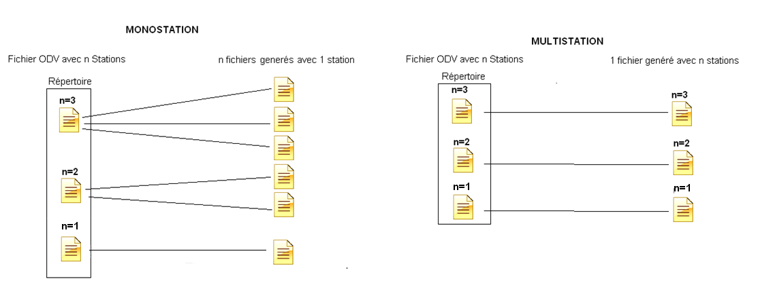

Figure 10- Directory conversion

#### Generation of a coupling table

If check box “Generate a coupling file” is checked, while reformatting files, MedSDN2CFPOINT creates a coupling file (as a text file) which gives the mapping between a unique identifier of a CDI element (LOCAL\_CDI\_ID which is one station of vertical profiles, one time-series or one trajectory) and the file in which this element can be found. The coupling file is used by SeaDataNet download manager.

The coupling file contains the following information:

* LOCAl\_CDI\_ID,
* Modus = 1 (for mono-station file), 3 (for multi-station file)
* (which is CFPOINT)
* File name

Example of a coupling file:

LOCAL\_CDI\_ID;MODUS;FORMAT;FILENAME

FI35200140070\_00040\_H10;3;CFPOINT;2001040070.nc

FI35200140070\_00050\_H10;3;CFPOINT;2001040070.nc

FI35200140070\_00060\_H10;3;CFPOINT;2001040070.nc

FI35200140070\_00070\_H10;3;CFPOINT;2001040070.nc

FI35200140070\_00080\_H10;3;CFPOINT;2001040070.nc

FI35200301012\_10239\_D01;1;CFPOINT;FI35200301012\_10239\_D01.nc

FI35200301012\_11943\_D01;1;CFPOINT;FI35200301012\_11943\_D01.nc

FI35200301012\_07160\_D01;1;CFPOINT;FI35200301012\_07160\_D01.nc

#### Start conversion button

A click on this button starts the validation of input parameters. Once the input parameters are checked and OK, conversion of files starts.

If a coupling file is asked, the first screen (Figure 11 - Name of the coupling file) that opens is to enter the name of the coupling file (by default this name is set to coupling .txt), then the user is asked to enter the “Output directory prefix” (Figure 10) which will be subtracted from the file name in the coupling file.

For example:

output file name = C:\username\NEMO\cruise\_name\file\_name

and output directory prefix = C:\username\NEMO

file name in the coupling file will be : cruise\_name\file\_name

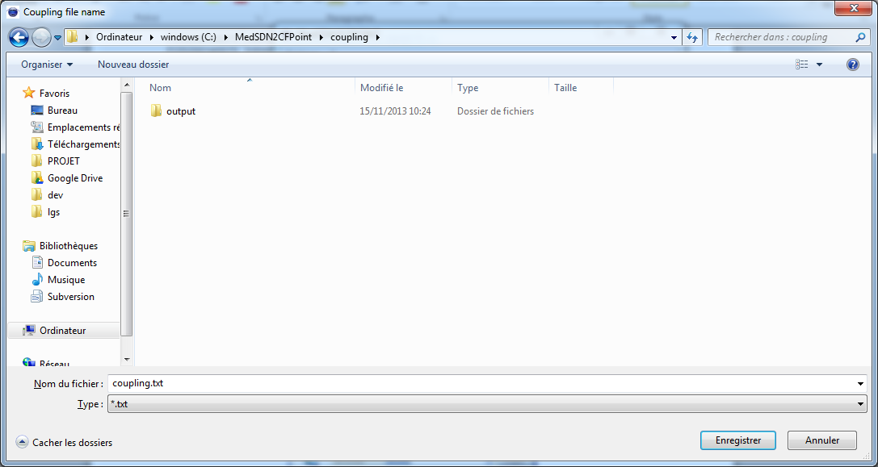

Figure 11 - Name of the coupling file

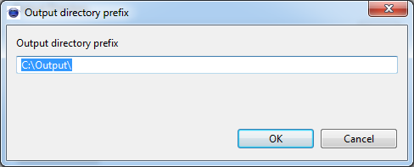

Figure 12 - Input of the Output directory prefix

#### Error messages

Error messages are written in the field under the “Start conversion” button.

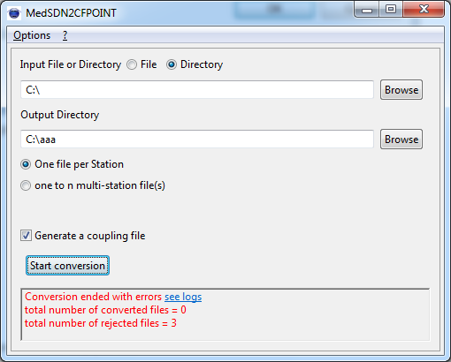

Figure 13 - Error message on EDMO Code

This message is reset to empty at each new file conversion.

### Processing

#### File Conversion

During the file conversion a separate window opens. A progress bar, the name of the file being converted and its rank /Total number of files are displayed.

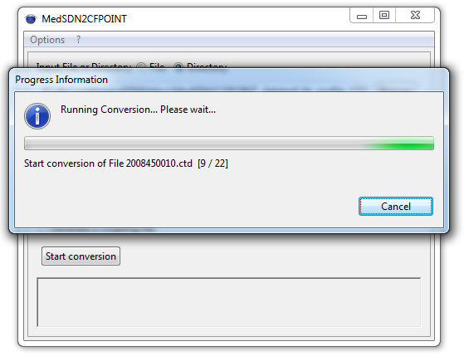

Figure 14 - Progress bar while conversion is running

Conversion can be cancelled at any time by clicking on the “Cancel” button.

For each file being converted, MedSDN2CFPOINT:

* Verifies the file format: conversion runs only if the file is at SDN MEDATLAS format otherwise an error is registered in the “Log file” and the software moves to the next file.
* Detect the type of file. Can be Profile, Trajectory or TimeSeries.
* Convert it To CFPOINT file(s).

MedSDN2CFPOINT generates automatically CDI SDN references in the CFPOINT file for each station.

#### Errors management

Errors are registered in a log file which is located in MedSDN2CFPOINT installation directory. It can be open through MedSDN2CFPOINT main screen by clicking on “see log” in the error window.



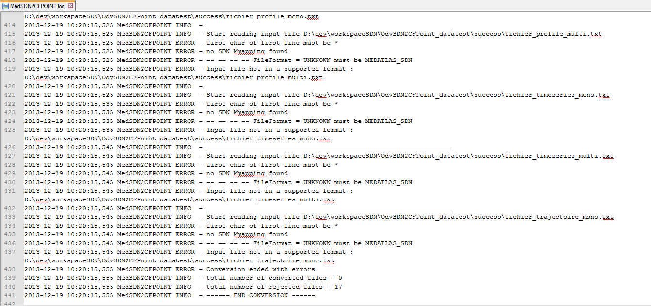

Figure 15 - Log file for errors

Maximum size of the error log file is 5 Mb. When this maximum size is reached, MedSDN2CFPOINT saves it and opens a new log file. The software keeps 4 log files maximum and deletes the oldest log files.

One line in the log file is composed as following:

* Date (format ISO 8601)
* Name of the Software
* Error severity level
* Error message

The severity level is one of the four following values:

|  |  |
| --- | --- |
| INFO | Informative messages for starting of the conversion or successful conversion |
| WARN | Informative messages which does not stop the conversion of the current file but which may need recommended actions (example: if a file is at BODC vocabulary V1 a warning tell the user that it is recommended to move it to BODC vocabulary V2) |
| ERROR | For conversion errors : conversion is cancelled on the current file but continues on the other files |
| FATAL | For conversion errors which stop the processing of the files |

For example:

* If a mapping between P09 and P01 is missing an ERROR is detected and the file containing this parameter is not converted.
* If the EDMO\_CODE is missing in the settings of MedSDN2CFPOINT anERROR is detected and file conversion stops.

#### Error table

|  |  |  |
| --- | --- | --- |
| N° | Error | Analyse |
| 1 | The output folder must be different from the input folder | change output directory path |
| 2 | 'Input File or Directory' parameter is mandatory. | choose an input file or a directory to convert |
| 3 | 'Output Directory' parameter is mandatory. | choose an output directory path |
| 4 | Input file / directory not accessible or readable | check if the Input file / directory is accessible |
| 5 | check if Output Directory not writeable | check if output directory is accessible |
| 6 | 'Output Directory' parameter must be a folder | check the output field, it must be a folder |
| 7 | No file found | check the input directory |
| 8 | Z Parameter not found | profile : the first Parameter must be PRES, trajectory, timeseries : SenSor Depth must be set |
| 9 | Data Type not found , Unknown dataType XXX | Check the data type of input file. It must exists in the format description table (page 11 of <http://www.seadatanet.org/content/download/16251/106283/file/SDN2_D85_WP8_Datafile_formats.pdf)> |
| 10 | P01 name not found for code : XXXX | the code XXXX is not found in P01 list, try to update list by execute update vocabulary |
| 11 | unit name not found for code : XXXX | the code XXXX is not found in P06 list, try to update list by execute update vocabulary |
| 12 | Errorparsing SDN Parameter | check SDN PARAMETERS |
| 13 | Error in format file | The type of file (vertical profile, time series or trajectory) does not match the data type (see table page 11 of <http://www.seadatanet.org/content/download/16251/106283/file/SDN2_D85_WP8_Datafile_formats.pdf)>) |

|  |  |  |
| --- | --- | --- |
| 14 | error while writing date / longitude / latitude | check the Longitude, the Latitude or the date Format |
| 15 | error while writing parameter, line XX | check Parameters value line XX |
| 16 | error while parsing the Medatlas element XXXX | check the metadata XXXX |
| 17 | error while reading station reference, line XX | check Station reference in input file |
| 18 | error while reading local cdi id, line XX | check LOCAL\_CDI\_ID Line in input file |
| 19 | error while reading data type, line XX | check Data type in input file |
| 20 | error on station dataType, line XX : dataType XXX is not identical to the first station dataType YYYY | check that all data types are identical Data type in input file station headers |
| 21 | error while reading station date and Time, line XX | check station Date and Time in input file |
| 22 | error while reading station latitude,line XX | check station latitude in input file |
| 23 | error while reading station longitude, line XX | check station longitude in input file |
| 24 | error while reading station bottom depth, line XX | check station bottom depth in input file |
| 25 | error while reading station dateTime and position QC, line XX | check station dateTime and position QC in input file |

|  |  |  |
| --- | --- | --- |
| 26 | error while reading station sensor depth, line XX | check station sensor depth in input file |
| 27 | error while reading station comment, line XX | check station comment in input file |
| 28 | error while reading station parameters number, line XX | check station parameters number in input file |
| 29 | error while reading station parameters, line XX | check station parameters in input file |
| 30 | error while reading station SDN parameters, line XX | check station parameters in input file |
| 31 | error on SDN parameter ZZZZ - YYYY, line XX: parameter does not exist in Medatlas header | check station parameters in input file |
| 32 | error while reading station EDMO code, line XX | check station EDMO code in input file |
| 33 | error in input file, line XX | check line XX in the file |
| 34 | mandatory parameter PRES for profile was not found in first position | Add the mandatory parameter |
| 35 | mandatory parameters for trajectory are [year (yyyy) month(mm), day(dd), time(hhmmss), lat, lon] or [year(yyyy), date(mmdd), time(hhmmss), lat, lon] | Add the mandatory parameters |

|  |  |  |
| --- | --- | --- |
| 36 | mandatory parameters for time series are [year (yyyy) month(mm), day(dd), time(hhmmss)] or [year(yyyy), date(mmdd), time(hhmmss)] | Add the mandatory parameters |
| 37 | Variable XXXX is not SDN Compliant | If you get this message, send an email to sdn-userdesk@seadatanet.org |
| 38 | First char of first line must be \* | check if the first line starts by \* |

## Batch mode

MedSDN2CFPOINT can be run in batch mode.

You must set the EDMO code, this is necessary before using MedSDN2CFPOINT in batch mode.

Launch MedSDN2CFPOINT with the -batch options and useful options as explained below:

MedSDN2CFPOINT -batch [-append] [-batch] [-ctFilename<arg>] [-i<arg>] [-o <arg>] [-outputPrefix<arg>] [-replace] [-mono] [-multi]

Options:

-batch launch MedSDN2CFPOINT in batch mode

-i<arg> Input file / directory

-o <arg> Output directory

-append append data in an existing coupling table file (replace must not be present)

-replace replace an existing coupling table file (append must not be present)

-outputPrefix<arg> Output prefix (coupling table filename must be present)

-ctFilename<arg> coupling table filename (outputPrefix must be present)

-mono/multi launch conversion in Mono or multi Station Mode

Example under windows:

|  |
| --- |
| C:\Program Files\MedSDN2CFPOINT>MedSDN2CFPOINT.exe -batch -i "C: \fooDirIn" -o "C: \fooDirOut"  -ctFilename "C:\fooDirOut\fooCoupling.txt" -outputPrefix "C:\fooDirOut" –replace -mono |

Example under linux:

|  |
| --- |
| /home/user/MedSDN2CFPOINT>MedSDN2CFPOINT -batch -i "/home/user/fooDirIn" -o "/home/user/fooDirOut" –ctFilename"/home/user/fooDirOut/fooCoupling.txt" -outputPrefix "/home/user/fooDirOut" –replace -mono |