**CN0385 Evaluation Board and Software User Guide**

**Overview**

[CN0385](http://www.analog.com/CN0345) is an isolated multichannel data acquisition system that is compatible with standard industrial signal levels. The components are specifically selected to optimize settling time between samples, providing 18-bit performance at channel switching rates up to roughly 750 kHz.

The [CN0385](http://www.analog.com/CN0345) can process eight gain-independent channels and is compatible with both single-ended and differential input signals. The analog front end includes the [ADG5207](http://www.analog.com/ADG1207) multiplexer, the [AD8251](http://www.analog.com/AD8251) programmable gain instrumentation amplifier (PGIA), the [AD8475](http://www.analog.com/AD8475) as a precision ADC driver for performing the single-ended-to-differential conversion, and the [AD4003](http://www.analog.com/AD7982), an 18-bit, 2 MSPS Precision ADC. Gain configurations of 0.4, 0.8, 1.6, and 3.2 are available.

The maximum sample rate of the system is 2 MSPS in Turbo Mode for single channel continuous sampling. The channel switching logic is synchronous to the ADC conversions, and the maximum channel switching rate is 1.5 MHz. Channel switching rates up to 100 kHz also provide 18-bit performance.

This user guide will discuss how to operate the [EVAL-SDP-CH1Z](http://www.analog.com/SDP) and the evaluation software to configure and collect data from the [EVAL-CN0385-FMCZ](http://www.analog.com/CN0345) Evaluation Board (CN-0385 Board). A complete design support package for the [EVAL-CN0385-FMCZ](http://www.analog.com/CN0345) evaluation board containing schematics, layouts (native and Gerber), and bill-of-materials can be found at: [CN0385-DesignSupport](http://www.analog.com/CN0345-DesignSupport).

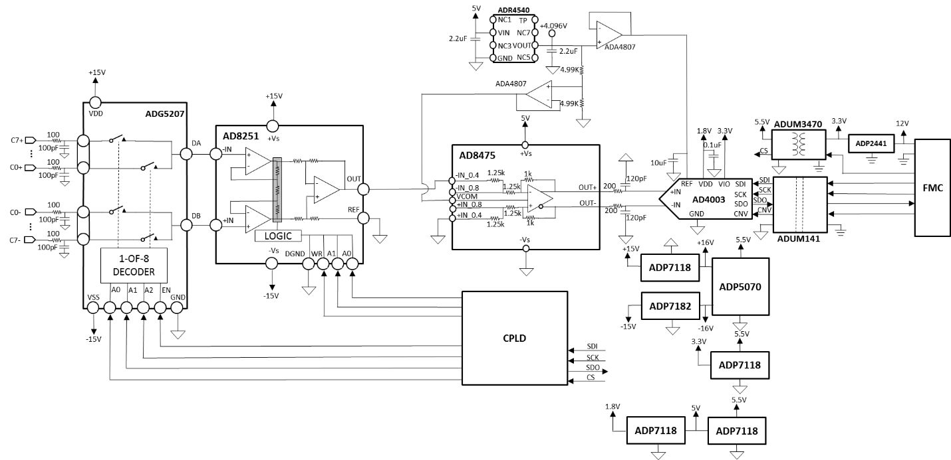

**Required Equipment**

[EVAL-CN0385-FMCZ](http://www.analog.com/CN0345) Evaluation Board

[EVAL-SDP-CH1Z](http://www.analog.com/SDP) Controller Board (SDP-H1 Board)

+5V to +12V DC power supply or wall wart (+9V wall wart included)

[CN0385 Evaluation Software](ftp://ftp.analog.com/pub/cftl/CN0345)

PC with a USB port and Windows® XP, Windows Vista® (32-bit), or Windows 7, 8 or 10 (32-bit) with .NET 4.0 framework installed (included in installation of SDP Drivers)

USB type A to USB type mini-B cable

Precision signal generators/dc sources

**General Setup**

The [EVAL-CN0385-FMCZ](http://www.analog.com/CN0345) board connects to the [EVAL-SDP-CH1Z](http://www.analog.com/SDP) Board via the 160-pin connector.

Refer to the Jumper Settings table for setting the [EVAL-CN0385-FMCZ](http://www.analog.com/CN0345) board to the desired power, reference, and signal chain configuration.

The included +9V power supply connects to P3 on [EVAL-CN0385-FMCZ](http://www.analog.com/CN0345).

The [EVAL-SDP-CH1Z](http://www.analog.com/SDP) Board connects to the PC via the USB cable.

**E**

**V**

**AL-CN0385-CH1Z**

**P1**

**P2/**

**P8**

**J1/P3**

**E**

**V**

**AL-SDP-CH1Z**

**USB**

**PC**

**5V TO 12V**

**POWER**

**AC/DC**

**SOURCE(S)**

13833-027

**Installing the Software**

1. Download the [CN0385 Evaluation Software](ftp://ftp.analog.com/pub/cftl/CN0345) and unzip the CN0385_Evaluation_Software.zip folder and run setup.exe.

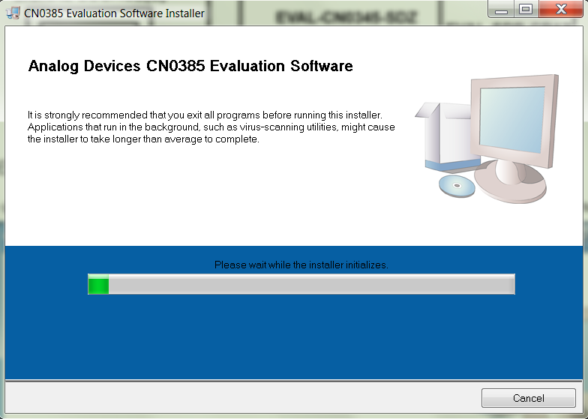

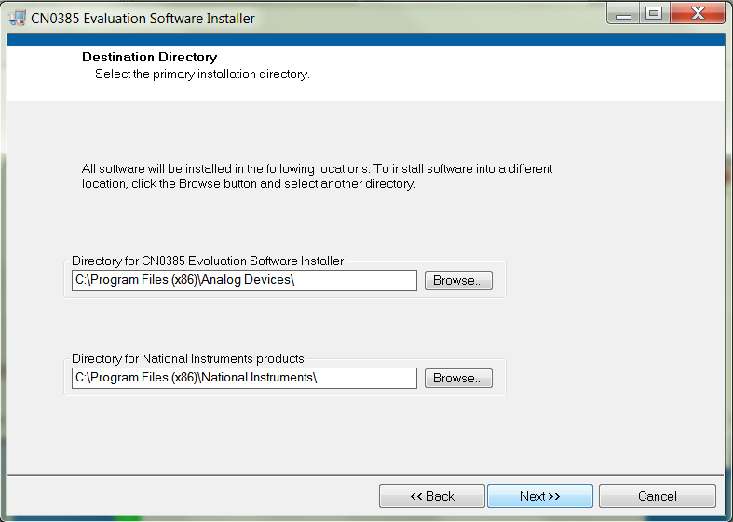

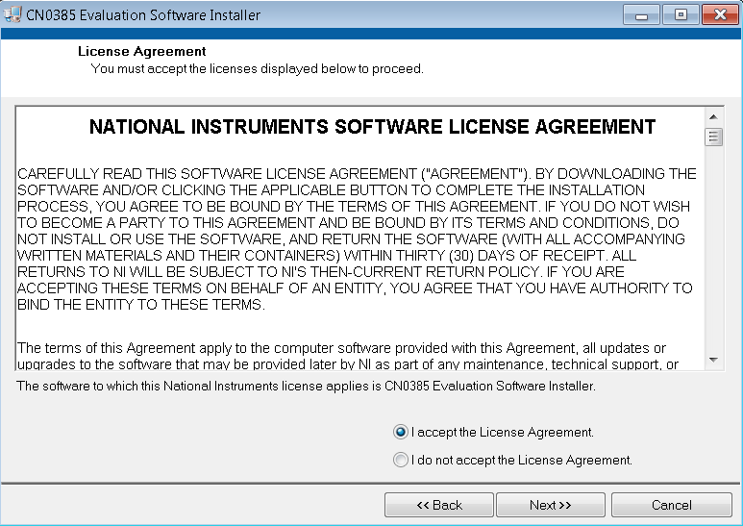

1. Click Next to view the installation review page.

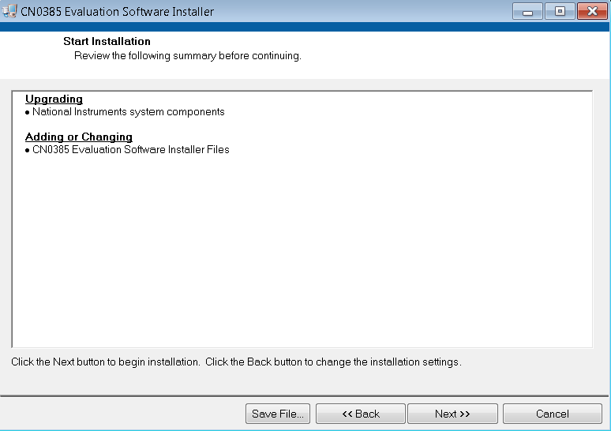

1. Click Next to start the installation.

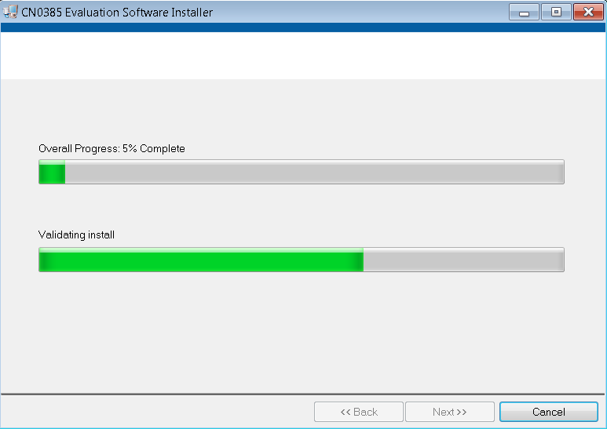

1. Upon completion of the installation of the CN0385 Evaluation Software, click Next for the installer of the ADI SDP Drivers to execute. (The SDP drivers include an installation of the .NET 4.0 framework.)

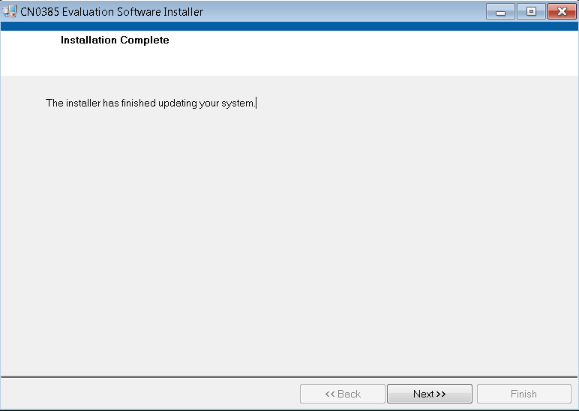

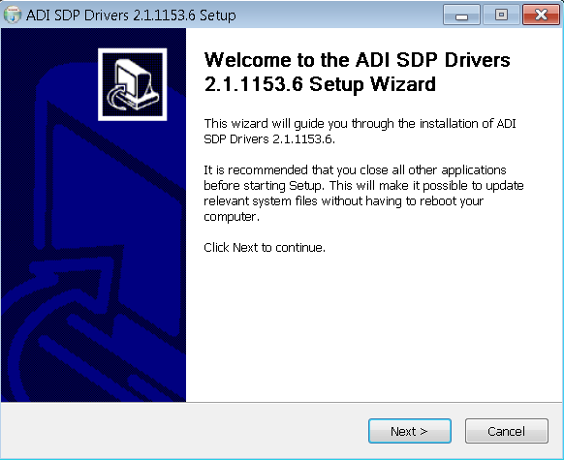

1. Press Next to set the installation location for the SDP Drivers.

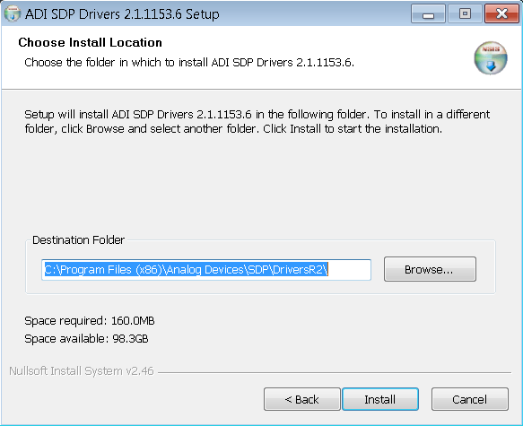

1. Press Install to install the SDP Drivers and complete the installation of all software. Click Close when done.

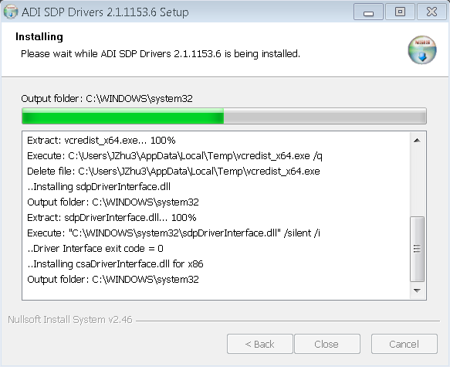

**Connecting the Hardware**

Configure the various jumper positions to the desired settings (refer to the Jumper Settings table below)

Connect P1 of the [EVAL-CN0385-FMCZ](http://www.analog.com/CN0345) (CN0385 Evaluation Hardware) to CON J4 of the [EVAL-SDP-CH1Z](http://www.analog.com/SDP) (SDP-H1 Board).

Connect the included 12V supply to Jack J7 on the [EVAL-SDP-CH1Z](http://www.analog.com/SDP) board.

Connect the included 9V supply to P3 on the [EVAL-CN0385-FMCZ](http://www.analog.com/CN0345) board.

Connect the USB Cable to J1 on the [EVAL-SDP-CH1Z](http://www.analog.com/SDP) (SDP-H1 Board).

Connect the USB Cable to the PC.

**Jumper Table**

Jumper Ref Des Position Function

|  |  |  |  |
| --- | --- | --- | --- |
| **Link** | **Default** | **Function** | **Comment** |
| J2 | A | Select external 9V adaptor or bench DC 9V from P3 or J1 | Change to B if using EVAL-SDP-CH1Z board supply 12V |
| S1 | A,B,C,D,E,F,G,H | Differential Inputs for all 8 chs | Change to 1,2,3,4,5,6,7,8 if using P8 as single-ended inputs |

**Using the Evaluation Software**

Software Control and Indicator Descriptions

**Front Panel**

**Configuration Tab**

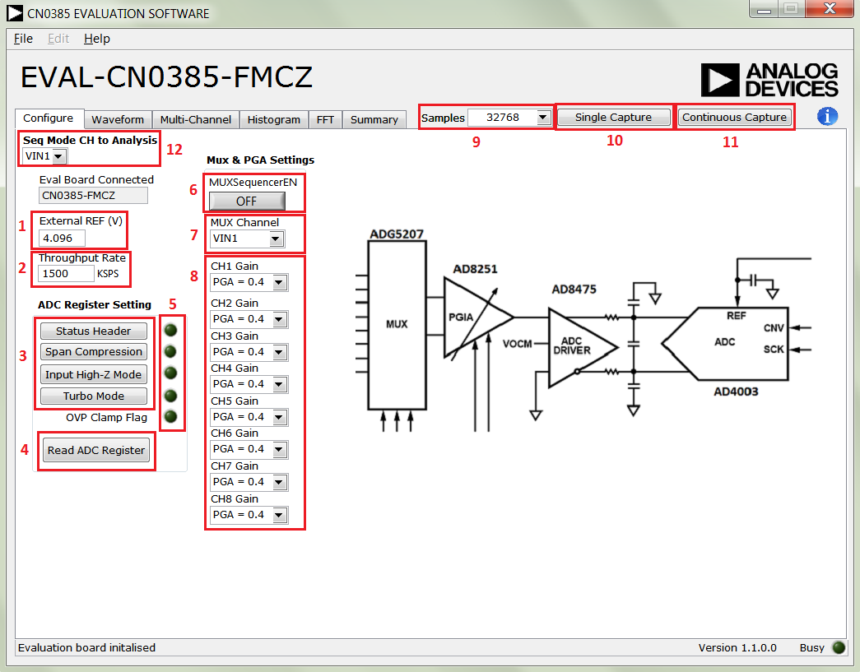

External REF (V)

Determines the value of the reference voltage used in calculations and analysis by the software. Affects aspects of the Waveform and Histogram plots (i.e. volt axis values, LSB-to-voltage conversions, etc.). Should be set to the value of the reference voltage used on the [EVAL-CN0385-FMCZ](http://www.analog.com/CN0345) Board (4.096 V by default).

Throughput Rate

Sets the sample rate of the [AD4003](http://www.analog.com/AD7982) (in KSPS). Note: the effective sample rate for each channel in the sequence (in KSPS) is equal to the value in Sample Rate divided by the number (1, 2, 4, or 8) of channels in the sequence.

ADC Register Setting

Set or clear the AD4003 register control bits by click the corresponding button.

Read ADC Register

Read back the AD4003 register control bits and OVP bit, and show them in the following LEDs on the right. “1” turns on the LEDs on, and “0” turns the LEDs off.

ADC Control and Status LEDs

After Read ADC Register, the control and status bits are assigned to the following LEDs on the right. “1” turns on the LEDs on, and “0” turns the LEDs off.

MUXSequencerEN

Set to ON to enable sequence mode, and set to OFF to disable sequence mode and use MUX Channel to select the target channel to sample.

MUX Channel

When MUXSequencerEN is OFF, MUX Channel is used to select the target channel to sample; When MUXSequencerEN is On, MUX Channel is used to select the last channel (1, 2, 4, or 8) in the sequencer to sample.

CHx Gain

Select the gain for each channel.

Samples

Selects the sample number to be performed for each acquisition. If the MUXSequencerEN is ON, it is the sample number for each channel.

Single Capture

Initiates a set of conversion samples for each acquisition.

Continuous Capture

Initiates multiple sets of conversion samples. Each set of conversions contains a number of samples set and repeats until Continuous Capture is depressed.

**Waveform Tab**

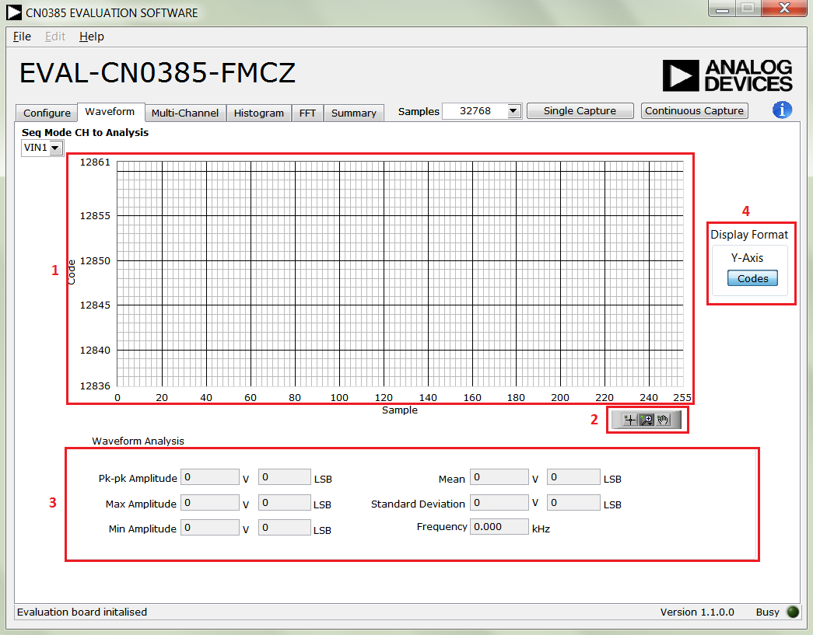

Waveform Plot

Displays the Waveform of the sampled data.

Waveform Graph Palette

Sets the display range of the Multi-Channel Waveform Plot.

Y-Axis Display Format

Selects whether the data will be displayed in raw code values or in equivalent voltage in the Plot. Note: code value to voltage conversions are calculated based on the value of VREF in the Configuration Tab.

Waveform Analysis

Calculation of the captured samples.

**Multi-Channel Tab**

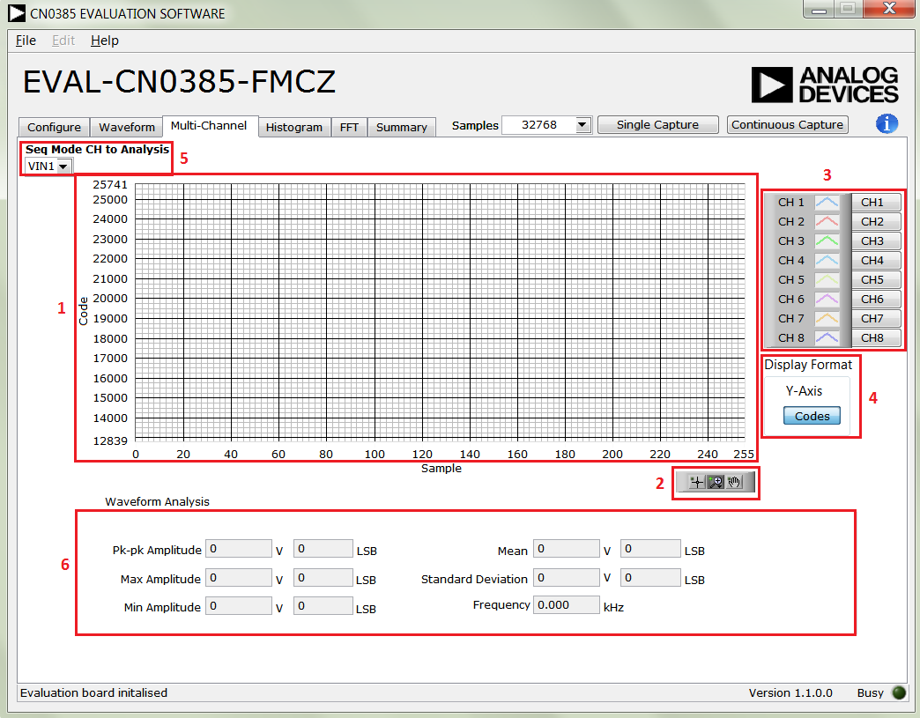

Multi-Channel Waveform Plot

Displays the Waveform of Displays the data readback from each of the active and visible channels in the conversion sequence.

Multi-Channel Waveform Graph Palette

Sets the display range of the Multi-Channel Waveform Plot.

Multi-Channel Selectors

Selects which channels' data are visible on the Multi-Channel Waveform Plot. Note: channels must be included in the sequence to be displayed.

Y-Axis Display Format

Selects whether the data will be displayed in raw code values or in equivalent voltage in the Plot. Note: code value to voltage conversions are calculated based on the value of VREF in the Configuration Tab.

Seq Mode CH to Analysis

Selects the channel for the Waveform Analysis in channel sequencer mode.

Waveform Analysis

Calculation of the captured samples.

**Histogram Tab**

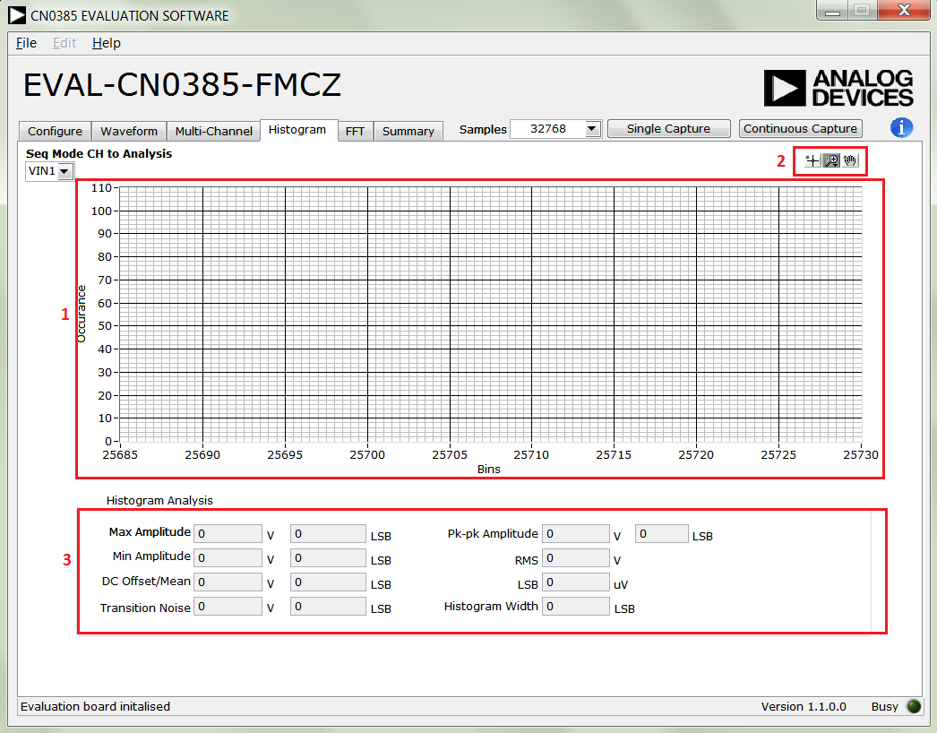

Waveform Plot

Displays the occurrences of the sampled codes.

Waveform Graph Palette

Sets the display range of the Histogram Plot.

Histogram Analysis

Calculation of the captured samples.

**FFT Tab**

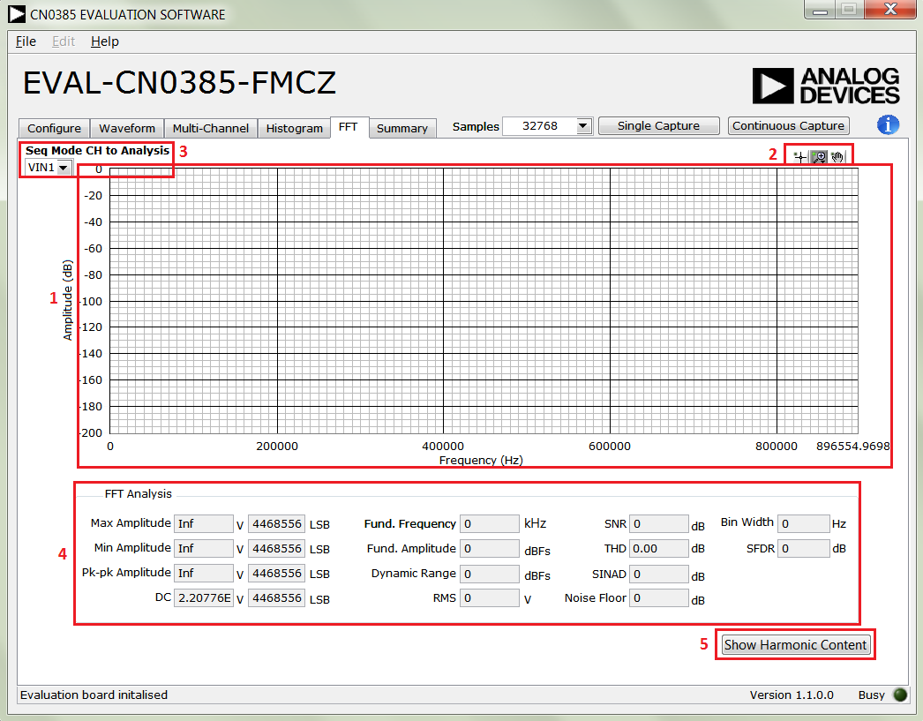

FFT Spectrum Plot

Displays the FFT frequency response of the sampled codes.

Waveform Graph Palette

Sets the display range of the FFT Plot.

Seq Mode CH to Analysis

Selects the channel for the FFT Analysis in sequencer mode.

FFT Analysis

Calculation of the captured samples.

Show Harmonic Content

Shows the fundamental frequency and 2nd to 5th harmonics.

**File**

Save Captured Data

Saves the current captured samples of the [CN0385 Evaluation Software](ftp://ftp.analog.com/pub/cftl/CN0345) as a .csv file.

Load Captured Data

Selects a previously saved samples of [CN0385 Evaluation Software](ftp://ftp.analog.com/pub/cftl/CN0345).

Take Screenshot

Make a capture the CN0385 Evaluation Software GUI and save it as a picture.

Print Screenshot

Make a capture the CN0385 Evaluation Software GUI and send it to printer.

Exit

Closes the [CN0385](http://www.analog.com/CN0345) Evaluation Software.

**Help**

Analog Devices Website

Opens the Analog Devices, Inc. website <http://www.analog.com/> using the PC's current default web browser.

About

Displays the current version information of the [CN0385 Evaluation Software](ftp://ftp.analog.com/pub/cftl/CN0345) in a pop-up.

Establishing a USB Connection Link

Verify that the SDP drivers are properly installed (see Installing the Software).

Ensure that the [CN0385](http://www.analog.com/CN0345) Evaluation Hardware and the SDP-H1 Controller Board are correctly connected and powered up.

Run the [CN0385 Evaluation Software](ftp://ftp.analog.com/pub/cftl/CN0345).

If the [CN0385](http://www.analog.com/CN0345) Evaluation Hardware is properly connected to the PC, the evaluation software will automatically establish a connection with the SDP-H1 Controller Board.

If the software does not detect the [CN0385](http://www.analog.com/CN0345) Evaluation Hardware, a pop-up will appear with options to reattempt the connection. Selecting Rescan will attempt to establish the USB connection again.

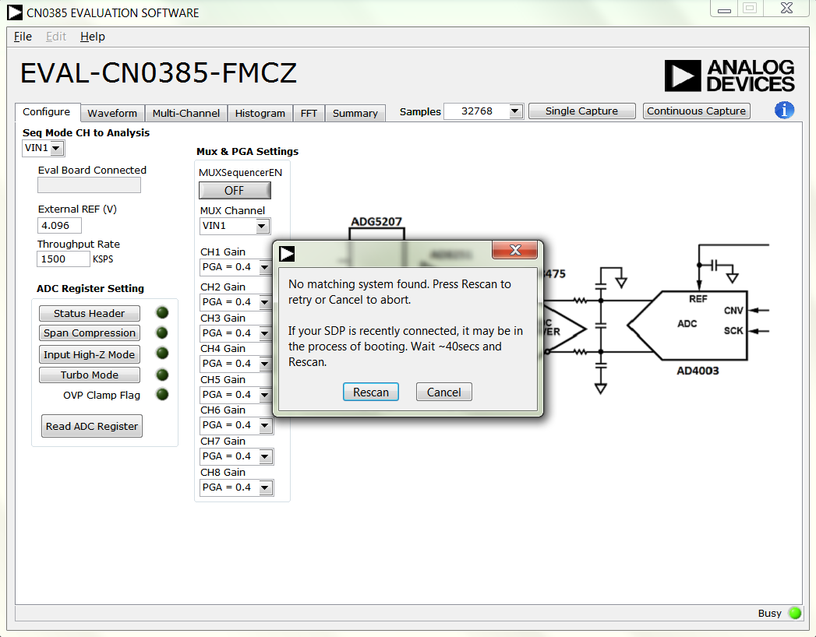

Configuring a Conversion for Capture

Configurations are defined in Configuration tab. Note: In normal mode the max sampling rate is 1.5 MSPS. Only when Turbo Mode is enabled, the sampling rate can go up to 2 MSPS. Turn MUXSequencerEN ON to enable the sequencer for multi-channel sampling. In the sequencer mode, it can only convert in sequence from channel 1 to the last channel in defined by MUX Channel.

Capturing Samples

After the configuration is done and the [CN0385](http://www.analog.com/CN0345) Evaluation Hardware and Software are connected, the software can initiate conversions. To capture samples:

Ensure that the value in VREF matches the reference voltage being used on the [CN0385](http://www.analog.com/CN0345) Evaluation Hardware.

Note that the Sample Rate is the sample rate of the [AD4003](http://www.analog.com/AD7982), not the effective sample rate for each channel.

Press either Single Capture to perform a single burst of sampling or Continuous Capture to perform repeated bursts of sampling sequences until stopped.

Viewing Conversion Results

After capturing samples or loading a previous set of conversion results, the data and analysis items can be viewed using the Waveform tab, Histogram tab, FFT tab and the Summary tab.

Select the Multi-Channel tab to view every channel's data on a single plot. The Multi-Channel Selectors set the visibility of each channel's data.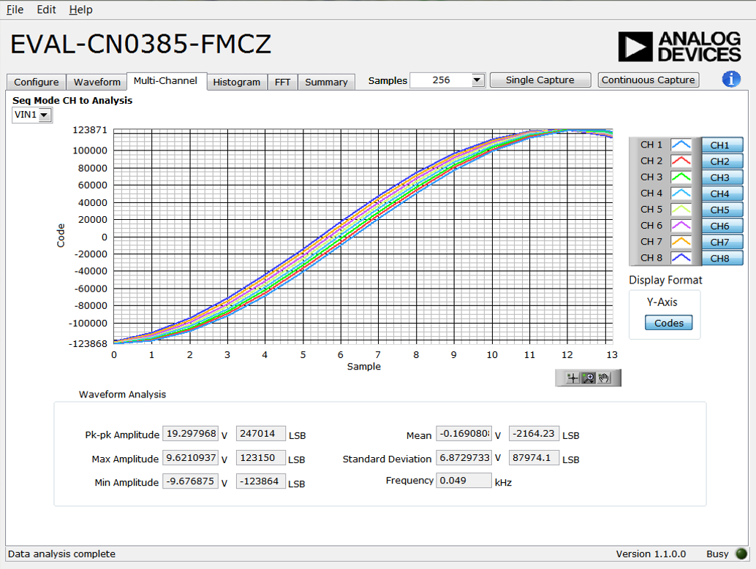

Select the Waveform tab to view the sampled channel's data or analysis results in non-sequencer mode. The Histogram and FFT tabs show the dc and ac analysis.

