**Document No. : 11-2016-11 Rev. B**

**Title : (EVAL-CN0385-FMCZ) Customer Evaluation Board Test Procedure**

|  |  |  |  |  |
| --- | --- | --- | --- | --- |
| REVISION HISTORY | | | | |
| **Revision** | **ECR #** | **Description of Change** | **Date** | **Author** |
| A | - | Initial Release | 16/09/27 | Steven Xie |
| B | - | Update with CPLD Programming | 16/11/11 | Steven Xie |
|  |  |  |  |  |

|  |  |
| --- | --- |
| **Required Approvers** | |
| **Approver Roles** | **Approver Names** |
| Apps Engineer | Maithil Pachchigar |
|  |  |
|  |  |
|  |  |
|  |  |
|  |  |
|  |  |
|  |  |
|  |  |
|  |  |

**Equipment Required:**

* EVAL-CN0385-FMCZ CFTL board
* EVAL-SDP-CH1Z board
* Audio Precision Sine Generator
* XLR Cable.
* BNC to SMA Cable.
* XLR to SMA interposer board
* Two pluggable screw Terminal Blocks, 9 Pos, 3.81mm pitch, Phoenix Contact MC 1,5/9-ST-3,81
* 9V DC mains adapter
* PC
* USB cable
* EVAL-CN0385-FMCZ evaluation software
* CN0385_EEPROM programming software
* Latticesemi cPLD LC4064V-75T48I programming [USB Cable – HW-USBN-2B and driver](http://www.latticesemi.com/en/Products/DevelopmentBoardsAndKits/ProgrammingCablesforPCs.aspx) (<http://www.latticesemi.com/en/Products/DevelopmentBoardsAndKits/ProgrammingCablesforPCs.aspx>)

**Procedure for programming the CFTL board EEPROM:**

1. Install the EVAL-CN0385-FMCZ GUI software.
2. Setup the link options as follows

Table 1. Table of Jumper Detail with Factory Default Setting

|  |  |  |  |
| --- | --- | --- | --- |
| **Link** | **Default** | **Function** | **Comment** |
| J2 | A | Select external 9V adaptor or bench DC 9V from P3 or J1 | Change to B if using EVAL-SDP-CH1Z board supply 12V |
| S1 | A,B,C,D,E,F,G,H | Differential Inputs for all 8 chs | Change to 1,2,3,4,5,6,7,8 if using P8 as single-ended inputs |

1. Connect the FMC connector on the EVAL-CN0385-FMCZ board to the FMC port on the SDP-H1.
2. Connect the 12V mains adapter to the SDP-H1.
3. Connect the 9V adapter (Stontronics T4817ST) or bench 9V supply to the EVAL-CN0385-FMCZ.
4. Check that both the “BF_POWER” and “SYS_PWR” LEDs are on.
5. Connect the SDP-H1 board to the PC’s USB port via J1 using USB cable.
6. Proceed through any dialog boxes that may appear (allowing the PC to recognise the SDP-H1 and install drivers as required).
7. Open the CN0385_EEPROM programming software folder.

Double click the CN0385_EEPROM PROGRAMMER.bat file.

* 1. Wait for the message “Board Successfully Programmed” to appear.

1. Press any key to close the program. (*Alternatively, the EEPROM can be programmed using FMC_EEPROM_Setup_1.0.5402.18645.exe to write the file EVAL-CN0385-FMCZ.fmceeprom in*)
2. Disconnect the SDP-H1 board from the PC by removing the USB cable.
3. Power cycle the SDP-H1 board and then reconnect the board to the PC.
4. Run the evaluation CD software. (Ensure running with latest version/that supplied)
5. Check that the software connects to the newly programmed board.
6. LED1 on the SDP-H1 should be flashing red and LED0 should be lit orange.

**Procedure for programming the CFTL board CPLD:**

1. Connecting HW-USBN-2B Programming Cable to EVAL-CN0385-FMCZ JTAG including TDO, TDI, TMS, TCK, 3.3V, AGND.
2. Connecting HW-USBN-2B with PC by USB cable. For driver installation, please be reference to the FTDI FTUSB Driver installation in ProgrammingCableUsersGuide.pdf.
3. Connect the 9V adapter (Stontronics T4817ST) or bench 9V supply to the EVAL-CN0385-FMCZ.
4. Check that all the “D16”, “D17”, “D4” and “D12” LEDs are on.
5. If there is no software of ispVM 18.1 on PC. Please download ispVM 18.1 from Latticesemi: [http://www.latticesemi.com/fileexplorer.aspx?media={ACBB8788-1D26-4059-B667-B041999EDCB0}&document_id=46801&tracker=logine](http://www.latticesemi.com/fileexplorer.aspx?media=%7bACBB8788-1D26-4059-B667-B041999EDCB0%7d&document_id=46801&tracker=logine)
6. Start up the software. Then click the menu.
   1. ispTools -> Scan Chain. Window of New Scan Configuration Setup will show as below in figure 1.

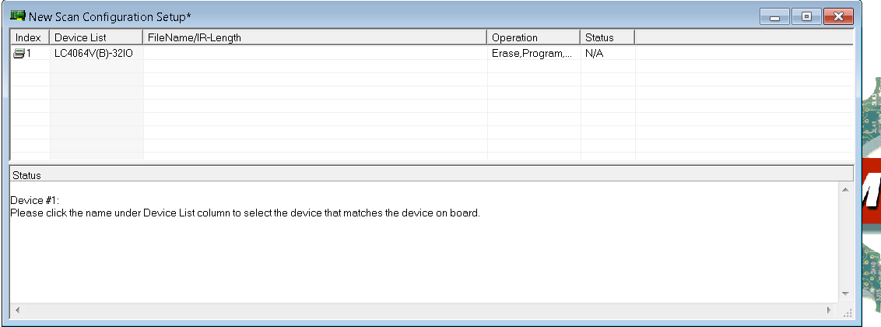

*Figure 1 CPLD JTAG Scan Chain*

* 1. Double click the 1st item on New Scan Configuration Setup, the window of Device Information pops up. Make the configuration as shown in figure 2. Click Browse to select the Data File **CN0385_CPLD.jed**.

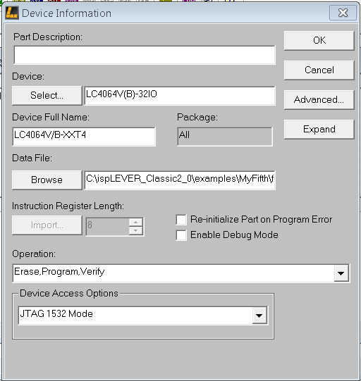

*Figure 2 Device Information Window*

* 1. Click Project >> Project Settings to open the Project Settings window. Click Advanced and set the **TCK LowPulse Width Delay (1 to 10x):** to 10 as shown in figure 3.

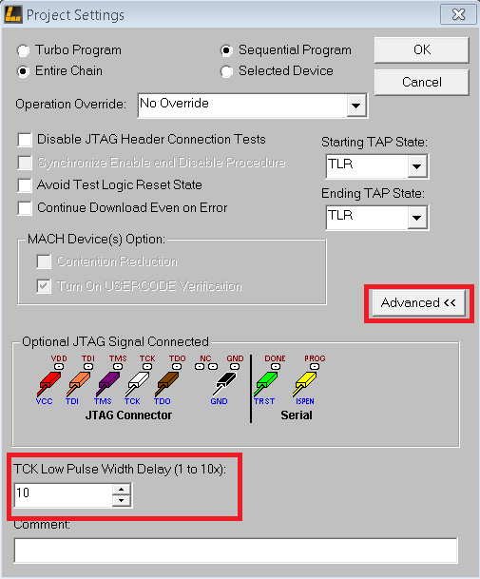

*Figure 3 Project Settings*

* 1. Click ispVM project-> download. It goes to flash programming of CPLD. When the programming is successful, it shows PASS in green as in figure 4.

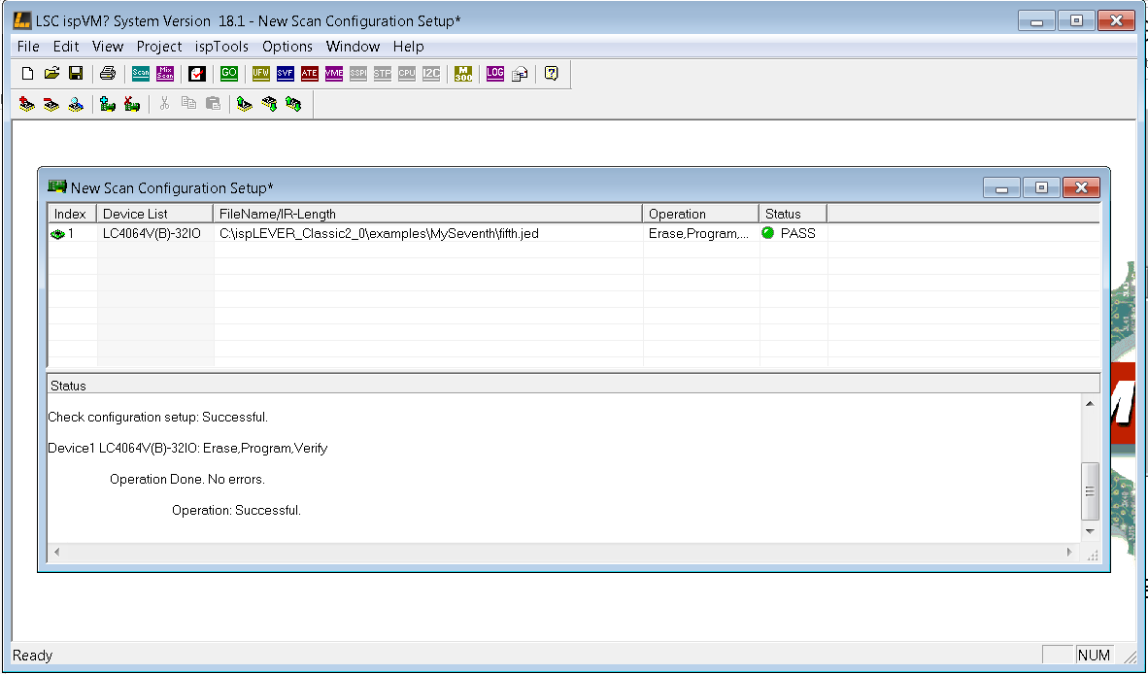

*Figure 4 Programming of CPLD*

1. Power recycle the CFTL board before testing it.

**Procedure for testing the board:**

1. Connect the XLR cable to the Audio Precision **Analog Output A**.
2. Connect the other end of the XLR cable to the **XLR to SMA interposer board**.
3. Connect the **XLR to SMA interposer board** to the daughterboard.
4. Open the Evaluation Software.
5. Check that all the “D16”, “D17”, “D4” and “D12” LEDs are on.
6. Read/Write Register Test
7. Select the Configure Tab in the software.
8. Click the **Status Header**, **Span Compression**, **Input High-Z Mode** and **Turbo Mode**.
9. Click the **Read ADC Register** button and check to see if the **Status Header**, **Span Compression**, **Input High-Z Mode** and **Turbo Mode** are lit ON in the ADC Register Setting Box as shown in Figure 7.
10. Click the **Status Header**, **Span Compression**, **Input High-Z Mode** and **Turbo Mode** again.
11. Click the **Read ADC Register** button and check to see if the **Status Header**, **Span Compression**, **High-Z Mode** and **Turbo Mode** are lit OFF in the ADC Register Setting Box.
12. AC accuracy test hardware setups
    1. **Differential Inputs in Normal Mode**
13. Make sure the switch S1 is at A, B, C, D, E, F, G, H for differential inputs.
14. Connect the XLR to SMA interposer board to the daughterboard at J4 and J3, which provides differential inputs to V1A and V1B.
15. Plug two pluggable screw Terminal Blocks, 9 Pos, 3.81mm pitch, MC 1,5/9-ST-3,81, such as Phoenix Contact 1803646, FEC 3704968 to P8 and P2.
16. Using wires/jumpers to short the 8 channel inputs (**V1A to V8A**) of P8 at the screw terminal inputs as shown in figure 10. The GND pin is left disconnected.
17. Using wires/jumpers to short the 8 channel inputs (**V1B to V8B**) of P2 at the screw terminal inputs as shown in figure 10. The GND pin is left disconnected.
18. The EVAL-CN0385-FMCZ GUI software is default in normal mode. Click **Turbo Mode (blue)** button to switch to Normal Mode (Grey) if needed.
    1. **Single-ended Inputs in Turbo Mode**
19. Make sure the switch S1 is at 1, 2, 3, 4, 5, 6, 7, 8 for single-ended inputs. Or, short the terminal connector P2’s 8 pins V1B ~ V8B to ground, so the terminal connector P8’s 8 pins V1A ~ V8A are used as singled-ended inputs.
20. Connect the BNC to SMA cable from AP UNBAL BNC to the daughterboard at SMA connector J4, which provides single-ended inputs to V1A. The **XLR to SMA interposer board is not used.**
21. Plug one pluggable screw Terminal Blocks, 9 Pos, 3.81mm pitch, MC 1,5/9-ST-3,81, such as Phoenix Contact 1803646, FEC 3704968 to P8. Let P2 disconnected.
22. Using wires/jumpers to short the 8 channel inputs (V1A to V8A) of P8 at the screw terminal inputs as shown in figure 11. The GND pin is left disconnected.
23. Click **Turbo Mode (blue)** button to make AD4003 into Turbo Mode.
24. AC accuracy Test
25. Setup AP as shown in figure 5 for differential inputs and figure 6 for single-ended inputs.
26. Select the Configure Tab in the software.
27. Click **Turbo Mode (blue)** to switch to Normal Mode (Grey) if needed.
28. Manually type 1500 in Normal Mode (default case) or 2000 in Turbo Mode in **Throughput** tab and hit ENTER
29. Set Samples to 524288
30. Select the target channel (1~8) to test by the dropdown MUX Channel as shown in figure 8 or figure 9.
31. Select the FFT Tab.
32. Click the **Single Capture** button.
33. Check SNR/THD of each channel against values below.

All 8 channels must meet the following values to pass with **differential inputs in Normal Mode** or **single-ended inputs in Turbo Mode**:

**EVAL-CN0385-FMCZ**

|  |  |
| --- | --- |
| **Parameter** | **Test Pass Values** |
| SNR | 91.0dB minimum |
| THD | -91.0dB minimum |

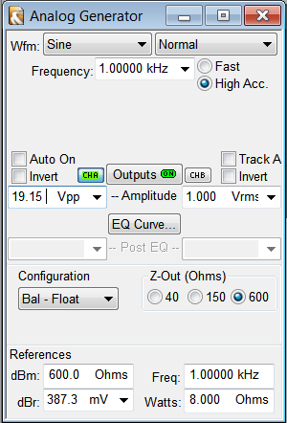

*Figure 5 Audio Precision Settings for differntial inputs*

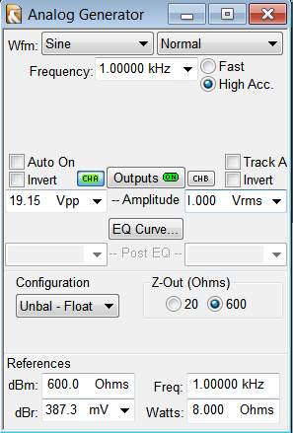

*Figure 6 Audio Precision Settings for single-ended inputs*

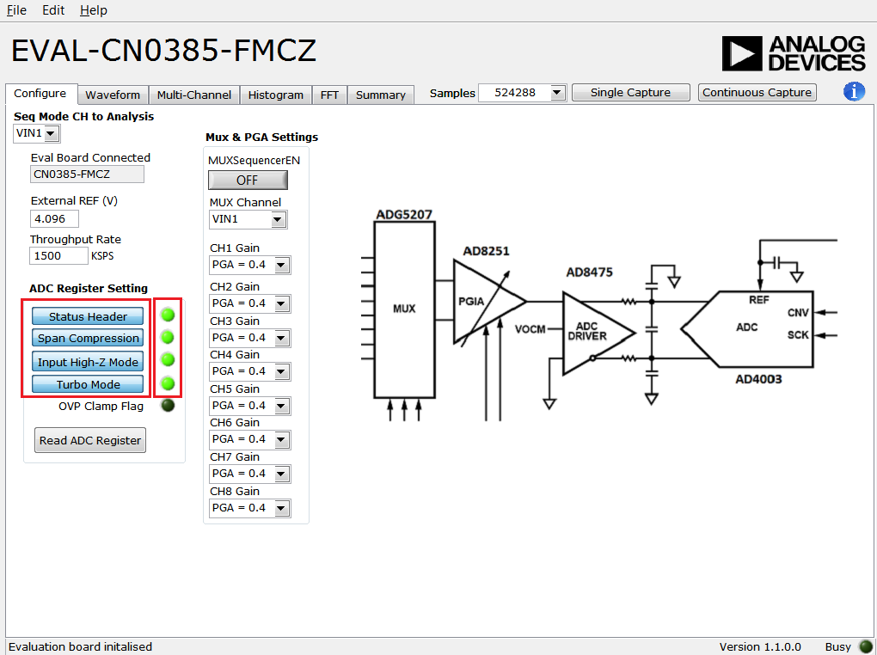

*Figure 7 Read Register*

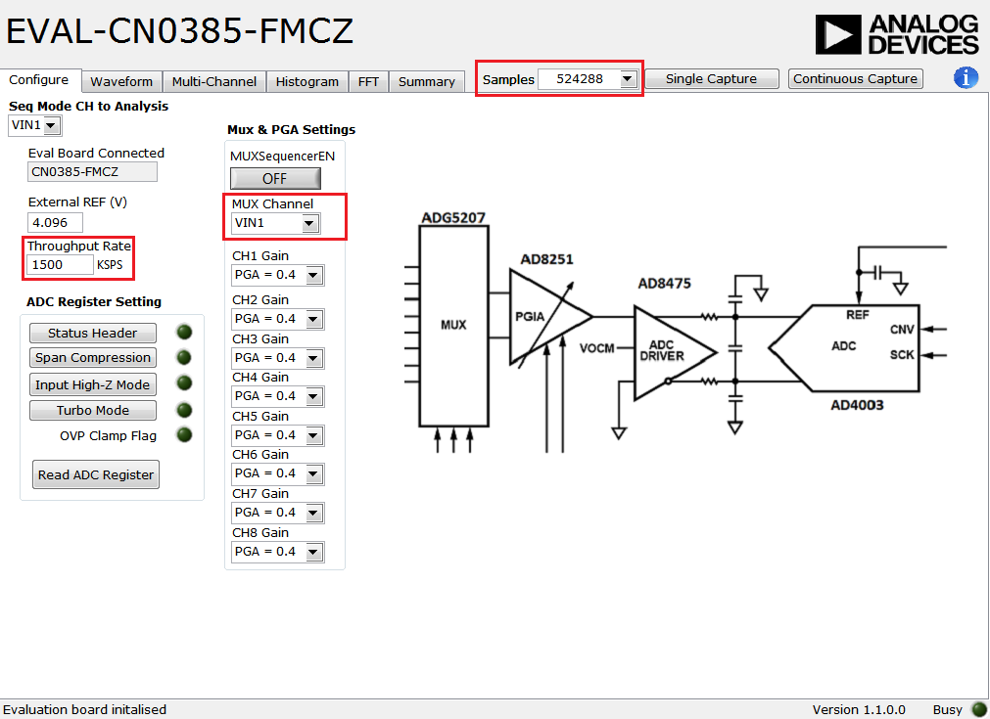

*Figure 8 Normal Mode*

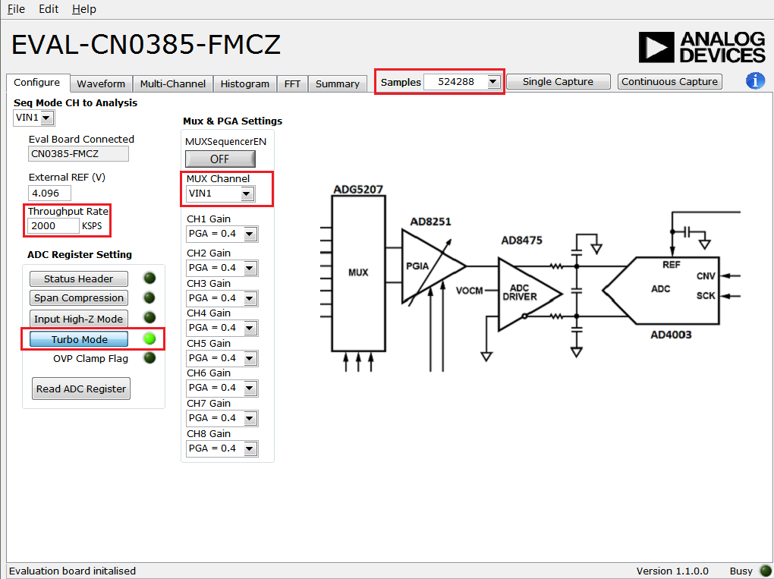

*Figure 9 Turbo Mode*

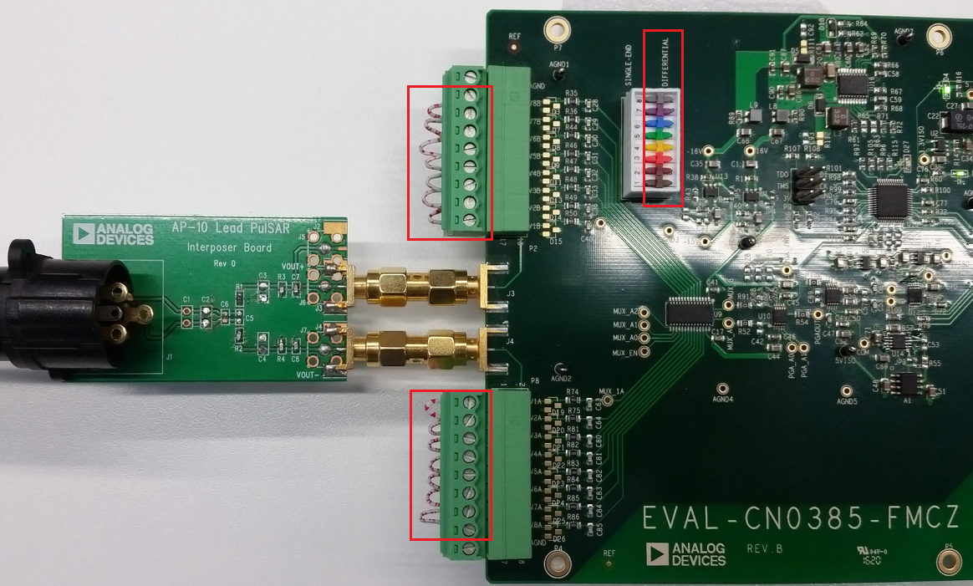

*Figure 10 Differential Input Connection*

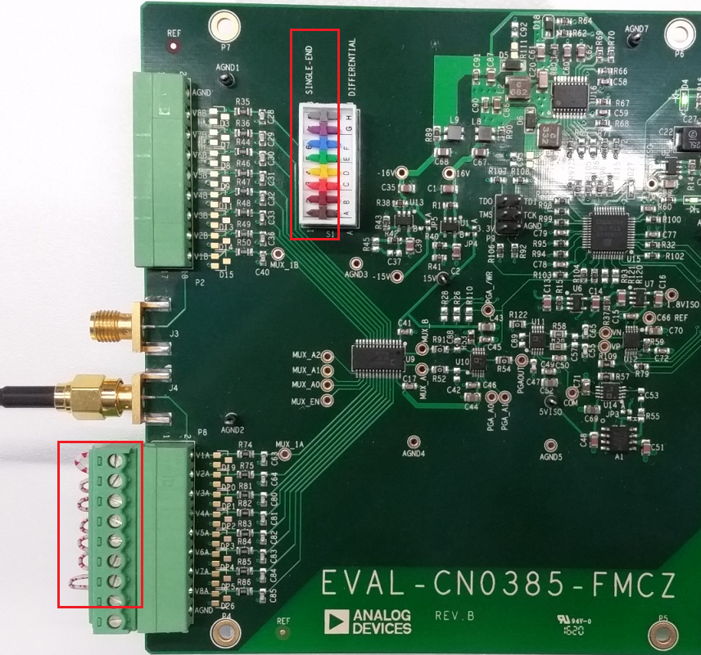

*Figure 11 Single-ended Input Connection*

**Test Results Recording**

For each tested board the Read Register, SNR and THD result should be logged in a word/PDF document in table format. See example below. This should be provided to the responsible applications engineer.

|  |  |  |  |
| --- | --- | --- | --- |
| **EVAL-CN0385-FMCZ W/O NO.: XXXXX** | | | **Read Register** |
| **Unit no.** | **SNR (dB)** | **THD (dB)** |  |
| **1** | **92.5** | **-98** | **Passed** |
| **2** | **92.6** | **-99** | **Passed** |

**Board Traceability & Certification.**

All boards must be individually labeled and traceable to a lot number. A certificate must accompany the lot certifying each individual board within the lot.