**Document No. :** [Title]

**Title :** ADF70301-xxxEZKIT **Customer Evaluation Board Test Procedure**

|  |  |  |  |  |
| --- | --- | --- | --- | --- |
| REVISION HISTORY | | | | |
| **Revision** | **ECR #** | **Description of Change** | **Date** | **Author** |
| A | ECR-0xxxxx | Initial Release |  | Seán O’Connell |
|  |  |  |  |  |
|  |  |  |  |  |

|  |  |
| --- | --- |
| **Required Approvers** | |
| **Approver Roles** | **Approver Names** |
| Apps Engineer | Vincent Heffernan |
|  |  |
|  |  |
|  |  |
|  |  |
|  |  |
|  |  |
|  |  |
|  |  |
|  |  |

# Requirements

## Equipment List

* Motherboard: ADZS-UCM3029-EzBrd
* Daughtercard: EV-ADF70301-xxxAZ Rev-A, where XXX is the appropriate band for the kit, i.e. 915, 868, 433 or 169
* Module: LCD Screen
* Cable: Mini USB cable

## Software Requirements

* ADF7030-1 Aragorn test program
* **ADI_CrossCoreSerialFlashProgrammer-Rel1.2.0.exe** must in installed in the default location on the PC

# Software Installation

1. Run the provided installer. The CrossCore Flash Programmer is automatically installed as part of Aragorn ADF7030-1 test program. Install to the default locations recommended by the installer.

# Assembly

1. Configure the jumpers on the Ez kit:

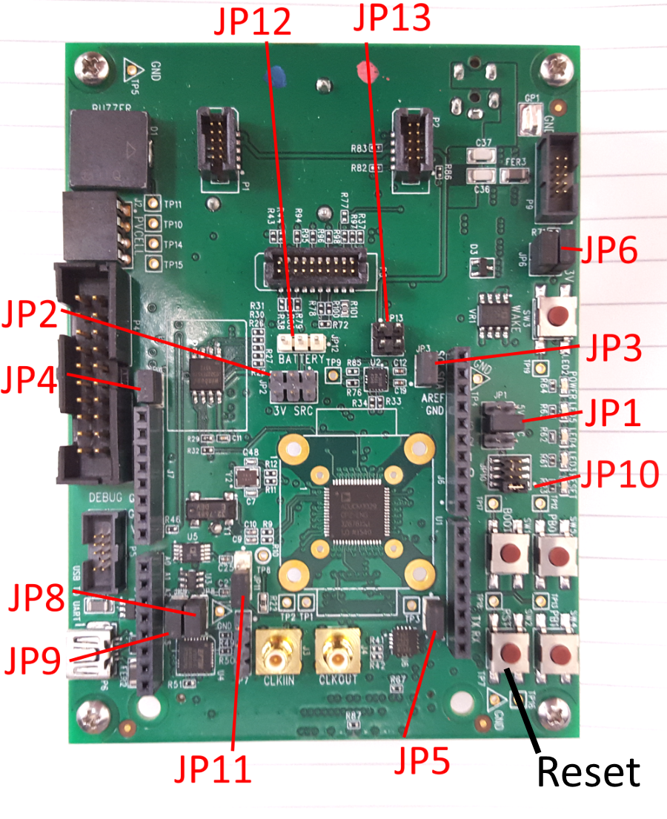Remove jumpers:

* JP13
* JP12
* JP2

Bridge jumpers:

* JP9
* JP8
* JP5 (default)
* JP4 (default)
* JP3 (default)

Connect jumpers:

* JP11: 2 to 3
* JP1: 3 to 4
* JP10: 1 to 2 (default)
* JP6: 1 to 2(default)
* JP6: 3 to 4 (default)

1. Configure the Jumpers on the LCD Module, using a jumper removed from the mainboard:

* JP3: 3 to 4
* Switch: centered (position 2)

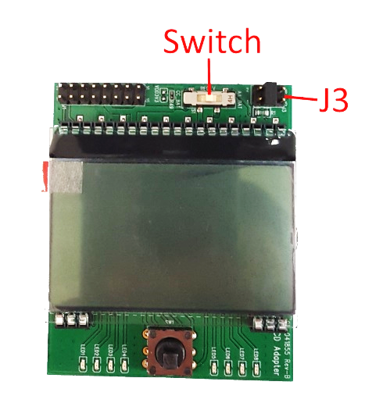

1. Install 4 x plastic standoff legs to the board, as shown below.
2. Remove coin cell battery. This is not included in kit. To be returned to Analog Devices.
3. Plug the ADF7030-1 daughter board into the Ez Kit motherboard. Ensure all 3 connectors are secured.
4. Plug the LCD module into the motherboard, as shown below.

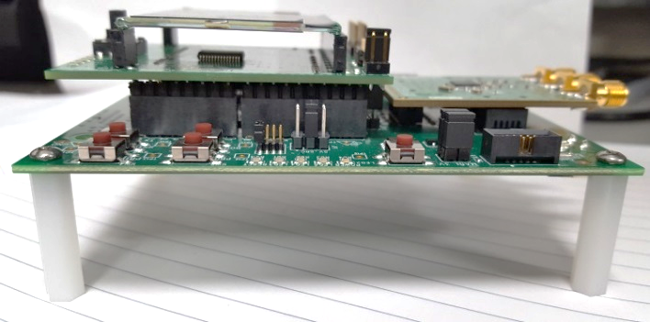 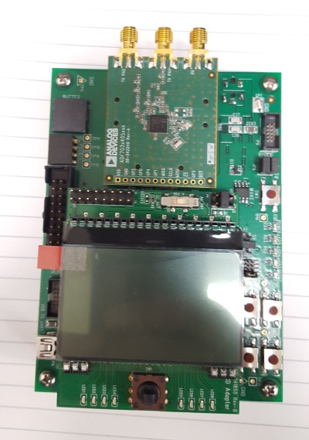

# Test Procedure

## Connect to the Board

1. Connect the USB cable between the USB connector on the Ez Kit mother board and the PC.  
   Only one motherboard should be connected to a PC at a time.

The FTDI drivers will install automatically though Windows when the first board is connected.

1. The green *Power* LED on the motherboard will turn on.
2. Open the ADF7030-1 Aragorn Test GUI. This is located under “Analog Devices” under “All Programs” in the Start menu.
3. Press the “**Flash Board**” button.   
   The CrossCore Flash Programmer is called in the background and programs the board, as shown below. This will take ~5 seconds. The CrossCore window will automatically close once the board is programmed.

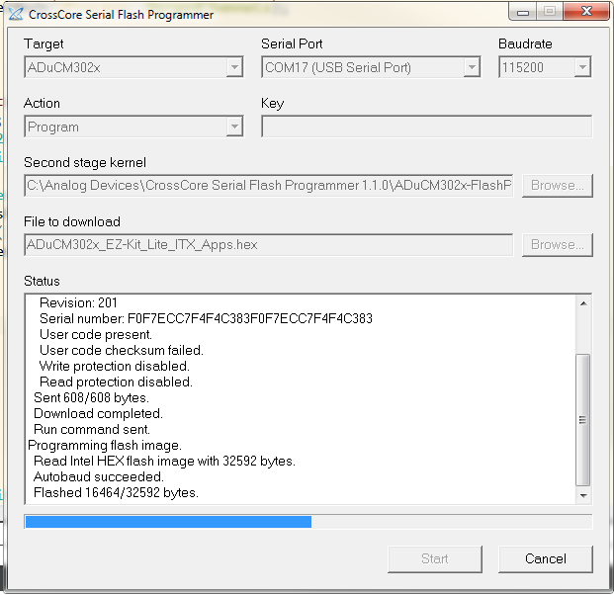

1. Press the reset button marked **RST** on the mainboard.   
   If the board has been correctly flashed the LEDs on the LCD module will blink momentarily one by one from LED1 to LED8 and the LCD will display “Main Menu” on the first line. If this not happen, unplug the board and repeat steps 1-4.

Write Information to the daughtercard



1. Ensure the correct daughtercard is inserted.
2. Press the joystick on the LCD module left to exit the main screen. The menu should disappear. The LCD screen should now say “ADF7030-1 Evaluation” on the first line.
3. Fill in the relevant information into the Daughtercard section of the GUI.
4. Press the “Write Information” button. This will take ~1minute and the GUI may freeze during this process. A popup will indicate when the information has been written.

* **FAIL: A popup will indicate failure: ”Error” or “Timeout”.**
* **PASS: A popup will display : “Success.”**

1. Press the reset button marked **RST** on the mainboard.
2. Press the joystick on the LCD module left to exit the main screen. The menu should disappear. The LCD screen should now say “ADF7030-1 Evaluation” on the first line.

## Daughtercard EEPROM Test

1. Press the *Test EEPROM* Button.

* **FAIL: The Module LCD Screen displays “TEST FAILED”.**
* **PASS: The Module LCD Screen displays “TEST PASSED”.**

## Module LCD Screen Test

1. Press the *Test LCD* Button.

* **FAIL: The Module LCD screen and LEDs do not change.**
* **PASS: The Module LCD screen shows the letters A to U on all 8 lines for 5 seconds and then clears itself.**

## Module Joystick/Joykey Test

1. Press the *Test Joystick* Button.
2. Follow the instructions on the LCD screen.

* **FAIL: The sequence on screen cannot be completed. Reset the board to continue to the next test.**
* **PASS: The instructions on the LCD screen can be completed. “TEST COMPLETE” is displayed at the end of the test sequence.**

## Module LEDs Test

1. Press the *Test LEDs* Button.
2. Follow the instructions on the LCD screen, repeated below.  
   Move the joystick in any direction to begin the test.  
   Press up 8 times and observe LED1 to LED8 on the Module turn on and then off.  
   At the end of the test all LEDs turn on.

* **FAIL: The Module LEDs do not change as instructed.**
* **PASS: Following the instructions on the LCD screen, the 8 LED are turned on then off in sequence. At the end of the sequence, all LEDs are turn on.**

## Daughtercard SPI Test

1. Press the *Test SPI* Button.

* **FAIL: The Module LCD Screen does not display “TEST PASSED”.**
* **PASS: The Module LCD Screen displays “TEST PASSED”.**

## Daughtercard GPIOs Test

1. Press the *Test GPIO* Button.

* **FAIL: The Module LCD Screen displays “TEST FAILED”.**
* **PASS: The Module LCD Screen displays “TEST PASSED”.**

## RSSI Calibration

1. Set the RF Generator to the appropriate channel frequency, i.e. 915MHZ for 915AZ boards, 868MHz for 868BZ boards, 169MHz for 168BZ boards etc.
2. Set the RF power to -77dBm and enable the output. The output power should compensate for cable losses.
3. Press the *Calibrate RSSI* Button.

* **FAIL: A popup will indicate failure ”Calibration Failed” or “Timeout”.**
* **PASS: A popup will display “Calibration performed”**