**Sound propagation velocities of Lomonosov Ridge sediments**

*General.* Sound propagation velocities in sediments are most often calculated from refraction or wide angle reflection soundings. These methods tend to reveal the maximal horizontal velocities in the sediment column rather than the mean vertical velocities needed for thickness calculations of sediment units. The single channel seismic reflection profiling method contains no information for any strict mathematical calculation of the mean vertical sound propagation velocities in the sediment column. However, under specific seafloor and sediment/bedrock conditions it is possible to estimate the mean vertical velocities with a reasonable accuracy, which at any rate is better than figures obtained by refraction or wide angle reflection soundings with regard to low sediment velocities.

*The Lomonosov Ridge experiment.* A set of single channel seismic reflection profiles were shot along and across the Lomonosov Ridge from IB Oden in September 2014 (Fig. 1).

Line4_LocatioMap.TIF

Fig.1. Location of seismic reflection profiles 20140923\_120444 to 201317 (Table 1). Profile 20140923\_191003 marked by red color. 84°10.66’N 149°10.57’E – 84°11.36’N 148°17.57’E.

Fig2a_200Hz.TIF

Fig.2. Seismic line 20140923\_191003 filtered around 200 Hz. Seafloor marked blue and proposed bedrock surface marked red. Depths in km at water velocity 1462 m/s.

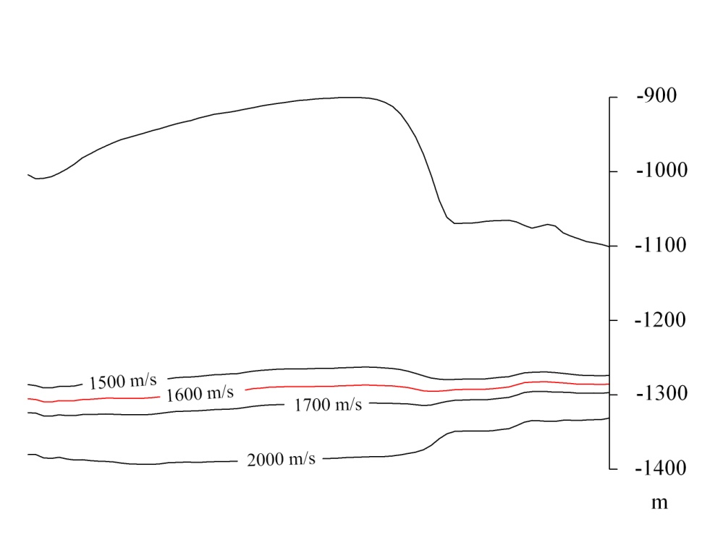

Fig. 3. Geologic section with the level of the proposed bedrock surface calculated for sound propagation velocities between 1500 m/s and 2000 m/s

Table 1. Seismic lines shot 2014-09-23, area 4, lines 1-8.

Line 4-1 20140923\_120444 Start: 12:04:44 Stop: 14:46:48

Line 4-2 20140923\_144945 Start: 14:49:45 Stop: 15:45:45

Line 4-3 20140923\_154758 Start: 15:48:00 Stop: 16:20:01

Line 4-4 20140923\_162207 Start: 16:22:10 Stop: 17:06:10

Line 4-5 20140923\_170736 Start: 17:07:37 Stop: 18:08:11

Line 4-6 20140923\_180930 Start: 18:09:32 Stop: 19:07:33

Line 4-7 20140923\_191003 Start: 19:10:03 Stop: 20:12:04

Line 4-8 20140923\_201317 Start: 20:13:19 Stop: 22:03:20

One of the seismic lines, namely 20140923\_191003 (Fig. 2) crosses over a steep slope in the seafloor, more than 150 m high starting at the ridge crest at c. 900 m bsl. Apart from a rather complicated pattern of sediment structures below the ridge crest, a strong and consistent reflector with no sign of tectonic disturbance was identified at a depth of c. -1300 m. In Fig. 2 it is marked by a red line. The comparably strong reflection, and the general absence of reflectors below this level, suggests that it marks the Cretaceous (?) bedrock surface. Only a very slight velocity pull up of the reflector below the ridge crest suggests that the mean vertical sound propagation velocity in the sediments here is indeed very low (Fig. 3).

A geological depth section was constructed across the slope and the level of the suggested bedrock surface was calculated and plotted for some velocities ranging from 1500 to 2000 m/s. Assuming that the suggested bedrock surface is indeed rather flat, a mean vertical sound velocity of 1600 m/s proved to be a good fit (Fig. 3).

*Comparison with previously published velocity data.*  In 1998, a number of multichannel seismic profiles were shot across the Lomonosov Ridge (Jukat 2005). The multichannel recordings were supplemented by sonobuoy refraction soundings in order to establish the sound propagation velocities of the sediments and bedrock of the Lomonosov Ridge and its surroundings. One of these seismic lines across the Ridge, namely 98550 is located within the same general area as the present seismic lines (Table 1). Thus, line 98550 crosses the Ridge at c. 83°30’ and the present line 191003 at c. 84° 11’. The sediment cover is essentially similar between the two areas.

The two sonobuoy refraction stations along line 98550 gave a velocity range for the uppermost sedimentary sequences of 2.1-2.6 km/s in SB9807 and 2.8-3.0 in SB9806 (Jokat 2005, Fig.8). It is unlikely that the extremely low vertical sound propagation velocity not exceeding c. 1600 m/s, that was the result of our experiment, would be resolved in the refraction soundings as presented by Jukat (2005, fig. 8). In our opinion the velocities presented by Jokat refer to a somewhat deeper level in the sequence, or possibly, to some thin none-representative sediment unit in the upper part.

Although located far north of our location, at c. 88°, the sediment sequence on the LomonosovRidge there has a structural and thickness resemblance to our area. The sound propagation velocities are in the order of 1.51 to 1.95 km/s for the sediment unit (Jokat et al., 2011, fig. 4). The thickness of the sediment unit is c. 400 m. These figures are in a good agreement with our calculations (Fig. 3).

Sound propagation velocities measured in the ACEX core drilled to a depth of c. 450 m on the Lomonosov Ridge near 88° revealed slowly increasing velocities from c. 1.5 km/s at the seafloor to ca. 1.6 km/s at a depth of 200 m into the core. At this depth there occurred an abrupt decrease in velocity back to c. 1.5 km/s, followed by a slow increase to c. 1600 m/s at termination depth (Backman et al., 2008, fig. 6). This is again in a good agreement with our velocity experiment.