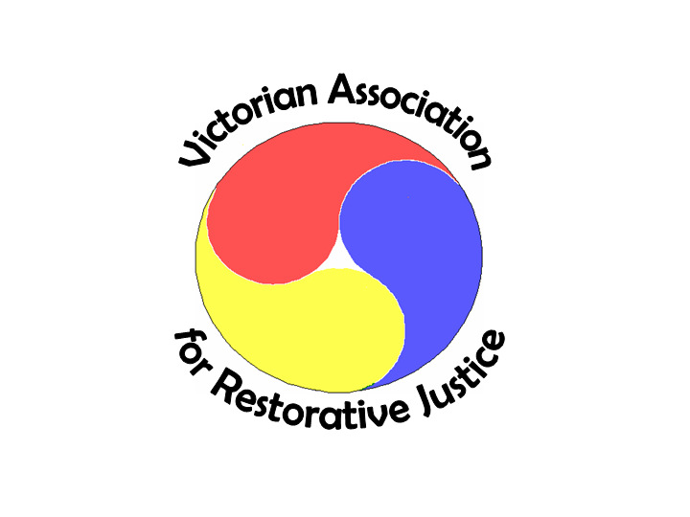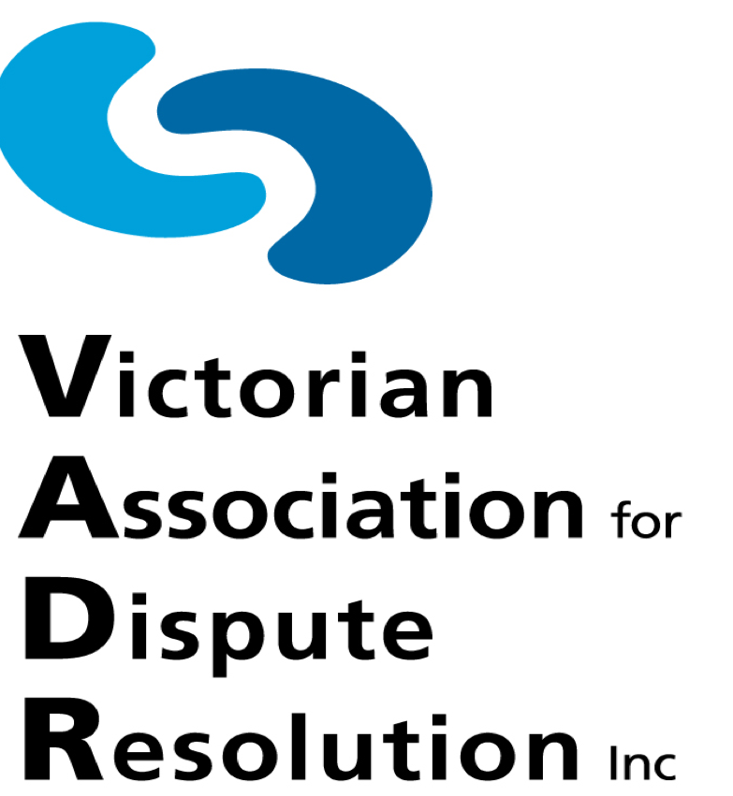

Wednesday 29 August 2018

FRED WRIGHT, RODNEY MCBRIDE, SUE ACKERLY

A new approach to conflict resolution: developing conflict-competent workplaces

In recent years, three Victorian State Government departments (DELWP, DHHS & DEDJTR) have established Workplace Conciliator/Facilitator programs which provide a confidential, safe and independent place for employees to talk about workplace issues and concerns and identify constructive options for early and informal resolution. The programs also work systemically to build conflict-competent workplaces.

In this interactive session facilitated by Michael Mitchell, Fred, Sue and Rod will provide an insight into their work, giving you a taste of the challenges and potential successes of using this approach to promote conflict-competent government workplaces.

THE PANEL

Fred Wright was appointed in 2011 to the first Workplace Conciliator role at what is now the Department of Environment, Land, Water and Planning (DELWP). He has over 38 years’ experience in public sector administration in Victoria and has worked in a range of operational and management positions across justice, human services and human rights portfolios.

Rodney McBride joined the Department of Health and Human Services (DHHS) in 2017 as their Workplace Facilitator. Rod has extensive experience providing psychological support services to staff in a wide variety of organisations, including the past five years in international settings. He is a registered psychologist and a trained mediator.

Sue Ackerly commenced as the Department of Economic Development, Transport, Jobs and Resources (DEDJTR)’s first Workplace Conciliator in March 2018. Sue has an extensive background in coaching, mediation, facilitation and helping people to resolve workplace issues within government, the not-for-profit and private sectors. She is a registered psychologist, and holds tertiary qualifications in management, workplace training and assessment, and science.

Facilitator Michael Mitchell is a VADR and VARJ Committee member and the Director of Mitchell Mediation. He is a former ACCS Conciliation Officer and ACCS Board member, who now holds a number of ADR appointments, including: facilitator in the Defence Force Ombudsman Restorative Engagement Program, Commonwealth Ombudsman Office; external ADR Provider, Early Case Assessment and Resolution Services, Administrative Appeals Tribunal; External Adviser/Conciliator to Colleges University of Melbourne, Fair Treatment Policy and Procedures; Sessional Seminar Leader/Tutor, Dispute Resolution at La Trobe University Law School; and external Panel Conciliator, Domestic Builders Dispute Resolution Victoria.

Details are as follows:

Date:     Wednesday 29 August 2018

Time:     5.30pm (registration/networking) for 6.00pm to 7.15pm

Venue:  Coopers Inn, cnr Exhibition & Little Lonsdale Streets, Melbourne

Cost:     Free (non-VADR members $25)

RSVP:    Email [admin@vadr.asn.au](mailto:admin@vadr.asn.au) by Monday 27 August 2018

The event carries one CPD point. Finger foods will be provided, and drinks are available at bar prices.