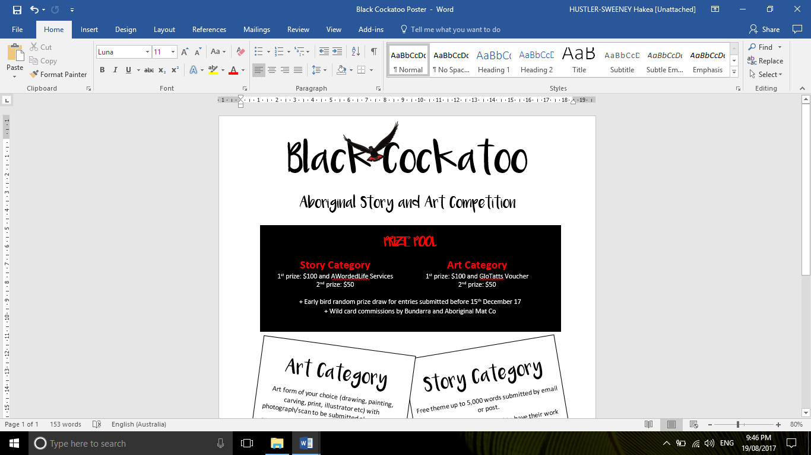

**TERMS AND CONDITIONS**

1. Work must be the original work of the applicant.
2. Work must not have previously won any competition or award.
3. Must be of Aboriginal descent.
4. Must be aged between 10-20 as at 20th November 2017.
5. One entry per category per person.
6. Entries can be a result of equal collaboration; this will be counted as each person’s only eligible entry in that category- art or story. It is the responsibility of the contributors to share their prizes.
7. All entries must be submitted before 5pm on 14th March 2018 to be considered for the competition.
8. Early bird draw open to entries submitted before 15th December 2017. This will be a random prize draw and not a reflection of the work itself.
9. Entries cannot be returned unless self-addressed, stamped return envelope supplied.
10. The decision of the judges is final. No feedback or discussion will be entered into about the result.
11. By submitting an entry, the applicant acknowledges that they have sought and been granted parental/guardian permission for works to be published.
12. Applicants give permission for their work to be used as part of media campaigns and advertising in print and on the internet.
13. Art must be submitted as a photograph/scan via email. Top 10 entries will be invited to have their work showcased at an exhibition and the opportunity to have works sold at auction will full proceeds to artist- this is at the artists discretion.
14. ‘Art’ is open to interpretation and can include paintings, drawings, photography, digital work etc.
15. Stories must not exceed 5,000 words.
16. Stories that include Dreaming or other culturally sensitive information must have permission of relevant Elders or community members before being submitted. This is the responsibility of the applicant.
17. Stories can be scribed by another person; the scribe must write word for word the story as spoken by the applicant.

 **SUBMISSION FORM**

***Applicant Details***

Name: __________________________________________ Age: __________________________

(as at 20th November 2017)

***Contact Details***

Applicant Postal Address: _________________________________________________________  
Phone: ___________________________ Email: _______________________________________

**AND/OR**

School/organisation name: ________________________________________________________  
Contact Name: _________________________ Contact Phone: ____________________________  
Contact Email: __________________________________________________________________

***Competition Entry***

Category:  Art piece and/or  Story

Title/s: _______________________ and/or _______________________

**Permissions:**

 I understand the TERMS and CONDITIONS of entry. Signature of applicant: ___________________

**Only** if under 18, I give ____________________ permission to enter the Black Cockatoo Story and Art Competition. I give permission for their name, photograph and work to be published.

Name: _________________________ Signature: ___________________ Date: ________________

**Attachments:**

* Submission Form
* Story file and/or art work photograph
* Stamped, self-addressed envelope (only is return of work is required)
* Optional- photograph of applicant

Email entries to: [author@hakeahustler.com.au](mailto:author@hakeahustler.com.au) by 5pm 14th February 2018

 **SHORTLIST CONSENT FORM**

*Congratulations for being shortlisted for the Black Cockatoo Art Prize! You are now invited to submit the physical copy of your piece to us for judging (and exhibition and/or auction with your consent)!*

***Applicant Details***

Name: __________________________________________ Age: __________________________

(as at 14th November 2017)

***Contact Details***

Applicant Postal Address: _________________________________________________________  
Phone: ___________________________ Email: _______________________________________

**AND/OR**

School/organisation name: ________________________________________________________  
Contact Name: _________________________ Contact Phone: ____________________________  
Contact Email: __________________________________________________________________

***Competition Entry***

Category:  Art piece and/or  Story

Title/s: _______________________ and/or _______________________

**Permissions:**

 I consent to my art work being displayed during the Black Cockatoo Competition Exhibitions.

 I consent to my art work being offered at auction during the Exhibitions with full payment to be made via direct debit to:

Name: _____________________________________________________________

BSB: ____________________ Account: _________________________________

 I do not consent to my work being (please circle) exhibited and/or auctioned.

**Attachments:**

* Consent form
* Art piece

Send entries to:  
Competition   
C/O Hakea Hustler and Carl Merrison