first and family name  
first and family name  
first and family name  
first and family name

Title: maximum two rows

subtitle: optional

Abstract:100-200 words in English language> Li Europan lingues es membres del sam familie. Lor separat existen-tie es un myth. Por scientie, musica, sport etc, litot Europa usa li sam vocabular. Li lingues differe solmen in li grammatica, li pronunciation e li plu commun vocabules. Omnicos directe al desirabilite de un nov lingua franca: On refusa continuar payar custosi traductores. At solmen va esser necessi far uniform grammatica, pronunciation e plu sommun paroles. Ma quande lingues coalesce, li grammatica del resultant lingue es plu simplic e regulari quam ti del coalescent lingues. Li nov lingua franca va esser plu simplic e regulari quam li existent Europan lingues. It va esser tam simplic quam Occidental in fact, it va esser Occidental. A un Angleso it va semblar un simplificat Angles, quam un skeptic Cambridge amico dit me que Occidental es. Li Europan lingues es membres del sam familie. Lor separat existentie es un myth. Por scientie, musica, sport etc, litot Europa usa li sam vocabular. Li lingues differe solmen in li grammatica, li pronunciation e li plu commun vocabules. Omnicos directe al desirabilite de un nov lingua franca: On refusa continuar payar custosi traductores. At solmen va esser necessi far uniform grammatica, pronunciation e plu paroles.

# General

The scientific committee of the IPW 2018 decides whether to accept or reject articles submitted according to technical and scientific criteria. By submitting a paper, the author agrees to adhere to the following conditions:

Articles have to be written by the author himself/herself. He or she must also be the copyright holder of all illustrative material submitted (photographs, drawings). Fees requested subsequently by third parties must be paid by the author.

The editorial office has the right to change, to supplement or to shorten the text according to language style, structure or content, or to ask the author to do so. Changes may also become necessary due to the particular scientific position of the journal. If the author does not agree to such alterations, he/she may withdraw the article.

Articles are primary publications that have neither been published in whole or in part previously nor submitted for publication elsewhere. This also concerns serial publications by scientific institutes and universities as well as internal corporate magazines. The article/essay may not be published elsewhere for a period of one year after its first publication in an Ernst & Sohn journal without the permission of the author and the editorial office.

Letters and responses to published articles and reports are welcomed. They should be factual and succinct, and the result of a previous agreement between the author and the writer of the letter. The editorial office requests copies of the entire correspondence. The discussion has to be brought to a conclusion in consultation with the editorial office. The editorial office does not assume any responsibility for the content, but may, however, curtail the length and set deadlines for the submissions.

# Structuring and design of manuscripts

## Outline and formal structure

The text length of an article may not exceed **six printed pages and respectively 22 000 characters (including spaces)** including figures, tables and bibliography, and must be written using MS Word. The number of illustrations should not be more than eight.

The title of a contribution should be short and to the point (maximum two rows). The first and family names of all the authors should be listed without any academic degrees on the top of the first page.

Every contribution should begin with an abstract (up to 200 words) of its contents.

When writing the text, authors should make every effort to use clear, straightforward language. They should avoid complicated, involved sentences, repetitions and writing in the first person. **Please ensure that your text is proofread by a competent user of the English language.** The manuscript must be ready for printing. The text is to be clearly structured by subheadings and numbered following the decimal system with normally not more than three decimal points. Every article starts with ‘1’ and ends with ‘Bibliography’.

The bibliography is followed by the family names and first names of all the contributing authors, their academic titles and full postal addresses (either private or their companies/institutes). The list of captions of figures and tables – numbered consecutively using Arabic numerals and marked in brackets in the text – is to be appended to the end of the contribution.

Authors are requested not to use footnotes. If unavoidable, they should contain only factual information and no bibliographical references. Footnotes should be numbered consecutively.

## Figures and tables

Each Table and picture must be numbered consecutively. Please provide the information of the source of the picture.

Table 1 Description of the different types of furnishing

|  |  |  |
| --- | --- | --- |
| **Variante** | **Mobiliar** | **Schallschirme** |
| **0** | ohne | ohne |
| **1** | 8 Bürotische | ohne |
| **2** | 8 Bürotische | mit reflektierend ausgestalteter Oberfläche |
| **3** | 8 Bürotische | mit absorbierend ausgestalteter Oberfläche |

Requirements for mechanical and line drawings, photographs and figures in black and white or full colour:

* Resolution of graphic files should be at least 300 dpi (always check width and height).
* Graphic files, photographs or other figures files are to be saved in EPS, TIF or JPG format (EPS and TIF files are preferred).

Please embed digital photopgraphs or other figures directly in your main document as demonstrated in the following figures 1 and 2.

The size of the illustrations is based on the print space:

* minimal width = 88 mm (single-column)
* maximal width = 181 mm (two columns)
* maximal height = 260 mm (full page, portrait format)

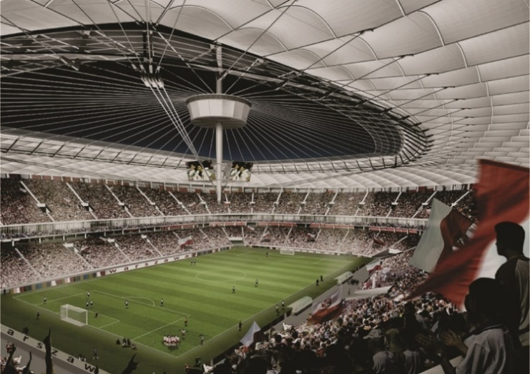

Fig 1 Photos should generally be provided in JPG format. A minimum resolution of 150 dpi is required. Source: Photographer/Institution

Fig. 2 Technical drawings, diagrams and line art should be supplied as vector data as possible (EPS, PDF, WMF). Alternatively, lossless compressed formats (TIFF, PNG) can be used. In this case, the minimum resolution of 300dpi is required. Subfigures should be numbered a), b), c) ... etc. Source: Photographer/Institution

## Symbols

Formulas and other symbols must be the same in texts, illustrations and tables. They should be clearly typed, preferably using a word-processing system (e.g. with a formula editing program) such that they cannot be misread.

Indices and exponents should be clearly subscripted or superscripted. Special formula symbols should be used in compliance with the prevailing norms. In particular, authors should take care not to mix Greek, Roman, Latin and Arabic symbols when typing in upper- or lower-case letters – e.g. γ (gamma), y and Y, o, O and 0 (zero), ω (omega), w und W, Arabic ‘1’ and the lower-case ‘l’ as in ‘letter’. Gothic letters should be replaced by semi-bold characters. Three-part terms are to be avoided wherever possible.

# Use of this template

The publishing house Ernst & Sohn provides this template in order to help authors to create their manuscript according to the publishing houses’ author guidelines. This document has been created using this template. You may delete its content in order to write your paper.

**Sending your manuscript**

For submission of manuscripts, please send both your manuscripts to the email address of the Workshop Secretariat: [ipw2018@boku.ac.at](mailto:ipw2018@boku.ac.at).

# Proofreading and corrections

The manuscript must be complete and final in terms of formulation and factual information so that no major corrections – only typesetting errors – will be necessary after typesetting. The author will receive a proof copy of the text, tables and figures. Subsequent requests for corrections cannot be processed.

**Bibliography**

Bibliographical references and quotations should be listed at the end of the paper. References should be numbered using Arabic numerals, the number of the reference appearing in the text in square brackets. The references should be quoted using abbreviated versions according to German standard DIN 1505. Within this document the format template Liste: Literatur is available to format bibliographical references. In the following, some citation examples of monographs and journal articles.

[1] Hass, R.; Meyer-Ottens, C.; Richter, E.: *Stahlbau-Brandschutz-Handbuch*. Berlin: Ernst & Sohn 1993.

[2] Haenel, J.; Kina, J.; Schaumann, P.: *Zur Erweiterung des Anwendungsbereiches von Stahlträgerverbundkonstruktionen*. Stahlbau 63 (1994), H. 4, S. 279–283.

Last but not least we ask the authors to provide us with the complete names, including academic titles, postal addresses as well as e-mail addresses.

**Authors**

Dr.-Ing. Max Mustermann

Technische Muster Universität

Institut für Musterbau

Musterstraße 1

12345 Musterhausen

max@mustermann.de

Prof. Dr.-Ing. Maxine Musterfrau

Technische Muster Universität

Institut für Musterbau

Musterstraße 1

12345 Musterhausen

maxine@musterfrau.de