**Summit Station Weekly Science Report**

**Reporting Period:**  February 18– February 24, 2019

**Completed by:** Mara Menahan and Nathan Bowker

**Comments:** The spring crew has enjoyed their first week on station as a crew of four. Science technicians have stayed busy with inventory and instrument maintenance. The ICECAPS Dataman computer experienced a hard drive failure on 2/19. Efforts to restore this system are ongoing, with significant progress made throughout the week.

Wind speeds at Summit ranged from 4.1 m/s, recorded from 2019-02-23, to 17.4 m/s recorded on both 2019-02-21 and 2019-02-22. The average wind speed for the week was 8.01 m/s. Temperatures ranged from a low of -54.62˚C on 2019-02-18 to a high of -21.3˚C on 2019-02-22. The average temperature was -36.62˚C.

Summit did not experience any north winds or low winds this week.

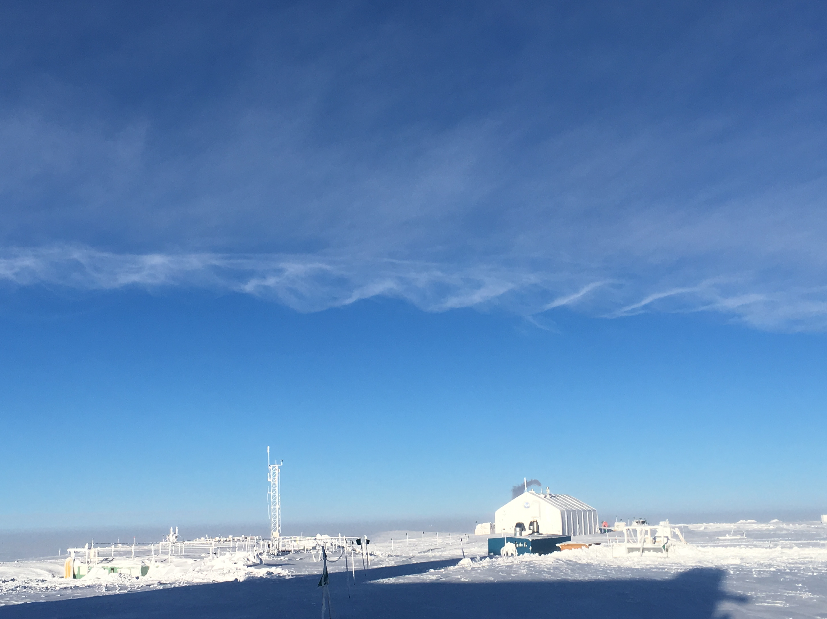

Kelvin-Helmholtz instability evident over station on 2/24.

**Please visit the clean air log at ftp://isr.sri.com/pub/summit/ftp/science/clean_air_traffic/**

|  |  |
| --- | --- |
| **Facilities** | **Comment** |
| TAWO |  |
| MSF |  |
| Green House |  |
| **Experiment** | **Notes** |
| NOAA CCGG flasks | Comment:  Date performed: 2019-02-22 |
| NOAA HATS flasks | Comment: twice per month  Date performed: 2019-02-23 |
| NOAA Surface Ozone | Comment: Calibrated on 2019-02-19.  % of time operating: 100% |
| NOAA Aethelometer | Comment: Instrument offsite for service.  % of time operating: 0% |
| NOAA Meteorology | Comment:  % of time operating: 100% |
| NOAA CLAP & Neph | Comment: Span check last occurred on 2019-02-19. Neph lamp replaced on 2019-02-19. CLAP filter changed on 2019-02-20.  % of time operating: 100% |
| Radionuclide Filter | Comment: Changed every other day.  % of time operating: 100% |
| Aerosol DRUM Sampler | Comment:  % of time operating: 100% |
| Bamboo Forest | Comment:  Date performed: 2019-02-20 |
| SnowFox | Comment:  Date performed: 2019-02-20 |
| ICESat Accumulation | Comment:  Date performed: 2019-02-16 |
| GFZ Potsdam Seismometer | Comment: Raised a section of cables to above-surface levels on 2019-02-23 at 1900z.  % of time operating: 100% |
| DTU Magnetometer | Comment:  % of time operating: 100% |
| UNAVCO | Comment: |
| Helmig CUGC | Comment: Added 1L of DI water to the H2 generator on 2019-02-19.  % of time operating: 100% |
| Steffen Tower Instruments | Comment:  % of time operating: 100% |
| Steffen Solar Instruments | Comment: Communicating with PI’s to restore power and comms to the CR23x data logger on the solar tracker.  % of time operating: 50% |
| ICECAPS-ACE Total Sky Imager | Comment: Offline for the winter.  % of time operating: 0% |
| ICECAPS-ACE Radiosonde | Comment: Sonde computer restarted on 2/24.  Dates performed: Twice daily. |
| ICECAPS-ACE MWR | Comment:  % of time operating: 100% |
| ICECAPS-ACE SODAR | Comment: Dishes cleaned on 2019-02-23  % of time operating: 100% |
| ICECAPS-ACE POSS | Comment: Offline since 2/19 due to Dataman hard drive failure.  % of time operating: 30% |
| ICECAPS-ACE MASC | Comment: Instrument offsite for service; expected return 2019-06.  % of time operating: 0% |
| ICECAPS-ACE MMCR | Comment:  % of time operating: 100% |
| ICECAPS-ACE CAPABL | Comment: Conducted further tests on 2/18. Awaiting advice from laser manufacturer for best path forward.  % of time operating: 0% |
| ICECAPS-ACE MPL | Comment:  % of time operating: 100% |
| ICECAPS-ACE Ceilometer | Comment:  % of time operating: 100% |
| ICECAPS-ACE PAERI | Comment:  % of time operating: 100% |
| ICECAPS-ACE IcePIC | Comment: IcePIC equipment cleaned and serviced on 2/22.  Date(s) performed: |
| ICECAPS-ACE CLASP | Comment: Instrument offsite for service.  % of time operating: 0% |
| ICECAPS-ACE CPC | Comment: Received air pump error code at 1411z on 2/20 because of an ice blockage in the sample outlet line. Cleared blockage and restarted instrument at 1427z.  % of time operating: 99% |
| ICECAPS-ACE OPC | Comment:  % of time operating: 100% |
|  |  |  |
|  |  |  |