**Summit Station Weekly Science Report**

**Reporting Period:**  November 19 – November 25, 2018

**Completed by:** Gus Allen, Troy Nave

**Comments:**

The techs did a “follow-up” ICESat Traverse on Sunday, 2018-11-25.

Wind speeds at Summit ranged from 1.7 m/s, recorded on 2018-11-23, to 21.8 m/s on 2018-11-20. Temperatures ranged from a low of -45.55˚C on 2018-11-22 to a high of -15.43˚C on 2018-11-20. Weekly average wind speed was 9.6 m/s and weekly average temperature was -25.81˚C.

Summit experienced no low winds during the week. North winds occurred on 2018-11-22 from 07:17 to 07:19.

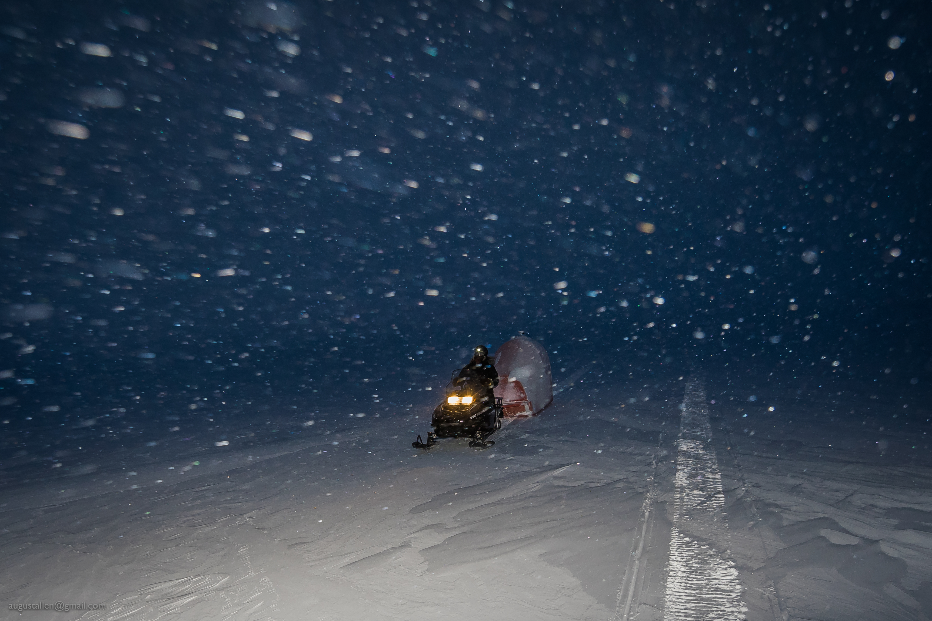

PFS Science Technician Troy Nave pulls the polypod carrying the GPS survey receiver for this week’s follow-up ICESat traverse.

**Please visit the clean air log at ftp://isr.sri.com/pub/summit/ftp/science/clean_air_traffic/**

|  |  |
| --- | --- |
| **Facilities** | **Comment** |
| TAWO |  |
| MSF |  |
| Green House |  |
| **Experiment** | **Notes** |
| NOAA CCGG flasks | Comment:  Date performed: 2018-11-22 |
| NOAA HATS flasks | Comment: every other week  Date performed: 2018-11-25 |
| NOAA Surface Ozone | Comment: Calibrated on 2018-11-20  % of time operating: 100% |
| NOAA Aethelometer | Comment: Offline since 2018-01-10. Instrument offsite for repair.  % of time operating: 0% |
| NOAA Meteorology | Comment:  % of time operating: 100% |
| NOAA CLAP & Neph | Comment:  % of time operating: 100% |
| Radionuclide Filter | Comment:  % of time operating: 100% |
| Aerosol DRUM Sampler | Comment:  % of time operating: 100% |
| Bamboo Forest | Comment:  Date performed: 2018-11-23 |
| SnowFox | Comment:  Date performed: 2018-11-21 |
| ICESat Accumulation | Comment: Per P.I. Kelly Brunt, only GPS data were collected, not manual accumulation measurements  Date performed: 2018-11-25 |
| GFZ Potsdam Seismometer | Comment:  % of time operating: 100% |
| DTU Magnetometer | Comment:  % of time operating: 100% |
| UNAVCO | Comment: |
| Helmig CUGC | Comment:  % of time operating: 100% |
| Steffen Tower Instruments | Comment:  % of time operating: 100% |
| Steffen Solar Instruments | Comment:  % of time operating: 100% |
| ICECAPS-ACE Total Sky Imager | Comment: Offline for the winter  % of time operating: 0% |
| ICECAPS-ACE Radiosonde | Comment:  Dates performed: Twice daily. |
| ICECAPS-ACE MWR | Comment: The 150-90 radiometer showed a communication error on 11-23. With direction from Erik Olson, tech was able to reboot the instrument and restart data collection on 11-25  % of time operating: 75% |
| ICECAPS-ACE SODAR | Comment:  % of time operating: 100% |
| ICECAPS-ACE POSS | Comment:  % of time operating: 100% |
| ICECAPS-ACE MASC | Comment: Instrument is offsite for repair and is due to return Summer 2019.  % of time operating: 0% |
| ICECAPS-ACE MMCR | Comment: Pitch 0.00, Roll 0.00  % of time operating: 100% |
| ICECAPS-ACE CAPABL | Comment: Issue with laser head 1 is still under assessment. Instrument experienced a disk boot error on 11-22 and was restored the same day. Instrument is presently operational using laser 2.  % of time operating: 95% |
| ICECAPS-ACE MPL | Comment: Calibration performed 11-20  % of time operating: 100% |
| ICECAPS-ACE Ceilometer | Comment:  % of time operating: 100% |
| ICECAPS-ACE PAERI | Comment:  % of time operating: 100% |
| ICECAPS-ACE IcePIC | Comment: No images captured this week  Date(s) performed: |
| ICECAPS-ACE CLASP | Comment: Instrument removed from MSF for service.  % of time operating: 0% |
| ICECAPS-ACE CPC | Comment: Instrument removed from MSF for service.  % of time operating: 0% |
| ICECAPS-ACE OPC | Comment: Operating normally  % of time operating: 100% |
|  |  |  |
|  |  |  |