Seismic line 3 – the approaches to the Lomonosov Ridge

Along seismic profile 3 (Figs. 1 & 2), a number of narrow frequency bands are tested to obtain interpretable records. High settings focused around 150-200 Hz bring out the shallow layers with a high resolution (Fig. 3), whereas lower settings around 50-75 Hz bring out the deep reflectors with lower resolution.

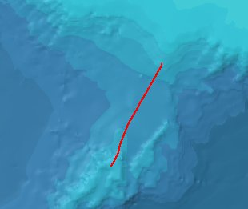

Fig. 1. Location of seismic line 3. Lomonosov Ridge is in the lower part of the figure.

Profile3-100Hz-16-70-100.tif

Fig. 4

Fig. 3

Fig. 2. Seismic profile 3 filtered around 100 Hz.

A setting focused around 150 Hz brings out the smooth even layering along the first part of the profile with a high resolution (Fig. 3). This filter setting does not permit penetration to deep bedrock reflectors as those below the Lomonosov Ridge.

The slope sediments in this part are in general evenly bedded, slowly decreasing in thickness downwards along the slope. The second unit below the seafloor in the upper part of the slope forms a soft bulge, increasing in thickness from c. 20 to c. 30 meters. Further downwards the

Line3-1_150Hz-16-50.tif

Fig. 3. The continental slope off the Sibirian Shelf, filtered around 150 Hz. For location see Fig. 2.

slope the unit thins out and finally disappears. All remaining units persist with decreasing thicknesses to the base of the Lomonosov Ridge. The sediment sequence on the Lomonosov Ridge contains only faint seismic reflectors, which may indicate smaller acoustic impedances in the sequence as compared to the slope sediments in the first part of the profile, i.e. more homogeneous sediments. Filtering around 200 Hz shows the layering, which in general parallells the shape of the Ridge (Fig. 4a). Filtering around 75 Hz is optimal to show the bedrock surface below the sediment squence (Fig. 4b). The thickness of the sediments ontop of the Creataceous (?) bedrock are calculated to exceed c. 1000 m. The bedrock surface is partly dislocated by faulting.

Line3-5_200Hz-16.tif

Fig. 4a. The Lomonosov Ridge part of seismic line 3, filtered around 200 Hz. The seafloor on the central ridge is marked by ice scouring. For location see Fig. 2.

Line3-5_75Hz-Edit.tif

Fig. 4b. The Lomonosov Ridge part of seismic line 3, filtered around 75 Hz. The location of the Cretaceous (?) bedrock surface is indicated (A) at depths of down to c. 1000 m below the seafloor. For location, see Fig. 2.