..Packet Size 2048 Bytes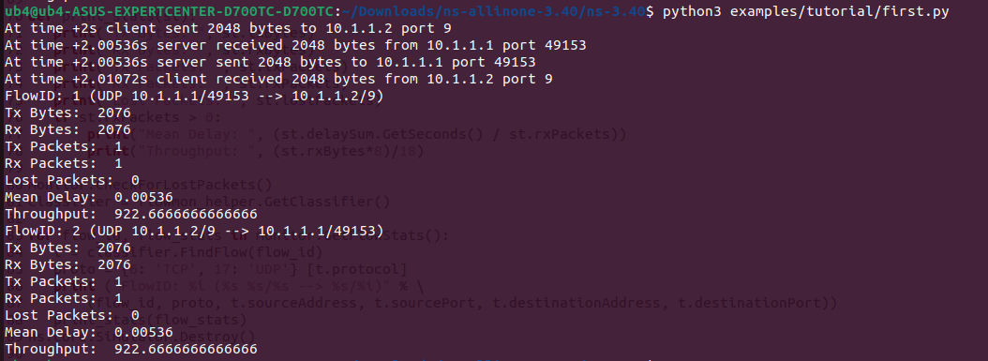..Packet Size 1024 Bytes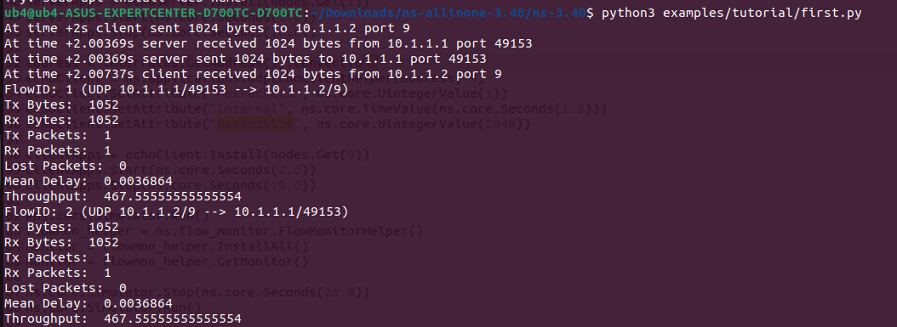..Packet Size 512 Bytes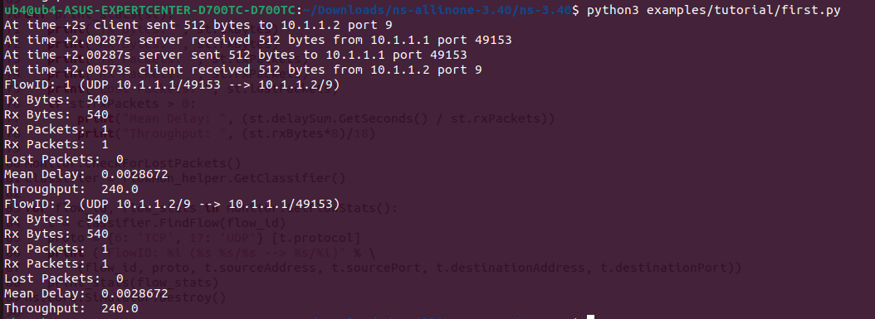

..Packet Size 256 Bytes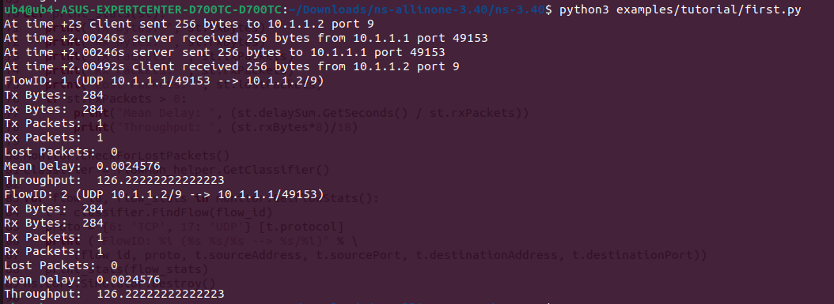..Packet Size 128 Bytes

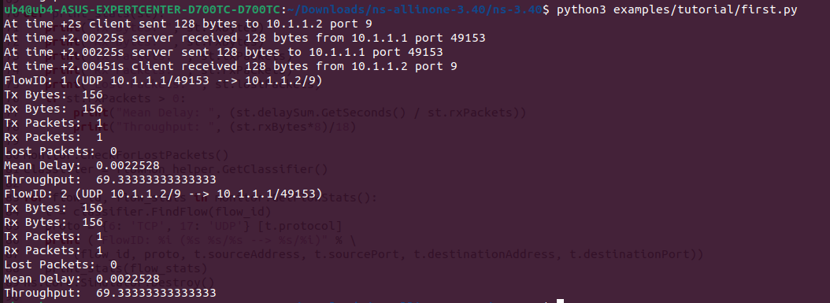

.Graph Packet Size vs Throughput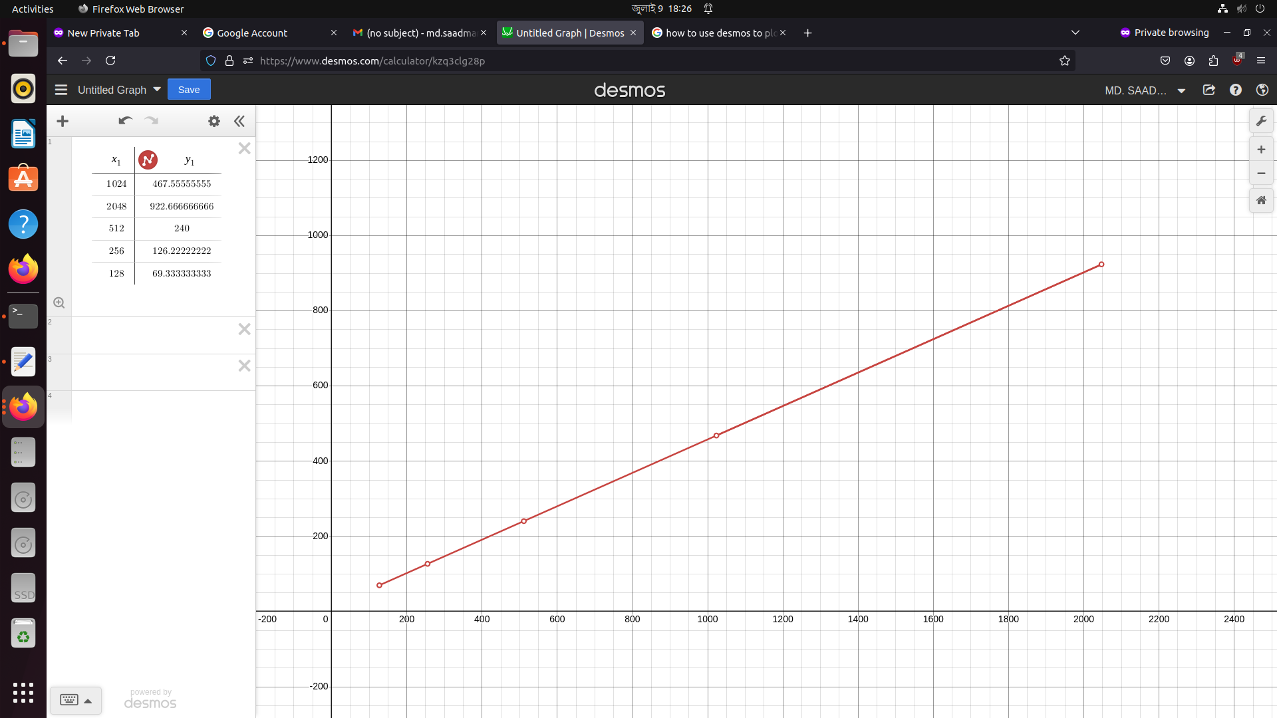

From the graph we can clearly see that, Throughput increases as we increase packet size. As we kept packet Size on the x axis and throughput on the y axis, after plotting the values we found a straight line which indicates that as we increase our packet size, throughput also increases.