Request Packet

.This is the data link layer header where we can see the arrival time of messege.

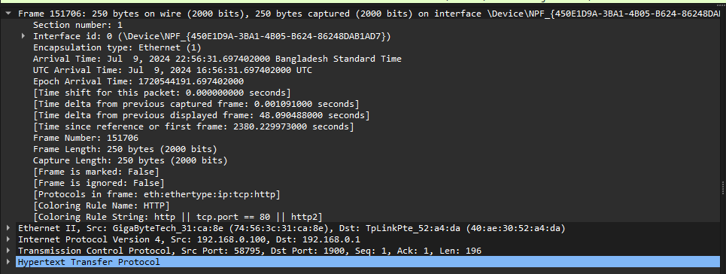

.This is the Data Link Layer Header. Here we can find the MAC address of source and destination.

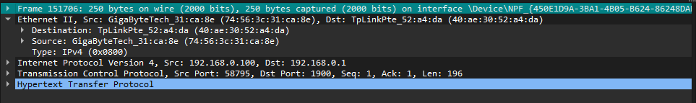

.This is the Network Layer header where we can see the source IP address and the Destination IP Address.

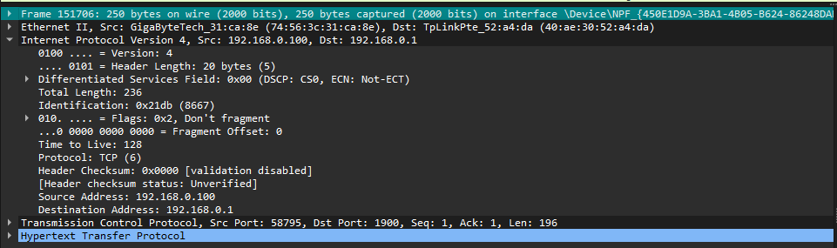

.This is the Transport layer header where we can find the Source Port, Destination Port and the acknowledgement flags.

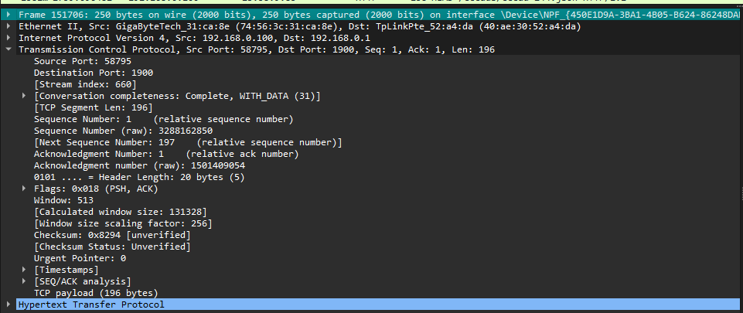

.This is the Application Layer Header , here we can see the request methods, http version etc.

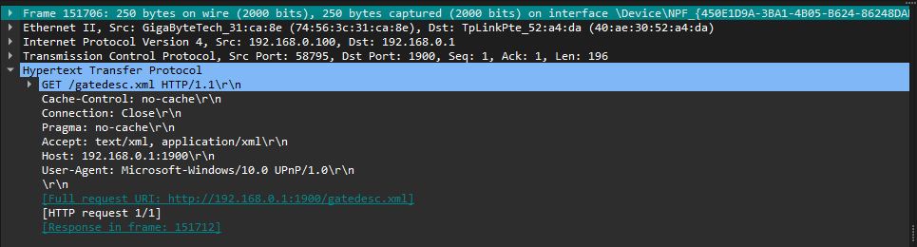

Response packet

..This is the data link layer header where we can see the arrival time of messege.

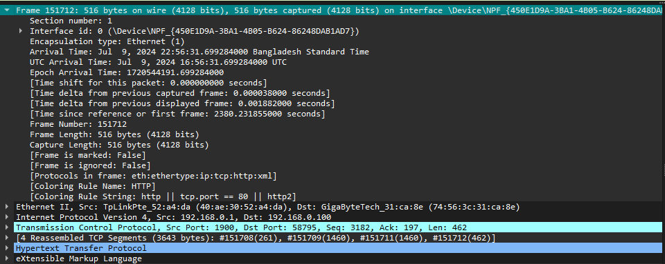

..This is the Data Link Layer Header. Here we can find the MAC address of source and destination.

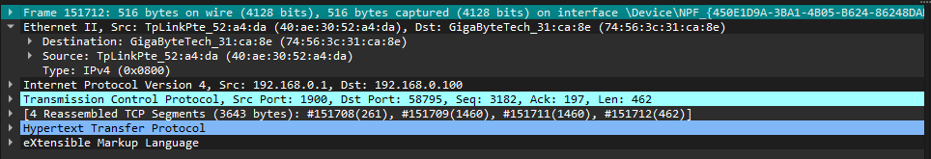

..This is the Network Layer header where we can see the source IP address and the Destination IP Address.

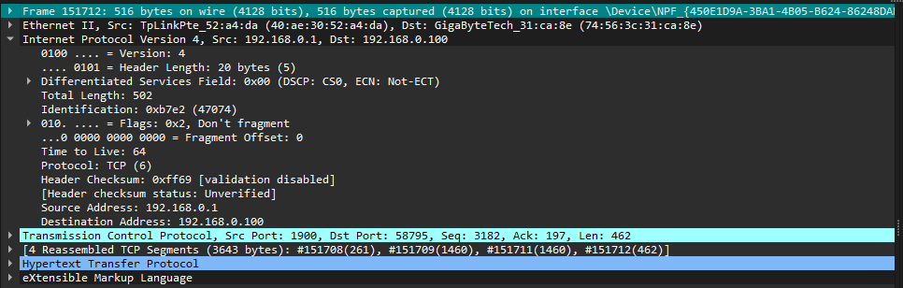

.

.This is the Transport layer header where we can find the Source Port, Destination Port and the acknowledgement flags.

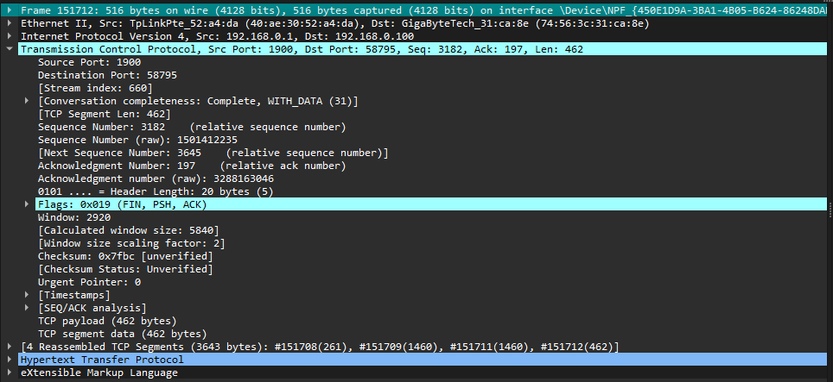

..This is the Application Layer Header , here we can see the response methods, http version , 200 ok messege etc.

