Project Report



Course title: Software Engineering Lab
Course code: CSE-3206
Session: July - December 2026
Date of Submission: 5 November 2026

Submitted to-
Rumana Yasmin
Department of Computer Science and Engineering
Bangladesh University of Professionals
Tanjim Taharat Aurpa
Department of Data Science and Engineering
Gazipur Digital University

Submitted by:
Team Members | ID | Name
01 | 24524203120 | Md. Tanjid Hossain Emon
02 | 24524203034 | MD. Nahidul Islam Shihab
03 | 24524203088 | Kawser Jahan Kafi
04 | 24524203132 | Nayeem Asfat

Department of Computer Science and Engineering
Bangladesh University of Professionals
Mirpur Cantonment, Dhaka-1216

Contents

1. Abstract and project overview

1.1 Project profile

2. Problem statement, objectives, scope, and stakeholders

2.1 Problem statement

2.2 Objectives

2.3 Scope

2.4 Stakeholders

3. Software engineering process and requirements

3.1 Development lifecycle

3.2 Functional requirements

3.3 Non-functional requirements

4. Feasibility and technology stack

4.1 Feasibility summary

4.2 Technology inventory

5. System analysis and design diagrams

5.1 System context and data flow (Level 0)

5.2 Logical component architecture

5.3 Actor–use-case view

5.4 Learning and completion activity

5.5 Quiz submission sequence

5.6 UML class diagram

6. Database and data design

6.1 ER diagram

6.2 Entity inventory

6.3 Integrity and persistence notes

7. Functional modules and interfaces

7.1 Important business rules

8. Function-wise test case catalogue

8.1 Application and public/auth/account routes

8.2 Administrator routes

8.3 Instructor routes

8.4 Student routes

8.5 Shared utility and business-logic functions

8.6 Test case design

9. Test execution evidence and coverage

9.1 Coverage interpretation

10. Non-functional requirements, security, and limitations

11. Deployment, maintenance, and future work

11.1 Local operation

11.2 Production checklist

11.3 Future enhancements

12. Conclusion

Individual Contributions

References

1. Abstract and project overview
EduVerse is a full-stack Learning Management System (LMS) that brings learners, instructors, and administrators into one web application. Students can browse and enroll in published courses, watch lessons, take quizzes, submit assignments, follow their progress, and download a completion certificate. Instructors create and manage courses, lessons, quizzes, and assignments and review student submissions. Administrators moderate courses and accounts and export platform reports.
The application is implemented with Node.js and Express, server-rendered EJS views, and a relational database. SQLite is the local-development and test provider; a MySQL provider is available for production configuration. The report presents the requirements, design, data model, core processes, and a function-wise test plan. The current automated suite was run for this report: 14 tests passed and none failed. That result applies only to the tests currently present, not to every proposed test in the catalogue.

1.1 Project profile
Attribute | Project detail
Application domain | Online learning / education technology
Primary users | Student, instructor, administrator
Architecture | Express web application with EJS presentation, route modules, services/utilities, and SQL persistence
Local runtime | Node.js (package requirement: version 20 or newer); SQLite
Production path | MySQL 8+ configuration and MySQL-backed sessions
Test framework | Node.js built-in test runner (node:test)

2. Problem statement, objectives, scope, and stakeholders

2.1 Problem statement
Learning activities are often fragmented across separate course pages, assessment tools, and manual tracking. EduVerse provides a single role-aware workflow to publish learning content, register learner activity, assess outcomes, review assignments, and recognize completion.

2.2 Objectives
• Provide distinct, authenticated experiences for students, instructors, and administrators.
• Support course discovery, enrollment, structured lessons, quizzes, assignment submission, grading, and progress visibility.
• Apply access control, password hashing, CSRF checks, upload validation, and session protections to key workflows.
• Maintain a modular codebase with repeatable automated tests and local setup.

2.3 Scope
Included: registration/login/logout; account settings; public course catalogue and detail pages; instructor course and learning-content management; learner enrollment, lesson video access, watch tracking, quizzes, assignments, progress, and PDF certificates; administrator moderation, diagnostics, and CSV reporting.
Not included as a verified capability: a cloud deployment, production-scale load capacity, measured page-load or uptime targets, malware scanning/quarantine, formal accessibility certification, and a live MySQL integration in this workspace. Arbitrary document-library management is outside the current feature set.

2.4 Stakeholders
Stakeholder | Needs / responsibilities
Student | Discover courses; learn, assess, submit work, monitor completion, and retrieve certificates.
Instructor | Author courses and learning materials; assess performance; grade submissions.
Administrator | Manage users and course approval; observe platform summary and export reports.
Platform operator | Configure secrets, database, TLS, backups, storage, monitoring, and recovery.
Development / QA team | Maintain modules, validate requirements, run automated tests, and review changes.

3. Software engineering process and requirements

3.1 Development lifecycle
A practical iterative lifecycle fits this project:
(1) elicit role-based functional and non-functional requirements;
(2) model use cases, data, and request flows;
(3) implement a small Express/EJS/database module;
(4) validate with unit and HTTP integration tests;
(5) review test evidence and known gaps; and
(6) deploy only after environment-specific operational checks. The repository includes a Node test command and a GitHub Actions workflow that installs dependencies, runs tests, and audits production dependencies.

3.2 Functional requirements
ID | Requirement | Primary actor
FR-01 | Register an account and securely authenticate; support logout and session-based role access. | Guest / all roles
FR-02 | Manage profile details and optionally change a password after current-password verification. | Authenticated user
FR-03 | Browse, search, filter, inspect, and enroll in published courses. | Guest / student
FR-04 | Access course lessons and supported video sources; record that a lesson video was watched. | Student
FR-05 | Create and take multiple-choice quizzes; automatically calculate scores and retain attempts. | Instructor / student
FR-06 | Create assignments, upload supported student files, and grade submissions with feedback. | Instructor / student
FR-07 | Create, edit, publish/unpublish, and delete courses and learning content. | Instructor
FR-08 | Show course progress; passing a lesson quiz requires at least 40% and can be retaken if failed. | Student
FR-09 | Issue a downloadable PDF certificate after all course lessons are complete. | Student
FR-10 | Manage accounts/courses, approve or reject courses, inspect diagnostics, and export a CSV report. | Administrator

3.3 Non-functional requirements
Quality attribute | Implemented evidence | Verification still needed
Security | bcrypt password hashes, role guards, session ID regeneration on login, CSRF checks, hardened cookies in production, security headers, login throttling, upload signature checks. | Independent security testing; HTTPS/TLS configuration; shared rate-limit storage for multiple instances; malware scanning.
Reliability | Relational constraints; transactional quiz completion; local SQLite backup utility retaining seven newest files. | Production restore drills, off-host/managed MySQL backups, failure recovery tests.
Performance / scale | MySQL pool and async query adapter exist. | Sub-3-second page-load and 10,000-concurrent-user goals are not measured or established.
Availability | Runtime health endpoint and admin diagnostics exist. | No 99% uptime SLA or monitoring evidence; redundancy and alerting remain deployment work.
Usability / accessibility | Responsive CSS and server-rendered pages. | Cross-device/browser review and a formal accessibility audit remain outstanding.
Maintainability | Separated route, middleware, utility, database, view, and test files; CI workflow. | Add operator runbook and broaden endpoint-level regression coverage.

4. Feasibility and technology stack

4.1 Feasibility summary
Area | Assessment
Technical | Feasible as a Node.js/Express web application. SQLite supports local setup; a MySQL adapter supports the production database path.
Operational | Local run is self-contained after npm install. Production requires secrets, database, HTTPS termination, upload/video storage, monitoring, and backup policy.
Economic | Uses open-source Node.js packages and a locally runnable stack; hosting and managed services depend on deployment choices.
Schedule / delivery | Feature modules are organized by role and can be tested incrementally. Production readiness cannot be inferred from local tests alone.

4.2 Technology inventory
Layer | Technology / responsibility
Runtime / web | Node.js, Express 4; route modules handle HTTP workflows.
Presentation | EJS templates, CSS, and a small browser-side theme script.
Persistence | better-sqlite3 for local/test; mysql2-based async provider and MySQL schema for configured production.
Authentication | express-session with SQLite session storage locally and a MySQL session store when configured; bcryptjs for password hashing.
File handling | multer upload handling, upload-signature validation, filesystem storage for lessons/assignments.
PDF | pdfkit streams completion certificates.
Testing / CI | node:test, Node fetch-based HTTP integration tests, GitHub Actions workflow.

5. System analysis and design diagrams
This section combines editable tabular models with UML diagrams to show the system context, components, roles, learning flow, request sequence, and core domain entities.

5.1 System context and data flow (Level 0)
External actor | Web client | EduVerse application | Persistence / files
Student | Browser ↔ | Public + student routes; auth, progress, assessment | Relational DB; session store; lesson/assignment files
Instructor | Browser ↔ | Instructor routes; course authoring and grading | Relational DB; lesson video storage
Administrator | Browser ↔ | Admin routes; moderation and CSV reports | Relational DB; runtime process metrics
Figure 1. External actors exchange requests/responses with EduVerse; application data, sessions, and uploaded files are stored in separate logical stores.

5.2 Logical component architecture
Client / assets | HTTP / session boundary | Role routes | Shared logic | Data / output
Browser EJS-rendered pages CSS / JS | Express middleware CSRF / sessions health / 404 / errors | public student instructor admin account / auth | requireAuth / requireRole async-router certificate / uploads rate limit / backup | SQLite (local/test) MySQL (configured prod) PDF / CSV / files
Figure 2. Request path and separation of concerns in the Express application.

5.3 Actor–use-case view
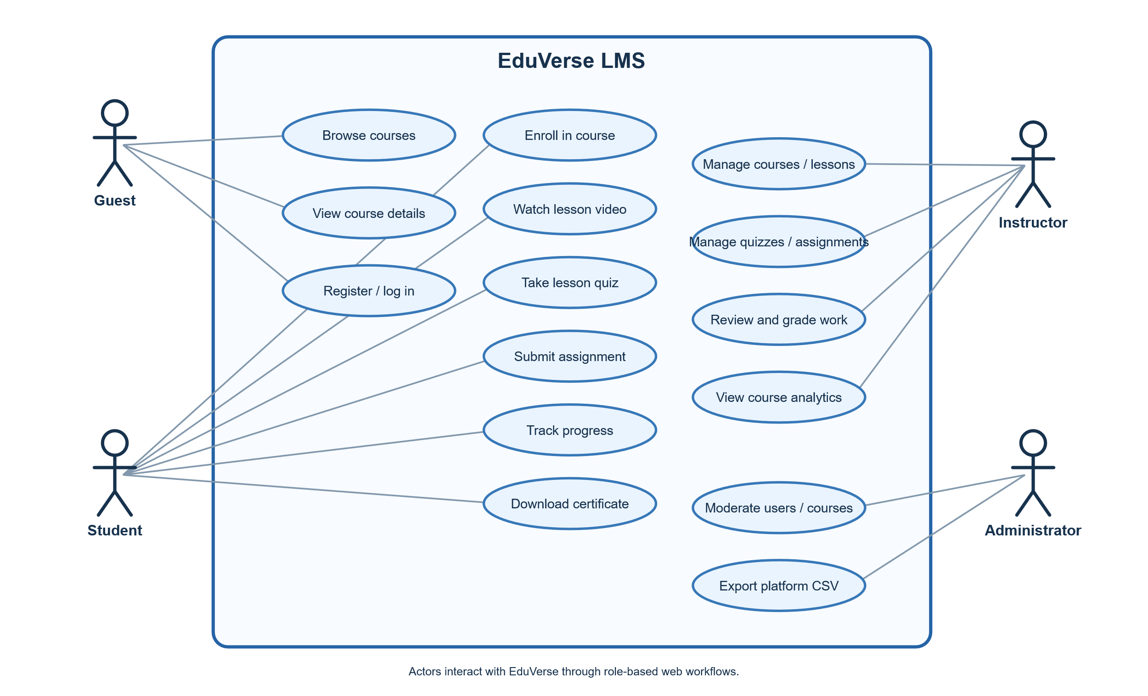
Figure 3. UML use-case diagram of EduVerse roles and system capabilities.
Actor | EduVerse system boundary — use cases
Guest | Browse landing page and published catalogue; inspect course details; register or log in.
Student | Enroll → view lessons/video → take quizzes → submit assignment → review progress → download certificate; manage account.
Instructor | Create/edit course → add lesson/quiz/assignment → publish/unpublish → inspect analytics → grade/download submissions.
Administrator | View dashboard/diagnostics → filter users/courses → suspend/delete users → approve/reject/delete courses → export CSV.
Table 1. Summary of principal role interactions with the system boundary.

5.4 Learning and completion activity
1. Discover | 2. Enroll | 3. Watch lesson | 4. Take quiz | 5. Evaluate / continue
Browse published course | Create enrollment | Watch video; watch marker unlocks lesson quiz | Answer every question; system stores score | Below 40%: retake; 40% or higher: lesson completes; all lessons complete: certificate becomes available
Figure 4. Student activity flow. A failed quiz may be retaken; completion is based on all lessons.

5.5 Quiz submission sequence
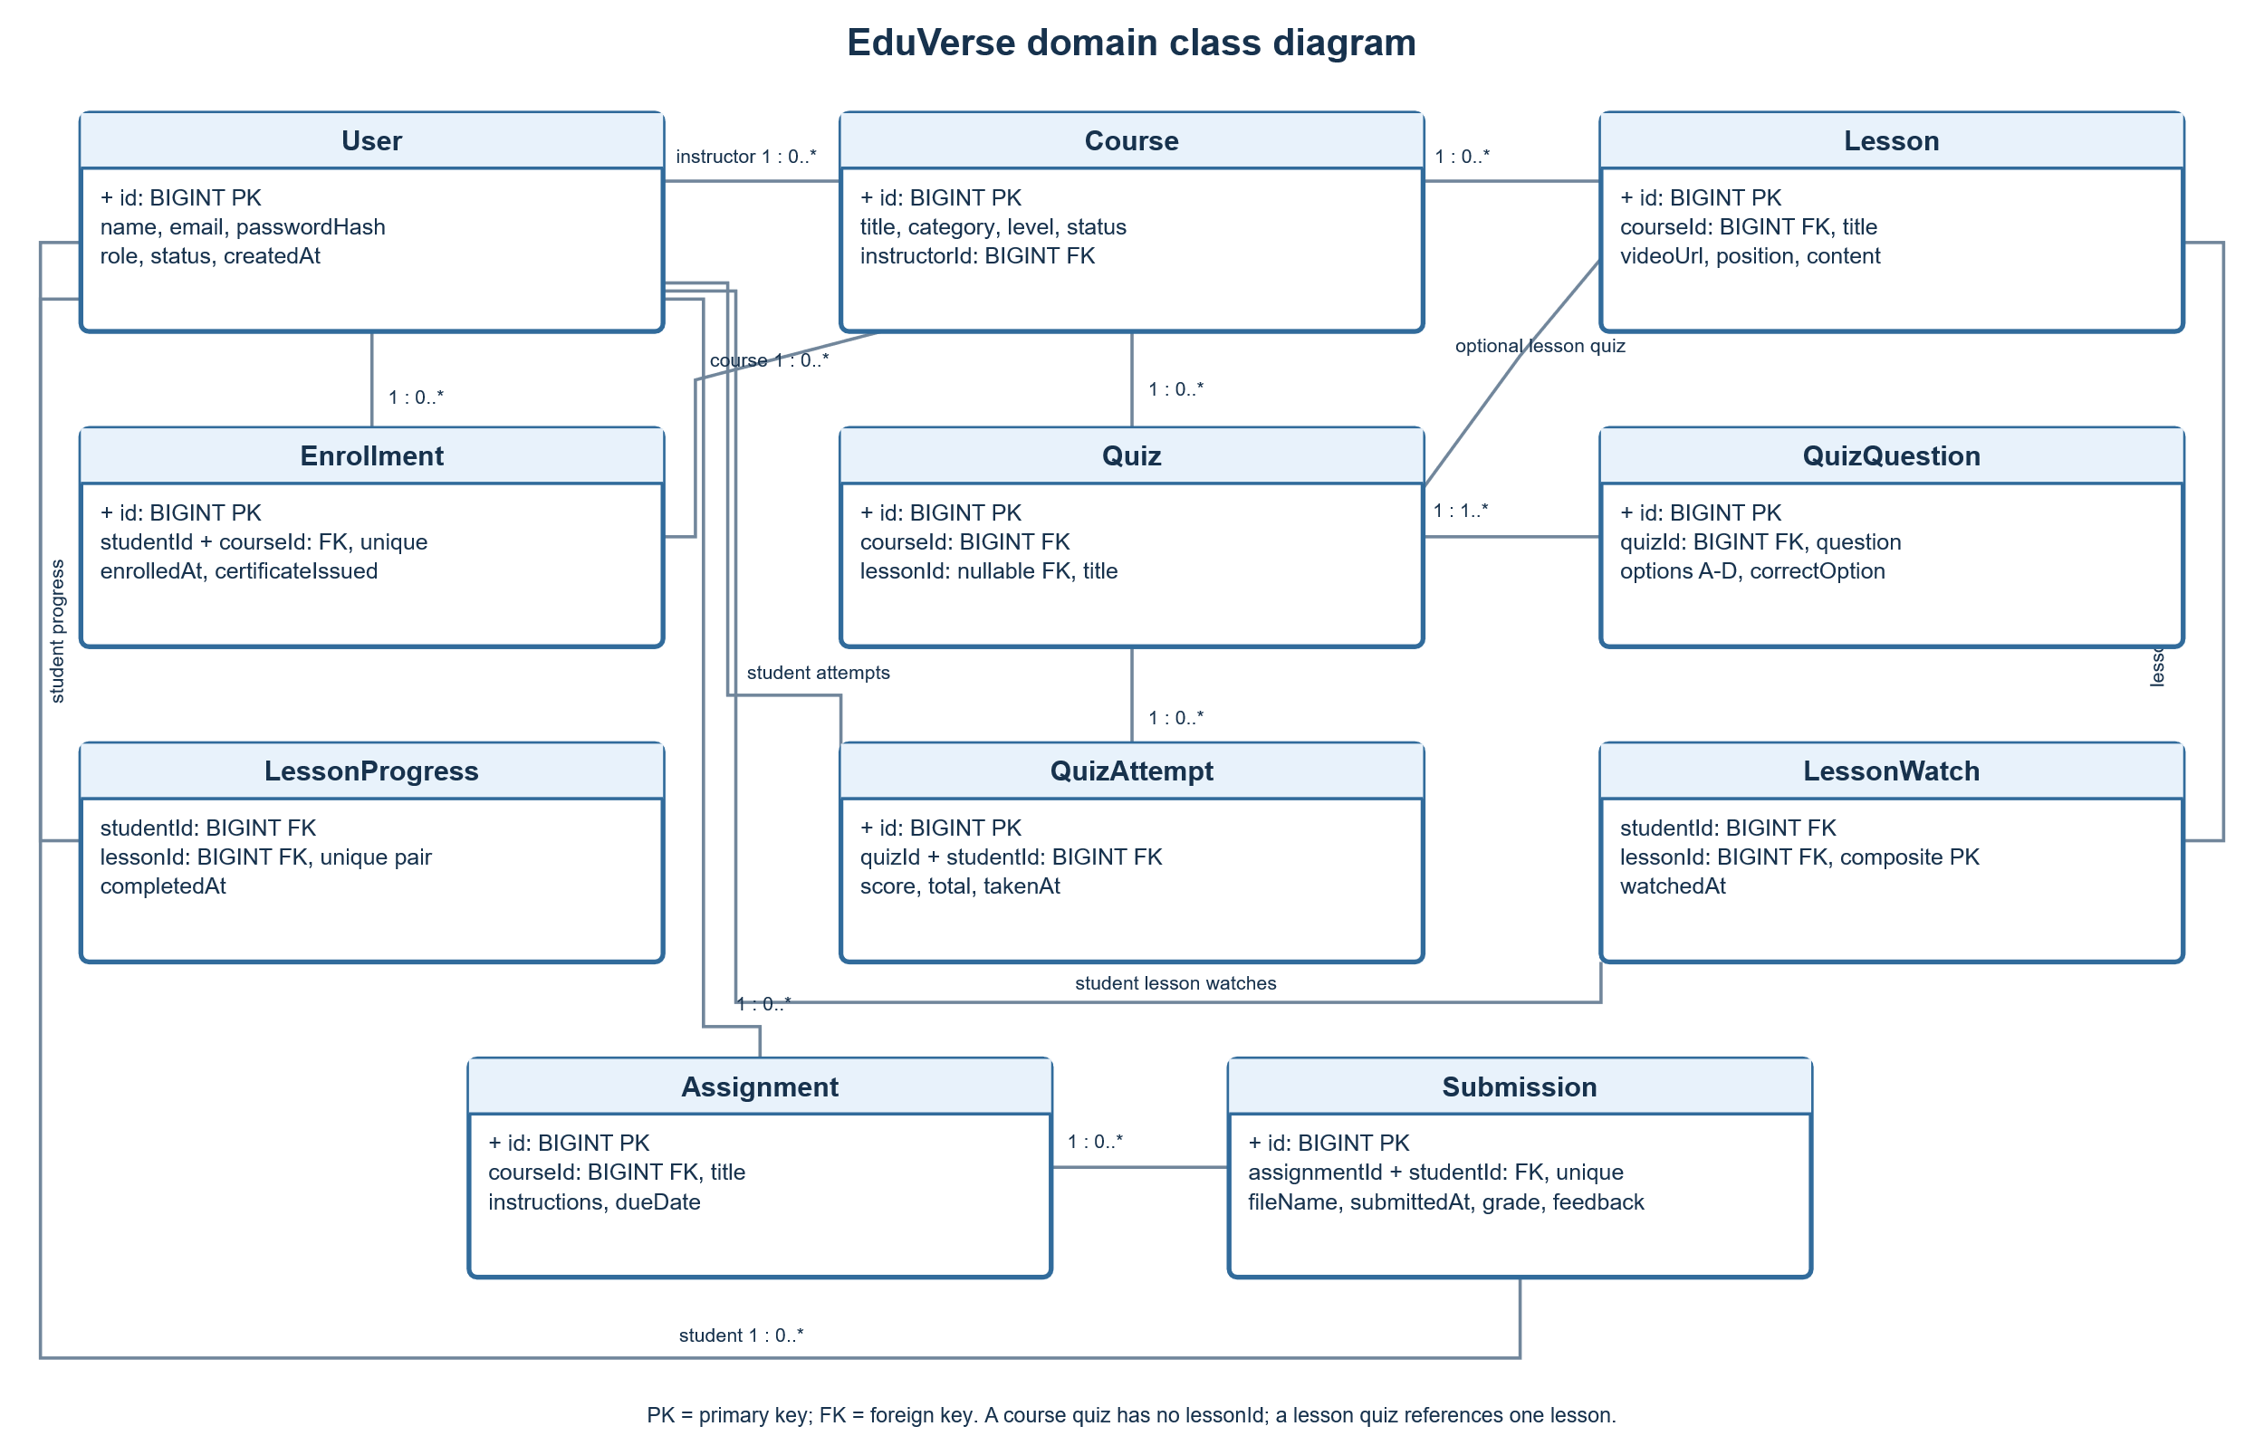
Figure 5. UML sequence diagram for lesson gating, quiz scoring, and certificate delivery.
Student / browser | Express route | Database | Outcome
GET course page | Load course, progress, quizzes | Read enrollment, lesson, quiz, attempt rows | Render learning page
POST lesson watched | Check student ownership/enrollment and video presence | Insert lesson_watches (idempotently) | Redirect to course
GET quiz | Check enrollment, watch marker, question threshold | Read quiz/questions/latest attempt | Render quiz or reject/redirect
POST quiz answers | Validate all choices; score and compare with 40% | Insert attempt; on pass insert progress; on 100% issue certificate flag | Redirect with latest result shown
Table 2. Request/response summary; lesson quizzes require enrollment, watched-video state, and at least 20 questions.

5.6 UML class diagram
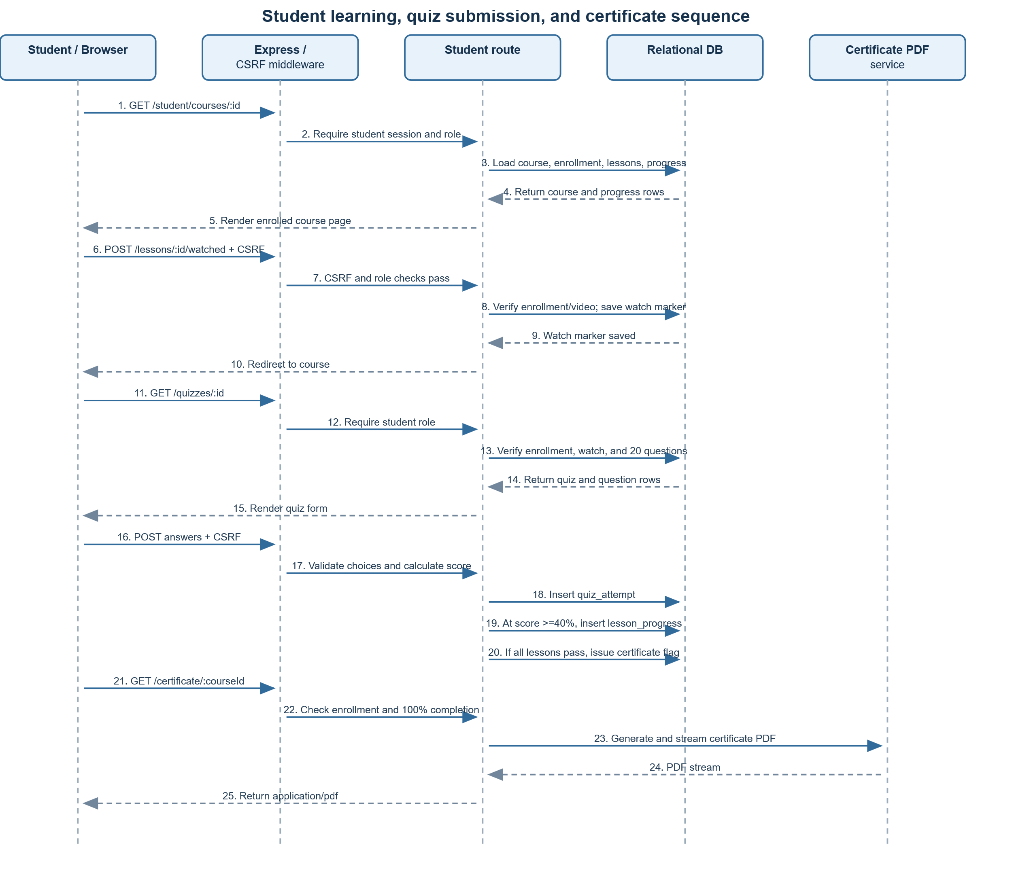
Figure 6. UML class diagram of the principal EduVerse data entities and relationships.

6. Database and data design

6.1 ER diagram
Identity / teaching | Course structure | Assessment | Learner activity
USERS PK id; role/status 1 instructor → many courses | COURSES PK id; FK instructor_id 1 course → many lessons | QUIZZES FK course_id; optional lesson_id 1 quiz → many questions | ENROLLMENTS FK student_id + course_id unique student/course
USERS 1 → N ENROLLMENTS USERS 1 → N QUIZ_ATTEMPTS | LESSONS FK course_id; position 1 lesson → quiz / progress | QUIZ_QUESTIONS FK quiz_id; correct option QUIZ_ATTEMPTS FK quiz_id + student_id | LESSON_WATCHES student_id + lesson_id key LESSON_PROGRESS unique student/lesson
ASSIGNMENTS FK course_id 1 assignment → submissions | SESSIONS sid, expiry, session data store varies by environment | SUBMISSIONS FK assignment_id + student_id unique assignment/student | CERTIFICATE_ISSUED stored on enrollment PDF generated on request
Figure 7. Entity relationship summary inferred from the SQLite/MySQL schemas. Foreign-key deletion cascades are configured for dependent records.

6.2 Entity inventory
Entity/table | Purpose / key relationships
users | Accounts, role, status, password hash; instructor owns courses; student identity is referenced by learning records.
courses | Course metadata/status; FK instructor_id → users.id.
lessons | Ordered course content and video URL; FK course_id → courses.id.
enrollments | Student/course association; unique pair; certificate_issued flag.
lesson_watches / lesson_progress | Per-student lesson watch marker and passed/completed record; each pair is unique.
quizzes / quiz_questions / quiz_attempts | Course or lesson quiz, four-option question bank, correct answer, source, and student score history.
assignments / submissions | Course task and student file/grade/feedback; one submission per student/assignment.
sessions | Persistent session data in MySQL schema; local session persistence uses SQLite store configuration.

6.3 Integrity and persistence notes
The database uses primary keys, foreign keys, unique constraints, role/status restrictions (SQLite checks and MySQL enums), and cascades for dependent rows. Local tests use an isolated temporary SQLite database. Production MySQL connectivity and data migration are implemented but require an actual configured MySQL service for integration verification.

7. Functional modules and interfaces
Module | Key responsibilities
Authentication / account | Registration, login/logout, role identity, profile update, optional password change, session renewal, login throttling.
Public catalogue | Landing page metrics, published-course search/category filter, detail and lessons preview.
Student learning | Enrollment, course dashboard, lesson video access, watch tracking, quiz scoring/retakes, assignment submission, progress, certificates.
Instructor workspace | Course CRUD and publication, lesson/video upload, per-lesson sample quiz creation, course quiz/question editing, assignment CRUD, performance analytics, grading and downloads.
Administrator workspace | Platform/runtime summary, account filtering and status changes, course moderation, CSV reporting.
Shared infrastructure | Role/auth middleware, async error forwarding, SQL adapters, upload signature validation, certificate streaming, SQLite backup scheduling.

7.1 Important business rules
• Public discovery exposes only published courses; a newly created instructor course starts pending.
• A student must enroll to access course lessons and assessments. Per-lesson quiz access requires the lesson video to be marked watched (or already completed).
• Lesson quizzes require at least 20 questions; a passing score is 40% or more. A lower score does not complete the lesson and can be retaken.
• Course progress is the percentage of lessons with completion records. An empty course has 0% progress. Certificate download is allowed only at 100%.
• Assignment upload size is capped at 15 MB and allowed formats are checked by extension/MIME and file signature; late submissions are rejected when a due date has passed.
• Instructor lesson video uploads are limited to MP4 and 500 MB; accepted video content is checked by signature. Upload validation is not a malware scanner.

8. Function-wise test case catalogue
Each route below is a testable application function. Expected results describe the intended behavior visible in the current implementation. “Covered” means exercised by the current automated tests run for this report; “Partial/indirect” means only a related path is exercised; “Planned” means no direct automated evidence was found in the current test suite. Execute the planned cases before claiming full regression coverage.

8.1 Application and public/auth/account routes
ID | Function / route | Test input / scenario | Expected result | Existing evidence
RT-01 | GET /healthz | Request health check with database available. | 200 JSON {status: ok}; security headers present. | Covered
RT-02 | GET /dashboard | Request while signed out, then as each role. | Guest redirects to login; signed-in user goes to role dashboard. | Planned
RT-03 | GET / | Open landing page with published and pending courses in DB. | Render featured published courses and platform counts; pending course excluded. | Planned
RT-04 | GET /courses?q=&category= | Search by title/description and select category. | Only published courses match; empty filters show full published catalogue. | Planned
RT-05 | GET /courses/:id | Open a published course, then nonexistent/pending course. | Published detail renders; unavailable course returns 404. | Planned
RT-06 | GET /register | Guest opens registration; authenticated user opens same URL. | Guest sees form; authenticated user is redirected to own dashboard. | Partial/indirect
RT-07 | POST /register | Submit valid, duplicate-email, mismatched, invalid-email, and boundary-length fields. | Valid student/instructor is stored with bcrypt hash and session; invalid data is rejected. | Planned
RT-08 | GET /login | Open login as guest and as authenticated user. | Guest sees form with CSRF token; signed-in user is redirected. | Partial/indirect
RT-09 | POST /login | Try valid, wrong, suspended-account, and repeated failed credentials. | Valid login rotates session and redirects; invalid/suspended login is rejected; limit returns 429. | Covered / partial
RT-10 | POST /logout | Logout with a valid session. | Session is destroyed, cookie cleared, and browser redirects to home. | Planned
RT-11 | GET /account | Request without session and with an authenticated session. | Guest redirected to login; user sees own profile without password hash. | Partial/indirect
RT-12 | POST /account | Update profile; test duplicate email, bad current password, mismatched/short new password. | Valid fields persist; invalid requests return validation error; password is re-hashed. | Partial

8.2 Administrator routes
ID | Function / route | Test input / scenario | Expected result | Existing evidence
RT-13 | GET /admin/dashboard | Open as admin, student, and guest. | Admin sees counts/runtime metrics; other roles are denied or redirected. | Covered (admin); denial partial
RT-14 | GET /admin/reports.csv | Export as admin; attempt as student; include a course title beginning with =. | Admin downloads UTF-8 CSV with expected metrics and formula-safe cell; student gets 403. | Covered
RT-15 | GET /admin/users | List all users and filter student/instructor/admin/invalid role. | Role filter returns matching users; invalid filter safely falls back to all. | Planned
RT-16 | POST /admin/users/:id/suspend | Toggle another active/suspended user; target self and missing ID. | Target status toggles; self-action is rejected; missing user returns 404. | Planned
RT-17 | POST /admin/users/:id/delete | Delete another user; attempt self-delete and missing ID. | User and dependent records are removed by FK cascade; self-delete is rejected. | Planned
RT-18 | GET /admin/courses | Filter by pending/published/rejected and invalid status. | Correct status set is displayed; invalid filter shows all. | Planned
RT-19 | POST /admin/courses/:id/approve | Approve a pending course, then browse it publicly. | Course status becomes published and public detail becomes available. | Planned
RT-20 | POST /admin/courses/:id/reject | Reject a pending course. | Course status becomes rejected and it is not publicly listed. | Planned
RT-21 | POST /admin/courses/:id/delete | Delete a course with dependent lesson/enrollment rows. | Course is removed and dependent relational rows cascade. | Planned

8.3 Instructor routes
ID | Function / route | Test input / scenario | Expected result | Existing evidence
RT-22 | GET /instructor/dashboard | Instructor with courses, enrollments, and pending work opens dashboard. | Only own-course counts and summaries are shown. | Partial/indirect
RT-23 | GET /instructor/courses/new | Open new-course form as instructor and as another role. | Instructor form renders; other roles are blocked. | Planned
RT-24 | POST /instructor/courses | Create with title and defaults; submit blank title. | Valid course created as pending and owned by session instructor; blank title rejected. | Planned
RT-25 | GET /instructor/courses/:id/edit | Owner opens edit; other instructor opens someone else course. | Owner sees form; non-owner receives not-found response. | Planned
RT-26 | POST /instructor/courses/:id/edit | Change title/metadata; submit blank title; attempt non-owned course. | Owned course is updated; invalid or non-owned edit is rejected. | Planned
RT-27 | POST /instructor/courses/:id/publish | Publish course with no lesson and with one lesson. | No-lesson course is blocked; course with lesson becomes published. | Planned
RT-28 | POST /instructor/courses/:id/unpublish | Unpublish an owned course. | Status returns to pending and public catalogue hides it. | Planned
RT-29 | POST /instructor/courses/:id/delete | Delete owned course; try non-owned course. | Owned course is deleted; non-owner cannot delete. | Planned
RT-30 | GET /instructor/courses/:id | Owner opens course; inspect analytics; non-owner tries. | Manage page lists lessons/quizzes/assignments/submissions and course metrics; ownership enforced. | Covered (analytics); ownership partial
RT-31 | POST /instructor/courses/:id/lessons | Upload valid MP4; forged MP4; invalid URL; missing title; both upload and URL. | Valid lesson and quiz/question bank are created; invalid inputs are rejected and temporary upload cleaned. | Covered (valid/forged/signature)
RT-32 | POST /instructor/lessons/:lessonId/delete | Delete owned lesson, missing lesson, and lesson owned by another instructor. | Owned lesson removed; missing returns 404; non-owner denied. | Planned
RT-33 | POST /instructor/courses/:id/quiz | Create course-level quiz twice. | One course-level quiz is created; second request does not duplicate it. | Planned
RT-34 | POST /instructor/quizzes/:quizId/questions | Add complete question; omit option; attempt quiz from another course. | Valid question saved; incomplete input does not save; ownership is enforced. | Planned
RT-35 | POST /instructor/questions/:questionId/delete | Delete question owned by instructor and try another instructor question. | Owned question deleted; missing/unauthorized case returns appropriate error. | Planned
RT-36 | POST /instructor/courses/:id/assignments | Add valid title/instructions/deadline; submit blank title. | Assignment stored with optional due date; blank title creates no assignment. | Planned
RT-37 | POST /instructor/assignments/:assignmentId/delete | Delete owned assignment and try non-owned assignment. | Owned assignment and dependent submissions are removed; non-owner is denied. | Planned
RT-38 | POST /instructor/submissions/:submissionId/grade | Submit grade below 0, within range, above 100, blank; attempt non-owned submission. | Grade is clamped to 0–100 (blank clears); feedback saved; ownership checked. | Planned
RT-39 | GET /instructor/submissions/:submissionId/download | Owner downloads a submission; non-owner and missing-file cases. | Correct original filename is downloaded; unauthorized request is denied; missing file is surfaced. | Planned

8.4 Student routes
ID | Function / route | Test input / scenario | Expected result | Existing evidence
RT-40 | GET /student/lessons/:lessonId/video | Enrolled/non-enrolled student; local/upload/missing video; request byte range. | Enrollment required; valid MP4 streams with range support; missing/unsupported/path-escape file is rejected. | Covered (enrolled range)
RT-41 | GET /student/dashboard | Student with enrolled courses, attempts, and partial/completed lessons. | Dashboard reports correct progress, counts, and latest quiz attempt. | Covered (latest score view)
RT-42 | POST /student/courses/:id/enroll | Enroll in published course twice; enroll in pending/nonexistent course. | One enrollment only; published course opens; unavailable course returns 404. | Partial (fixture pre-enrolled)
RT-43 | GET /student/courses/:id | Open enrolled course; then non-enrolled course. | Enrolled user sees ordered lessons, quiz states, assignments, and progress; other user is redirected to public detail. | Covered
RT-44 | POST /student/lessons/:lessonId/watched | Mark a video lesson watched twice; try non-enrolled/no-video/missing lesson. | Watch row is idempotent; quiz unlock condition is set; invalid access is rejected. | Covered (watch-to-quiz)
RT-45 | GET /student/quizzes/:quizId | Check enrolled status, watched marker, quiz with <20 lesson questions, course-level quiz. | Lesson quiz is gated until watched and 20 questions exist; course quiz is accessible to enrolled student. | Covered (lock and ready)
RT-46 | POST /student/quizzes/:quizId/submit | Submit missing/invalid answers, failing score, exactly 40%, passing score, and retake. | All answers required; score/attempt saved; ≥40% completes lesson; failure can be retaken; 100% course updates certificate flag. | Covered (score, retake, 40%)
RT-47 | POST /student/assignments/:assignmentId/submit | Upload valid file, forged signature, unsupported/oversize file, late assignment, and replacement. | Enrolled and on-time supported file accepted; invalid/late blocked; replacement updates one submission and resets grade. | Covered (deadline/signatures; partial)
RT-48 | GET /student/certificate/:courseId | Request certificate before completion, after completion, and without enrollment. | Incomplete course returns 400; complete enrolled user receives PDF and issued flag; non-enrolled request denied. | Covered (completion and PDF)

8.5 Shared utility and business-logic functions
ID | Function | Test input / scenario | Expected result | Existing evidence
UT-01 | requireAuth / requireRole / redirectIfAuthenticated | Exercise guest, matching role, wrong role, and authenticated user on guest-only page. | Guest returns to login with return target; wrong role gets 403; matching role continues; authenticated guest-page request redirects. | Partial / planned
UT-02 | createAsyncRouter / error middleware | Reject an async route promise and trigger Multer size/type error. | Async failure reaches centralized 500 response; upload errors map to safe 400/413 message. | Planned
UT-03 | courseProgress | Course with 0 lessons, 1/2 completed, and all lessons completed; run SQLite and MySQL adapter tests. | Return 0, rounded percentage, and 100 respectively; database dialect behavior matches. | Partial (feature-flow evidence)
UT-04 | courseAnalytics | No students, no lessons, quiz attempts, and mixed course completion. | No division error; accurate average score/attempt count/completion rate. | Partial (dashboard renders)
UT-05 | Login rate-limit helpers | Record 10 failures from one IP, hit the next request, expire window, then succeed. | Requests are limited with Retry-After; expired counters clear; successful login clears state. | Covered (throttling)
UT-06 | listCcnaVideos | Temporary folder with numeric filenames, spaces, and non-MP4 file. | Natural sorting; clean titles; irrelevant files ignored. | Covered
UT-07 | createSampleQuestions / insertSampleQuestions | Generate sample bank for known topic and persist it for lesson quiz. | Twenty unique topic-labelled MCQs, four distinct options, valid answer keys; inserted source marked sample. | Covered (generator; insert partial)
UT-08 | validateUploadedFile / hasValidUploadSignature | Compare valid and forged MP4, PDF/Office/text/image, ZIP, HTML payload, and empty file. | Content signature matches declared supported format; HTML and malformed/forged data are rejected. | Covered (MP4 and assignment checks)
UT-09 | createDatabaseBackup / scheduleDatabaseBackups | Create snapshot with sample data, run retention across eight or more dated copies. | Backup remains readable and only seven newest copies are retained; scheduler logs errors. | Covered (backup/retention)
UT-10 | streamCertificate | Stream PDF for a completed course and inspect headers/PDF signature. | Valid PDF response, download filename, student/course/date/certificate ID present. | Covered (download flow)
UT-11 | MySQL SQL adapter / session store / SQLite→MySQL migration | Configure disposable MySQL, verify CRUD/transactions/session persistence and refuse non-empty migration target. | Queries normalize safely; transactions commit/rollback; session rows persist; migration preserves SQLite source. | Planned — no live MySQL configured

8.6 Test case design
Test approach: use equivalence partitioning for roles, credentials, and uploaded files; boundary-value analysis for the 20-question and 40% pass thresholds; and state-transition checks for watched lessons, quiz attempts, progress, and certificate eligibility.
Execution note: cases marked Executed are represented in the current node:test suite; Planned cases are design coverage and are not claimed as executed.
ID | Scenario / test data | Expected result | Technique / status
TC-01 | Register with valid, duplicate, malformed email and password boundary values. | Valid account is created with a password hash; invalid or duplicate input is rejected. | Equivalence + boundary; Planned
TC-02 | Guest/student requests an administrator-only page or CSV report. | Guest is redirected to login; student receives 403; admin-only data is not disclosed. | Role / negative; Partial (denial covered)
TC-03 | Enroll twice in a published course, then try a pending course. | One enrollment exists; pending/unavailable course is rejected. | State / negative; Planned
TC-04 | Open a lesson quiz before and after recording the video as watched. | Quiz is blocked before watch; enrolled student can continue after watch when ready. | State transition; Executed
TC-05 | Try a lesson quiz with 19 questions, then with exactly 20. | Below 20 is unavailable; 20-question quiz renders. | Boundary value; Executed
TC-06 | Submit 7/20 correct, retake, then submit exactly 8/20. | 35% attempt is saved without completion and can be retaken; 40% completes the lesson. | Boundary + state; Executed
TC-07 | Upload a PDF with a forged signature and an accepted file with valid signature. | Forged content is rejected and not retained; valid supported file is accepted. | Negative / file validation; Executed
TC-08 | Submit an assignment after its configured due date. | Request is rejected with a deadline message; no submission is stored. | Boundary / negative; Executed
TC-09 | Request a certificate before completion and after passing every lesson. | Before completion access is denied; at 100% a downloadable PDF is returned. | State transition; Executed
TC-10 | Admin exports CSV containing a formula-leading title; student requests same route. | Admin receives formula-safe CSV; student receives 403. | Authorization / output; Executed
TC-11 | Update profile to a duplicate email or change password with a wrong current password. | Invalid update is rejected and stored profile/password remain unchanged. | Negative / equivalence; Planned
TC-12 | Instructor publishes a course with no lessons and then with at least one lesson. | Empty course remains unpublished; course with a lesson can be published by its owner. | Precondition / role; Planned

9. Test execution evidence and coverage
Command executed from the project root: npm test (package script: node --test). Result on 5 November 2026: 14 tests passed, 0 failed, 0 skipped. The test process used temporary SQLite storage and test fixtures.
Automated test area | Evidence observed | Report test IDs
Health endpoint and response headers | HTTP 200 JSON health response; nosniff and frame-denial headers. | RT-01
CSRF protection | Invalid login CSRF token rejected before authentication. | RT-09; UT-01 boundary
Student learning and video | Enrolled course and local MP4 byte-range streaming; lesson quiz lock/unlock. | RT-40, RT-43, RT-44, RT-45
Lesson quiz outcomes | Retake after 35%; pass at exactly 40%; progress changes only after pass. | RT-45, RT-46, UT-03
Account and admin report | Profile update; student denied admin CSV; admin CSV includes formula-safe title. | RT-12, RT-13, RT-14
Instructor lesson upload and metrics | Analytics page; forged MP4 rejected and removed; valid MP4 uploaded; sample questions generated; student streams upload. | RT-30, RT-31, RT-40, UT-08
Assignment deadline and signature | Late submission rejected; accepted/rejected upload signatures and HTML rejection covered. | RT-47, UT-08
Quiz scoring and dashboard | Attempt score/total persisted and latest result shown. | RT-41, RT-46
Certificate flow | Completion issues downloadable PDF certificate. | RT-48, UT-10
Login throttle | Repeated failed login attempts limited by client address. | RT-09, UT-05
Video inventory / question generator / backup | Natural sort, 20-question sample bank structure, valid backup data and seven-copy retention. | UT-06, UT-07, UT-09

9.1 Coverage interpretation
The test run confirms 14 current test cases pass, but multiple report test IDs are proposed cases rather than separate automated tests. The route catalogue explicitly marks the gap so that planned tests are not mistaken for executed evidence. No live MySQL service was available for database integration testing.

10. Non-functional requirements, security, and limitations
Concern | Current implementation / evidence | Remaining validation or mitigation
Authentication and authorization | Session-backed identity; role guards; bcrypt hashes; session renewal on registration/login. | Add explicit route-level authorization tests and verify session behavior behind actual production proxy/TLS.
CSRF / browser hardening | CSRF token check for POST; multipart requests require same-origin Origin; common browser security headers. | Add broader negative tests across all mutating forms and verify proxy/origin configuration.
Login throttling | In-process client-address limiter: ten failures per 15-minute window; cleanup timer. | Shared store needed across app instances; consider distributed limiter and monitoring.
Uploads | MIME/extension, maximum size, and signature checks; unsupported HTML rejected. | No malware scanner/quarantine; validate storage permissions, backups, retention, and operational cleanup.
Production database | MySQL schema, pool/query adapter, and session store are implemented. | No MySQL endpoint configured; run migration/integration and rollback tests before deployment.
Performance / scalability | No deployment or benchmark evidence in this test run. | Measure representative course/catalogue/video flows; load-test to stated SRS goals and tune based on evidence.
Availability / recovery | SQLite backup utility retains seven newest local copies. | Configure off-host production backups, restore drills, uptime monitoring, alerts, and an incident plan.
Accessibility / compatibility | Responsive styling exists; browser support is not certified. | Manual keyboard/screen-reader review, WCAG audit, and target browser/device tests.

11. Deployment, maintenance, and future work

11.1 Local operation
The repository documents this basic flow: install Node dependencies with npm install; seed demo data with npm run seed; run npm test; start with npm start; browse at http://localhost:3000. Seeded demo credentials are documented in the project README and should remain development-only.

11.2 Production checklist
1. Set a unique SESSION_SECRET and secure database credentials through the hosting environment.
2. Configure MySQL, TLS certificate verification, production session storage, and verify database migrations/import against an empty target.
3. Terminate HTTPS at a trusted proxy; verify secure cookies and proxy-hop configuration.
4. Provision persistent upload/video storage, retention policy, file malware scanning, and access controls.
5. Configure managed/off-host backups and perform restore drills; add monitoring, alerting, and CI/CD.
6. Run browser compatibility, accessibility, performance, concurrency, and security testing in a production-like environment.

11.3 Future enhancements
• Add distributed login throttling, audit events for administrative actions, and malware scanning/quarantine.
• Expand route-level automated tests to cover every planned RT/UT case and include MySQL integration tests.
• Verify measurable targets (latency, concurrency, availability) using repeatable test environments.
• Add accessibility and cross-device acceptance testing; refine course content and question-bank quality controls.
• Document production operations, recovery, storage lifecycle, and data-retention policies.

12. Conclusion
EduVerse demonstrates a complete academic LMS workflow across students, instructors, and administrators. Its role-based routes, relational data model, quiz-driven progress, assignment review, and certificate generation provide a clear basis for Software Engineering Lab topics including requirements engineering, modular design, data modeling, access-control design, process modeling, testing, and maintenance. The automated test suite currently passes all 14 tests. The function-wise catalogue in this report distinguishes that existing evidence from additional tests required for comprehensive coverage. Production readiness should be evaluated separately, especially for MySQL operation, scale, availability, accessibility, HTTPS, and malware scanning.

References
1. EduVerse project README.md — project description, technology stack, local setup, and operational notes.
2. EduVerse SRS-GAP-REPORT.md — implementation status and outstanding non-functional/production verification.
3. db/schema.mysql.sql and db/database.js — relational entities, keys, constraints, and local schema initialization.
4. routes/*.js, middleware/auth.js, and utils/*.js — application behavior and reusable functions.
5. test/app.test.js and test/utilities.test.js — current automated HTTP integration and utility test cases.
End of report

Individual Contributions
i)Nayeem Asfat— Login and Public Course
- Registration, login, and logout
- Profile and password update
- Role-based access control
- Search and category filtering in the course catalog

ii) MD.Tanjid Hossain Emon — Student Learning
- Course enrollment and student dashboard
- Lesson video viewing and watch tracking
- Taking quizzes, viewing scores, and retaking quizzes
- Assignment submission
- Progress tracking and certificate download

Iii) MD. Nahidul Islam Shihab — Instructor Features
- Create, edit, publish, and unpublish courses
- Lesson and video upload
- Create quizzes and assignments
- View student submissions, provide grades and feedback
- View course analytics

iv) MD. Kawser Jahan Kafi — Admin, Database, and Testing
- Suspend/delete users and approve/reject courses
- Admin dashboard and CSV report generation
- Database schema and SQLite/MySQL management
- Backup, session management, and CI/test verification

