Sales Data Analysis Report

Intern Name: Mohammad Taufiq Firozkhan Multani

Company: Brainwavy Matrix Solutions

Date: April 23, 2025

# 1. Introduction

This report presents a comprehensive analysis of sales data for a commercial retail store. The analysis includes insights on sales trends, best-selling products, supplier performance, and key business metrics derived using Excel, Python, and Power BI.

# 2. Monthly Sales Overview

Retail and warehouse sales have been tracked over time to identify monthly and yearly trends. This allows us to observe seasonal patterns and understand fluctuations in customer demand.

Visualization: Line chart comparing Retail vs Warehouse sales over time.

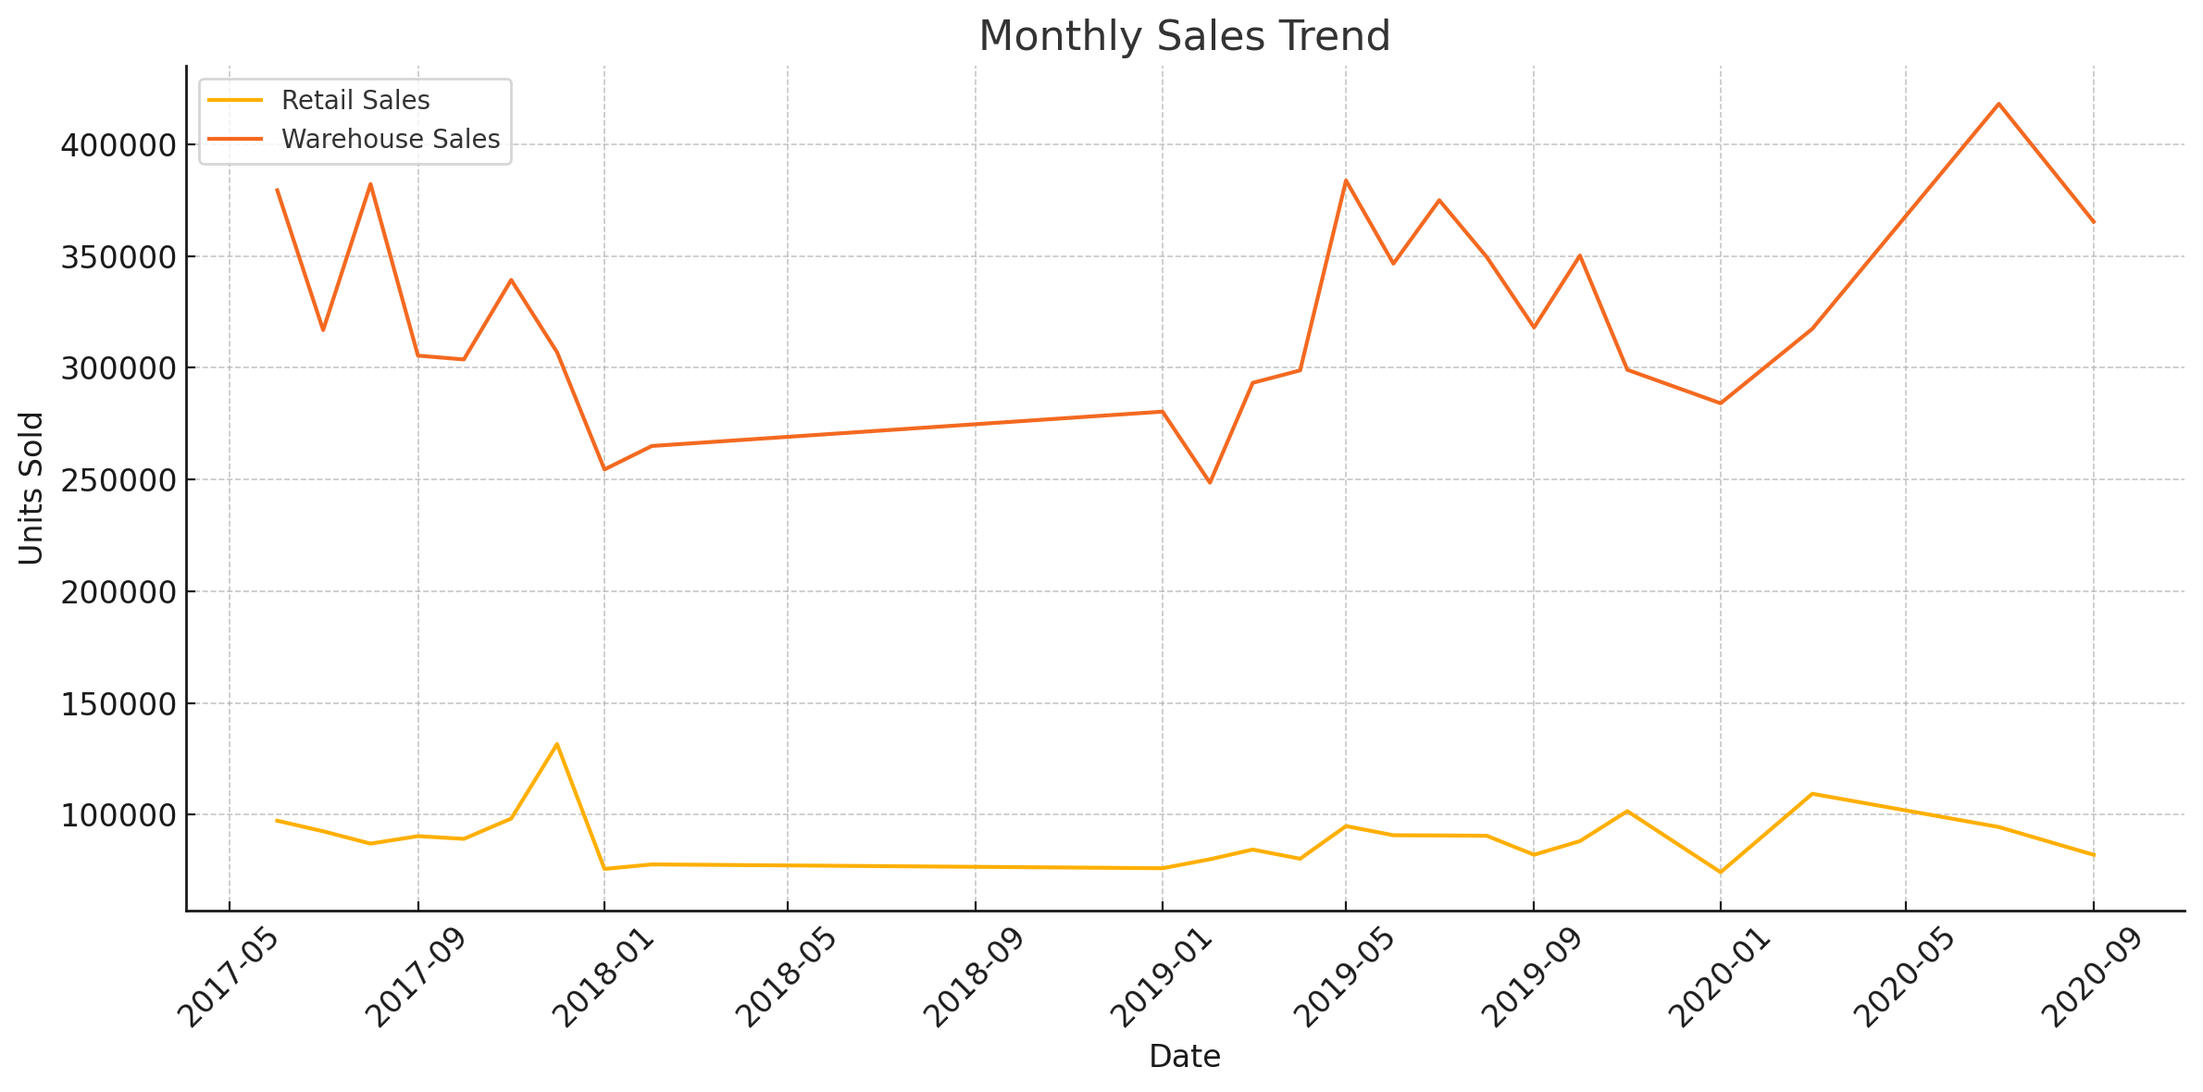

# 3. Top 10 Best-Selling Products

A bar chart was created to highlight the top 10 best-selling products based on total retail sales. This visualization helps identify which products contribute most to store revenue.

Visualization: Bar chart showing top 10 items by Retail Sales.

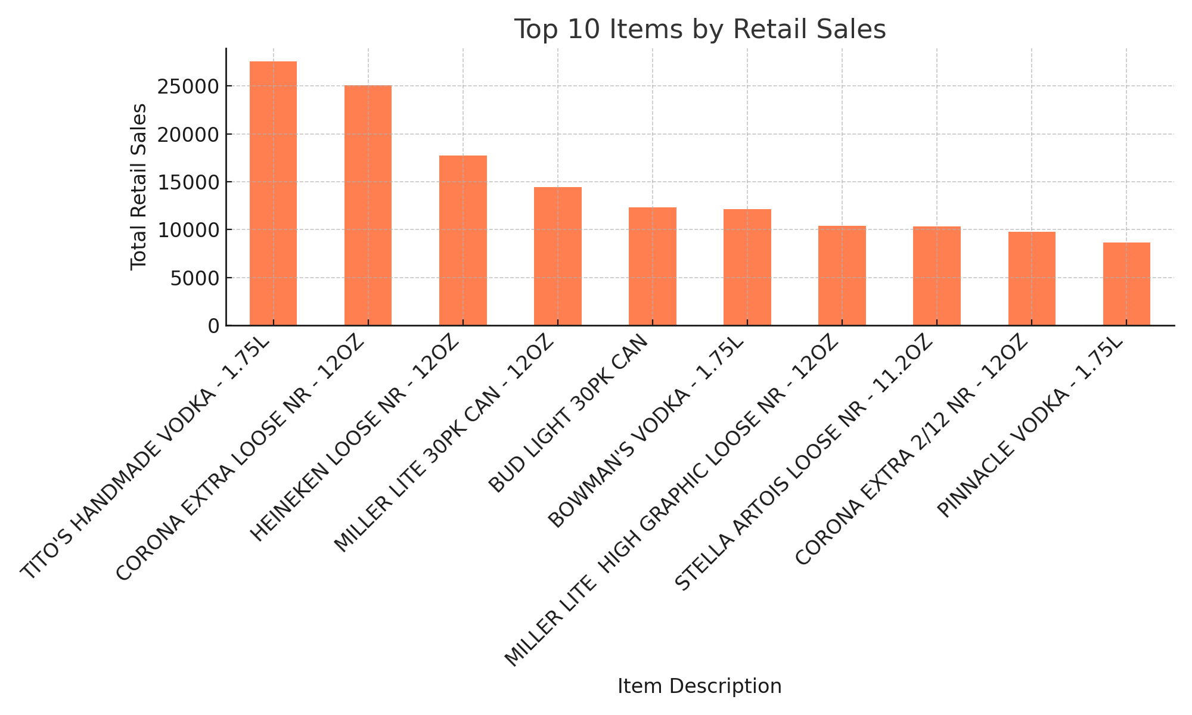

# 4. Supplier Analysis

Sales were analyzed across suppliers to identify which suppliers provided the most revenue-generating products.

Visualization: Pie/Bar chart representing supplier-wise retail sales.

# 5. Power BI Dashboard & KPIs

An interactive Power BI dashboard was created to visualize key performance indicators including:  
- Total Retail Sales  
- Total Warehouse Sales  
- Total Unique Items  
- Monthly Sales Trends  
- Supplier Breakdown  
- Product Performance Table

The dashboard includes slicers for year, supplier, and item filtering.

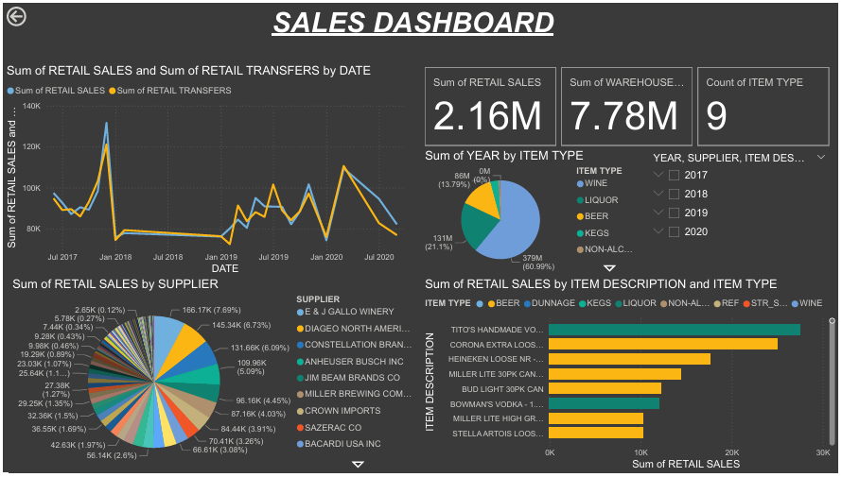

# 6. Insights & Recommendations

- Focus inventory planning on high-performing products.  
- Investigate low-sales periods for potential improvements.  
- Maintain strong supplier relations for top-performing items.  
- Use historical trends for demand forecasting during peak seasons.

# 7. Tools Used

• Excel for Pivot Table creation and initial data inspection.  
• Python for data cleaning and generating visualizations.  
• Power BI for dashboarding and interactive data exploration.