Social Media Sentiment Analysis Report

Intern Name: Multani Mohammad Taufiq Firozkhan

Company: Brainwavy Matrix Solutions

Task 2 – Data Science/Data Analytics Internship

Title: Social Media Sentiment Analysis Using NLP and Power BI

Date: May 15, 2025

# 1. Introduction

This report summarizes a complete sentiment analysis project carried out as part of my internship at Brainwavy Matrix Solutions. The objective was to analyze synthetic social media data to detect sentiment trends using Natural Language Processing (NLP) and visualize the results interactively using Power BI.

# 2. Objective

To extract and analyze public sentiment from a dataset of social media posts, classify them into Positive, Neutral, or Negative categories using VADER, and visualize key trends, distributions, and engagement metrics in Power BI.

# 3. Dataset Overview

- Total Records: 2,000 social media posts  
- Key Fields:  
 • Post Content  
 • Sentiment Label (predefined)  
 • Post Date and Time  
 • Number of Likes, Shares, Comments  
 • Post Type and Language

# 4. Tools Used

- Python (Pandas, VADER, Matplotlib)  
- Google Colab  
- Power BI Desktop  
- Microsoft Word

# 5. Methodology

## a) Data Cleaning

- Lowercased all text for consistency  
- Removed punctuation, URLs, and special characters  
- Removed common stopwords using NLTK

## b) Sentiment Analysis

- Used VADER (Valence Aware Dictionary and sEntiment Reasoner)  
- Generated compound sentiment scores for each cleaned post  
- Classified posts into Positive, Neutral, or Negative based on score thresholds

## c) Visualization

- Created a sentiment distribution bar chart using matplotlib  
- Built an interactive dashboard in Power BI with slicers, charts, KPIs, and trends

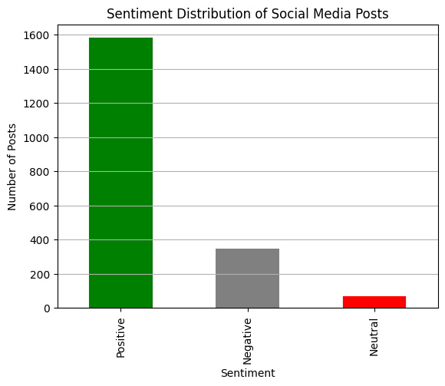

# 6. Dashboard Visuals

The Power BI dashboard includes the following components:

- Total Posts, Likes, Shares, Comments (Cards)  
- Sentiment Distribution (Bar Chart)  
- Sentiment Over Time (Line Chart)  
- Post Type Distribution (Pie Chart)  
- Top Posts Table with Engagement Score  
- Slicers for Sentiment, Post Type, Date Range

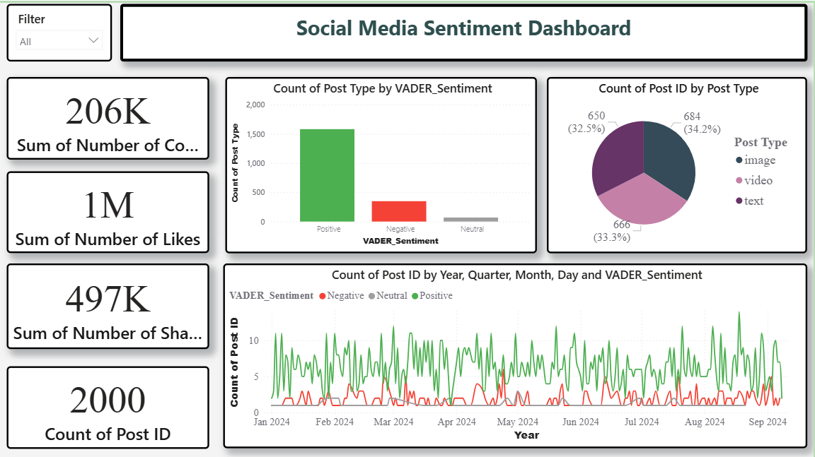

# 7. Key Insights

- Most posts were classified as Positive  
- Negative sentiment posts were fewer but had higher engagement on average  
- Text post types were the most common  
- Sentiment patterns changed over time

# 8. Conclusion

This project demonstrated how NLP and visualization tools can be used to extract meaningful insights from social media data. It improved my skills in data preprocessing, sentiment analysis, and dashboard creation.