**Instructions to download and install Selenium WebDriver automation components on Windows**

Below are the download and installation steps

1. Download JDK 8

<https://www.oracle.com/technetwork/java/javase/downloads/jdk8-downloads-2133151.html>

Use above link to go the JDK 8 download page, read the instructions on this page, select the version you want to download based on your operating system, following the instruction “How to install JDK for windows” to install it. Verified the installation.

1. Download Eclips:

<https://www.eclipse.org/downloads/packages/release/Neon/3>

download 2nd one “Eclipse IDE for Java Developers”: below for Win-64

Unzip the downloaded file into a directory of your choice.

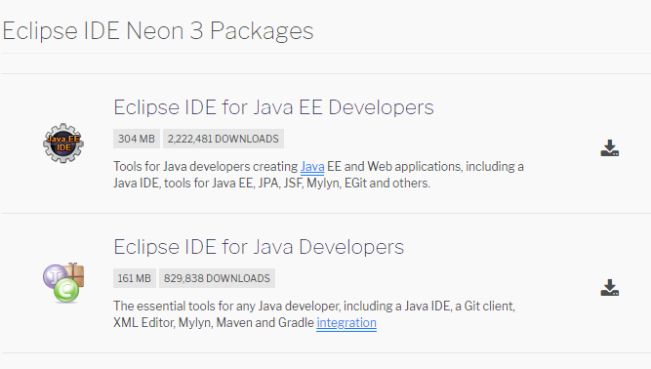

1. Download Selenium: 2.53 version

<http://selenium-release.storage.googleapis.com/index.html>

Use above link to Download “selenium-server-standalone-2.53.0” into a directory of your choice.

Use above link to Download “selenium-server-2.53.0” into a directory of your choice.

1. Download Firefox version-46 (not needed for this ProQuest project, but as best practice I put here)

<https://filehippo.com/download_mozilla-firefox/67599/>

after download Firefox, click on

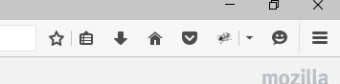

Then “OPTION” >>> “Advanced” >>>”UPDATE” >>>Check 2nd Radio button. Below screenshots.

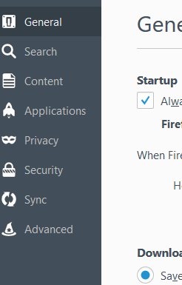

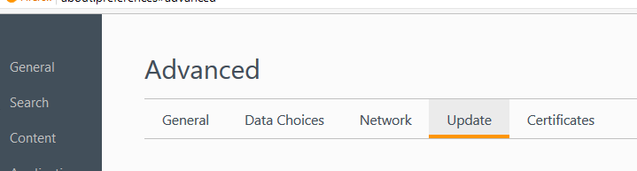

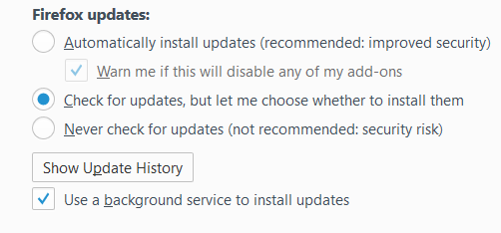

1. Download latest Google Chrome version

Use Google to find the latest Chrome version, download and install it if you don’t have one on your machine.

1. Download ChromeDriver- WebDriver for Chrome

<https://chromedriver.chromium.org/downloads>

Use above link to select a ChromeDriver version that match to your chrome version on your machine, download it and save to a directory of your choice.