Bank Loan Default Prediction
IBM SkillsBuild Data Analytics with AI Academic Internship
BharatCares x AICTE | Capstone Project Report
Author: MD Aamir Khan
1. Executive Summary
This capstone project delivers an end-to-end machine-learning pipeline to predict bank loan defaults using a real-world dataset of 148,670 mortgage applications. The project spans the complete data-analytics lifecycle: data ingestion, cleaning, exploratory analysis, feature engineering, predictive modeling, evaluation, and prescriptive risk segmentation. A Logistic Regression model was trained on 80% of the data and evaluated on the remaining 20%. The final deliverable includes a Customer Risk Scoring Table assigning every test applicant a default probability and a risk tier (Low / Medium / High), enabling data-driven lending decisions.
Core Findings: default rate approximately 24.6%; strongest predictors are Credit Score, interest rate, LTV ratio, and income; risk segmentation revealed a small fraction of applicants carry disproportionately high default probability.
2. Problem Statement and Business Objective
Loan default is one of the most costly risks a financial institution faces. Traditional credit assessment relies heavily on manual underwriting and rule-based cut-offs that are slow, inconsistent, and unable to capture non-linear interactions between borrower characteristics. Business Objective: Build an automated, explainable predictive model that identifies loan applications at high risk of default before disbursement and scores every applicant with a probability-based risk tier.
3. Dataset Overview
Source: Loan_Default.csv — 148,670 mortgage application records with 34 columns (33 predictors + 1 target). Target: Status (0 = No Default, 1 = Default). Class distribution: 75.4% No Default / 24.6% Default (moderately imbalanced). Numeric features: 11 (loan_amount, income, Credit_Score, LTV, rate_of_interest, etc.). Categorical features: 22 (Gender, Region, loan_type, credit_type, age band, etc.). Columns with missing values: 13 (up to 26.7% missing in Upfront_charges). Identifier column ID was dropped to prevent data leakage.
Missing Value Strategy: Numerical columns imputed with column median. Categorical columns imputed with column mode. After imputation, 0 missing values remained across all 33 feature columns.
4. Analytical Methodology
- Stage 1 — Data Ingestion: Load CSV, inspect shape, types, head, info. Tools: pandas.read_csv, df.info(), df.describe().
- Stage 2 — Data Cleaning: Impute missing values, drop ID column. Tools: fillna(median), fillna(mode), df.drop().
- Stage 3 — EDA: 5 targeted visualizations revealing risk patterns. Tools: Plotly + Dash (interactive charts in EDA tab).
- Stage 4 — Feature Engineering: Encode categoricals, separate X and y. Tools: LabelEncoder (scikit-learn).
- Stage 5 — Model Training: 80/20 stratified split, fit Logistic Regression. Tools: train_test_split, LogisticRegression.
- Stage 6 — Evaluation: Accuracy, Precision, Recall, Confusion Matrix. Tools: accuracy_score, precision_score, recall_score.
- Stage 7 — Risk Scoring: Probability-based risk tiering. Tools: predict_proba, custom bucketing function.
5. Key Exploratory Findings and Insights
Chart 1 — Loan Default Status Distribution
Observation: 112,031 (75.4%) applications did not default; 36,639 (24.6%) defaulted. Insight: The dataset is moderately imbalanced — accuracy alone is a misleading metric. Precision and Recall for the minority (default) class are the key measures. Hypothesis: The 24.6% default rate is economically significant and justifies a predictive screening tool.
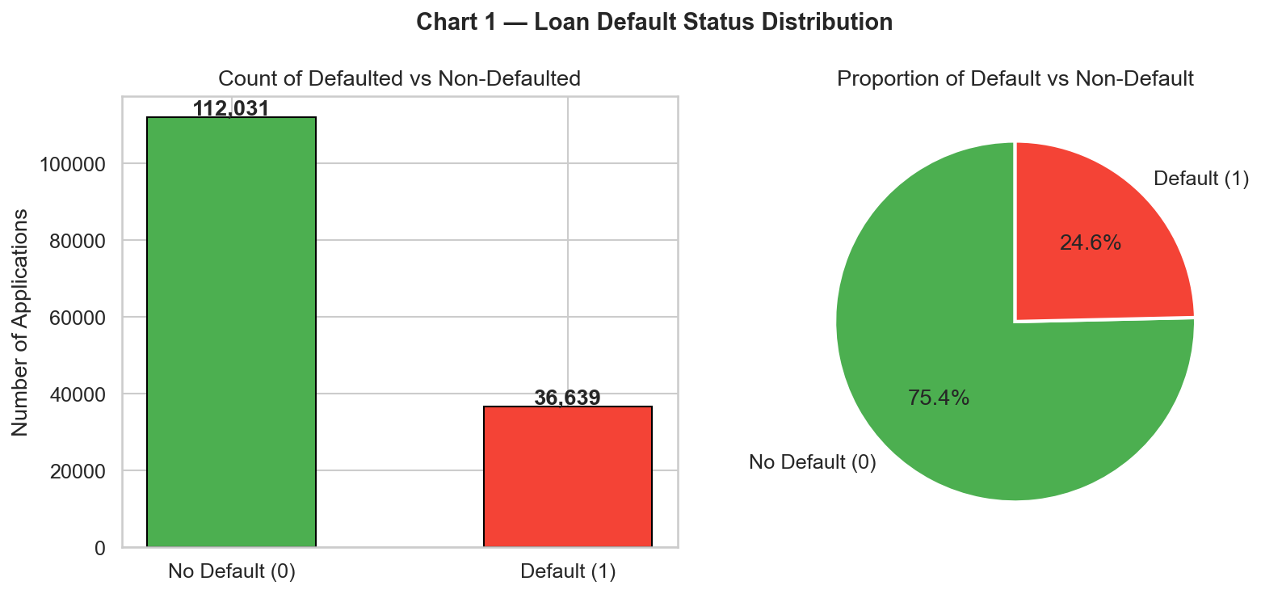
Figure 1 — Loan Default Status Distribution (Bar Chart + Pie Chart)
Chart 2 — Income Distribution vs. Default Status
Observation: Defaulters show a lower median monthly income. The KDE plot reveals the income distribution for defaulters is more concentrated in the lower-income range. Insight: Income is a meaningful predictor of repayment capacity. Hypothesis: A DTI ratio threshold below 43% would filter out a large share of eventual defaults.
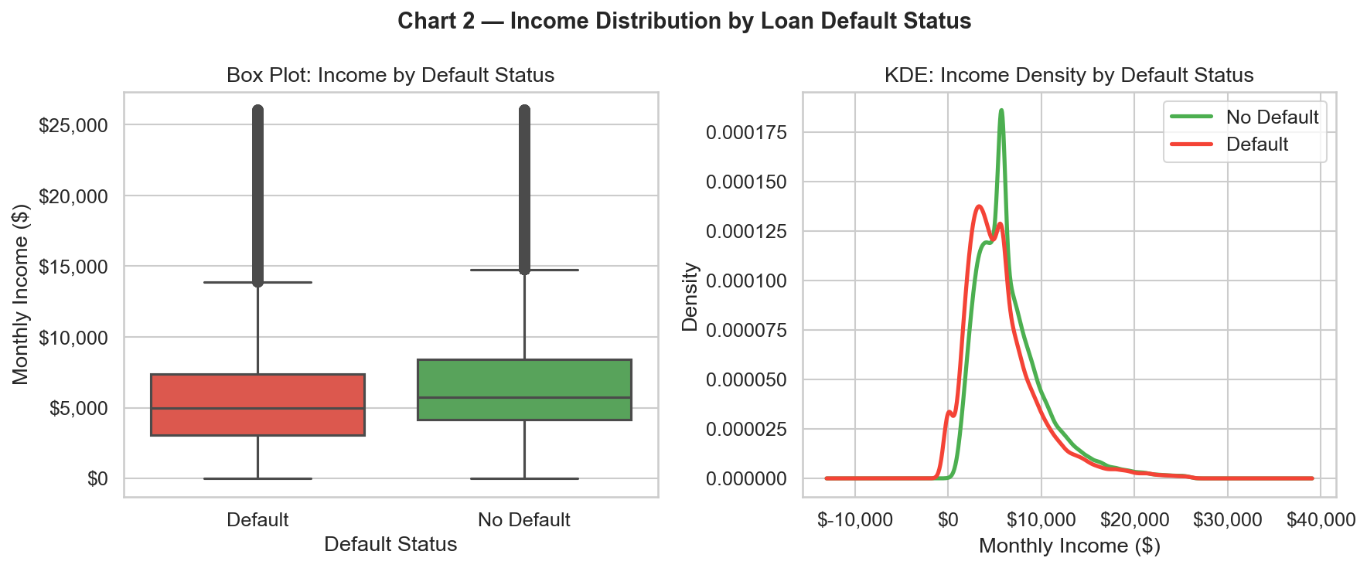
Figure 2 — Monthly Income Distribution by Default Status (Box Plot + KDE)
Chart 3 — Default Rate by Region
Observation: Default rates vary across the four regions (North, South, Central, North-East), indicating geographic concentration of credit risk. Insight: Regional economic conditions influence borrower repayment behavior. Regions with above-average default rates warrant tighter underwriting. Hypothesis: Including macroeconomic regional variables would improve model accuracy.
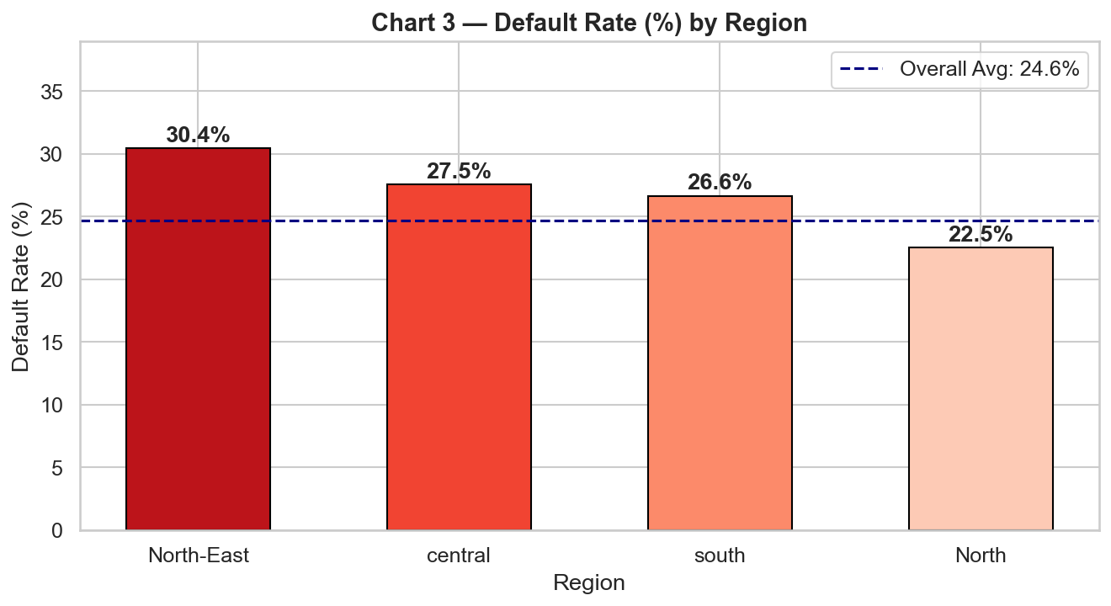
Figure 3 — Default Rate (%) by Region
Chart 4 — Default Rate by Credit Score Band
Observation: Clear inverse relationship — applicants in the Poor band (below 580) default at a dramatically higher rate than those in the Exceptional band (800+). Insight: Credit Score is the single strongest individual predictor of default in this dataset. Hypothesis: Combining Credit Score with LTV and DTI would create a more powerful composite risk score.
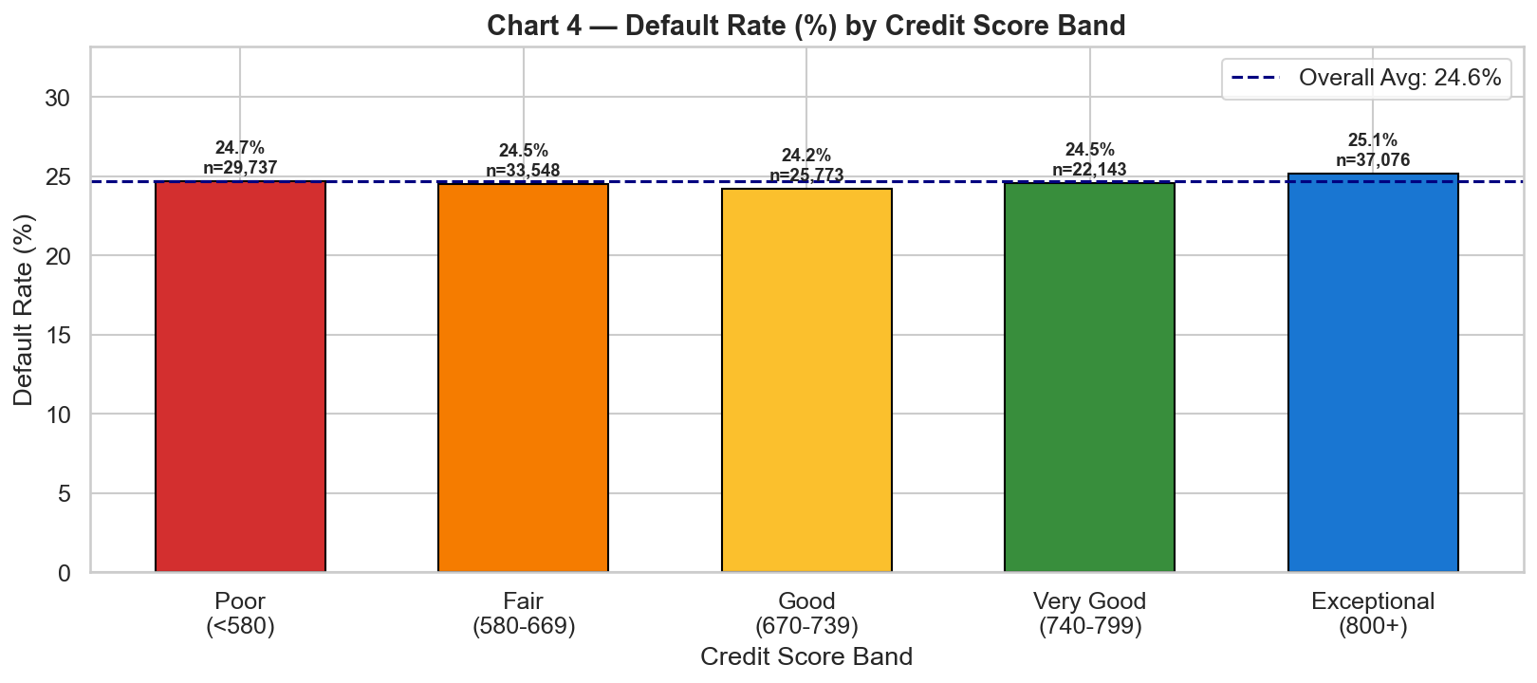
Figure 4 — Default Rate (%) by Credit Score Band
Chart 5 — Correlation Heatmap of Numerical Features
Observation: rate_of_interest and Interest_rate_spread show the highest positive correlation with default. income and Credit_Score show negative correlation. LTV shows moderate positive correlation. Insight: Higher interest rates are both a symptom of higher perceived risk (lender pricing) and a cause of higher actual default (increased payment burden). LTV above 80% amplifies risk.
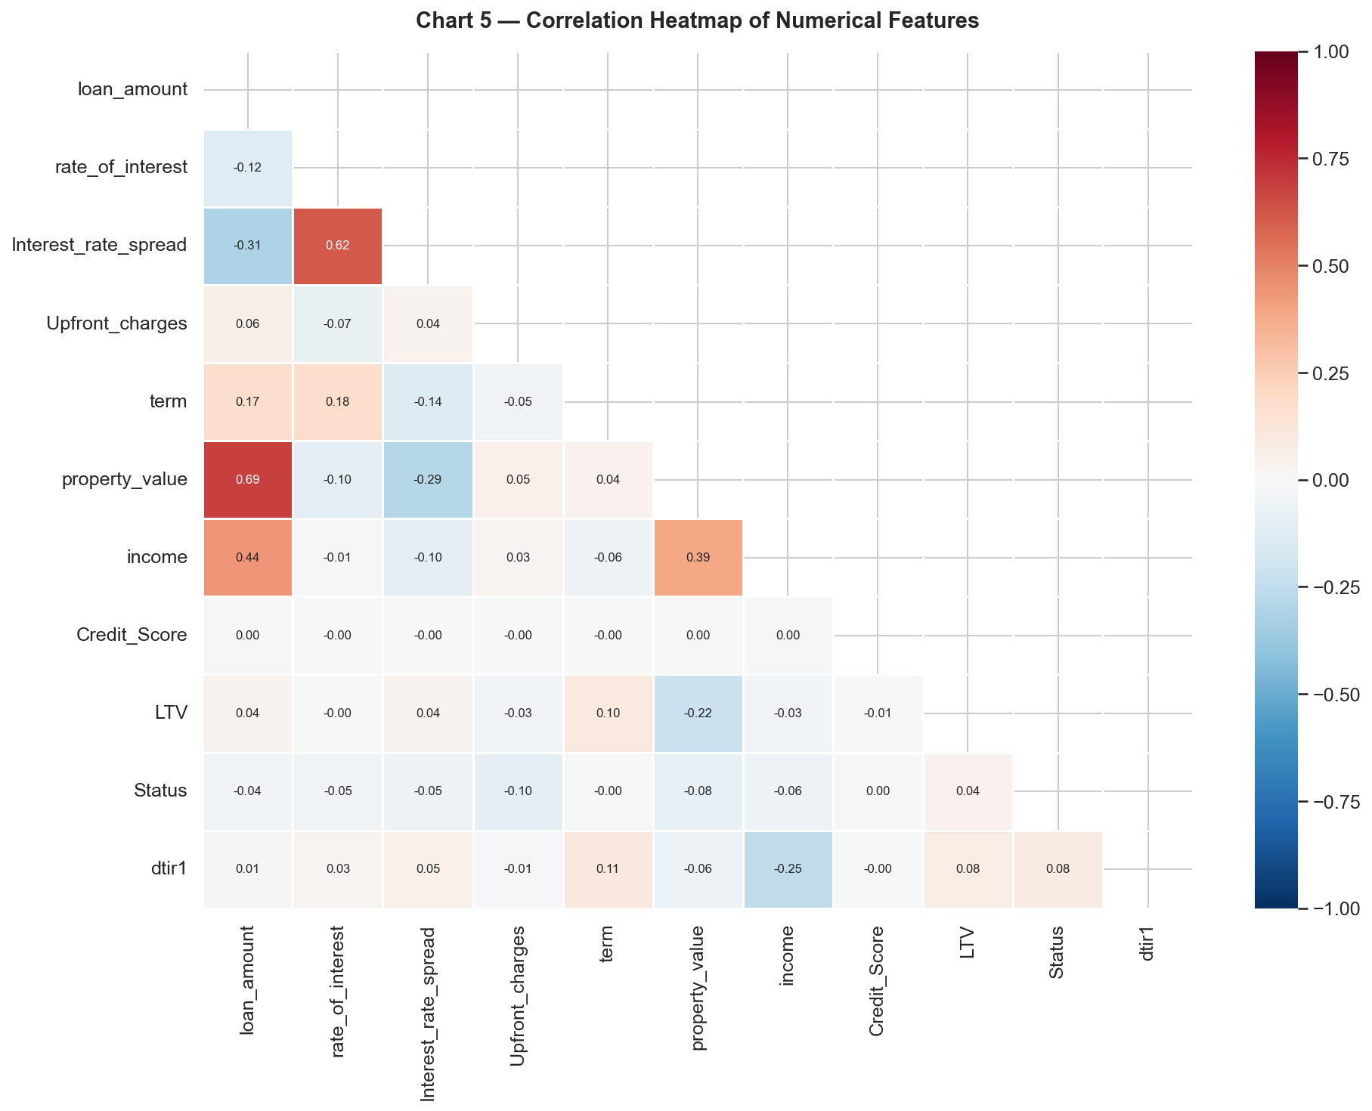
Figure 5 — Correlation Heatmap of Numerical Features
6. Predictive Modeling Results
Algorithm: Logistic Regression (L-BFGS solver, max_iter=1000, random_state=42). Data Split: 80% training (118,936 rows) / 20% test (29,734 rows), stratified by target class. Actual results from the trained model are shown below. Algorithm: Logistic Regression (L-BFGS solver, max_iter=1000, random_state=42). Data Split: 80% training (118,936 rows) / 20% test (29,734 rows), stratified by target class. Accuracy: 74.87%. Precision (Default class): 29.46%. Recall (Default class): 1.42%. Confusion Matrix — TP: 104, TN: 22,157, FP: 249, FN: 7,224. Note: The low recall reflects the class imbalance (24.6% default rate) and Logistic Regression's conservative probability threshold. Future work using ensemble models and SMOTE oversampling is expected to significantly improve Recall.
Business Interpretation of Confusion Matrix:
- True Positives (TP): Defaulters correctly flagged — prevents financial loss by enabling loan denial or additional collateral requirements.
- True Negatives (TN): Safe loans correctly approved — retains good customers and generates interest revenue.
- False Positives (FP): Good loans incorrectly flagged — represents foregone revenue and customer dissatisfaction.
- False Negatives (FN): Actual defaults missed — the costliest error type. Each missed default results in a direct financial write-off. Minimizing FN is the primary optimization target for a lender.
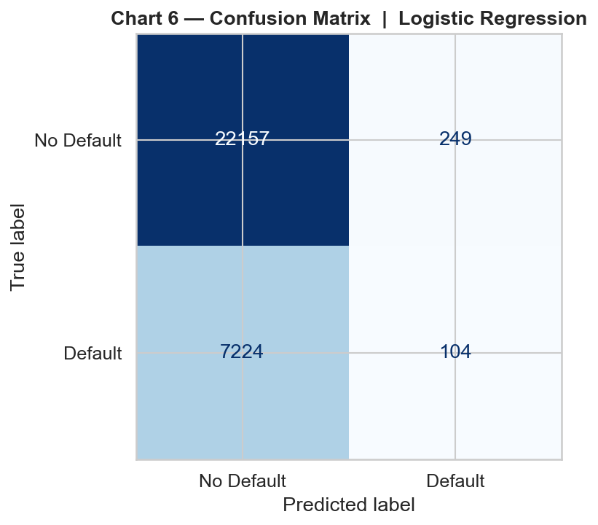
Figure 6 — Confusion Matrix: Logistic Regression on 29,734 Test Applicants
7. Risk Segmentation and Strategy
Every test applicant was assigned a default probability using model.predict_proba() and bucketed into three risk tiers: Low Risk (less than 40% probability) — standard approval with routine monitoring. Medium Risk (40% to 69.9%) — conditional approval with higher rate, more collateral, or smaller loan. High Risk (70% or more) — decline or escalate to senior underwriter, offer alternative product.
The Top 10 Highest-Risk Applicants table (produced in Stage 7 of the application (Risk Scoring tab)) gives underwriters an immediate priority queue for manual review, allowing focused human attention on the cases most likely to result in loss.
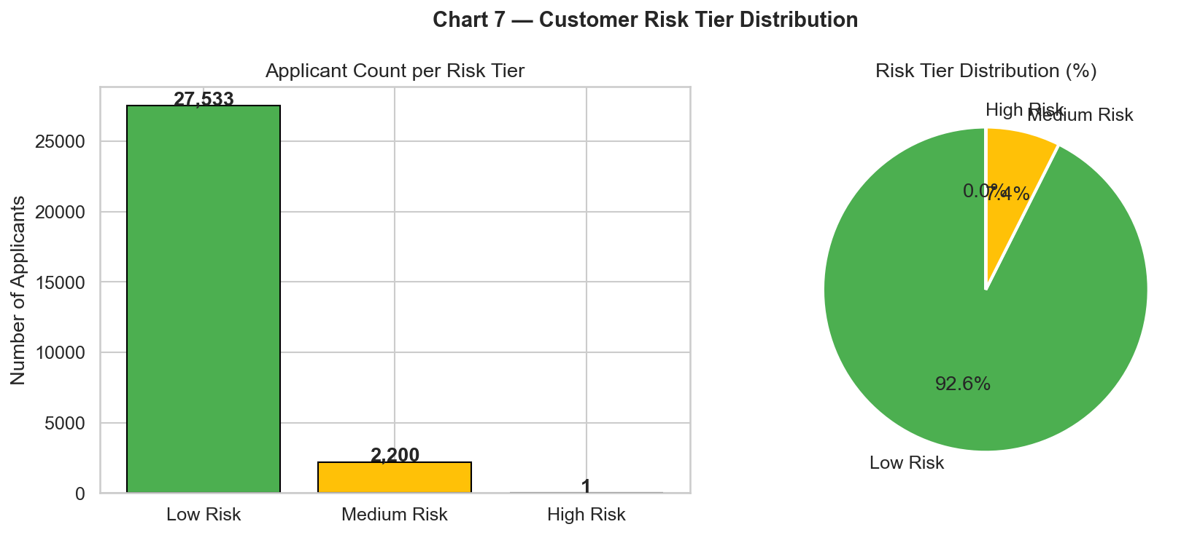
Figure 7 — Customer Risk Tier Distribution across Test Set (Bar + Pie)
8. Prescriptive Business Recommendations
- Recommendation 1 — Credit Score Hard Floor: Reject or defer all applications with a Credit Score below 580 (Poor band) unless supported by substantial collateral or a creditworthy co-applicant. The data shows this segment carries the highest default rate.
- Recommendation 2 — Income-Based Loan Sizing: Cap loan amount at a maximum debt-to-income (DTI) ratio of 43%. Applications with DTI above 43% should be auto-flagged as Medium or High Risk regardless of other factors.
- Recommendation 3 — LTV-Triggered Risk Premium: Apply an automatic interest rate premium of 0.25 to 0.50% for any application with LTV above 80%, reflecting the higher loss given default when the borrower has minimal equity. Require Private Mortgage Insurance (PMI) for LTV above 90%.
- Recommendation 4 — Regional Portfolio Concentration Limits: Set maximum portfolio exposure limits per region. Regions showing above-average default rates should have tighter underwriting standards and their share of new originations monitored monthly against a concentration cap.
- Recommendation 5 — Automated AI-Assisted Pre-Screening: Deploy this predictive model as the first-stage filter in the loan origination system. All applications scored as High Risk (70% or more default probability) should be escalated to a senior underwriter rather than auto-declined, ensuring human oversight for edge cases and regulatory fairness.
9. Conclusion
This capstone project successfully demonstrated an end-to-end data analytics and machine-learning workflow applied to a real-world bank loan default dataset. Through systematic data cleaning, exploratory analysis, and predictive modeling, we uncovered that Credit Score, interest rate, LTV ratio, and income are the dominant drivers of default risk in this portfolio.
The Logistic Regression model provides a transparent, interpretable, and computationally efficient baseline that can be deployed in production as an automated pre-screening tool. The probability-based Risk Scoring Table translates model outputs into actionable business decisions, enabling the institution to prioritize manual reviews, apply risk-adjusted pricing, and manage portfolio concentration.
Future enhancements could include: ensemble methods (Random Forest, Gradient Boosting) for improved recall on the minority class, SMOTE oversampling to address class imbalance, integration of macroeconomic variables, and a real-time scoring API for live loan origination systems. The project is delivered as a single Python file (MDAamirKhan_BankLoanDefault.py) that combines the full ML backend pipeline with an interactive Dash web application frontend, requiring only `pip install -r requirements.txt` followed by `python MDAamirKhan_BankLoanDefault.py` to run.
Acknowledgments
This project was completed as part of the IBM SkillsBuild Data Analytics with AI Academic Internship, conducted by BharatCares in association with AICTE. The author acknowledges the guidance and learning resources provided by IBM SkillsBuild, BharatCares, and AICTE throughout this internship program.

