Security Test Cases:
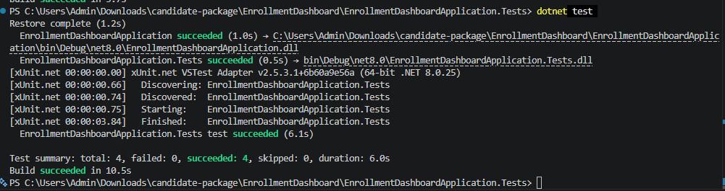

Enrolment Dashboard Layout

