Types of display:

1. led display
2. segment display
3. led matrix(dot matrix)

led display disadvantage:

how mach energy leds take only led take (15mA 🡪 5v)==75mW

1. high power consumption

how many pin you take to use 7-segment ? 🡺 7pins if we use ground out

for ex : to make clock show hh:mm:ss it wil take 6 of 7-segment which you can’t do it

1. number of pins is big

we have advantage:

1-atractive

2- small size

3- big view angle

Light polarization

So we have LCD : Liquid crystal

Light polarization first:

We know the light is electromagnetic wave so : it orthogonal متعامده

And it was in different planes مختلف المستويات

So we called it unporalized light and every usual light is unporalized

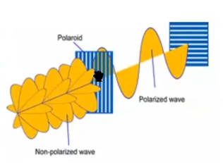

So what do you think if we use object with little small tine holes in it to block light

We called block polarizer

So we have wave in one direction as we want

So if we use another block and rotate it in 90o what will happen??

It blocked !!!!

How we get light thus??

We can rotate light in 90o so it can through .

But how??

Her we use liquid crystal display or LCD

Liquid crystal : it state of mater have fluidity and hardness of solid

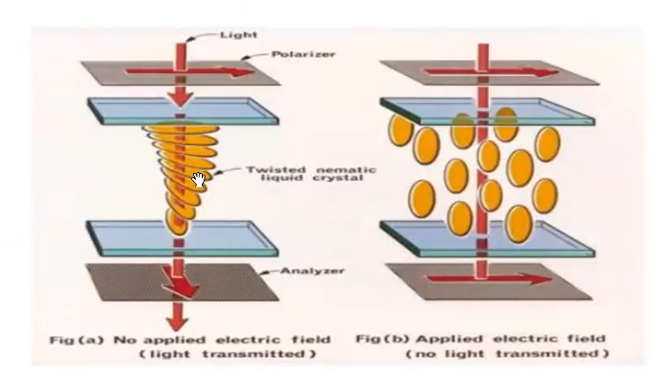In normal state it liquid but can change it internal structure with voltage effect

So he have two state rotate atoms in 90o whit no voltage effect

And stand still with voltage effect

And have transparent

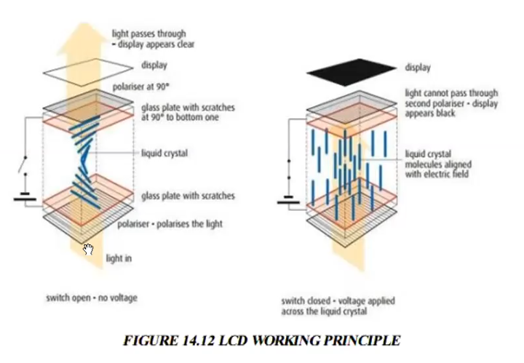

Note : does not lite your LCD too much time on to not git dry

What that mean??

Liquid crystal stay on voltage effect too long my be no get back to first state when can rotate light

LCD have it source light from One big Led .

We have types of LCD:

1-segment LCD 🡺 don’t have pixles have segments not usually use in Embedded

2- alphanumeric LCD(char LCD)🡺 its gride of char every char is a grid of pixels

We cant control every pixel in char grid we control a char grid whole

So ?? who cont let me control every single pixel !!!

Microcontroller of LCD

Not allow me to make Arabic char

3- Graphical LCD🡺 it a one big gride and you can access every char and control it

Have types:

1- monochrome : have one led source

2-colored LCD : RGB Can control on every Led to control color

LCD Module: LED Source + liquid crystal +polarizer + panel +microcontroller

LCD data sheet open!!!!!!!!!

In LCD we can say we have 4 segments of pens on it :

Power segment /control segment /data segment /back light segment

Power pins:

1. VSS 🡺 ground
2. VDD 🡺 5v

There vcc,vdd

Or vss,vee

For volat porew high and low

Then we have vo for :contrast 🡺how much light you will give

between 0 to 5 v

if 0 is very low for 5 is highest

2-control pins:

1-RS(Register select): if 0 🡺 command /if 1 🡺 data.

2-R/W(Read/write): if 0 write (active low)/if 1 read.

We can read as (busy flag)

3-E (Enable): her mean turn on/off the LCD it mean read data from

Data pins .

Data pins no periodically read from it , it just when you put E pins high then low

And we called it enable pulse.

3-Data pins: 8 pins used to transfer data/commend

4- back light LED: A(anod)🡺5v /N(cathod)🡺ground

So we have 11 pins connecting direct with ATMEG32

Then will write driver for LCD

What we need from LCD???

Send commend

Send data

And of course we need to initialize the LCD!!!!!