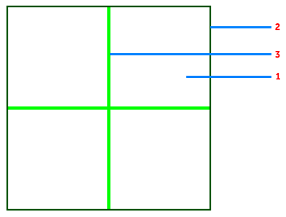Documentation for Stream-SSJ(Rotary)

1. Rotary– #Rotary_var
2. Rotary_borders – #Rotary_var
3. Rotary_axis_XY – #Rotary_crosshair_var

Code

Body {

Overflow: hidden;

}

Canvas{

Opacity: 0.5;

}

#Rotary_var{

width: 250px;

border-width: 2px;

border-color: rgba(0, 81, 0, 1);

}

#Rotary_crosshair_var{

width: 4px;

background-color: rgba(0, 255, 0, 1);

}body – Full page

overflow: hidden; - hide scrollbars

canvas – all that is drawn

opacity – transparency

**1,2**  
width – window width

border-width – border width

bordert-color – border color

**3**  
width – axis thickness

background-color – axis color