For line 1, the program is getting user input in form of a string and storing it in variable ‘a’.

Line 3, I define the name of the function and I set variable ‘a’ as a parameter.

Line 4, I created variable ‘c’ this is in order that I can use to store the number of letters or numbers that is in ‘a’.

Variables ‘b,d and e’ will be used to check later against ‘a’ to see if they meet the requirements if a strong password. Variables ‘st1,st2,st3’ will be used to hold Boolean values later.

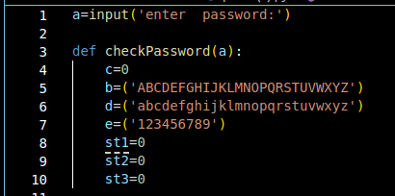

From line 13 till 17, I am using a for

loop to increment ‘c’ whenever

there is an

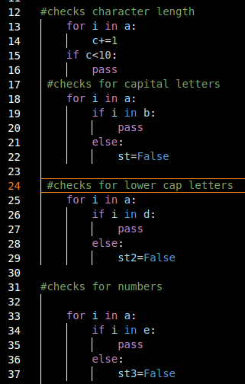item in ‘a’ which will give the character

length of the password.

Line 18 till 24, I use for loop to iterate through ‘

a’ again and then see if each item is in ‘b’ to check

for the upper-case letters and then it

will continue to line 25, otherwise if there

isn’t then will set variable ‘st1’ to false f

or later comparison.

And this is similar up to line 37.

‘st1’ being false means no upper-case letters, ‘st2’

being false means no lower-case letters

and ‘st3’ means no numbers either.

Then line 39 till 43, it will check if the variables are false and if ‘c’ containing the character length of the password is less than 10. All of that being false will mean the password is weak otherwise the password is strong and meets the criteria. Then I call the function of ‘a’.

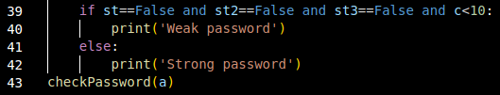

S