For line 1 the program is open the preferences file and its storing it as f, then for lines 3 ttill 7 it is reading each line and storing it in separate variables.

For line 8 till 13, it’s a function that will remove the spaces in between the numbers that are from variables ‘a’ to ‘f4’, and this is because it makes it easier to compare the number of same elements when determining the preferences shared.

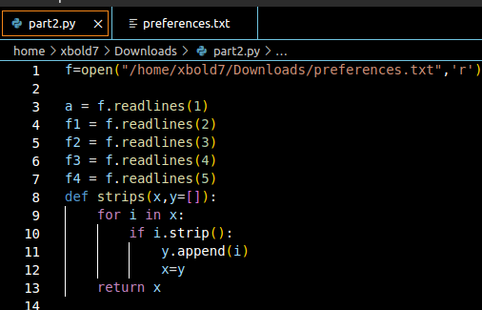

For lines 16-39, line breaks are removed from the

variables ‘a-f4’, then those variables are updated.

The string variables in line 35-38 are for later

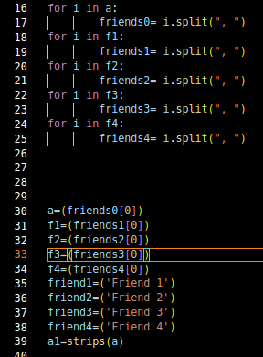when the program prints the results. Then strips function is called on a to remove the empty spaces in between the numbers.

Then in lines 43 to 55, the function for finding the preferences is defined. For the parameters, x is for the first friend or the first line from the preferences text , y is for any of the others friends to compare with and z is for the string variables in lines 35-38. ‘c’ variable holds numbers of similarities. Lines 52 to 55 the function is called on the different friends.

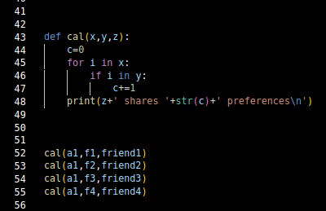

Output is like this

