CS 5313 : Computer network

Assignment # 2a: Reliable File Transfer Report

Name: Md Abu Sayed (80718658)

**Strategy:** Initially, I open a serversocket at server program which waits for client connections. After making connection with client, server will send the size of the file wanted by the client so that client knows how many packets he/she is going to receive. And then client will wait to receive that specific number of packets. When transfer is complete client will send a “CLOSE” message to close connections and server will wait again for client connection. First, I run Server and Client program on mac and ubuntu in localhost. Then finally, run both on core.

**Instruction for running:** To run server and client, first you need to go to file directory in command prompt and then run following in command prompt. You need to run server first, then client.

python3 rftServer.py

python3 rftClient.py

Following syntax should follow for server program

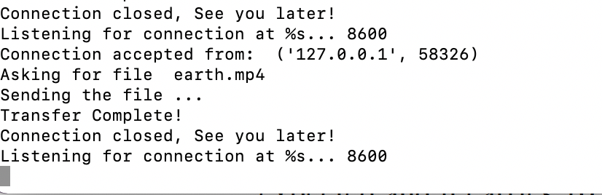

Following syntax should follow for client program

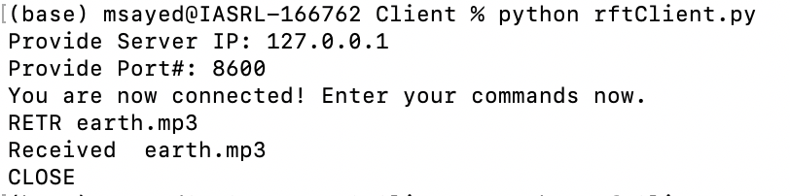

**Execution sample:**

Traces of successfully run the server and client in localhost, where sever able to transfer .txt, .jpeg, .pdf, .mov, .mp3, and .mp4 files.

Screenshot of server part when I run in localhost.

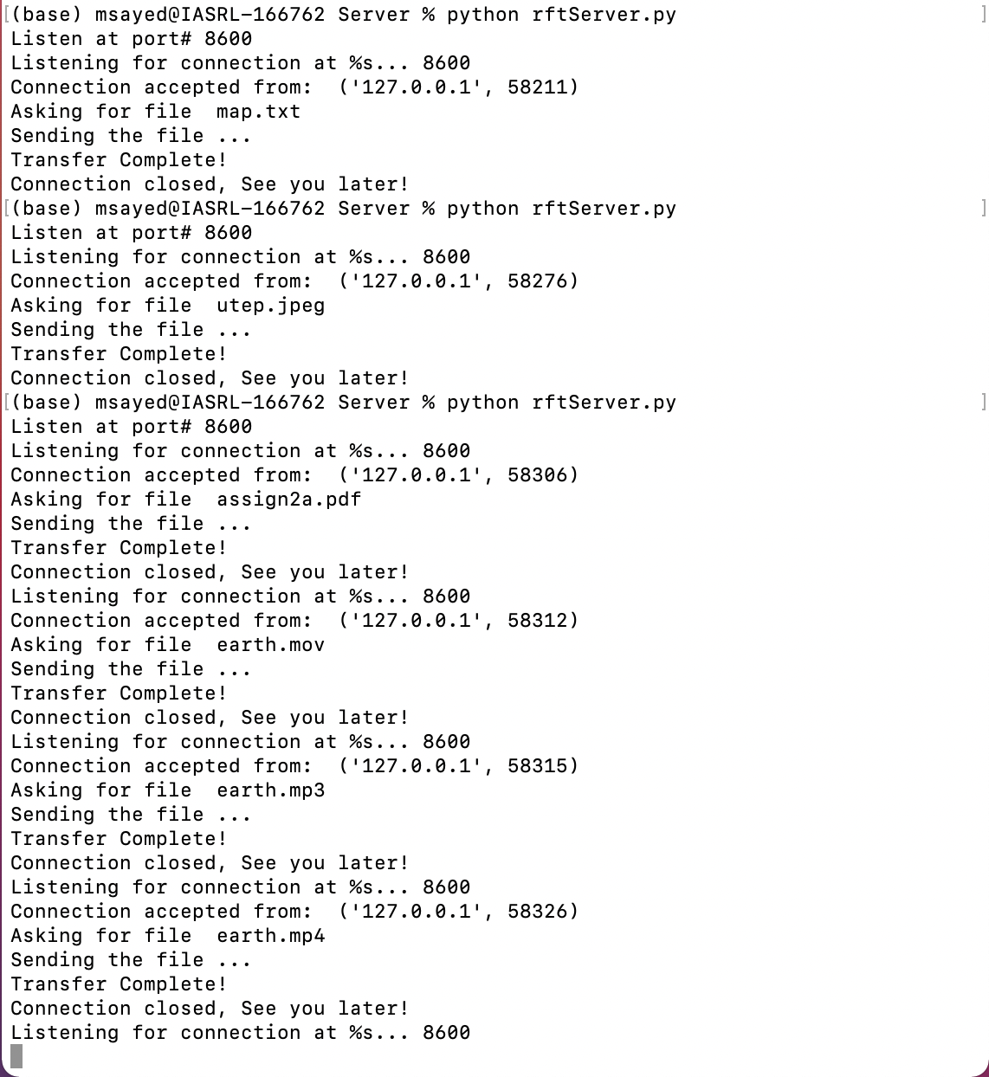

Screenshot of client part when I run in localhost.

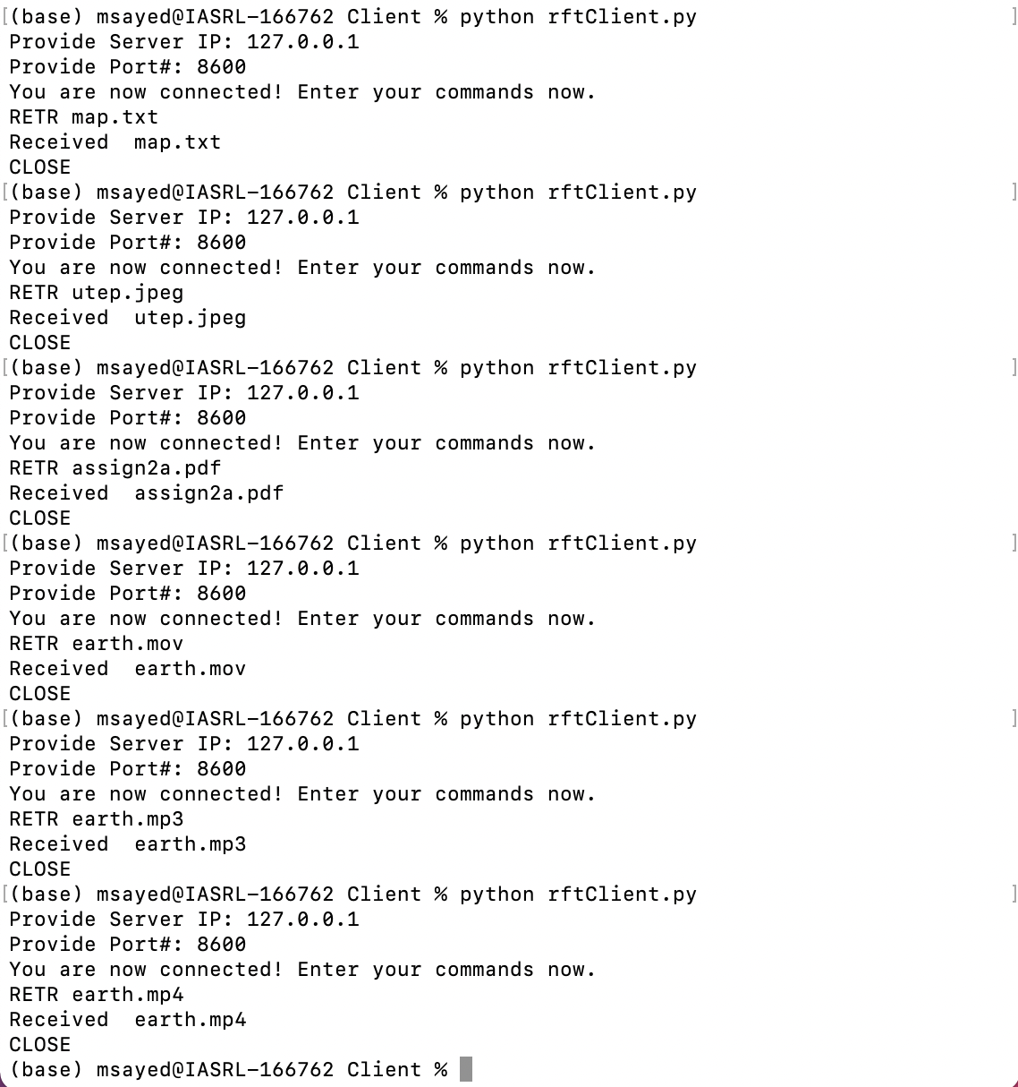

**Core Emulator:**

Screenshot of sample client server network given below.

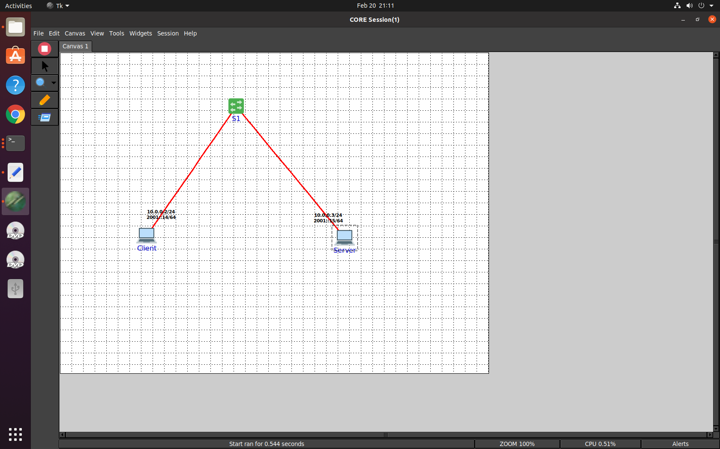

Screenshot of server in core emulator given below.

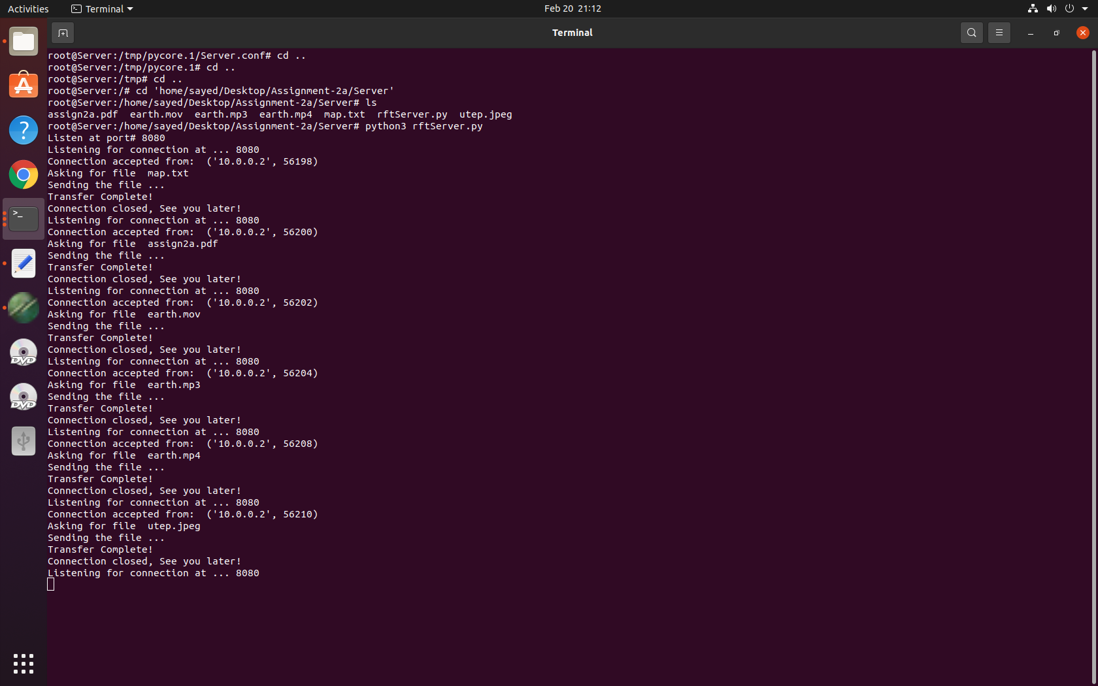

Screenshot of client in core emulator given below.

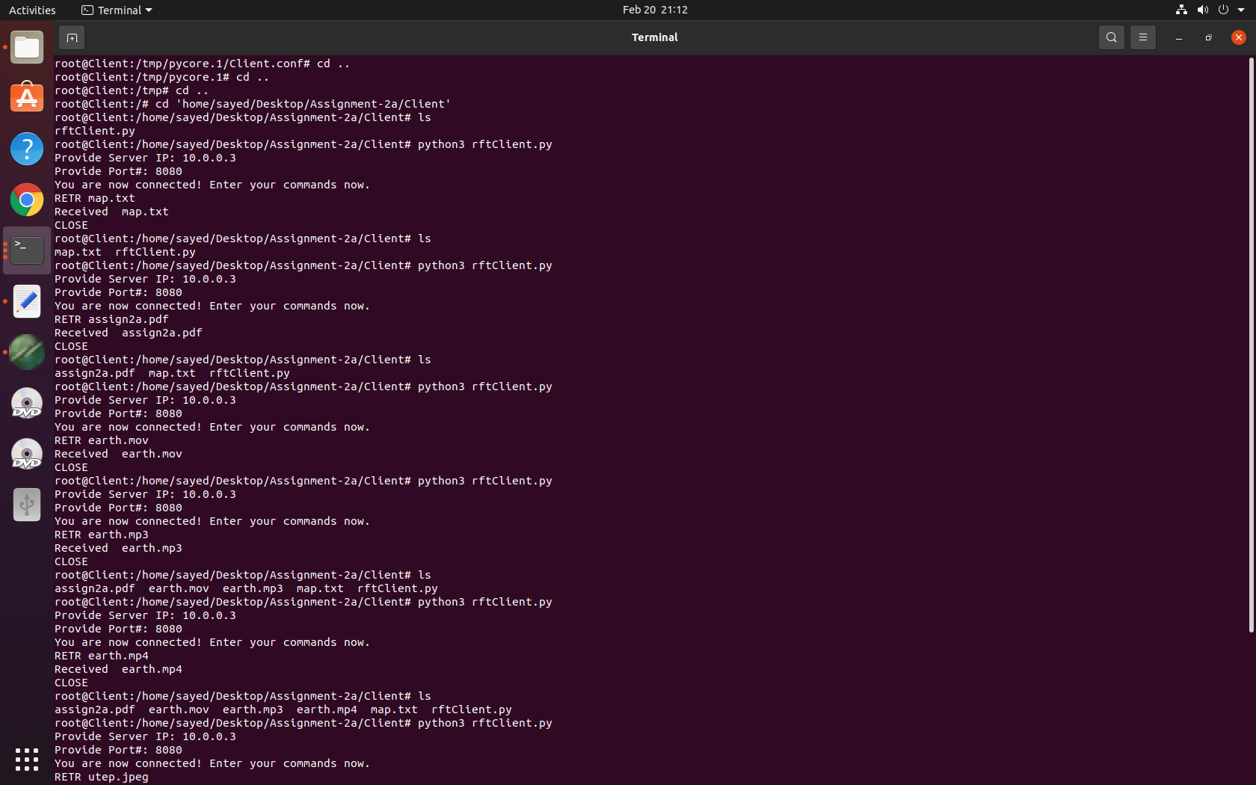



After complete file transfer, I run **diff** in Client folder.

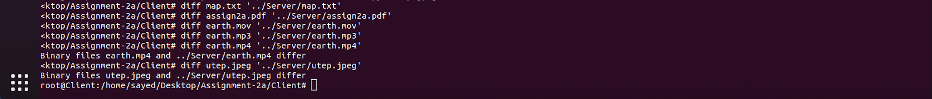

It shows my earth.mp4 and utep.jpeg files are different and other four files are same. The reason behind this is, I got this error ” UnicodeDecodeError: 'utf8' codec can't decode byte 0xa5 in position 0: invalid start byte”, when transferring both files. That’s why I use ‘utf8’ in encode and decode. I think that’s the reason for losing some bits. But overall file content is the same.

**Comments:**

1. Anytime if unable to open server socket in a particular port, try with different port number as existing connection on that port in localhost.
2. I send file size from server to client, so that client has idea about how many packets are going to receive. Because of that sometime, socket.recv(buffer_size) waits to receive bytes with full buffersize. On that scenario, program shows error. Restart and run the program again solve the issues.

References :

1.https://realpython.com/python-sockets/#echo-client-and-server

2.https://www.thepythoncode.com/article/send-receive-files-using-sockets-python