**Packet Filtering in Software Defined Networks (Assignment #3)**

**Member1: Md Abu Sayed, email -** [**msayed@miners.utep.edu**](mailto:msayed@miners.utep.edu)

**Member2: Moqsadur Rahman, email –** [**mrahman20@miners.utep.edu**](mailto:mrahman20@miners.utep.edu)

**Task1 - Programming to create a custom network topology:**

* Screenshots of the pingall, iperf and dump commands:

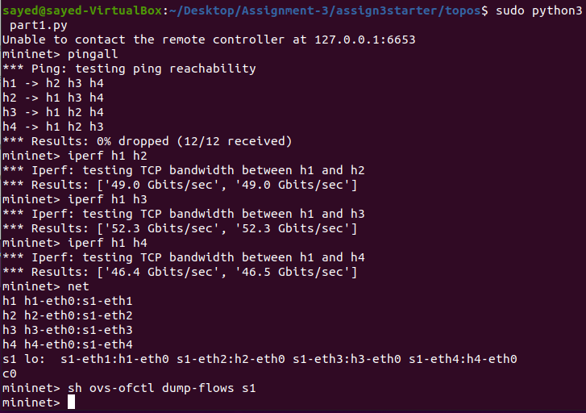

**Task2 - SDN Controller using POX:**

* Screenshots of the pingall and iperf commands:

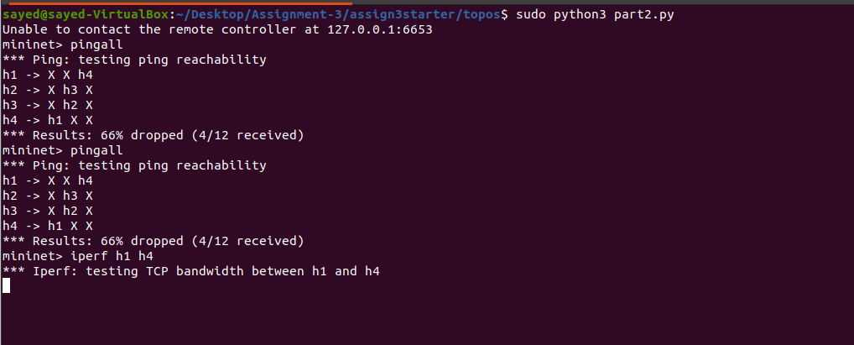

* Screenshots of the dpctl dump-flows commands

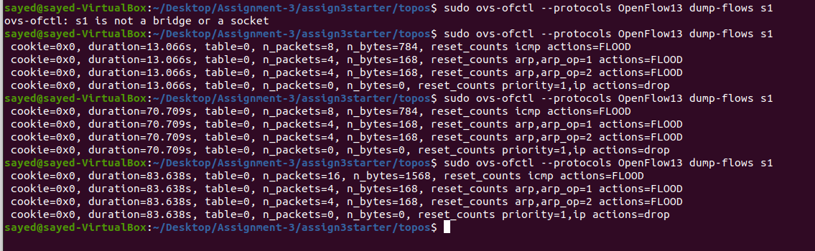

**Task3 - Firewall in real network:**

* Screenshots of the pingall, iperf hnotrust1 h10 and iperf h10 serv1 commands

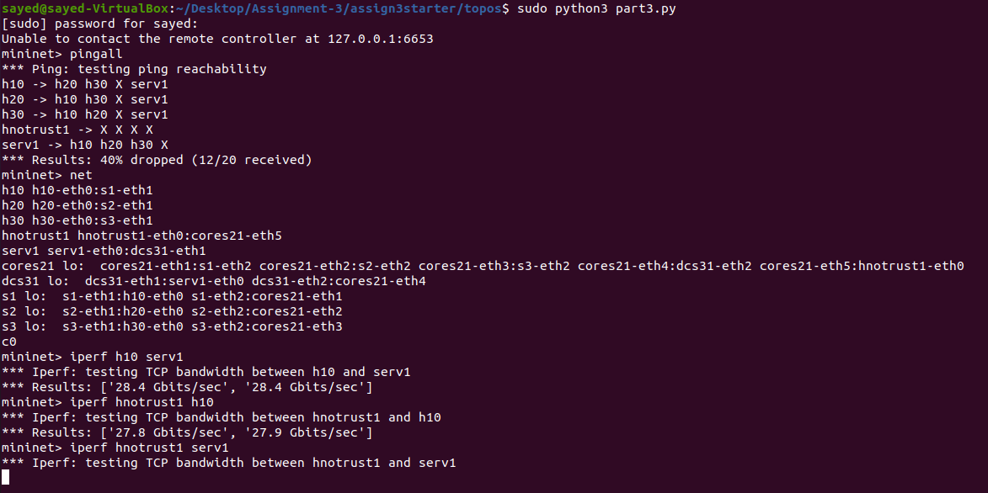

* Screenshot of dpctl dump-flows command

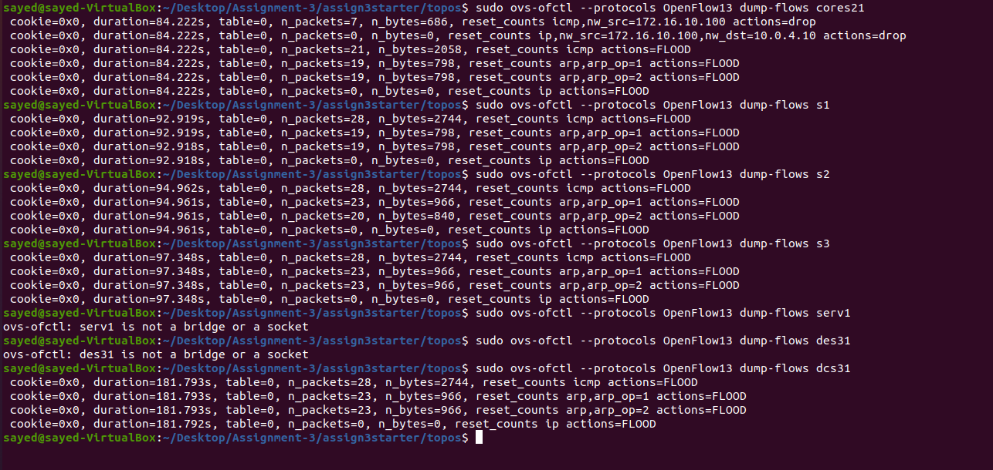

**References:**

* <https://noxrepo.github.io/pox-doc/html/>
* <http://mininet.org/walkthrough/>
* <https://docs.openvswitch.org/en/latest/>
* <https://docs.pica8.com/display/PICOS2111cg/PicOS+OpenFlow+Tutorials>

**Group Activity:**

|  |  |  |
| --- | --- | --- |
| **Task Lists** | **Student-1’s Contribution**  **(Md Abu Sayed)** | **Student-2’s Contribution**  **(Moqsadur Rahman)** |
| Implementation | Task3 | Task1, Task2 |
| Screenshots, README.txt and Report | All the screen shots and README.txt | Report |