CS 5313 : Computer network

Assignment1 Report

Name: Md Abu Sayed (80718658)

**Code description:** First I read ‘log.txt’ file to get info what resources are in cache now.

file = open("log.txt", "r")

contents = file.read()

dictionary = ast.literal_eval(contents)

file.close()

Then I create server socket, waiting connection from client in a infinite loop and dispatch client request to proxy_handler thread.

tcpSerSock = socket(AF_INET, SOCK_STREAM)

tcpSerSock.bind((sys.argv[1], 8888))

tcpSerSock.listen(100)

while True:

tcpCliSock, addr = tcpSerSock.accept()

thread = threading.Thread(target = proxy_handler, args = (tcpCliSock, addr))

thread.setDaemon(True)

thread.start()

In proxy_handler first I extract resource name from http request message of client browser.

message = tcpCliSock.recv(1024)

first_line = message.split(b'\r\n')[0]

resource = first_line.split(b' ')[1]

resource_name = resource.decode()[1:]

Then I checked whether cache hit or miss happen.

lock = threading.Lock()

lock.acquire()

hit = True if resource in dictionary.keys() else False

lock.release()

When hit happens, I fetch resource from cache and send to client browser.

lock = threading.Lock()

lock.acquire()

tcpCliSock.send(dictionary[resource])

lock.release()

For miss, I established a connection with webserver and make a Http request to webserver.

tcpWebSerSock = socket(AF_INET, SOCK_STREAM)

tcpWebSerSock.connect((link, 80))

req = "GET " + "http://" + resource_name + " HTTP/1.0\n\n"

tcpWebSerSock.send(str.encode(req))

Finally, send webserver response to client browser and store that response to cache.

tcpCliSock.send(http_response)

lock = threading.Lock()

lock.acquire()

dictionary[resource] = http_response

with open('log.txt','w') as data:

data.write(str(dictionary))

lock.release()

**Instruction for running:** To run ProxyServer, first you need to go to file directory in command prompt and then run following in command prompt.

python ProxyServerMultiClient.py 127.0.0.1

python ProxyServerSingleClient.py 127.0.0.1

From web browser you can request particular page in this format.

127.0.0.1:8888/[yahoo.com](http://yahoo.com)

Anytime you can see the ‘log.txt’ to observe cache resources.

**Execution sample:**

Initially log file looks like.

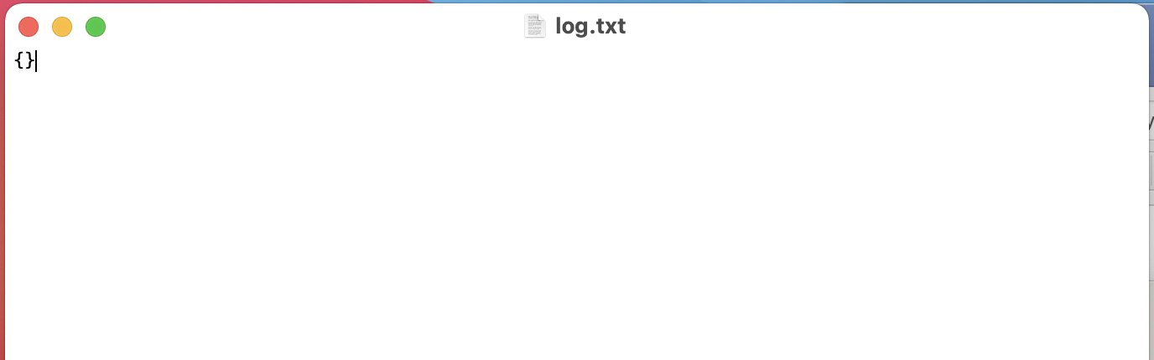

After running ProxyServerMultiClient.py and request my.utep.edu at browser.



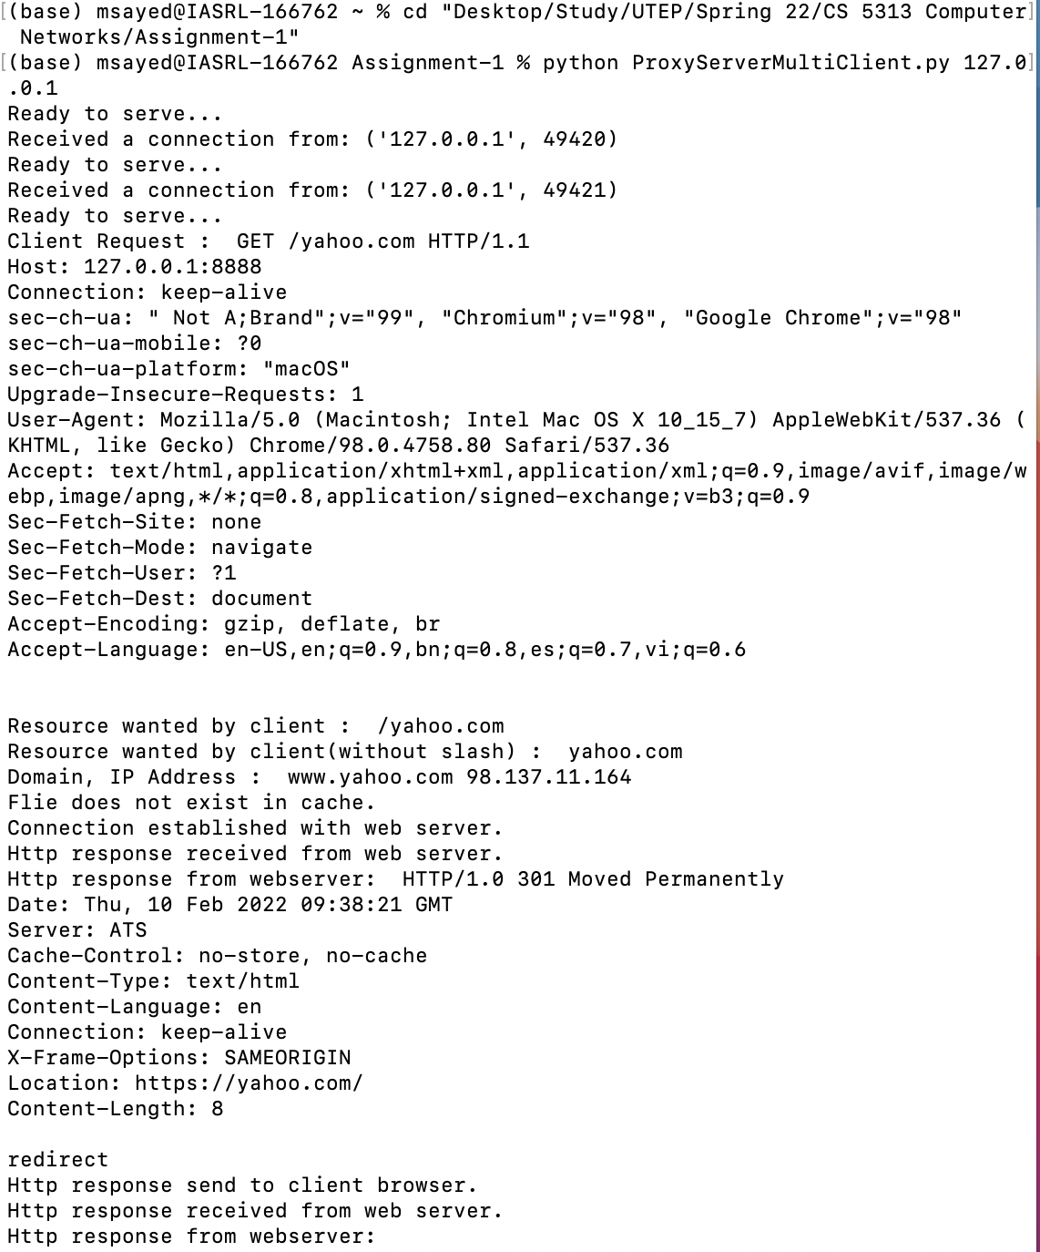

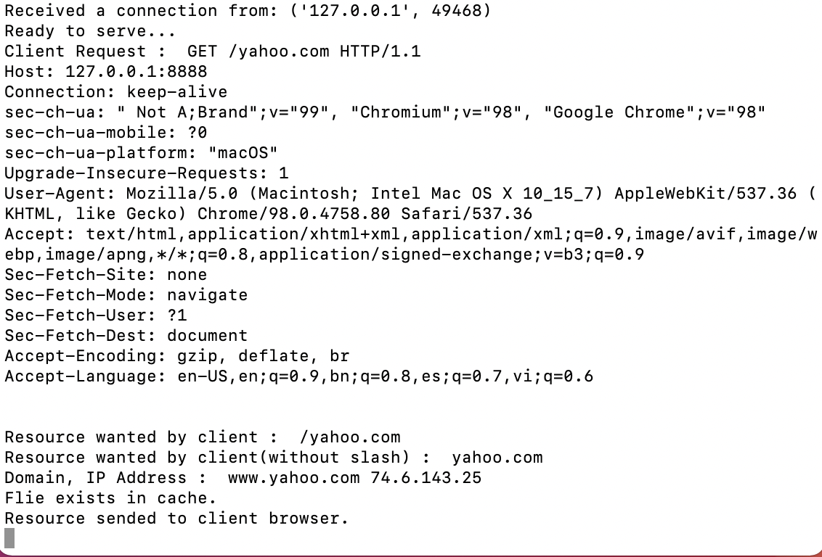

Log.txt now.

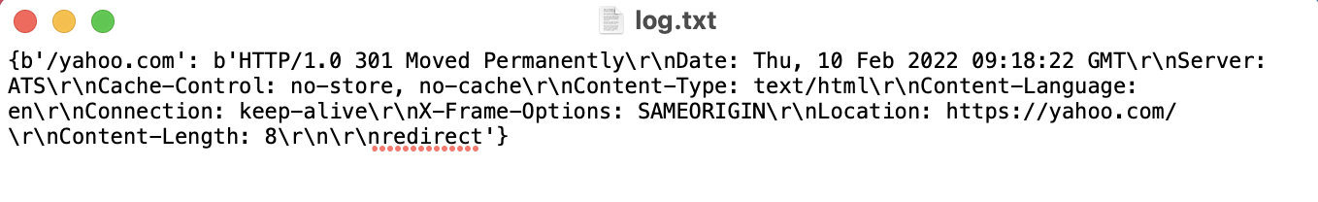

Because of multithreading, sometime printing statements are not in particular order. That’s why I also provide ProxyServerSingleClient.py file. if you run it for yahoo.com , will see following output.

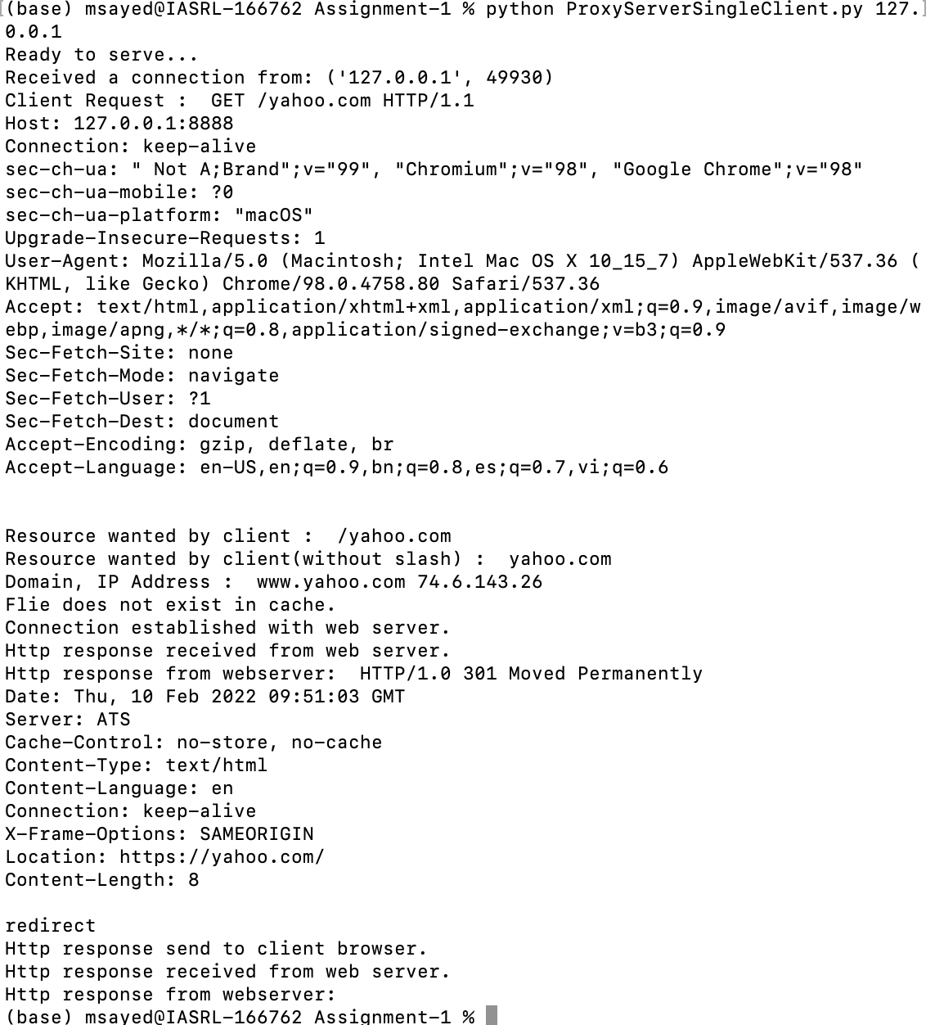

Again when you request for yahoo.com.

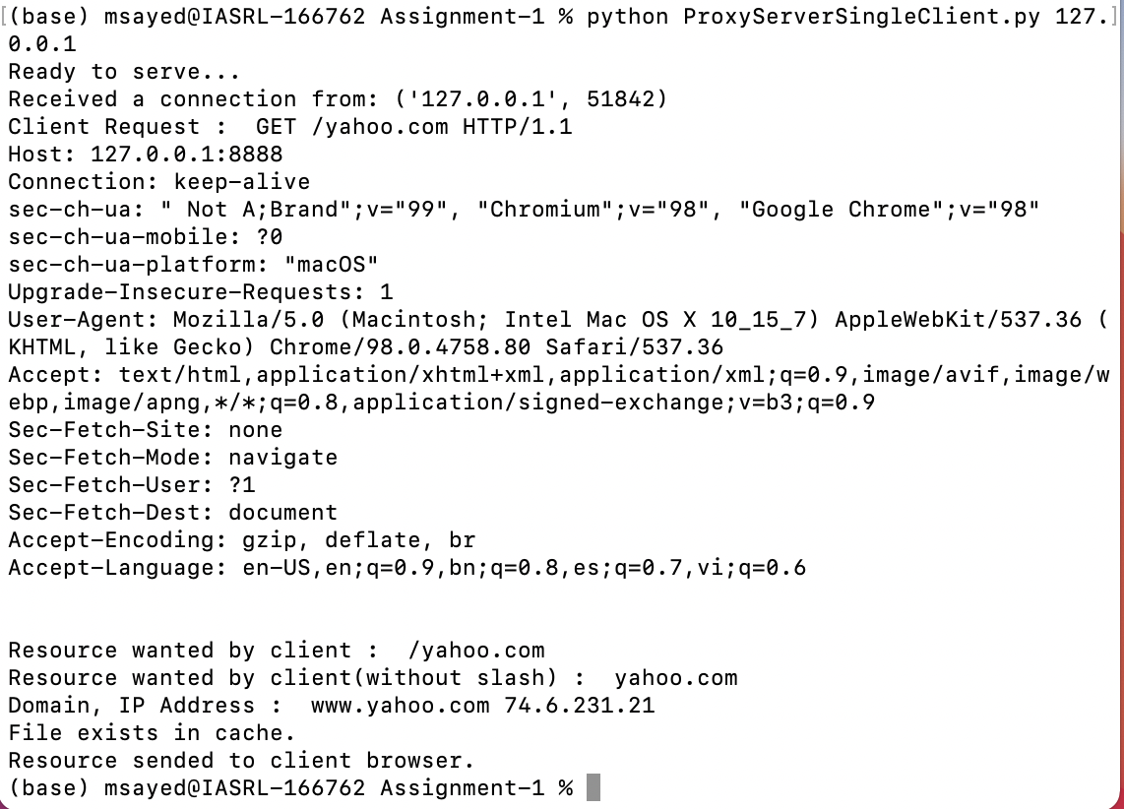

**Comments:** Just try to see these sites (yahoo, youtube, my.utep.edu). Unable to load any other web as we are using only http request, sometime some ICMP messages generation.

References :

1.https://realpython.com/python-sockets/#echo-client-and-server

2.https://www.geeksforgeeks.org/creating-a-proxy-webserver-in-python-set-1/

3.https://stackoverflow.com/questions/59978887/python-how-to-perform-socket-communication-via-socket-makefile