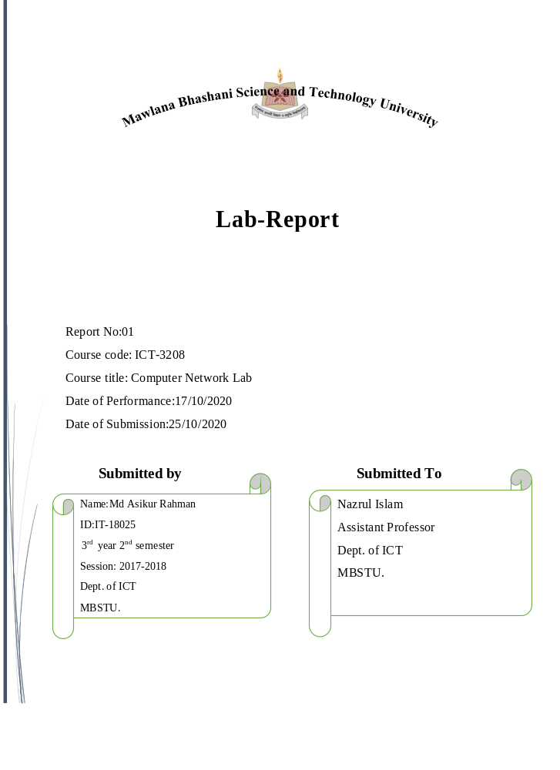

Experiment No:01
Experiment Name: Warmup exercises on Introduction to mininet and command

Installing net tool:
command : sudo apt install net-tools
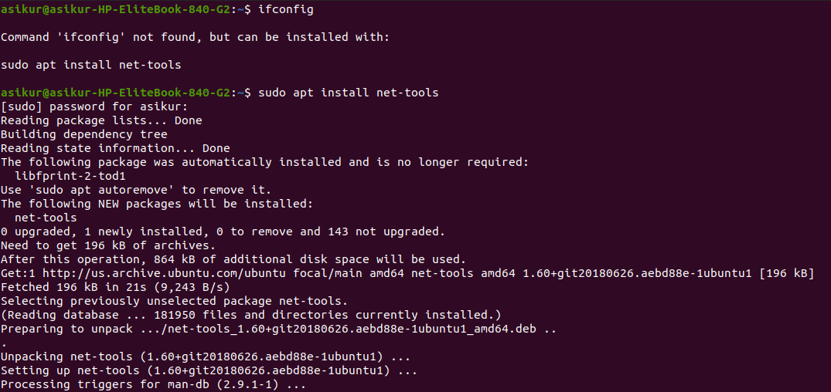

ifconfig : stands for "interface configuration." It is used to view and change the configuration of the network interfaces on your system.
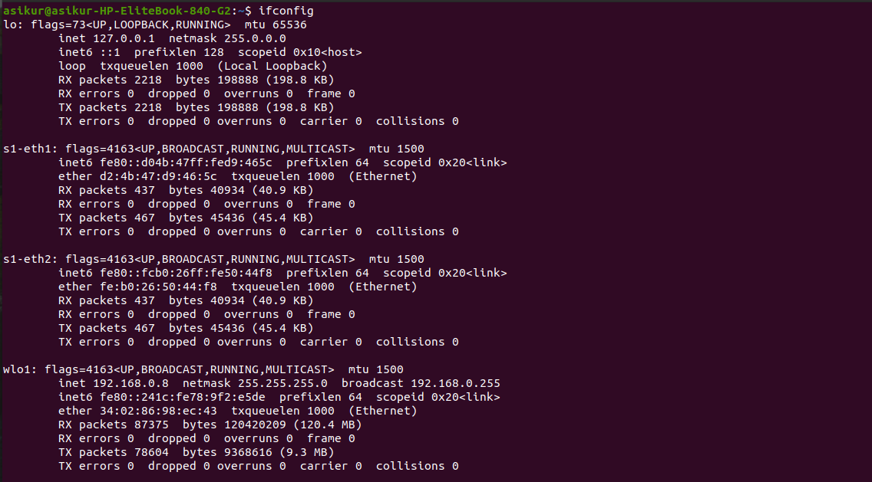
ifconfig -a: Displays the configuration of all interfaces, both active and inactive.
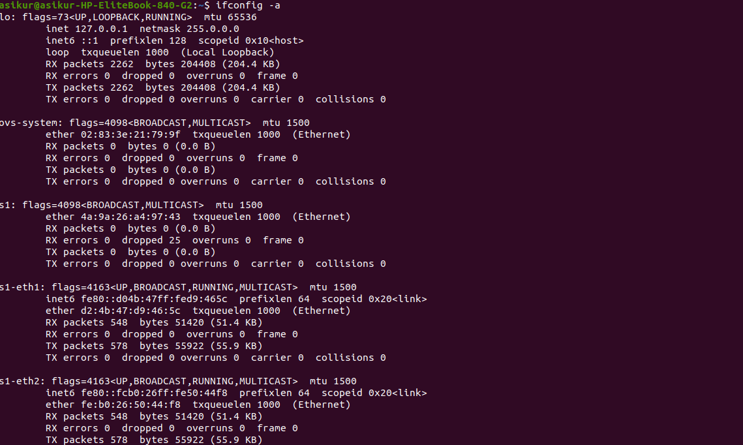

Installing mininet:
command: sudo apt-get install mininet
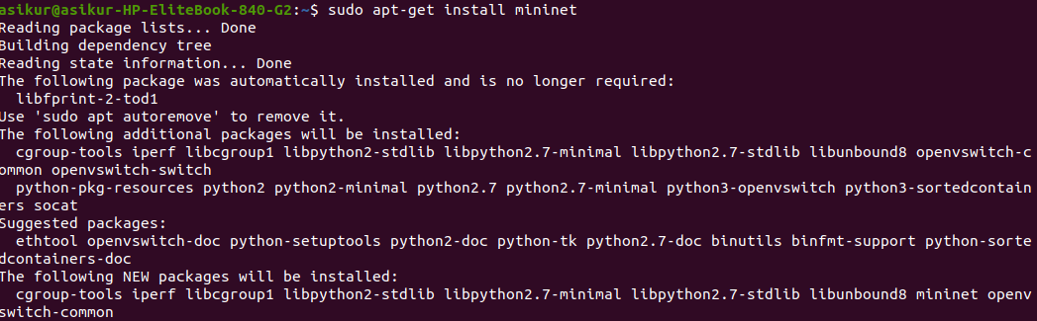

Create Virtual Network:

We will be using CLI(sudo mn command) to manage our virtual network. The default topology includes two hosts (h1,h2), OpenFlow Switch(s1) and OpenFlow controller(c0).

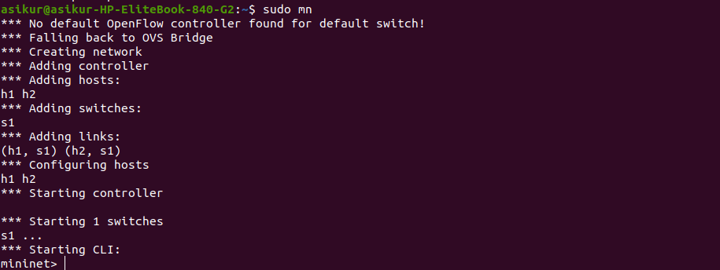

This command launches a simple 2 host, 1 controller, 1 switch topology. The following diagram outlines the topology.
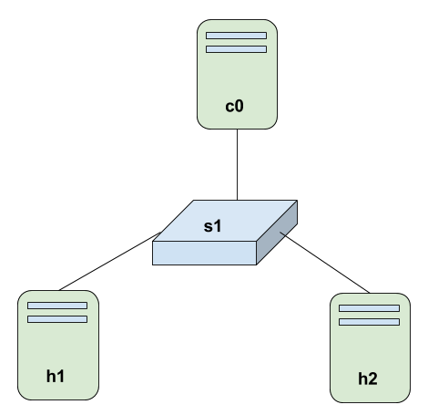

Help command: Run the help option to view the list of commands available:

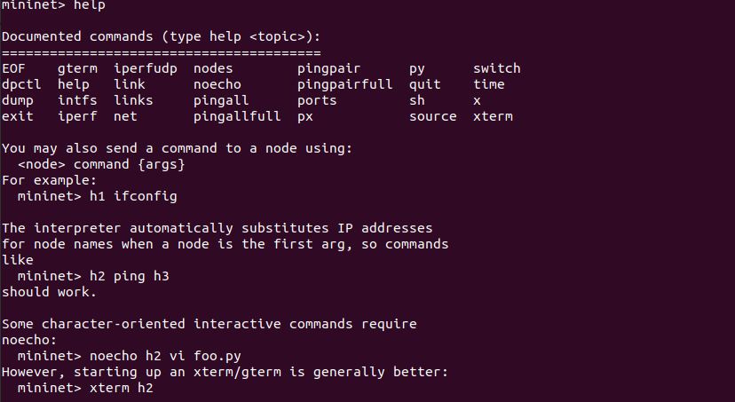
nodes command: Shows the nodes we created with the simple Mininet command:

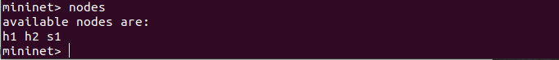

net command: This command shows the links of all nodes

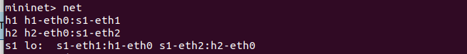

dump command: which displays summary information about all devices:

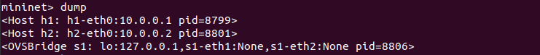

py command: Mininet Command-Line Interface (CLI) Commands command line is py , then that command is executed with Python.
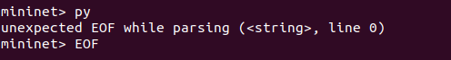
X command:
Time command:
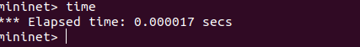
h1 ifconfig -a: This command will display the IP address, broadcast address and MAC address of the host h1. The command h2 ifconfig -a are also as the command
h1 ifconfig -a.
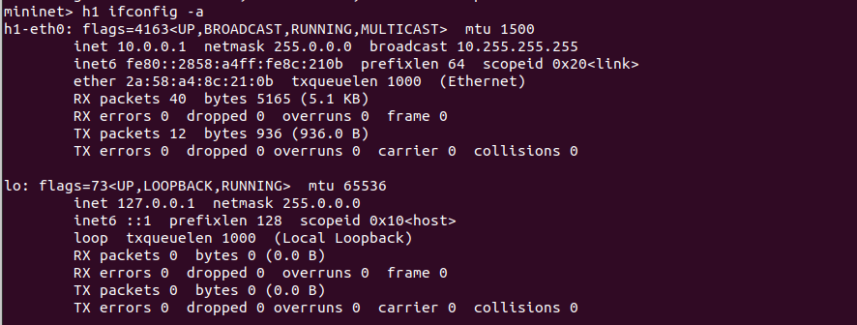

ping command: We can test connectivity between the host by using ping command.
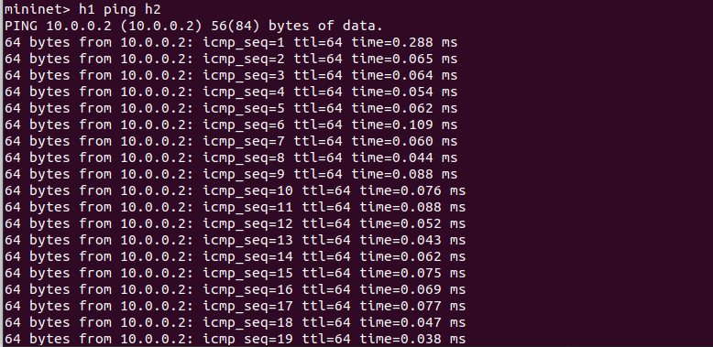

Pingall command: This command will make each host in the network ping every other host in the network. In the network that we have, h1 will ping h2, and h2 will ping h1.

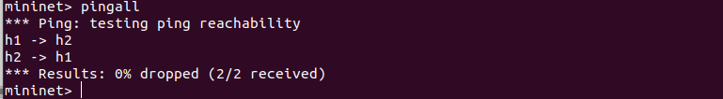

create topology : topo=single,4 that means controller , switch is one and host are 4 like h1,h2,h3,h4

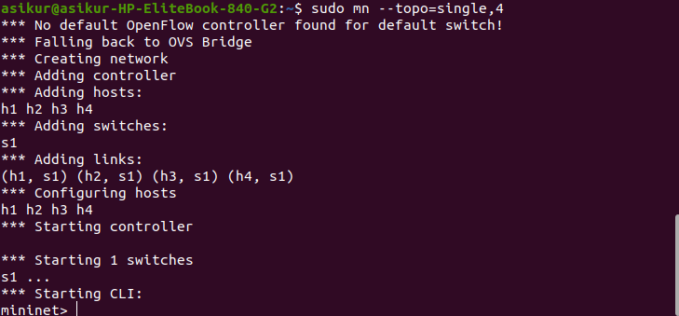
xterm command: The command to open the xterm window is:
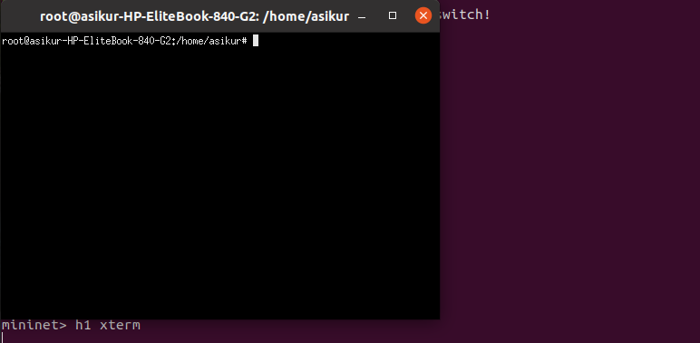

sudo mn -x command :
one node one new corresponding terminal.

exit command:

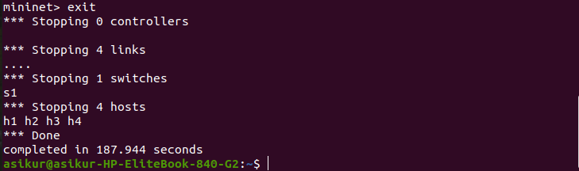

EOF command:
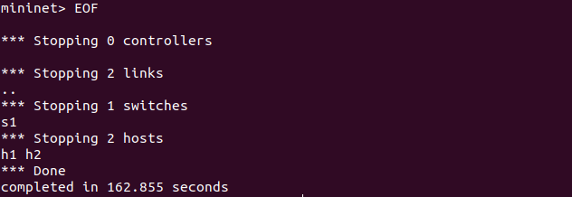

cleanup command: If Mininet crashes for some reason, clean it up:
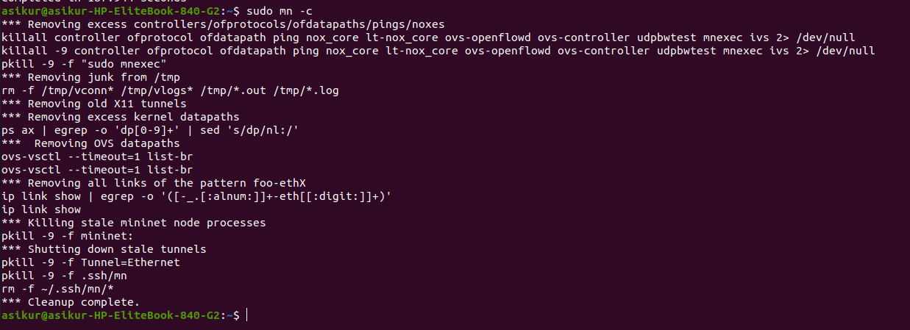

Discussion:
By doing this lab ,we can learn about followings objectives:
1.Learn the basic commands in Mininet
2.Learn how to create basic network topologies in Mininet
3. Learn Mininet API
This walkthrough demonstrates most Mininet commands, as well as its typical usage in concert with the Wireshark dissector.

