

Service hub

Project Proposal



March 4, 2017

CSE-324

Ananya Bhattacharjee #1305046

Abir Shafy Bindu #1305052

MD. Al Amin #1305054

Project Name: Service-Hub

Functionalities:

This software is mainly an e-commerce site. It will work as a bridge between users and technicians, who provides different types of domestic services like electric, sanitary, computer services and so on.

There will be 2 types of users.

1. Root User
2. Service Provider(Technicians)

* Both the root users and the service providers have to have an account to use this software. For signing up both have to provide necessary information.
* Root user have to provide his/her identity along with the location where s/he lives. Service providers have to provide the information regarding their skill and experience about the service he will provide, along with basic info. Thus service providers will be divided in some categories in the system.

When a root user has any problem, and s/he needs service,

* S/he has to search for the technicians in the system. For this search s/he has to provide his/her current location and the type of service s/he needs. User can also provide his/her address from Google Map.
* S/he can also provide some short description about the problem.
* Then the system will show the user the list of technicians. The list of technicians will be sorted based on distance, rating and some other info.
* Users can see the assumed time technician may provide the service. Among the technicians user will select one technician and may call him about the problem.
* Here they will bargain and fix the deal.
* After that technician will go to the root user’s place and provide service.
* After the service is provided user will review the service and give rating to the technician.

Technicians can see the list of services requested to him.

* S/he may accept or reject any service offer.
* If s/he accepts, s/he would provide the estimated time needed.
* After finishing his/her service, s/he will mark the job done.

Motivation

• Household services such as electric or sanitary services are necessary in regular life.

• In an era where everything is getting digitalized, there is little effort on online markets for such household services.

* Customers often do not get the services they need.
* Technicians sometimes do not get jobs according to their skills.

• Similar fields such as online shopping systems have already drawn attention of people.

Tools and Technologies:

We want to implement our system in android platform. This app will have two versions - user and technician. We have an initial plan to use Firebase for implementing database.

Work Schedule:

|  |  |  |  |  |  |  |  |
| --- | --- | --- | --- | --- | --- | --- | --- |
| Week/work | Week 7 | Week 8 | Week 9 | Week 10 | Week 11 | Week 12 | Week 13 |
| Sample Frame |  |  |  |  |  |  |  |
| Order |  |  |  |  |  |  |  |
| Create Account and login |  |  |  |  |  |  |  |
| Database Entry |  |  |  |  |  |  |  |
| Google map |  |  |  |  |  |  |  |
| Testing |  |  |  |  |  |  |  |
| GUI design and update |  |  |  |  |  |  |  |

Sample Graphical User Interface

For Sign up

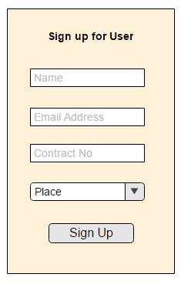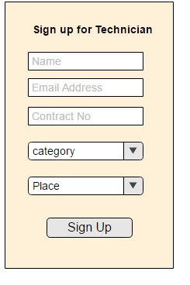

Search for a technician

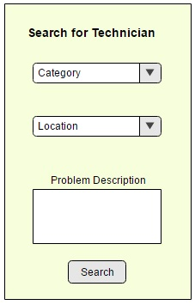

Contract with technician

