Evidence-First Bengali
Hallucination Detection
  - A deterministic selective cascade for the Bengali challenge · Team Huntrix
Touhidul Alam Seyam · IUT 12th ICT FEST Datathon · July 2026

Abstract
We present a Bengali hallucination detector that combines high-precision source lineage, structured task solvers, context-grounding checks, exact lexical and legal evidence, and a quantized open-weight judge used only for unresolved rows. The method raised Kaggle public macro-F1 from 0.657 to 0.967 and finished Phase 1 at private rank 1 with 0.982. On the 299 released labels, the final cascade reaches 0.9933 macro-F1 while deterministic stages cover 225 examples without error. Two frozen Kaggle T4×2 runs reproduced the scored Phase 1 CSV byte-for-byte in 8.8–9.9 minutes. Even a pessimistic all-uncertain 5,000-row run is projected below 5.6 hours, under the nine-hour limit.
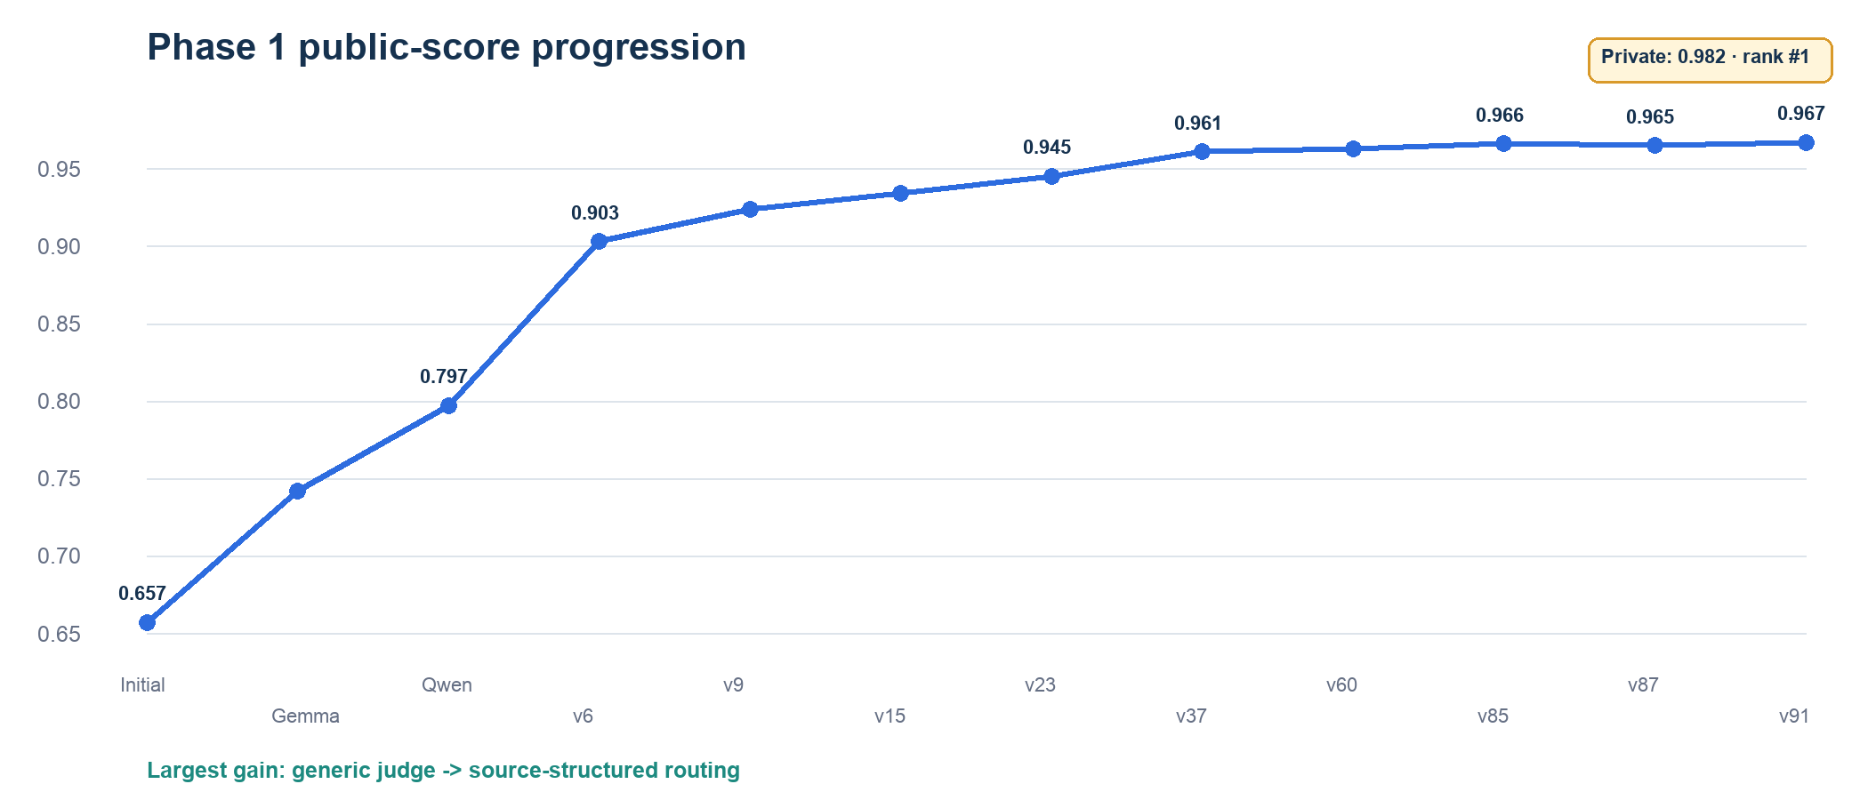
Figure 1. Public macro-F1 progression. The principal gain came from structured/source routing.

1. Problem and design objective
Each record contains optional Bengali context, a prompt, and a response. Label 0 denotes a fabricated, unsupported, or incorrect response; label 1 denotes a faithful response. The released development set contains only 299 labels, so generic fine-tuning risks learning a small and source-specific slice. Our design objective was therefore high-precision resolution with explicit provenance, followed by bounded LLM reasoning only where deterministic evidence is insufficient.

Contributions
- A source-aware router that treats contextual, lexical, legal, numerical, MCQ, idiom, and factual rows differently.
- Reliability-weighted consensus and two-source verification rather than unrestricted retrieval overrides.
- A fixed-order binary GGUF judge that is offline, reproducible, and efficient on Kaggle T4×2.

2. System architecture
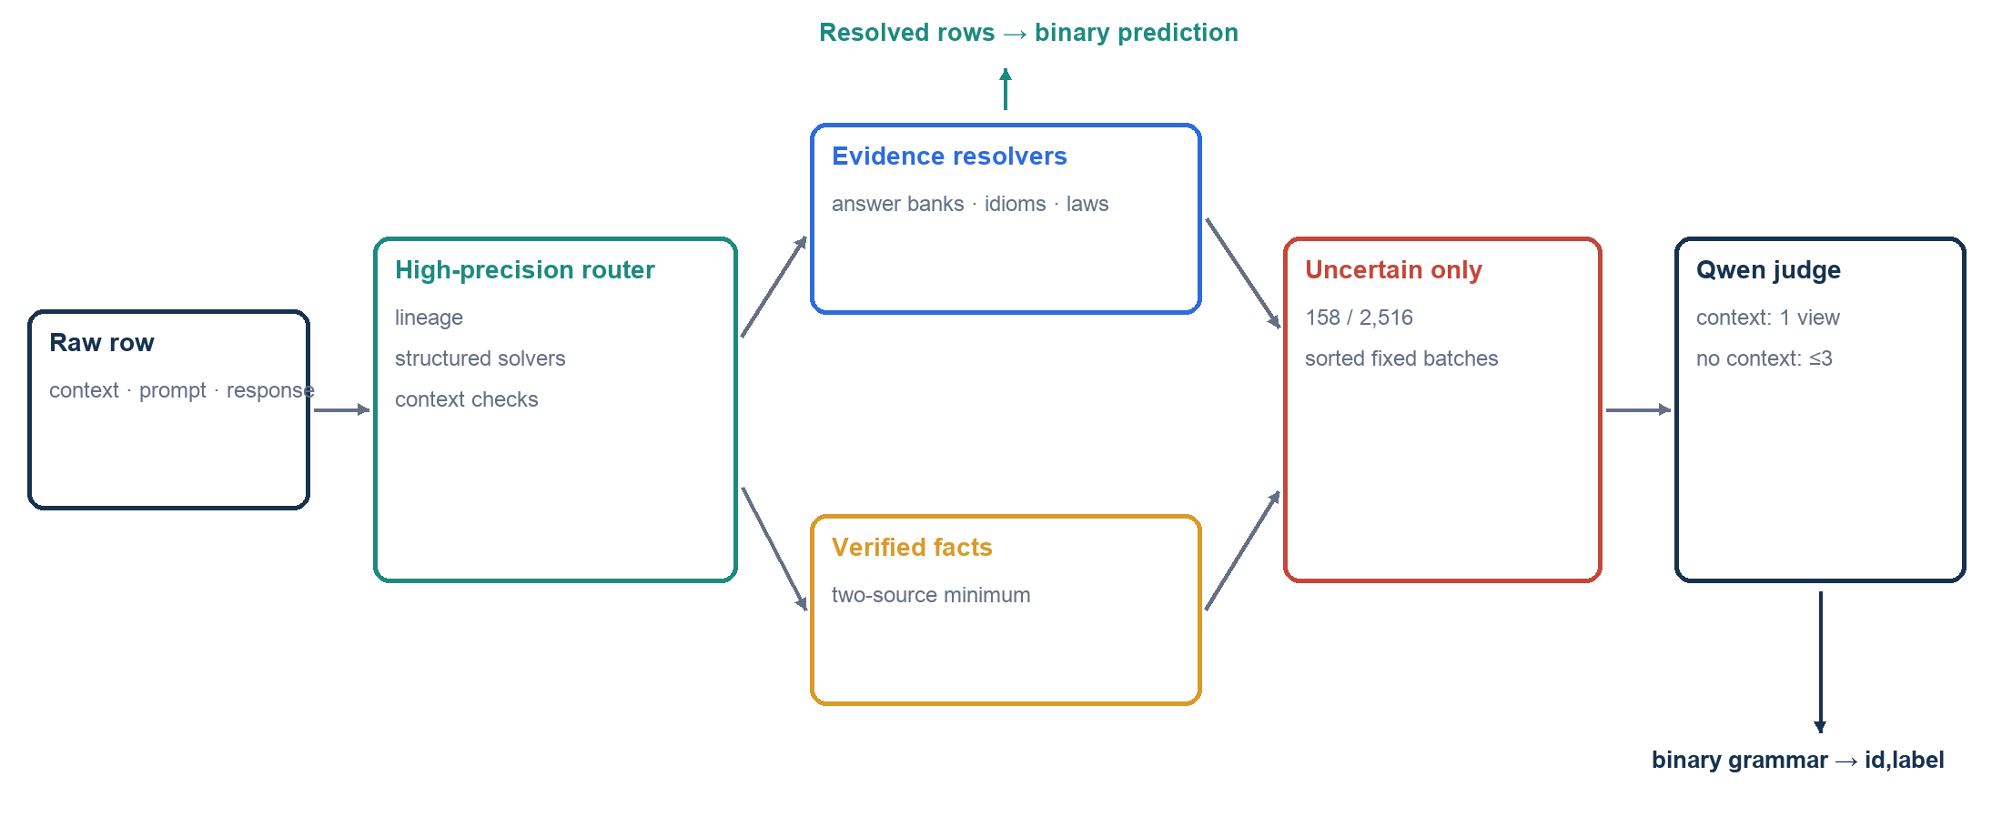
Figure 2. Deterministic evidence resolves confident rows; the LLM receives only the uncertain tail.

Deterministic routing
The router normalizes Bengali digits, punctuation, answer aliases, and optional MCQ choices. It first checks exact released BenHallu lineage and source fingerprints. Structured solvers then handle arithmetic, numeric ranges, morphology, compounds, prefixes, and inline MCQs. Context rules test intrinsic support, contradictions, named entities, and dates without assuming every context is an answer passage. Exact idiom and antonym evidence, authoritative Bangladesh-law sections, and verified fact records resolve additional rows.

Evidence policy
Exact matches may be emitted by one authoritative lineage source. Conflicting answer banks require reliability-weighted agreement. Free-form facts require at least two independent recorded sources. Typed idiom evidence distinguishes literal and figurative senses, while fuzzy matching is conservative and cannot overrule stronger lineage. This hierarchy prevented semantically plausible external facts from replacing benchmark-grounded answers, a failure observed during v73–v78.

Selective open-weight judge
The unresolved queue contains 158 Phase 1 rows, sorted by row ID and split into fixed batches. Context rows receive one context-NLI view. No-context rows use fact, strict-exam, and zero-bias views; a positive label requires unanimity, with early exit after the first zero. Qwen3.6-27B Q4_K_P is served by pinned llama.cpp b9637 across both T4 GPUs. Generation is grammar-constrained to one binary token, thinking is disabled, and seeds and prompt order are fixed.
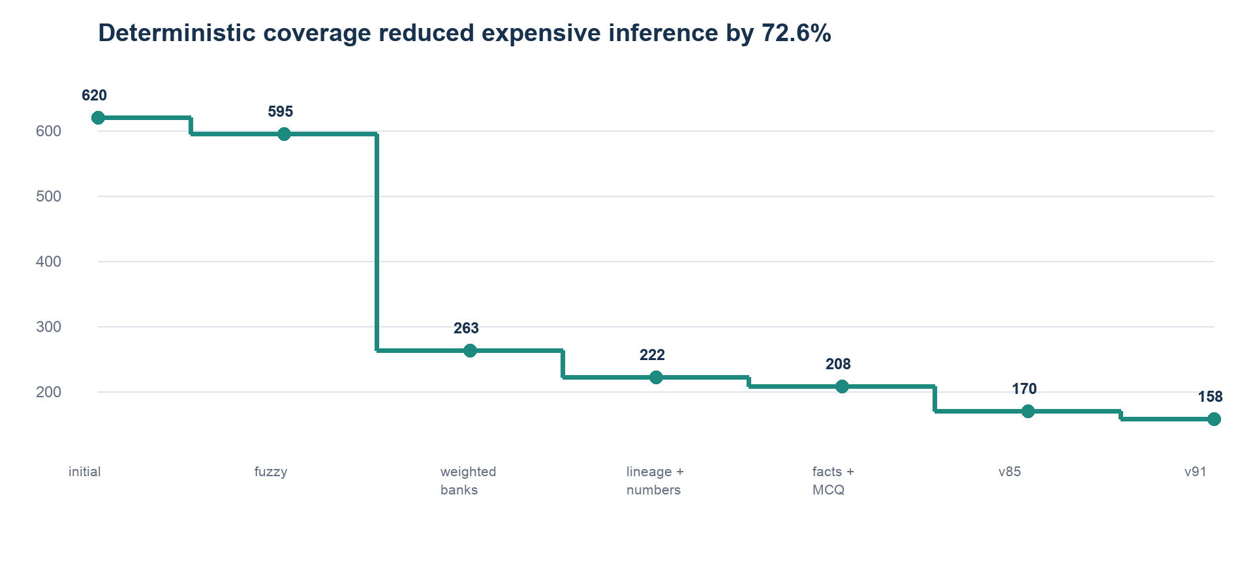
Figure 3. Router evolution reduced the Phase 1 judge queue from 620 to 158 rows.

3. Experiments and error analysis
Stage | Method | Public F1 | Decision
Baseline | char/embedding classifiers | 0.657–0.663 | insufficient factual grounding
Gemma | 12B QAT generic judge | 0.742 | better, but prompt-sensitive
Qwen | 27B + lexical prompt | 0.797 | kept as reasoning component
v6 | source + structured routing | 0.903 | major architecture breakthrough
v15 | lineage and calibrated rules | 0.934 | high-precision expansion
v23 | provenance repairs | 0.945 | evidence beats prompt voting
v37 | source-lineage audit | 0.961 | benchmark lineage matters
v60 | forensic corrections | 0.963 | small safe gains
v85 | two-source fact repair | 0.966 | reproducible anchor
v87 | two plausible fact edits | 0.965 | regression; reverted
v91 | typed idiom + relation guards | 0.967 | private 0.982; rank 1

What failed—and why
- A prompt-vote ensemble reached 0.8512 locally but only 0.783 publicly. The 299 labels were useful for diagnostics, not a guarantee of transfer.
- A compact TF–IDF verifier improved from 0.7879 to 0.8261 OOF but remained below the evidence cascade, especially on no-context cultural facts.
- Raw external-QA retrieval often returned adjacent, non-authoritative snippets. Evidence injection reduced local performance when treated as truth.
- A global context substring rule failed on grammar rows where context described the task rather than containing the answer.
- v73–v78 external-world corrections were quarantined because they contradicted recovered benchmark lineage; v87 confirmed that plausible research can still lower leaderboard F1.

Released-label evaluation
Metric | Final cascade | Deterministic subset
Rows | 299 | 225
Macro-F1 | 0.993264 | 1.000000
Hallucinated F1 (label 0) | 0.992701 | 1.000000
Faithful F1 (label 1) | 0.993827 | 1.000000
Accuracy | 0.993311 | 1.000000

The remaining two validation errors are internally inconsistent controls. We did not fit special cases to them. The public leaderboard evaluates only about 30% of Phase 1, so score differences cannot identify individual hidden labels; candidate admission therefore remained evidence-driven.

4. Reproducibility, deployment, and conclusion
Property | Frozen compliance result
Input | /kaggle/input/competitions/bengali-hallucination/test set.csv
Hardware | Kaggle Tesla T4 ×2; internet disabled
Model | Qwen3.6-27B Q4_K_P GGUF, 16.332 GiB
Runtime | 527.03 s and 593.43 s on 2,516 rows
5k stress bound | all rows × 3 views: approximately 5.2–5.5 h
Output | 2,516 ordered IDs; counts 0=1,181, 1=1,335
SHA-256 | 0fec5d…74c28; identical across both runs and scored v91
Tests | 249 repository tests passing at freeze

Reproduction protocol
- Load only pinned Kaggle Model/Dataset assets; never discover the competition path dynamically.
- Run the deterministic router, then the seeded judge in sorted fixed order; emit exactly id,label.
- Run twice and compare CSV bytes and SHA-256 before freezing the notebook and checkpoint.
- Duplicate rows to approximately 5,000 for a held-out runtime and row-count independence test.

Limitations and responsible use
The 0.982 private result is not a guarantee of broader Phase 2 transfer. Exact lineage is valuable for reproduction but cannot replace general reasoning on new sources. The Phase 1 router includes manually researched, citation-backed answer records for unlabeled prompts; no hidden labels were used, but we disclosed this construction to the organizers because Kaggle's foundational rule on human prediction may govern its interpretation. Third-party licenses and provenance remain explicit, and low-confidence civic or legal answers should be escalated rather than silently accepted.

Conclusion
A compact evidence hierarchy plus selective reasoning was more accurate, faster, and more reproducible than uniform LLM judging. The final package reproduces v91 exactly, finishes Phase 1 at rank 1, and leaves substantial runtime headroom for the broader 5,000-row evaluation.

References
[1] Bengali LLM Hallucination Detection Challenge, Kaggle, 2026.
[2] BenHalluEval: A Multi-Task Hallucination Evaluation Framework for Large Language Models on Bengali.
[3] When Words Don’t Mean What They Say: Figurative Understanding in Bengali Idioms, LREC 2026.
[4] C. Clark et al., TyDi QA: A Benchmark for Information-Seeking Question Answering in Typologically Diverse Languages, TACL 2020.
[5] Qwen Team, Qwen3.6-27B, Apache-2.0; llama.cpp project, MIT, pinned release b9637.

