Environmental Water Requirement Tool for the Murray-Darling Basin
Manual
February 2024

Published by the Murray–Darling Basin Authority
MDBA publication no: 0
ISBN (online): ISBN generated by communications
ISBN (print): ISBN generated by communications
 GPO Box 1801, Canberra ACT 2601 |  1800 230 067
 engagement@mdba.gov.au |  mdba.gov.au

© Murray–Darling Basin Authority 2025

Ownership of intellectual property rights

With the exception of the Commonwealth Coat of Arms, the MDBA logo, trademarks and any exempt photographs and graphics (these are identified), this publication is provided under a Creative Commons Attribution 4.0 licence. (https://creativecommons.org/licenses/by/4.0)
The Australian Government acting through the Murray–Darling Basin Authority has exercised due care and skill in preparing and compiling the information and data in this publication. Notwithstanding, the Murray–Darling Basin Authority, its employees and advisers disclaim all liability, including liability for negligence and for any loss, damage, injury, expense or cost incurred by any person as a result of accessing, using or relying upon any of the information or data in this publication to the maximum extent permitted by law.
The Murray‒Darling Basin Authority’s preference is that you attribute this publication (and any Murray‒Darling Basin Authority material sourced from it) using the following wording within your work:
Cataloguing data
Title: Environmental Water Requirement Tool for the Murray-Darling Basin, Murray‒Darling Basin Authority Canberra, 2025. CC BY 4.0
Accessibility
The Murray‒Darling Basin Authority makes its documents and information available in accessible formats. On some occasions the highly technical nature of the document means that we cannot make some sections fully accessible. If you encounter accessibility problems or the document is in a format that you cannot access, please contact us.
Acknowledgement of the Traditional Owners of the Murray–Darling Basin
The Murray−Darling Basin Authority pays respect to the Traditional Owners and their Nations of the Murray−Darling Basin. We acknowledge their deep cultural, social, environmental, spiritual and economic connection to their lands and waters.
The guidance and support received from the Murray Lower Darling Rivers Indigenous Nations, the Northern Basin Aboriginal Nations and our many Traditional Owner friends and colleagues is very much valued and appreciated.
Aboriginal people should be aware that this publication may contain images, names or quotations of deceased persons.

Version control
Version | Revision date | Author/modifier | Distributed to
v.1.1

Contents
Introduction Error! Bookmark not defined.
EWR assessment method 2
Access to EWR tool 2
Input hydrological data to EWR tool 2
Parameter sheet 3
Observed data 3
Modelled scenario 3
Within the EWR tool 6
Outputs from the EWR tool 6
Output results description 7
Description of ewr_results dataframe 7
Description of yearly_ewr dataframe 8
Description of all_events dataframe 9
Description of all_successful_events 10
Description of all_inter_events 11
Description of all_successful_interevents 11
NSW EWRs Error! Bookmark not defined.
Introduction to NSW EWR development Error! Bookmark not defined.
NSW flow categories Error! Bookmark not defined.
Cease-to-flow Error! Bookmark not defined.
Assessment rules for cease-to-flow NSW Error! Bookmark not defined.
Low flows and baseflow Error! Bookmark not defined.
Assessment rules for low flow and baseflow NSW Error! Bookmark not defined.
Standard flows Error! Bookmark not defined.
Assessment rules for standard flow Error! Bookmark not defined.
Code Error! Bookmark not defined.
Volumetric Error! Bookmark not defined.
Assessment rules for volumetric Error! Bookmark not defined.
Code Error! Bookmark not defined.
Multigauge Error! Bookmark not defined.
Code Error! Bookmark not defined.
Wier pool Error! Bookmark not defined.
Code Error! Bookmark not defined.
Lake level Error! Bookmark not defined.
Assessment rules for lake level NSW Error! Bookmark not defined.
Code Error! Bookmark not defined.
Nesting flows Error! Bookmark not defined.
Assessment rules for nesting flows NSW Error! Bookmark not defined.
Code Error! Bookmark not defined.
SA EWRs Error! Bookmark not defined.
Introduction to SA EWR development Error! Bookmark not defined.
SA flow categories Error! Bookmark not defined.
In-channel flow and entitlement flow Error! Bookmark not defined.
Floodplain flow Error! Bookmark not defined.
Coorong, Lower Lakes and Murray Mouth flow Error! Bookmark not defined.

.

EWR assessment method
The EWR_tool contains the standalone Python package called py-ewr. This Python package takes daily flow data in the form of observed flows or modelled scenario flow data. It then accesses the EWR parameter sheet to look for all the EWRs available at the sites that were loaded in with the flow data and calculates the achievement of each applicable EWR using the supplied flow time series. This calculation involves a number of statistics outlined in the EWR assessment categories section of this document. When using the installable py-ewr package or jupyter interface, EWR results are provided via 6 Pandas dataframes. These are described in more detail below. The EWR tool is version controled via open source GitHub repository . Figure 1 shows schenatic of EWR tool work flow.

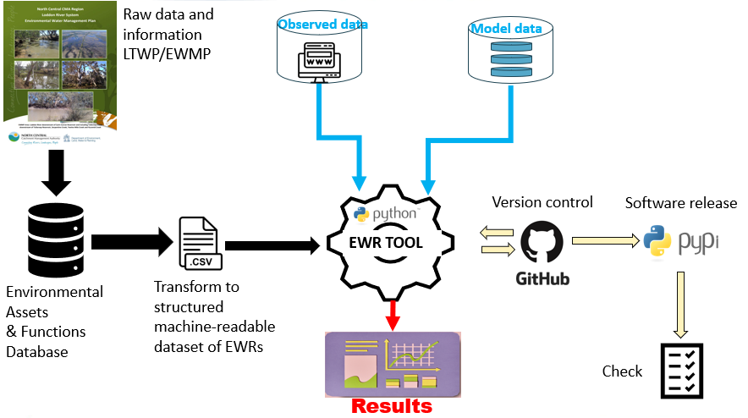
Figure 1 Schematic of EWR tool work flow

Access to EWR tool
EWR tool codes are available as open source for public access via GitHub repository. On the GitHub repository, users can find instruction on how to install the Python package via command line using pip: ‘pip install py-ewr’. If you find any issues with the package, please submit an issue on the Github issues repository.

Input hydrological data to EWR tool
This Python package has embedded a parameter sheet and takes daily flow data for two types of analysis. In the form of observed flows or modelled scenario flow data.

Parameter sheet
Each time the tool is run, it will read the parameter sheet data stored with the code. The parameter sheets include parameters defined in states long term plans. The parameter sheet can be downloaded from GitHub repository. Users who wish to explore different sets of rules as defined in the parameter sheet, advised to download the parameter sheet into their local pc or individual repositories and apply changes. Applied changes can be pushed into main branch on GitHub where MDBA team will assess case by case requests.

Observed data
If using this option, the tool will fetch the observed data from relevant water data portals for the selected locations using a python package called MDBA_Gauge-Getter which is part of EWR tool package. MDBA Gauge Getter provides a unified and simple interface to collect surface water data from the following state water portals as shown in Table 1. The tool is configured to abstract away the details specific to each state water portal and return a consistent structure. By default it will return a daily mean of a flow in ML/day for a given gauge number, but storage level, storage volume, other intervals and aggregations are available
Table 1 State water portals
State | Site | Source
NSW | realtimedata.waternsw.com.au | CP
QLD | water-monitoring.information.qld.gov.au | PUBLISH
VIC | data.water.vic.gov.au | AT
SA | bom.gov.au/waterdata/ | BOM Water Data Online

Modelled scenario
If using this option, the user will need to specify the locations of the modelled scenario data files. If the user has model formats (including variations of datetime formats) that fall outside of this, please contact the developers, listed on Github with the EWR_tool, as they will be able to amend the tool to ingest other formats. Failure to follow these formatting requirements could result in errors. The py_ewr package is currently compatible with 3 model formats:
- BigMod – MDBA
- Source – NSW (res.csv)
- IQQM – NSW 10,000 years.
If you have other scenario modelled data formats that are not covered here please contact the MDBA at dataservices@mdba.gov.au and they will be able to amend the code to make it compatible with other model formats.

BigMod-MDBA format
An example of the MDBA BigMod format time series formatting (colours shown for emphasis in this manual only) is in Figure 2. The orange value (cell A6) contains the number of sites in the dataset – it is important this is accurate, so if time series are modified this should be updated too.
The tool ingests the header data (in this example rows 1 to 8 inclusive), and then the flow data (rows 9 inclusive and onwards). The header data is used to construct new column headings using the site-measurand-quality information highlighted below. This is the key information used later in the tool. The list of newly constructed header data then replaces the current headings loaded in. This is critical when manipulating BigMod time series, because if you delete header data but not the matching column, the header data list will not match the columns and you could get erroneous results.
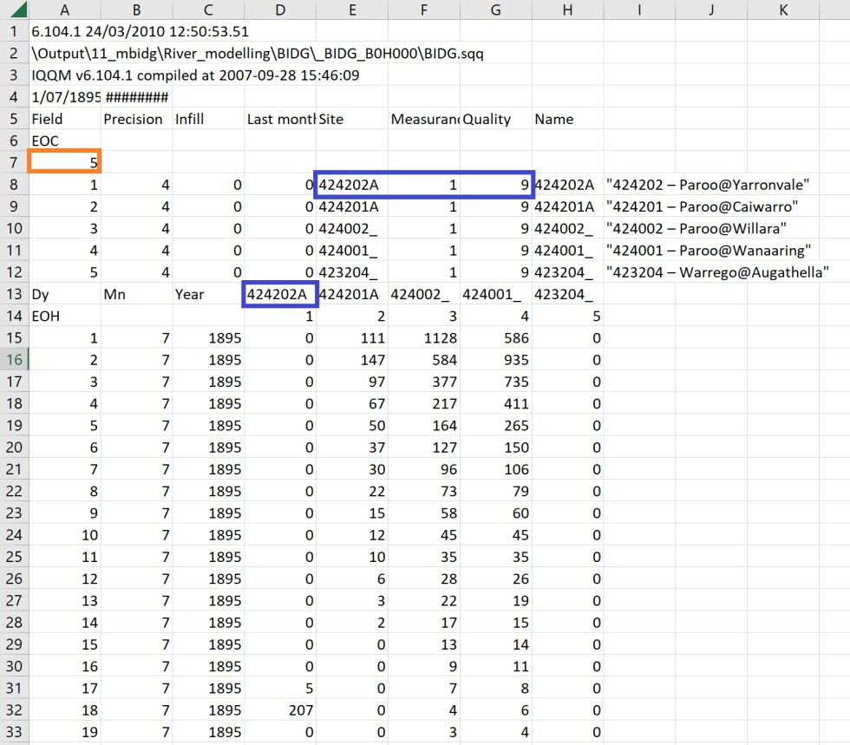
Figure 2 Example of BigMod format data

Source-NSW (res.csv) format
Figure 3 shows an example of res.csv output (noting the highlighting is for the purposes of this manual only). Some key elements of this layout include the EOC value of 5 (shaded orange), representing 5 sites with data. The tool will take a list of the header
data ‘Name’ column, and save this to the flow data headings (as demonstrated with the shading, the top value in the name column will be saved to the left most flow heading, and so on). These flow data headings are then matched with their respective gauges using the ‘SiteID_NSW.csv’ file in the model_metadata folder and checked against any EWRs in the database for that location.
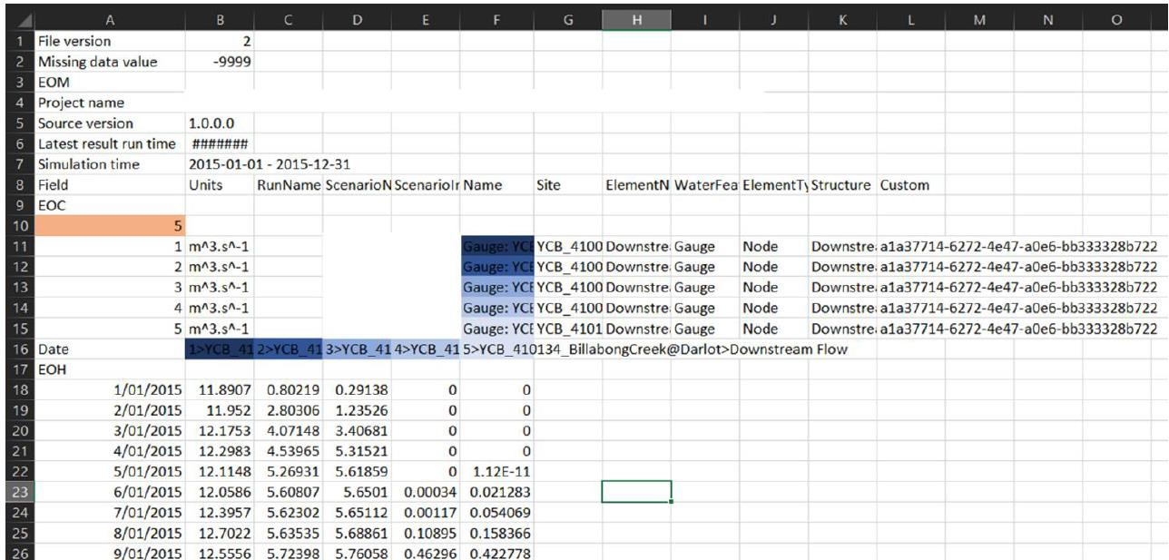
Figure 3 Example of Source format data

IQQM-NSW 10,000 years format
The tool has been written to handle these 10,000-year climate series as requested by New South Wales. Figure 4 gives an example of the file format. This option takes a ‘.csv’ file, and is required to have a ‘Date’ column and a column titled with a text string that contains a gauge (highlighted blue here for display purposes). As long as the gauge is written in the heading, the program will be able to find this, and use it to link to the EWR database.
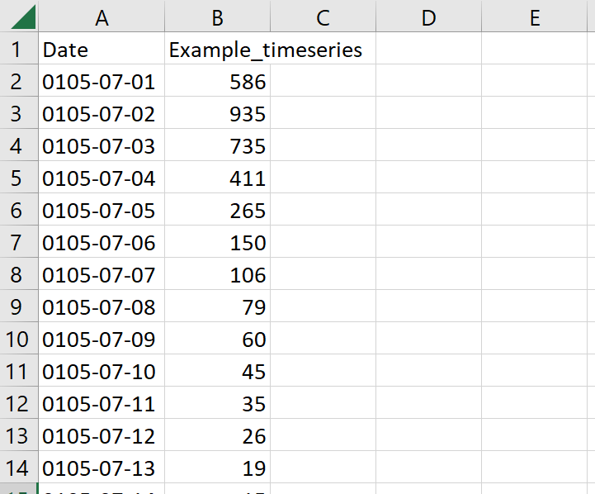
Figure 4 Example of IQQM model data

Within the EWR tool
The package is made up of:
- 5 Python scripts (the tool)
- 7 Python test files
- modelled scenario data metadata for linking model nodes to gauges. If users notice model locations are not being evaluated, it may be because of missing relational links between nodes and gauges. This is updated regularly, by the MDBA, to add in any missing links.

Outputs from the EWR tool
The tool outputs 6 Pandas dataframes as shown in Figure 5:
- ewr_results
- yearly_ewr
- all_events
- all_successful_events
- all_inter_events
- all_successful_interevents.
These report on 5 elements of EWR achievement that are tracked in the tool:
- successful achievements – when all parts of the EWR are met, including multiple successful events in a single year
- successful events – when all parts of the EWR are met, excluding multiple events per year
- any event – any event that meets the flow/level/volume requirement and falls within the timing window irrespective of duration. This allows for partial duration successes to be reported, information that is important for water management.
- inter-event periods between successful events
- inter-event periods between all events.

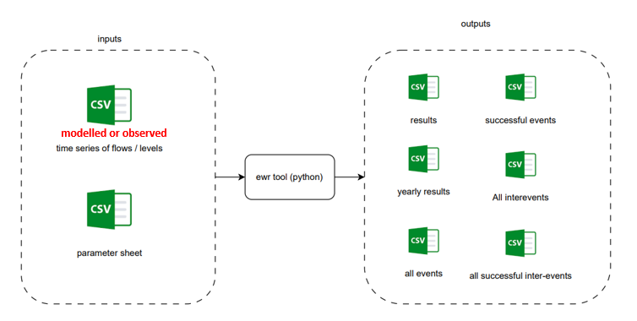
Figure 5 EWR tool output results

Output results description

Description of ewr_results dataframe
The ewr_results dataframe provides a summary of the results for each EWR over the entire period of the input time series. It also provides separate results for events that meet all EWR parameters and events that meet the EWR flow/level/volume threshold and timing requirements but not necessarily the duration requirements. Table 2 provides a description of ewr_results dataframe outputs. Table 2 provides a description of ewr_results dataframe outputs.

Table 2 Descriptions of ewr_results dataframe
Columns | Description | Example
Scenario | Type or name of the scenario | observed
Gauge | Gauge number | 410001
PlanningUnit | Planning unit name | Willandra Creek
EwrCode | EWR code | BF1_a
Multigauge | Gauge number if there is a second gauge used for the EWR. Identifies the second gauge so flows from the 2 gauges can be combined. Is currently used only for ‘multigauge’ EWRs | 454
EventYears | Count of event years (years where all annual EWR parameters are met, e.g. flow/level/volume threshold, duration and timing) | 1
Frequency | Calculated frequency as % of years achieved (based on the number of successful vs total years in the input time series).  Calculated for cease-to-flow using the maxRollingAchievement column from the yearly_ewr dataframe. All other EWRs use eventYears column from the yearly_ewr dataframe. | 50
TargetFrequency | Target frequency specified in the LTWP as % of years | 50
AchievementCount | Count of total achievements (how many times all EWR parameters, including multiple events per year requirements, were successfully met for the entire time series. Some EWRs require more than one successful event per year) | 2
AchievementPerYear | AchievementCount divided by the total number of years in the input time series | 0.5
EventCount | Sum of numEvents, from yearly_ewr dataframe, for successful EWR events that meet all flow/level/volume threshold, duration and timing requirements. When multiple events are required for the achievement of an EWR these are counted as individual events | 1
EventCountAll | Sum of numEventsAll, from yearly_ewr dataframe (any event that has met the flow/level/volume threshold and timing requirements) | 2

Description of yearly_ewr dataframe

The yearly_ewr dataframe provides a yearly summary for each EWR and each water year included in the input data. Table 3 provides a description of yearly_ewr dataframe outputs.

Table 3 Description of yearly_ewr dataframe
Columns | Description | Example
Year | Water year (1 July to 30 June), i.e. an event starting 24 October 2022 that finishes on 30 April 2023 will show the year 2023 | 2023
eventYears | 1 if all parts of the EWR were achieved and 0 if not (all parts of the EWRs need to be met). CTFs (except ALT_CTF) will be given a 1 in this column if they exceed duration (do not meet LTWP requirements); however, if they span multiple water years a 1 will only be applied in the year that the event finishes.  See maxRollingAchievement for annual reporting on CTFs that exceed maximum durations (given 1). This column aligns with original LTWP development and is best used for annual reporting | 1
numAchieved | Count of EWR achievements in the year | 2
numEvents | Count of individual successful events achieved in the year. Count 1 for each time an event exceeds the minimum required duration (successful EWR event, meets all threshold, duration and timing requirements). A count of greater than one can also be achieved for very low flow and baseflows if the number of days in the water year is exceeded more than once (e.g. duration requirement is 55 days and 110 days occurs numEvents would be 2) | 2
numEventsAll | Count of events in the year. Count 1 for each irrespective if the minimum event requirement and duration are achieved | 3

Description of all_events dataframe
The all_events dataframe details each individual event (an event that meets the timing and flow, volume or water level requirements) irrespective of any duration or minimum event requirements, i.e. it will detail an event that meets the flow/level/volume threshold at the correct timing of year but does not check for the required minimum duration. Table 4 provides a description of all_events dataframe outputs.

Table 4 Descriptions of all_events dataframe
Columns | Description | Example
scenario | Type or name of the scenario | observed
gauge | Gauge number | 410033
pu | Planning unit name | Willandra Creek
ewr | EWR code | VF1_a
waterYear | Water year (1 July to 30 June), i.e. event starting 24 October 2022 that finishes on the 30 April 2023 will show the year 2023 | 2023
startDate | Start date of EWR event in format DD/MM/YYYY | 1/07/2022
endDate | End date of EWR event in format DD/MM/YYYY | 30/06/2023
eventDuration | Event duration in days. This is the number of days an EWR event goes for including the days that fall below the threshold when a ‘within event gap tolerance’ is specified. This column will be different to the eventLength column only when an EWR has a ‘within event gap tolerance’ that occurs throughout its duration | 365
eventLength | Event length in days. This is the number of days an EWR event goes for excluding the days that fall below the threshold when a ‘within event gap tolerance’ is specified. This column will be different to the eventDuration column only when an EWR has a ‘within event gap tolerance’ that occurs throughout its duration and it will have less days | 330
multigauge | Gauge number if there is a multigauge in the EWR (second gauge)

Description of all_successful_events
The all_successful_events is a version of the all_events dataframe that provides the same outputs but has filtered out all events that have durations less than the minimum required duration defined in the EWR tables as specified in each plan. Table 5 provides a description of all_successful_events dataframe outputs.

Table 5 Description of all_successful_events dataframe
Columns | Description | Example
scenario | Type or name of the scenario | observed
gauge | Gauge number | 410033
pu | Planning unit name | Willandra Creek
ewr | EWR code | VF1_a
waterYear | Water year | 2022
startDate | Start date of EWR event in format DD/MM/YYYY | 1/07/2022
endDate | End date of EWR event in format DD/MM/YYYY | 30/06/2023
eventDuration | Event duration in days | 365
eventLength | Event length in days | 365
multigauge | gauge number if there is a multigauge in the EWR (second gauge)

Description of all_inter_events
The all_inter_events dataframe is the inverse of the all_events dataframe and provides the max inter-event period between each individual event (an event that meets the timing and flow, volume or water level requirements) irrespective of any duration requirements. Table 6 provides a description of all_inter_events dataframe outputs.

Table 6 Description of all_inter_events dataframe
Columns | Description | Example
scenario | Type or name of the scenario | observed
gauge | Gauge number | 410033
pu | Planning unit name | Willandra Creek
ewr | EWR code | VF1_a
startDate | Start date of EWR inter-event period in format DD/MM/YYYY | 1/07/2022
endDate | End date of EWR inter-event period in format DD/MM/YYYY | 30/06/2023
InterEventLength | Inter-event duration in days | 365

Description of all_successful_interevents
The all_successful_interevents dataframe is the inverse of the all_successful_events dataframe, providing the inter-event period between successful events. Table 7 provides a description of the all_successful_interevents dataframe outputs.

Table 7 Description of all_successful_interevents dataframe
Columns | Description | Example
scenario | Type or name of the scenario | observed
gauge | Gauge number | 410033
pu | Planning unit name | Willandra Creek
ewr | EWR code | VF1_a
startDate | Start date of EWR inter-event period in format DD/MM/YYYY | 1/07/2022
endDate | End date of EWR inter-event period in format DD/MM/YYYY | 30/06/2023
InterEventLength | Inter-event duration in days | 365

