FUTURE PATH

Student Advising System — LocalDB edition
Updated implementation-aligned design and beginner walkthrough. 18 October 2026. Technical draft for group review; complete actual team identities, responsibilities and approved-design reconciliation. Windows/LocalDB execution remains unverified in this Linux workspace.
See docs/Validation.md for exact current build/test results. Original SQLite baseline evidence is historical reference only.

Future Path — Systems Design Specification
Implementation version 1.1 (LocalDB migration) • INF2011S • Technical draft for team review
Team members, student numbers, responsibilities, actual milestone dates and signatures must be completed by the team. This document describes the implemented design and must be reconciled with any previously submitted specification. It does not assert that Windows manual tests or a marking assessment have taken place.

1. Introduction

1.1 Overview
Future Path translates the supplied student advising case study into a standalone desktop system. This specification explains its scope, screens, object interactions, classes, relational data model, reports, controls and test approach. It provides a blueprint for understanding and maintaining the implementation and a basis for comparing test outcomes against the stated requirements.

1.2 Context and scope
South African Grade 11 and 12 learners need early guidance about the relationship between school results, interests, degree requirements and possible funding. Learners capture a profile, subjects and marks, complete an interest questionnaire, select one degree, and receive an explained advisory result, alternatives and optional funding information. They can export a summary for a parent, teacher or advisor.
Career Advisors authenticate to retrieve saved sessions, create follow-up assessments and generate reports. System Administrators authenticate to maintain reference data and staff accounts, review the audit trail and back up the database. Application submission, official admission decisions, online funding applications, live university information, parent accounts, multilingual support, web hosting and external AI are outside this iteration.

1.3 Assumptions and constraints
- C# / .NET 10 Windows Forms, Windows 10/11 x64, one user and one application instance per local database.
- SQL Server Express LocalDB is the local relational database server on the same Windows machine. The database is FuturePathStudentAdvisingSystem, prepared explicitly with the Database scripts. No web server, cloud runtime or internet connection is needed for advising.
- Three tiers: Presentation (`FuturePath.Desktop`), Business Logic (`FuturePath.Business`), and Data Access (`FuturePath.Data`). The composition root wires them together; business contracts are interfaces.
- No ChatGPT, Gemini, Copilot, external AI, online API or internet feature is part of the running application. All advice is calculated locally from stored rules and questionnaire data.
- Grade 11 results are provisional. Sample programmes and funding must be verified with official sources. A near match is not an assertion that entry requirements are met.
- Names and contacts are optional to minimise personal information. Grade is required. No ID number, date of birth or household income is collected.
- Personal profile details are created with an assessment. A staff follow-up preserves identity and creates a new assessment with changed marks, grade, programme or responses. Previous results remain immutable.
- An explicit confirmation distinguishes missing subjects from an incomplete list. If the list is incomplete, the system returns More Information Needed rather than assuming a missing required subject is not taken.
- Questionnaire answers are a 1–5 Likert scale. All active questions must be answered for a complete assessment. At least eight are seeded.
- A missing mandatory subject or mandatory mark shortfall greater than five points means Not Currently Eligible. A shortfall of one to five points is Possible Match. Strong Match additionally requires interest alignment ≥60%.
- Funding availability is evaluated using the computer's current local date, with the closing date inclusive. Sessions and report timestamps are recorded in UTC. Funding records can therefore change between an assessment and a later export; the report generation date is explicit.
- Historical scores and explanations are stored. Reference labels, learner identity and current open funding are read at report time; editing a reference label may change a historical report's displayed name, not its saved scores. Original exported documents are not overwritten automatically.
- Local files are protected by the Windows account. Application authorization does not encrypt the database or defend against direct filesystem access.

2. User interface and dialogue design

2.1 Interface flow
flowchart TD
Home[Overview] --> Profile[New session: profile / grade]
Profile --> Marks[Subjects and marks]
Marks --> Interests[Interest questionnaire]
Interests --> Select[Faculty, degree and funding opt-in]
Select --> Result[Check and persist assessment]
Result --> Alternatives[Explained outcome and ranked alternatives]
Result --> Funding[Open linked funding if requested]
Result --> Summary[Advisory summary viewer]
Summary --> Export[Text / HTML export or Windows print]
Home --> Login[Staff sign-in]
Login --> Advisor[Learners and saved sessions]
Advisor --> Summary
Advisor --> Followup[Create new follow-up from saved session]
Followup --> Profile
Login --> Reports[Activity and exception reports]
Reports --> Export
Login --> Admin[Administrator-only maintenance]
Admin --> Reference[Reference records / staff accounts]
Admin --> Backup[Audit review and local backup]
The main window hosts all learner/staff/report/editor UserControls. AdvisingPage uses retained panels instead of selectable tabs, with Back/Next validation and a clear step indicator. Summary preview stays in the shell. The sidebar is rebuilt after authentication. Authorization is also checked in the business services, so hiding buttons is not the security boundary. A guest can export only sessions created in the current workspace. Signing out clears workspace ownership and screen content. Navigating away from unsaved entries asks for confirmation.

2.2 Screen standards
Segoe UI at 10pt is the default, with larger headings. A navy sidebar identifies navigation; teal buttons indicate the primary action. White cards on a light background group related information. Labels appear above inputs, required fields use `*`, dates use Windows date controls, marks use numeric controls, and reference fields use dropdown lookups. Outcomes are always labelled in text; colour alone does not convey meaning.
Forms are DPI-aware, have a minimum size, and scroll when content exceeds the available space. Standard controls support keyboard focus and Tab navigation. Inputs have accessible names. Dialogs use consistent Save/Cancel actions. Failed validations explain the field or rule that needs attention; destructive navigation and subject removal use confirmations. Saved assessments become read-only, and follow-ups preserve the previous session.

2.3 Detailed screen layouts and data
The supplementary screen wireframes show the implemented structure; they are design drawings, not screenshots. Input is marked I, retrieved data R, calculated output C and persisted output P.
Screen | Main controls / data | Actions and output
Overview | Brand/sidebar, learner instructions, offline status, advisory/privacy disclaimer (R) | Start session or staff sign-in
Profile | Name/alias, school, province, email, phone (I, optional); Grade 11/12 lookup (I, required) | Next validates the page; Back retains input; identity saved only with confirmed assessment
Subjects and marks | Active subject dropdown (R→I); numeric 0–100 mark (I); selected-subject grid; all-subjects confirmation (I) | Add, update selected, remove selected, continue; reject duplicates
Interests | Active question text/category (R); one 1–5 or unanswered choice per question (I) | Continue; normalized category scores calculated on assessment (C)
Programme | Faculty and filtered active degree lists (R→I); description and requirements (R); funding opt-in (I) | Check eligibility and save; report incomplete information when necessary
Outcome | Outcome, weighted score, interest alignment, requirement checks and gaps (C→P) | Review result and start new session from sidebar
Alternatives | Up to five eligible/near-match degrees, outcome and score (C→P) | Why this alternative? shows detailed reasons; no guaranteed admission
Funding | Opt-in state (P); relevant active/open records, type, eligibility, documents, deadline and contact (R) | Guidance only; no web request or application submission
Advisory viewer | Profile, academic/interest data, results, alternatives, optional funding, dates, rule version and disclaimer (R/P) | Save .html/.txt; Print/PDF; Back to source; Finish to overview
Staff sign-in | Username and masked password (I), show-password checkbox | Authenticate; role is loaded from database, never selected by the user
Advisor | Search name/degree/session # and UTC dates (I); session grid and selected explanation (R) | View summary; create follow-up; reports
Administrator | Reference-area selector, grid, typed editor with lookup/numeric/date/text/boolean fields (R/I) | Add, edit, activate/deactivate; account maintenance; audit; backup
Reports | Inclusive from/to dates, optional search term (I); report cards | Generate activity/exception report, display, export or print

3. Design sequence diagrams

3.1 Check eligibility and generate advisory outcome
sequenceDiagram
actor Learner
participant UI as AdvisingPage (Presentation)
participant Service as AdvisingService (Business)
participant Engine as RecommendationEngine (Business)
participant Store as SqlServerStore (Data)
participant DB as SQL Server LocalDB
Learner->>UI: Submit profile, marks, answers and degree
UI->>Service: Assess(AdvisoryInput)
Service->>Store: GetLookup / GetQuestions / GetProgrammes
Store->>DB: Parameterized reads
DB-->>Store: Reference data and rules
Store-->>Service: Typed domain objects
Service->>Service: Validate ranges, duplicates, grade and references
alt Invalid input
Service-->>UI: ValidationException with actionable message
else Valid input (possibly incomplete)
Service->>Engine: Assess(input, programmes, questions, now)
Engine->>Engine: Required/OR subject checks, gap analysis and scoring
Engine-->>Service: AdvisorySession with outcome and alternatives
Service->>Store: SaveSession(session)
Store->>DB: BEGIN: learner, session, marks, answers, scores, results; COMMIT
DB-->>Store: New session ID
Store-->>Service: ID
Service->>Service: Register current workspace ownership
Note over Store,DB: Creation audit commits with the assessment
Service-->>UI: Saved AdvisorySession
UI-->>Learner: Explained result; funding if requested; summary action
end
Domain validation happens before writes. A single transaction saves the complete assessment; a failed write rolls it back. The assessment creation audit is included in the same transaction as the complete assessment. A high overall score cannot override a mandatory subject gap.

3.2 Generate alternative recommendations
sequenceDiagram
participant UI as AdvisingPage
participant Service as AdvisingService
participant Store as SqlServerStore
participant DB as SQL Server LocalDB
participant Engine as RecommendationEngine
UI->>Service: Assess(input)
Service->>Store: GetProgrammes(activeOnly=true)
Store->>DB: Active degrees in active faculties + requirements + mappings
DB-->>Store: Stored programme rules
Store-->>Service: List<DegreeProgramme>
Service->>Engine: Assess(input, programmes, questions, now)
loop Each active degree except selected
Engine->>Engine: Evaluate subjects, OR groups, marks, average, interests, preference
Engine->>Engine: Keep StrongMatch or PossibleMatch only
end
Engine->>Engine: Sort Strong first, then score descending, then name; take five
Engine-->>Service: Session containing selected result and alternatives
Service->>Store: SaveSession including ranked RecommendationResult rows
Store->>DB: Persist selected rank 0 and alternatives ranks 1..5
Service-->>UI: Explained, ranked alternatives
Alternative eligibility uses the same rules as the selected degree. More Information Needed and Not Currently Eligible programmes are not offered as suitable alternatives. An empty result explains that more information or advisor assistance may be needed.

4. Design class model
classDiagram
class IFuturePathStore {
<<interface>>
+GetProgrammes(bool) List~DegreeProgramme~
+GetQuestions(bool) List~InterestQuestion~
+GetFunding(int, DateOnly) List~FundingOption~
+SaveSession(AdvisorySession, int?) int
+GetSession(int) AdvisorySession
+FindSessions(DateOnly, DateOnly, string) List~SessionSummary~
+SaveReference(string, int, values) int
+Backup(string) void
}
class IClock { <<interface>>
+UtcNow DateTime
+Today DateOnly
}
class AdvisingPage { -services AppServices
-marks BindingList~SubjectMark~
+HasUnsavedInput bool
~SubmitAssessment() void
}
class AdvisingService { -store IFuturePathStore
-access AccessSession
-clock IClock
+Assess(AdvisoryInput) AdvisorySession
+Load(int) AdvisorySession
+Search(DateOnly, DateOnly, string) List~SessionSummary~
}
class RecommendationEngine {
+Evaluate(AdvisoryInput, DegreeProgramme, questions) Recommendation
+Assess(input, programmes, questions, DateTime) AdvisorySession
+CalculateInterests(responses, questions) Dictionary
}
class AdvisoryInput { +Learner LearnerProfile
+DegreeId int
+PreferredFacultyId int
+SubjectsComplete bool
+FundingRequested bool
+Marks List~SubjectMark~
+Responses List~InterestResponse~
}
class LearnerProfile { +Id int
+Name string
+Grade int
+School string
+Province string
+Email string
+Phone string
}
class SubjectMark { +SubjectId int
+SubjectName string
+Mark decimal
}
class InterestResponse { +QuestionId int
+Score int
}
class DegreeProgramme { +Id int
+FacultyId int
+Name string
+Active bool
+MinimumAverage decimal
+Requirements List~ProgrammeRequirement~
+Interests List~InterestWeight~
}
class ProgrammeRequirement { +SubjectId int
+MinimumMark decimal
+Mandatory bool
+AlternativeGroup int
+Note string
}
class InterestWeight { +CategoryId int
+Weight decimal
}
class AdvisorySession { +Id int
+CreatedUtc DateTime
+RuleVersion string
+Input AdvisoryInput
+Selected Recommendation
+Alternatives List~Recommendation~
+InterestScores Dictionary
}
class Recommendation { +DegreeId int
+Outcome AdvisoryOutcome
+SubjectScore decimal
+MarkScore decimal
+InterestScore decimal
+PreferenceScore decimal
+OverallScore decimal
+Explanation string
}
class AccessSession { -ownedSessions HashSet~int~
+UserId int?
+Role UserRole
+RequireStaff() void
+RequireAdmin() void
+RequireSession(int) void
+SignOut() void
}
class AuthenticationService { +Login(string, string) void
+ChangePassword(string, string) void
+SaveUser(int, string, UserRole, bool, string) void
}
class PasswordHasher { +Hash(string) string
+Verify(string, string) bool
}
class MaintenanceService { +Rows(string) List~ReferenceRow~
+Save(string, int, values) int
+Backup(string) void
}
class ReportService { +Summary(int) ReportDocument
+Activity(DateOnly, DateOnly, bool, string) ReportDocument
+Export(ReportDocument, string) void
}
class SqlServerStore { +DatabaseName string
+Initialize() void
}
class AppForm
class MainForm
AppForm <|-- MainForm
IFuturePathStore <|.. SqlServerStore
AdvisingPage --> AdvisingService
AdvisingService --> IFuturePathStore
AdvisingService --> IClock
AdvisingService --> AccessSession
AdvisingService --> RecommendationEngine
AuthenticationService --> PasswordHasher
AuthenticationService --> AccessSession
AuthenticationService --> IFuturePathStore
MaintenanceService --> AccessSession
MaintenanceService --> IFuturePathStore
ReportService --> AccessSession
ReportService --> IFuturePathStore
AdvisoryInput "1" *-- "1" LearnerProfile
AdvisoryInput "1" *-- "1..*" SubjectMark
AdvisoryInput "1" *-- "0..*" InterestResponse
DegreeProgramme "1" *-- "1..*" ProgrammeRequirement
DegreeProgramme "1" *-- "1..*" InterestWeight
AdvisorySession "1" *-- "1" AdvisoryInput
AdvisorySession "1" *-- "1..6" Recommendation
`+` denotes public, `-` private and `~` internal visibility. Interfaces permit substitutable repositories and clocks. Concrete services are composed rather than inherited unnecessarily. `AppForm` provides shared form behaviour. `AccessSession` has private identity setters; successful authentication alone establishes staff identity. Entity objects carry strongly typed domain data between tiers. `ReportComposer` renders a document independently from storage, and `ReportDocument.ToHtml()` encodes user text.
Supplementary classes are `InterestQuestion` (Id, CategoryId, Category, Text), `FundingOption` (Id, Name, Type, Eligibility, Documents, ClosingDate, Contact, Sample), `UserAccount` (Id, Username, PasswordHash, Role, Active, FailedAttempts, LockedUntilUtc), `SessionSummary` (report/search projection), and reference metadata classes `ReferenceDefinition`, `ReferenceField` and `ReferenceRow`. The concrete schema and complete attribute types are documented in Data-Dictionary.md.

5. Relational model and data dictionary
The complete ERD is provided as `diagrams/ERD.svg` and in the Word specification. Database/02_CreateTables.sql is authoritative. Every table has a primary key; child records have enforced foreign keys. Lookup names are unique without case sensitivity. Marks and responses use composite keys to prevent per-session duplicates.
erDiagram
GradeLevel ||--o{ Learner : current_grade
GradeLevel ||--o{ AdvisorySession : assessed_grade
Learner ||--o{ AdvisorySession : has
Faculty ||--o{ DegreeProgramme : offers
Faculty ||--o{ AdvisorySession : preferred
DegreeProgramme ||--o{ AdvisorySession : selected
AdvisorySession ||--o{ LearnerSubject : captures
Subject ||--o{ LearnerSubject : receives_mark
DegreeProgramme ||--o{ ProgrammeRequirement : requires
Subject ||--o{ ProgrammeRequirement : defines
InterestCategory ||--o{ InterestQuestion : groups
AdvisorySession ||--o{ LearnerInterestResponse : answers
InterestQuestion ||--o{ LearnerInterestResponse : answered_in
DegreeProgramme ||--o{ DegreeInterestMapping : maps
InterestCategory ||--o{ DegreeInterestMapping : weighted
AdvisorySession ||--o{ SessionInterestScore : calculates
InterestCategory ||--o{ SessionInterestScore : scored
AdvisorySession ||--o{ RecommendationResult : generates
DegreeProgramme ||--o{ RecommendationResult : recommended
FundingOption ||--o{ FundingFaculty : links
Faculty ||--o{ FundingFaculty : funded
FundingOption ||--o{ FundingProgramme : links
DegreeProgramme ||--o{ FundingProgramme : funded
AdvisorySession ||--o{ ExportReport : exported
UserAccount o|--o{ AuditEvent : acts
The design is in 3NF: learner and reference data are stored once; no subject list, answer list or funding link is stored in a repeated text field. Many-to-many relationships use junction tables. Requirement IDs determine their degree, subject and threshold. Session facts determine marks, responses and calculated results for that assessment, rather than a learner's latest marks. Programme faculty is derived through DegreeProgramme, not copied into the session. PreferredFacultyId is an independent preference, not a duplicated derived faculty.
Session GradeId records grade **at the time of assessment**, while Learner.GradeId is the grade entered on profile creation; they can differ in a later follow-up. Stored recommendation scores, category scores and explanations are immutable assessment outputs with a RuleVersion, not recalculated current profile values. Export documents are file artifacts, with normalized export metadata. See Data-Dictionary.md for all keys, types, constraints and relationships.

6. Report design
All reports show title, generation time, criteria, results and the advisory disclaimer. Printed output adds page numbers. Display/export is available offline and never submits an application.

6.1 Learner Advisory Summary
Purpose: give one learner a shareable plan. Intended users: the learner, parent/teacher chosen by the learner, and authenticated staff. Source: saved learner/session, subject results, questionnaire category scores, recommendation rows and currently open linked funding if requested. Selection: exactly one authorized session. Sort: subjects alphabetically, interests descending, alternatives by stored rank. Calculations: overall captured average plus persisted component scores. Generated after assessment or staff review; displayed, text/HTML-exported or printed.
FUTURE PATH | LEARNER ADVISORY SUMMARY
Generated [UTC] | Session [#] | Assessed [UTC] | Rule version
Learner [name/anonymous] | Grade [11/12] | School / Province
Selected [programme] ([faculty]) | Outcome [text] | Score [%]
Subjects and marks [one row each] | Overall captured average
Interest categories [category / %]
Explanation and improvement areas [met rules / explicit gaps]
Alternative programmes [name / outcome / score / explanation]
Funding [if requested: type / criteria / documents / date / contact]
Next steps [verify official criteria, consult advisor]
Preliminary guidance disclaimer | Privacy notice

6.2 Degree Interest and Eligibility
Purpose: identify patterns in advising demand and outcomes. Users: Career Advisor or Administrator. Source: AdvisorySession, Learner, DegreeProgramme, Faculty and selected RecommendationResult. Selection: inclusive UTC session-date range and optional literal search by learner/programme/session ID. Sort: faculties/degrees by descending session count then name; details by learner and date. Calculations: session count, distinct learners, counts by outcome/faculty/degree and funding-request count. Used before guidance meetings or planning; display/export/print.
FUTURE PATH | DEGREE INTEREST AND ELIGIBILITY REPORT
Generated [UTC] | Dates [from..to] | Search [criteria]
Sessions [count] | Distinct learners [count]
Outcomes: Strong [n], Possible [n], Not eligible [n], Incomplete [n]
Most selected faculties [faculty / sessions]
Selected degrees [degree / total / each outcome count]
Funding requested [n] of [total] sessions
Session details [learner / grade / degree / outcome / score / reasons]
Session-count interpretation | Disclaimer | Staff privacy notice

6.3 Learners Not Currently Eligible Exception Report
Purpose: prioritize follow-up guidance. Users: Career Advisor or Administrator. Source and date/search criteria as above, restricted to Not Currently Eligible and More Information Needed. Sort by learner/date. Includes grade, programme, outcome, score, explicit missing-subject/mark/information reasons and assessed date. Totals count sessions and distinct learners. Display/export/print during follow-up planning. It does not label a learner permanently ineligible.
FUTURE PATH | LEARNERS NOT CURRENTLY ELIGIBLE — EXCEPTIONS
Generated [UTC] | Filter [inclusive dates and optional search]
Sessions [n] | Distinct learners [n]
[#] Learner | Grade | Assessment date | Programme
Outcome [not eligible / more information] | Score
Reasons / gaps [specific next-action information]
No matching records [when empty]
Disclaimer | Staff privacy notice

7. Input/output standards and integrity controls

7.1 Input standards
Grade is 11/12 only. Optional names/schools have a 120-character limit; emails 150 and valid email syntax; phone 7–20 characters using digits and normal punctuation. Province uses a South African lookup. Marks accept 0–100 with decimal precision; subjects must be valid active lookups and unique per session. Questionnaire answers are integers 1–5 with one response per active question; unanswered questions are permitted only as an incomplete assessment. Dates use date controls. Funding types use a fixed lookup: Scholarship, Bursary, Financial aid, External funding, Merit award.

7.2 Built-in validation
Validation is duplicated appropriately at UI, business and database boundaries. The UI guides input; business services independently check grade, contact formats, references, marks, duplicate subjects/answers and response ranges; SQL Server LocalDB enforces referential integrity and ranges. Active programmes must have a mandatory requirement and an interest mapping, with active referenced subjects/faculty/questions. New programmes are initially saved inactive until configured. Optional requirements cannot accidentally substitute for mandatory requirements; positive OR groups explicitly express accepted alternatives.

7.3 Input integrity
SQL is parameterized, with an explicit whitelist for reference table/field identifiers. Unique constraints prevent duplicate lookup names, degree/subject requirements, degree/category mappings and funding links. Transactions save the complete session atomically. The UI confirms removal and navigation with unsaved changes. Administrative changes preserve historical sessions by deactivation rather than deletion. The application is single-user; it does not support simultaneous multiuser editing. Backup uses SQL Server BACKUP DATABASE WITH COPY_ONLY,CHECKSUM and RESTORE VERIFYONLY to a new .bak file.

7.4 Output integrity
Rules produce one of four labelled outcomes with reasons. Scores cannot conceal hard gaps. Required missing information takes precedence over a complete eligibility claim. Only active degrees in active faculties are recommended; only active, unexpired related funding is displayed. Reports include dates, disclaimers and sample warnings. HTML encodes learner-supplied text to prevent active markup. Export first writes a temporary file on the destination volume, then replaces the destination, avoiding truncation on a failed write. Export metadata is written after file creation. Saved results are not silently recalculated by subsequent reference maintenance.

8. Security and access design
Capability | Learner workspace | Career Advisor | Administrator
Create assessment / view active reference options | Yes | Yes | Yes
Load/export assessment | Current workspace's own sessions | All saved sessions | All saved sessions
Search learner/session records | No | Yes | Yes
Activity/exception reports | No | Yes | Yes
Maintain reference data / accounts / backup / audit review | No | No | Yes
Change own staff password | No account | Yes | Yes
Passwords use PBKDF2-SHA256, 210,000 iterations and unique 16-byte random salts; comparisons use constant-time verification. Passwords require 12–128 characters including a letter and digit. Five failed logins lock the account for five minutes. User role is retrieved from the account after successful authentication. Account listings do not expose password hashes, and audit events do not contain passwords. The current administrator cannot deactivate or demote itself. Guests cannot elevate their role by selecting a role in the UI.
Every privileged business entry point calls RequireStaff/RequireAdmin; session reads/exports call RequireSession. Hiding navigation is an additional usability measure. Authenticated single-user staff are trusted with local advising records; protect the Windows login, exported files and backups. Data encryption and network identity providers are outside this iteration.

9. Recommendation rules and scoring
For each independent mandatory requirement, or mandatory OR group treated as one requirement:
- Subject coverage is 100 if an accepted subject has a mark, otherwise zero.
- Mark match is `min(100, entered / required × 100)`, using the best available OR choice by mark-minus-minimum margin. A zero threshold scores 100 when the subject is present.
- Subject and mark component scores are the average across mandatory groups. Optional helpful subjects do not reduce eligibility.
- Each question contributes `(answer − 1) × 25` to its category; multiple questions in one category are averaged.
- Degree interest alignment is the weighted mean of mapped category scores. Weights and mappings are stored in the database.
- Faculty preference is 100 for the preferred faculty, zero otherwise.
- Overall ranking is `0.35S + 0.35M + 0.25I + 0.05F`, rounded to two decimal places. Components are displayed rounded; internal precision is used for the final total.
Incomplete capture/questionnaire/configuration yields More Information Needed. Otherwise, missing mandatory subject or >5-point mandatory/average gap yields Not Currently Eligible; a 0–5-point shortfall or interest <60 yields Possible Match; otherwise Strong Match. Alternatives exclude the selected degree and retain only strong/possible matches, with Strong first, then descending overall score, then name, limited to five. An overall-average rule includes all captured subjects, including Life Orientation, when configured; no unofficial national APS formula is implied.

10. Implementation and ownership plan
This reflects the implemented dependency order. Actual team ownership and dates must be entered before submission; no student contribution or approval is invented.
Order | Activity / deliverable | Dependency | Suggested responsibility
1 | Requirements, constraints, screen/sequence/class/ERD/report design | Case study and Part 1 | Whole team; named reviewers to be recorded
2 | Normalized schema, keys/checks and sample data | Approved data design | Database lead, with peer review
3 | Domain models, recommendation engine, validation and tests | Rules and data contracts | Business-logic lead
4 | Repository, transactional persistence, authentication and audit | Schema and interfaces | Data/security lead
5 | Learner form workflow and result/alternative/funding integration | Services and stored data | Presentation lead
6 | Advisor, maintenance, accounts, reports and export/print | Authorized services | UI/report lead
7 | End-to-end integration, case-study outcomes, integrity/security checks | All components | Cross-review by each member
8 | Windows layout/printing/offline acceptance, packaging, demo rehearsal | Green automated tests | Whole team
Milestones: reproducible database; passing required outcomes; complete learner workflow; complete staff/report workflow; green tests; Windows acceptance evidence; final source/package/specification review. Record any deviation from the submitted design, especially the controlled SQLite-to-LocalDB migration, explicit OR requirements and interest-aware Strong Match rule.

11. Test plan

11.1 Environment
Development: .NET 10 SDK and Windows desktop development tooling on Windows 10/11 x64. A self-contained .NET release includes the .NET runtime but still requires separately installed SQL Server Express LocalDB. Cloud validation: Linux x64 compiles all projects with Windows targeting and executes pure rule/validation/report checks against exact JSON input fixtures. LocalDB integration tests explicitly skip on Linux; no other database provider substitutes for SQL Server. Windows-only tests and interactive acceptance must run on Windows.

11.2 Areas and approach
The portable suite executes shared profile/mark/question validation, eligibility boundaries, exact Part B outcomes, alternative ranking, report composition/encoding, password hashing and guest entry restrictions. The ported Windows LocalDB suite covers real funding queries, persistence, exports/metadata, database constraints, roles, login failures/lockout, password changes, maintenance, backups/restore and follow-ups. Tests use valid, invalid, boundary and exception cases and a fixed clock for time-dependent rules. Portable tests execute the real engine and validation/report composition, but do not claim persistence verification. The ported integration tests exercise real disposable LocalDB databases on Windows.
Four Windows tests construct form/editor/report controls, drive real learner capture/save, check Back/Next retention and absence of early writes, and verify that report/editor controls do not open a second main window. They are not claimed as executed in Linux. Manual Windows acceptance covers layout at 100/125/150% DPI, keyboard navigation, real printing/PDF, offline use, second-instance protection, save cancellation and filesystem failures.

11.3 Detailed cases, problem tracking and schedule
Test-Cases.md contains TC01–TC26 with initial state, test data and expected outcomes, including every mandatory Part B demonstration. Record actual outcomes, tester, date, evidence and defect IDs at the demonstration. Resolve defects with a reproduction, cause, change, affected-test rerun and closure evidence. Run portable tests after business changes, real LocalDB tests after data changes, Windows tests after UI changes, and manual acceptance before packaging/demonstration. Archive TRX output with the exact source revision/package checksum. Validation.md distinguishes passed automated checks from unrun Windows acceptance.

12. Relationship between design and implementation
The solution's project boundaries, source class names, schema and workflows implement this specification. Source is supplied for review and explanation. The original integrated starter contained placeholder actions and SQL Server scripts; the supplied reference provided working services over SQLite; this update retains those services and migrates persistence to SQL Server LocalDB. It preserves the required and additional learner records while computing recommendation results consistently rather than copying prewritten sample outcome rows.
The case-specific Part 1 instructions take precedence over unrelated hotel/booking/occupancy examples in the generic Word template. This specification includes the two required Future Path sequence diagrams and all three required reports. It is an implementation-aligned technical draft, not a substitute for team review, approval history or the Windows acceptance evidence still to be collected.

LocalDB implementation update
Setup is explicit through Database/01–04 and SETUP-DEMO.cmd. Startup verifies SchemaVersion and never drops/recreates/seeds. SchemaVersion is metadata in addition to the 20 domain entities shown above. No existing SQLite data file was attached; those files are left untouched. The transferred reference inputs and generated SQL outcomes are retained under validation/reference and Database/03_SeedData.sql.
Only Microsoft.Data.SqlClient is a direct runtime package; the existing provider PKCS dependency is security-pinned. Existing xUnit/Test SDK packages remain test-only. See Dependencies.md. The implementation is not package-free. Detailed SQL types/limits now come from the generated Data-Dictionary.md and LocalDB schema, not the archived original SQLite diagram.
The learner's Next action requires the questionnaire answers, while the engine/service can still classify incomplete imported drafts as More Information Needed. Existing Yusuf/incomplete sample data is preserved. Reports add totals of sessions with stored subject/mark/questionnaire gap reasons. The prior source's 58 SQLite tests passed before migration; that baseline is not LocalDB verification. Current validation and Windows limitations are in Validation.md.

Updated implementation diagrams and design wireframes

One-window navigation
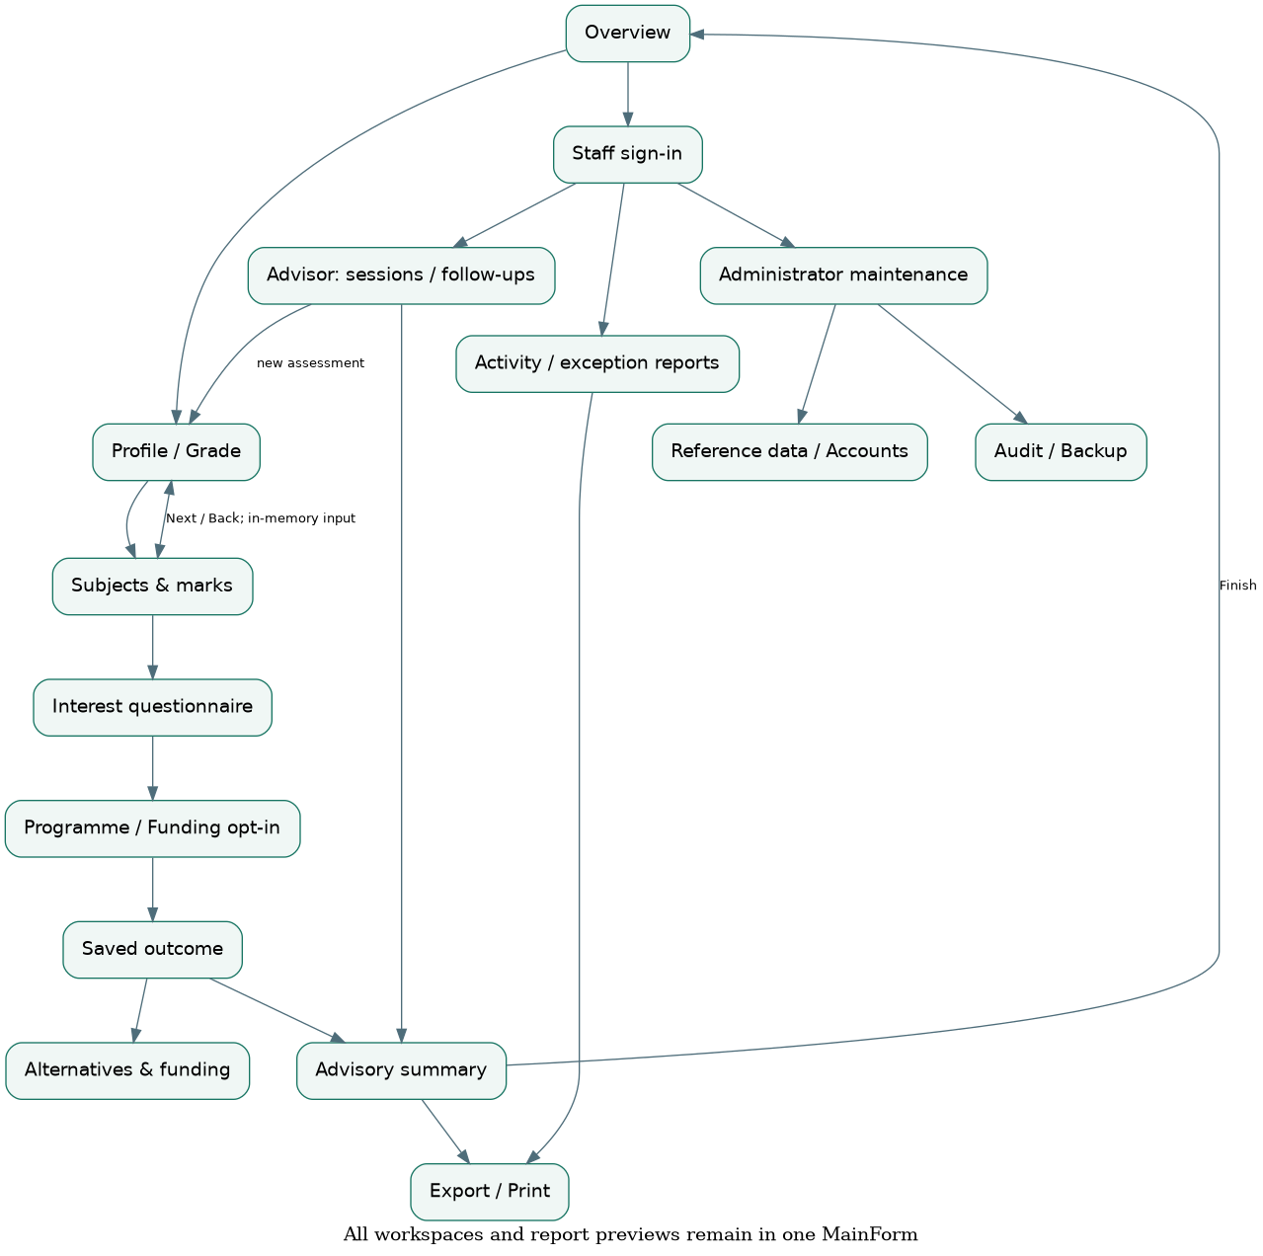
Design diagram, not a Windows runtime screenshot.

Class model
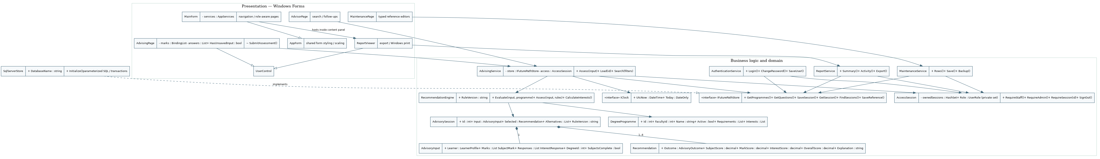
Design diagram, not a Windows runtime screenshot.

LocalDB ERD
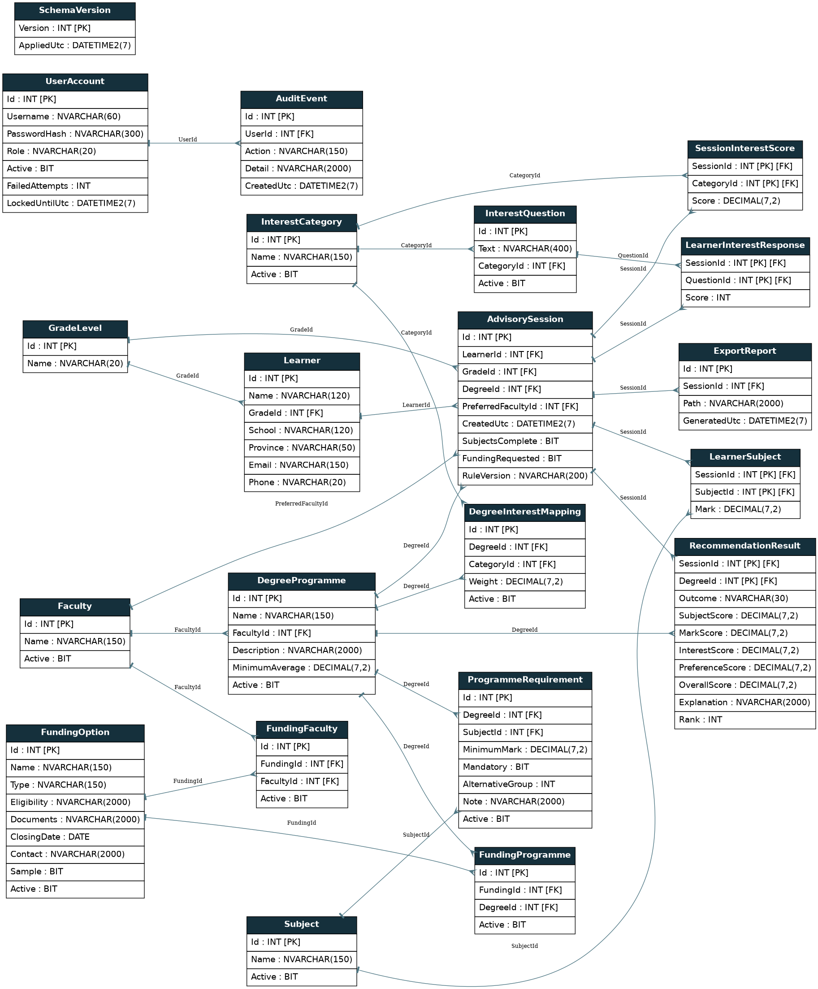
Design diagram, not a Windows runtime screenshot.

Eligibility sequence
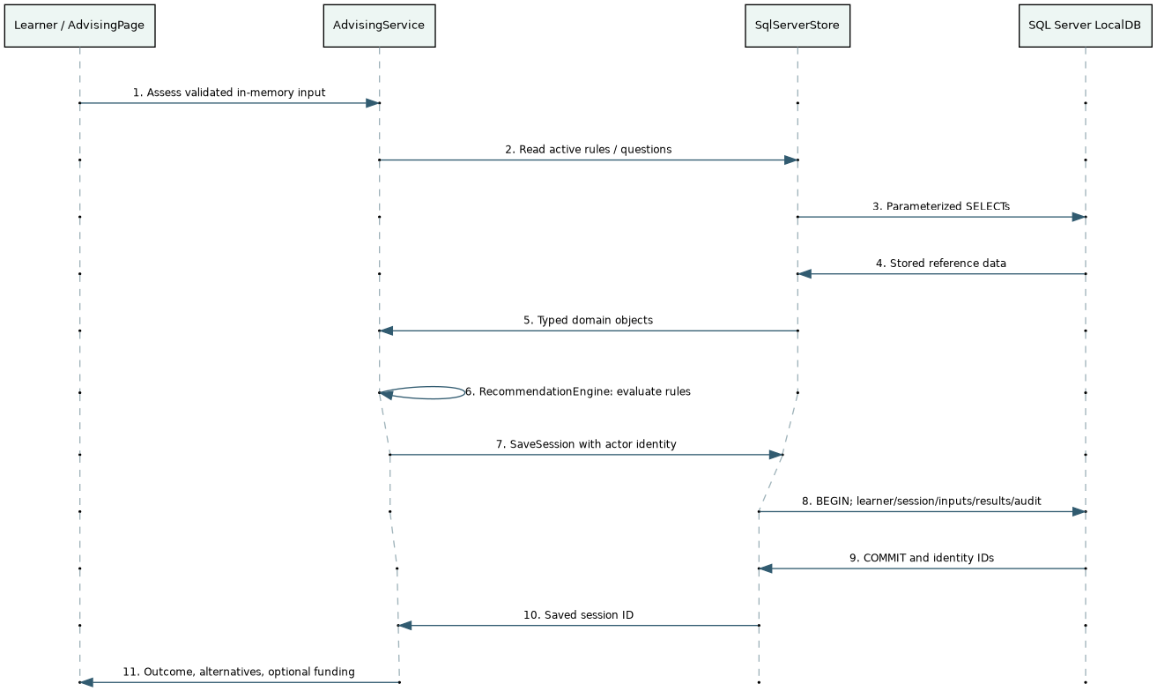
Design diagram, not a Windows runtime screenshot.

Alternative sequence
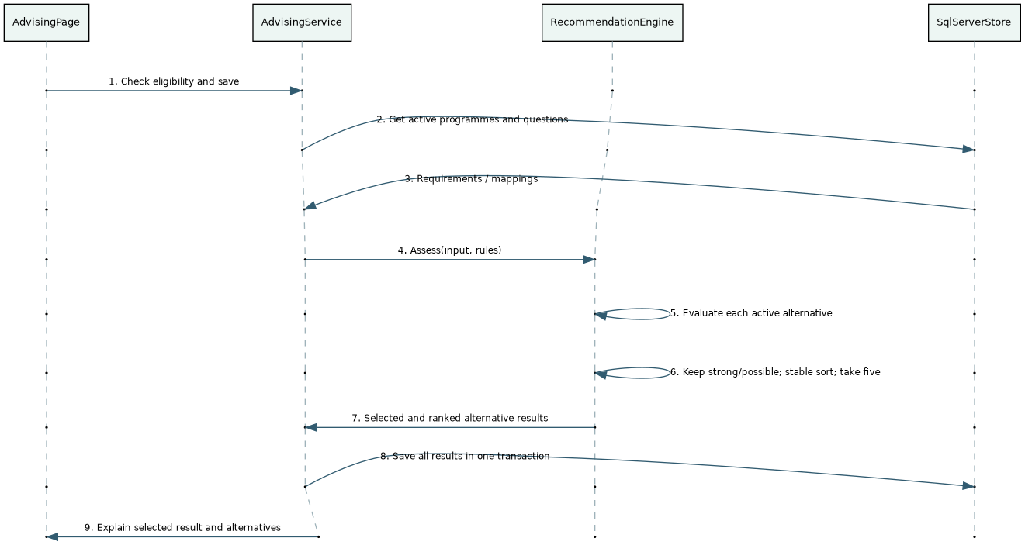
Design diagram, not a Windows runtime screenshot.

Screen wireframes 1
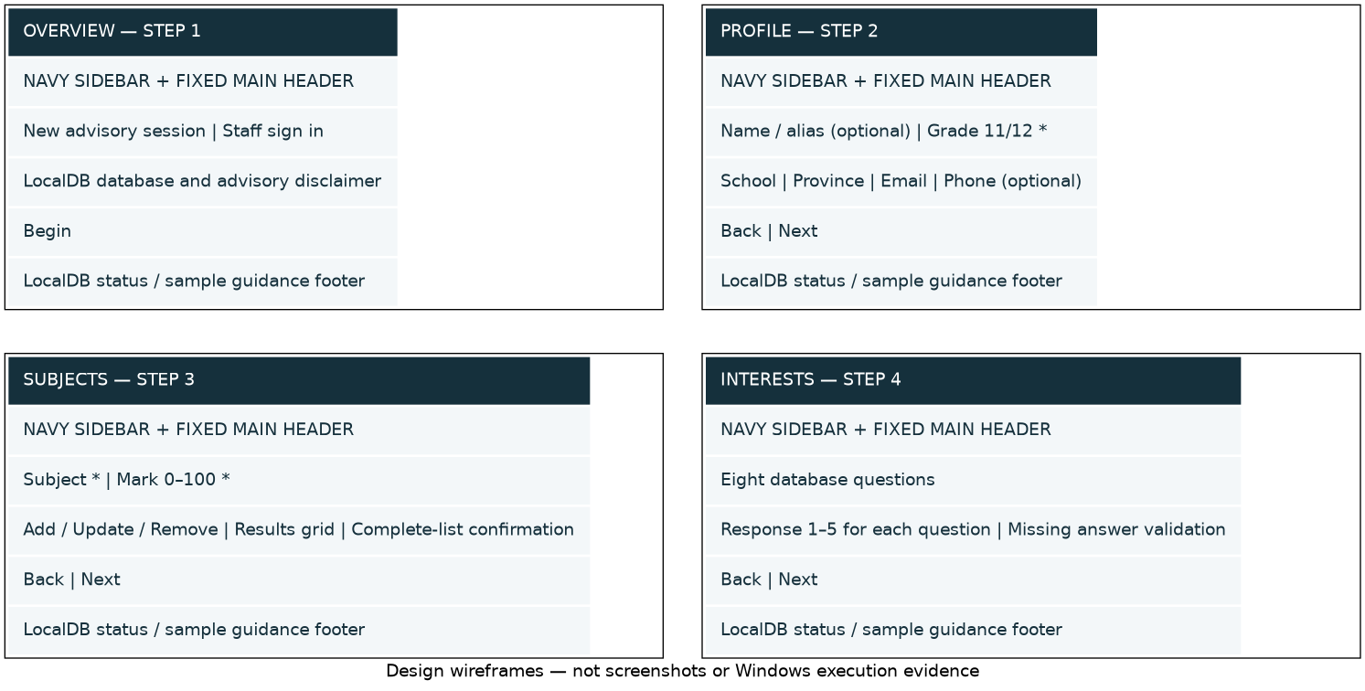
Design diagram, not a Windows runtime screenshot.

Screen wireframes 2
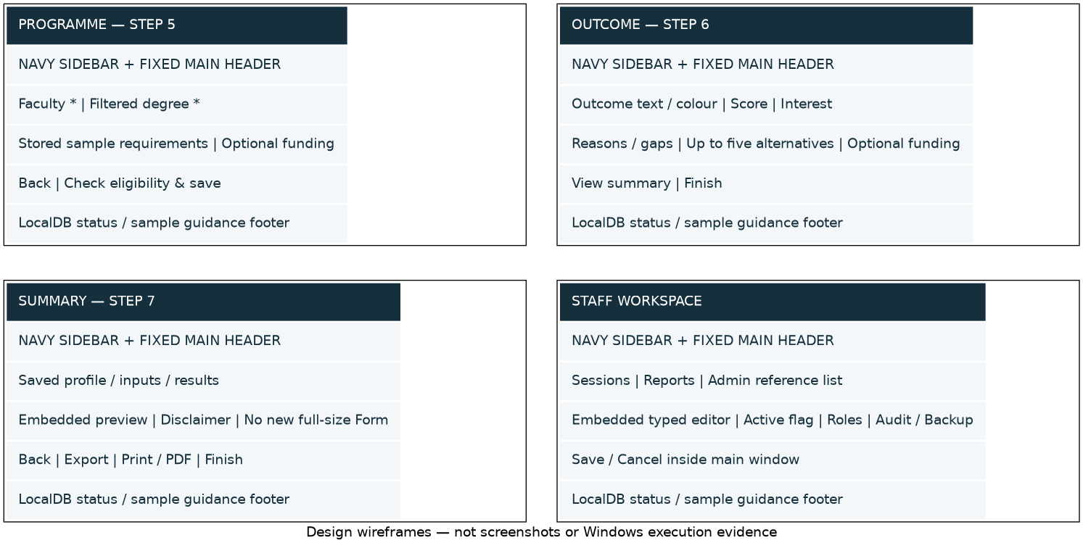
Design diagram, not a Windows runtime screenshot.

Appendix: SQL Server data dictionary

SQL Server LocalDB data dictionary
Authoritative schema: `Database/02_CreateTables.sql`. The20 reference domain tables and exact entity/column names are preserved. `SchemaVersion` is additional installation metadata. No cascading delete is introduced. Empty strings represent optional learner fields; only optional staff lockout/audit identity values are NULL.
`INT IDENTITY(1,1)` replaces implicit file-database row identifiers. `BIT` represents flags, `DECIMAL(7,2)` stores marks/scores/weights, `DATE` stores inclusive funding deadlines, and `DATETIME2(7)` stores UTC instants. Unicode strings have explicit limits. Case-insensitive unique reference labels and username constraints are retained.

AdvisorySession
Column | SQL Server type | Key | Required | Purpose / constraint
Id | INT IDENTITY | PK | Yes | Generated identity; not supplied by normal application inserts
LearnerId | INT | FK → Learner.Id | Yes | See schema CHECK/UNIQUE/default and business validation
GradeId | INT | FK → GradeLevel.Id | Yes | 11 or 12; session grade is at assessment time
DegreeId | INT | FK → DegreeProgramme.Id | Yes | See schema CHECK/UNIQUE/default and business validation
PreferredFacultyId | INT | FK → Faculty.Id | Yes | See schema CHECK/UNIQUE/default and business validation
CreatedUtc | DATETIME2(7) | — | Yes | UTC timestamp
SubjectsComplete | BIT | — | Yes | 0 = false;1 = true
FundingRequested | BIT | — | Yes | 0 = false;1 = true
RuleVersion | NVARCHAR(200) | — | Yes | Snapshot of the scoring/outcome policy

AuditEvent
Column | SQL Server type | Key | Required | Purpose / constraint
Id | INT IDENTITY | PK | Yes | Generated identity; not supplied by normal application inserts
UserId | INT | FK → UserAccount.Id | No | See schema CHECK/UNIQUE/default and business validation
Action | NVARCHAR(150) | — | Yes | See schema CHECK/UNIQUE/default and business validation
Detail | NVARCHAR(2000) | — | Yes | See schema CHECK/UNIQUE/default and business validation
CreatedUtc | DATETIME2(7) | — | Yes | UTC timestamp

DegreeInterestMapping
Column | SQL Server type | Key | Required | Purpose / constraint
Id | INT IDENTITY | PK | Yes | Generated identity; not supplied by normal application inserts
DegreeId | INT | FK → DegreeProgramme.Id | Yes | See schema CHECK/UNIQUE/default and business validation
CategoryId | INT | FK → InterestCategory.Id | Yes | See schema CHECK/UNIQUE/default and business validation
Weight | DECIMAL(7,2) | — | Yes | See schema CHECK/UNIQUE/default and business validation
Active | BIT | — | Yes | 0 = false;1 = true

DegreeProgramme
Column | SQL Server type | Key | Required | Purpose / constraint
Id | INT IDENTITY | PK | Yes | Generated identity; not supplied by normal application inserts
Name | NVARCHAR(150) | — | Yes | See schema CHECK/UNIQUE/default and business validation
FacultyId | INT | FK → Faculty.Id | Yes | See schema CHECK/UNIQUE/default and business validation
Description | NVARCHAR(2000) | — | Yes | See schema CHECK/UNIQUE/default and business validation
MinimumAverage | DECIMAL(7,2) | — | Yes | See schema CHECK/UNIQUE/default and business validation
Active | BIT | — | Yes | 0 = false;1 = true

ExportReport
Column | SQL Server type | Key | Required | Purpose / constraint
Id | INT IDENTITY | PK | Yes | Generated identity; not supplied by normal application inserts
SessionId | INT | FK → AdvisorySession.Id | Yes | See schema CHECK/UNIQUE/default and business validation
Path | NVARCHAR(2000) | — | Yes | Exported file path; metadata written only after file creation
GeneratedUtc | DATETIME2(7) | — | Yes | UTC timestamp

Faculty
Column | SQL Server type | Key | Required | Purpose / constraint
Id | INT IDENTITY | PK | Yes | Generated identity; not supplied by normal application inserts
Name | NVARCHAR(150) | — | Yes | See schema CHECK/UNIQUE/default and business validation
Active | BIT | — | Yes | 0 = false;1 = true

FundingFaculty
Column | SQL Server type | Key | Required | Purpose / constraint
Id | INT IDENTITY | PK | Yes | Generated identity; not supplied by normal application inserts
FundingId | INT | FK → FundingOption.Id | Yes | See schema CHECK/UNIQUE/default and business validation
FacultyId | INT | FK → Faculty.Id | Yes | See schema CHECK/UNIQUE/default and business validation
Active | BIT | — | Yes | 0 = false;1 = true

FundingOption
Column | SQL Server type | Key | Required | Purpose / constraint
Id | INT IDENTITY | PK | Yes | Generated identity; not supplied by normal application inserts
Name | NVARCHAR(150) | — | Yes | See schema CHECK/UNIQUE/default and business validation
Type | NVARCHAR(150) | — | Yes | See schema CHECK/UNIQUE/default and business validation
Eligibility | NVARCHAR(2000) | — | Yes | See schema CHECK/UNIQUE/default and business validation
Documents | NVARCHAR(2000) | — | Yes | See schema CHECK/UNIQUE/default and business validation
ClosingDate | DATE | — | Yes | Inclusive local closing date
Contact | NVARCHAR(2000) | — | Yes | See schema CHECK/UNIQUE/default and business validation
Sample | BIT | — | Yes | 0 = false;1 = true
Active | BIT | — | Yes | 0 = false;1 = true

FundingProgramme
Column | SQL Server type | Key | Required | Purpose / constraint
Id | INT IDENTITY | PK | Yes | Generated identity; not supplied by normal application inserts
FundingId | INT | FK → FundingOption.Id | Yes | See schema CHECK/UNIQUE/default and business validation
DegreeId | INT | FK → DegreeProgramme.Id | Yes | See schema CHECK/UNIQUE/default and business validation
Active | BIT | — | Yes | 0 = false;1 = true

GradeLevel
Column | SQL Server type | Key | Required | Purpose / constraint
Id | INT | PK | Yes | See schema CHECK/UNIQUE/default and business validation
Name | NVARCHAR(20) | — | Yes | See schema CHECK/UNIQUE/default and business validation

InterestCategory
Column | SQL Server type | Key | Required | Purpose / constraint
Id | INT IDENTITY | PK | Yes | Generated identity; not supplied by normal application inserts
Name | NVARCHAR(150) | — | Yes | See schema CHECK/UNIQUE/default and business validation
Active | BIT | — | Yes | 0 = false;1 = true

InterestQuestion
Column | SQL Server type | Key | Required | Purpose / constraint
Id | INT IDENTITY | PK | Yes | Generated identity; not supplied by normal application inserts
Text | NVARCHAR(400) | — | Yes | See schema CHECK/UNIQUE/default and business validation
CategoryId | INT | FK → InterestCategory.Id | Yes | See schema CHECK/UNIQUE/default and business validation
Active | BIT | — | Yes | 0 = false;1 = true

Learner
Column | SQL Server type | Key | Required | Purpose / constraint
Id | INT IDENTITY | PK | Yes | Generated identity; not supplied by normal application inserts
Name | NVARCHAR(120) | — | Yes | See schema CHECK/UNIQUE/default and business validation
GradeId | INT | FK → GradeLevel.Id | Yes | 11 or 12; session grade is at assessment time
School | NVARCHAR(120) | — | Yes | See schema CHECK/UNIQUE/default and business validation
Province | NVARCHAR(50) | — | Yes | See schema CHECK/UNIQUE/default and business validation
Email | NVARCHAR(150) | — | Yes | See schema CHECK/UNIQUE/default and business validation
Phone | NVARCHAR(20) | — | Yes | See schema CHECK/UNIQUE/default and business validation

LearnerInterestResponse
Column | SQL Server type | Key | Required | Purpose / constraint
SessionId | INT | PK FK → AdvisorySession.Id | Yes | See schema CHECK/UNIQUE/default and business validation
QuestionId | INT | PK FK → InterestQuestion.Id | Yes | See schema CHECK/UNIQUE/default and business validation
Score | INT | — | Yes | See schema CHECK/UNIQUE/default and business validation

LearnerSubject
Column | SQL Server type | Key | Required | Purpose / constraint
SessionId | INT | PK FK → AdvisorySession.Id | Yes | See schema CHECK/UNIQUE/default and business validation
SubjectId | INT | PK FK → Subject.Id | Yes | See schema CHECK/UNIQUE/default and business validation
Mark | DECIMAL(7,2) | — | Yes | See schema CHECK/UNIQUE/default and business validation

ProgrammeRequirement
Column | SQL Server type | Key | Required | Purpose / constraint
Id | INT IDENTITY | PK | Yes | Generated identity; not supplied by normal application inserts
DegreeId | INT | FK → DegreeProgramme.Id | Yes | See schema CHECK/UNIQUE/default and business validation
SubjectId | INT | FK → Subject.Id | Yes | See schema CHECK/UNIQUE/default and business validation
MinimumMark | DECIMAL(7,2) | — | Yes | See schema CHECK/UNIQUE/default and business validation
Mandatory | BIT | — | Yes | 0 = false;1 = true
AlternativeGroup | INT | — | Yes | 0 = independent; positive number = OR choices within the degree
Note | NVARCHAR(2000) | — | Yes | See schema CHECK/UNIQUE/default and business validation
Active | BIT | — | Yes | 0 = false;1 = true

RecommendationResult
Column | SQL Server type | Key | Required | Purpose / constraint
SessionId | INT | PK FK → AdvisorySession.Id | Yes | See schema CHECK/UNIQUE/default and business validation
DegreeId | INT | PK FK → DegreeProgramme.Id | Yes | See schema CHECK/UNIQUE/default and business validation
Outcome | NVARCHAR(30) | — | Yes | See schema CHECK/UNIQUE/default and business validation
SubjectScore | DECIMAL(7,2) | — | Yes | See schema CHECK/UNIQUE/default and business validation
MarkScore | DECIMAL(7,2) | — | Yes | See schema CHECK/UNIQUE/default and business validation
InterestScore | DECIMAL(7,2) | — | Yes | See schema CHECK/UNIQUE/default and business validation
PreferenceScore | DECIMAL(7,2) | — | Yes | See schema CHECK/UNIQUE/default and business validation
OverallScore | DECIMAL(7,2) | — | Yes | See schema CHECK/UNIQUE/default and business validation
Explanation | NVARCHAR(2000) | — | Yes | See schema CHECK/UNIQUE/default and business validation
Rank | INT | — | Yes | 0 = selected;1–5 = ranked alternatives

SchemaVersion
Column | SQL Server type | Key | Required | Purpose / constraint
Version | INT | PK | Yes | Supported schema version (currently1)
AppliedUtc | DATETIME2(7) | — | Yes | UTC timestamp

SessionInterestScore
Column | SQL Server type | Key | Required | Purpose / constraint
SessionId | INT | PK FK → AdvisorySession.Id | Yes | See schema CHECK/UNIQUE/default and business validation
CategoryId | INT | PK FK → InterestCategory.Id | Yes | See schema CHECK/UNIQUE/default and business validation
Score | DECIMAL(7,2) | — | Yes | See schema CHECK/UNIQUE/default and business validation

Subject
Column | SQL Server type | Key | Required | Purpose / constraint
Id | INT IDENTITY | PK | Yes | Generated identity; not supplied by normal application inserts
Name | NVARCHAR(150) | — | Yes | See schema CHECK/UNIQUE/default and business validation
Active | BIT | — | Yes | 0 = false;1 = true

UserAccount
Column | SQL Server type | Key | Required | Purpose / constraint
Id | INT IDENTITY | PK | Yes | Generated identity; not supplied by normal application inserts
Username | NVARCHAR(60) | — | Yes | See schema CHECK/UNIQUE/default and business validation
PasswordHash | NVARCHAR(300) | — | Yes | PBKDF2 iteration count:salt:derived key (never plaintext)
Role | NVARCHAR(20) | — | Yes | See schema CHECK/UNIQUE/default and business validation
Active | BIT | — | Yes | 0 = false;1 = true
FailedAttempts | INT | — | Yes | 0–5, reset on success/expiry/password reset
LockedUntilUtc | DATETIME2(7) | — | No | UTC timestamp; optional lock expiry

Integrity and history
Per-session subjects/responses/category scores use composite primary keys. Degree/subject, degree/category, funding/faculty and funding/programme combinations are unique. Recommendation rank is unique per session. Marks and component scores are0–100; questionnaire responses1–5; weight >0 and ≤10; OR group0–99. Grade IDs are11/12. Foreign keys reject orphan records.
A session transaction includes learner creation (when needed), session metadata, all inputs, persisted results/category scores and its audit row. The profile identity remains unchanged on staff follow-ups. Historic scores/reasons/rule version are not recalculated on startup or reference edits.
Reference labels and current funding are read for reports at report time, as in the input design. Schema/script grammar has been checked here; real SQL Server constraint, save, restart, backup/restore and repeatability tests still require Windows LocalDB.

Appendix: Code walkthrough

Beginner code walkthrough

1. Start the real app
Open **FuturePath-App.sln**, build and press F5. In the full solution the startup project is **FuturePath.Desktop**, not a test project. `RUN-FUTUREPATH.cmd` builds only Desktop and starts its Windows executable.
`src/FuturePath.Desktop/Program.cs` configures Windows Forms, chooses the LocalDB database name (default `FuturePathStudentAdvisingSystem`), prevents a second app instance for that name, verifies setup with `SqlServerStore.Initialize()`, and opens **one MainForm**. It does not create/seed/delete databases at startup. `AppServices` constructs the access session and business services. This is direct construction, not a dependency-injection framework.

2. One window, different contents
`MainForm` owns the fixed sidebar/header/status and central `content` panel. `ShowPage()` changes the UserControl in that panel. Home is step1 of7. `NewAdvisory()` creates `AdvisingPage` for steps2–6. Staff workspaces and editors are controls in this same shell. Only small credential/native message/file/print dialogs open separately.
`AdvisingPage` builds each step's controls once and keeps them in `steps`. `ShowStep()` removes the previous panel without disposing it, then displays the next panel. That is why Back retains values. `GoNext()` calls shared validation before changing the step. `GoBack()` never writes data. `Dirty()`/`HasUnsavedInput` allow MainForm to warn before leaving an unfinished draft. Finish goes back to Home.
`MainForm.ViewReport()` hosts `ReportViewer` (a UserControl) as step7, retaining the originating page so Back preserves its inputs or staff filters. `ReportViewer` handles SaveFileDialog and standard Windows printing. It does not contain SQL or calculate eligibility.

3. Validate and save an assessment
`AdvisingPage.ReadProfile()` and `ReadResponses()` translate controls to model values. `SubmitAssessment()` creates `AdvisoryInput` and calls `AdvisingService.Assess()`.
`AdvisingValidation` checks grade/optional contact details,0–100 marks, duplicate subjects, active subject IDs, answer range/duplicates and required answers for Next. Business service validation repeats these checks independently of the UI. Imported/incomplete inputs can still be assessed as More Information Needed; the ordinary questionnaire Next action requires answers.
`AdvisingService` retrieves current rules/questions through `IFuturePathStore`, calls the pure `RecommendationEngine`, and passes the finished session to `SqlServerStore.SaveSession()`. That method opens a transaction, inserts the learner if needed, inserts the session, all marks/responses/category scores, selected/alternative results and its creation audit. SQL Server returns identity IDs using `OUTPUT INSERTED.Id`. Commit happens only after every write succeeds; disposal rolls back a failed transaction. No record is saved for each Next click.
After success, `AccessSession.OwnSession()` permits that guest workspace to load/export the new session. The UI renders the persisted result and becomes read-only. A staff follow-up loads previous inputs and saves a **new** session for the existing learner; it does not overwrite the old result or replace learner identity.

4. Explain the recommendation engine
`RecommendationEngine` has no form controls, database connections or online calls. Named constants define the 35/35/25/5 weights, five-point near-match limit and60% strong-interest threshold.
`RequiredGroups()` separates independent mandatory requirements from explicitly stored OR groups. `Evaluate()` compares subject presence and marks, checks any configured average, converts1–5 questionnaire answers to0–100 category scores and calculates interest alignment from degree mappings. It collects specific reasons and applies outcome precedence:
1. Incomplete capture/questionnaire/configuration → More Information Needed.
2. Confirmed absent required subject or >5-point mandatory/average gap → Not Currently Eligible.
3. A positive gap up to5 points or weak interest → Possible Match.
4. All hard requirements met plus interest≥60 → Strong Match.
A high score never overrides a hard gap. A Possible Match caused by a mark shortfall is not academically eligible. `Assess()` evaluates alternatives with the same rules, excludes selected/inactive degrees, keeps strong/possible results, sorts stably and takes at most five. Rule version, component scores and explanation are saved with the session.
Walk through Labeeqah: Mathematics58 versus stored60 produces a2-point gap, so Possible Match rather than inventing acceptance. Aadiel-Raboo's Mathematical Literacy cannot replace compulsory Mathematics in Computer Science because no such OR group is configured.

5. Follow the data access
`DatabaseConnection` constructs one Windows-integrated LocalDB connection. `SqlServerStore` implements the existing domain-specific `IFuturePathStore` contract. Methods have a clear purpose:
Method | Reads/writes
`GetLookup("Subject")` | Active school subjects
`GetProgrammes(true)` | Active faculties/degrees plus requirements and interest weights
`GetQuestions()` | Active questions and categories
`SaveSession()` | Complete assessment in one transaction
`GetSession()` | Stored inputs/results/rule version/category scores; never recalculates history
`GetFunding(degreeId,today)` | Active/open programme-specific or applicable faculty-wide funding
`FindSessions(from,to,search)` | Saved-session projection used by staff/report services
`SaveReference()` | Validated allowlisted entity/field insert/update
`RecordExport()` | File metadata after a real export
`Backup()` | New copy-only SQL Server `.bak`, checksummed and verified
Connections/readers/commands are disposed with using. User values use parameters. SQL identifiers come from the existing fixed `ReferenceCatalog`, never user-entered table names. SQL keys/checks/unique constraints independently protect data. The schema has the same20 domain entities; SchemaVersion is installation metadata.

6. Staff security and maintenance
`AuthenticationService.Login()` retrieves the account and its actual role, checks active state/lockout, verifies salted PBKDF2, records success/failure and then sets identity internally. There is no role selector or hardcoded login bypass. Five failures lock for five minutes; expiry/success/reset clears the counter.
`AccessSession.RequireStaff()`, `RequireAdmin()` and `RequireSession()` protect business operations independently of hidden navigation. Guests can access only their current workspace's created sessions. Staff can review saved sessions as in the reference specification. Signing in/out clears guest ownership and screen information.
`MaintenanceService` validates typed values, links and activation rules. `MaintenancePage` lists reference records; `ReferenceEditor`/`AccountEditor` are now embedded controls with Save/Cancel. Programme/funding deactivation retains history. Account lists omit password hashes. The current administrator cannot disable/demote itself. Audit messages never contain passwords.

7. Reports, export and print
`ReportService.Summary()` authorizes and reads the saved assessment, then `ReportComposer.Summary()` builds readable text. `Activity()` authorizes staff, applies date/search filters and groups saved sessions by faculty/degree/outcome. Exception reports include Not Currently Eligible and More Information Needed. Gap totals count sessions containing the stored subject/mark/questionnaire reasons, not today's rules.
`ReportDocument.ToHtml()` HTML-encodes user text. `Export()` writes to a temporary file on the same destination volume and then moves it into place, so a failed write does not truncate an existing report. Only after creation does it record export metadata. `ReportViewer` previews the document inside MainForm and uses PrintDocument/PrintDialog for printing or Microsoft Print to PDF.

OOP tied to actual code
Concept | Concrete example
Encapsulation | AccessSession's private identity setters and ownership set; MainForm owns navigation state
Abstraction | IFuturePathStore exposes advising operations without exposing SQL to controls
Polymorphism | SqlServerStore implements IFuturePathStore; SystemClock/TestClock implement IClock
Composition | AppServices constructs services; session contains input/results; MainForm contains page controls
Inheritance | MainForm/LoginDialog extend AppForm; page/editor/report controls extend UserControl; validation exceptions extend Exception
Separation of concerns | UI gathers/displays; Business validates/calculates/authorizes; Data executes SQL
The portable checks execute real rules/validation/report composition against reference input fixtures. They are **not** SQL integration tests. Run the complete suite on Windows with LocalDB and collect manual layout/printing evidence before presenting. Do not claim an unrun test or an invented group contribution.

Appendix: Dependencies

Dependencies and restore
The app remains .NET 10 Windows Forms. No framework downgrade, ORM, third-party UI/report library, cloud SDK feature, web server or runtime AI/API was introduced.
Direct package | Version | Scope | Reason
Microsoft.Data.SqlClient | 7.1.1 | Application runtime (`FuturePath.Data`) | Supported ADO.NET SQL Server/LocalDB connection, commands, parameters and transactions
Microsoft.NET.Test.Sdk | 17.14.1 | Tests only, retained | Existing Visual Studio/dotnet test host
xunit | 2.9.3 | Tests only, retained | Existing unit/integration test framework
xunit.runner.visualstudio | 3.1.1 | Tests only, retained; PrivateAssets=all | Existing test discovery/runner
`Directory.Packages.props` records versions centrally. **System.Security.Cryptography.Pkcs10.0.13** pins an already required transitive SQL client dependency to a patched version. It is not an unrelated added runtime feature. The provider also brings its normal native SNI, configuration, identity-model and framework helper dependencies; exact resolved versions/hashes are in each project's `packages.lock.json`. Windows integrated security is the only configured application authentication route to SQL Server; no cloud identity service is called by the app.
This is not a package-free application. Modern .NET 10 needs a SQL Server provider package. Using the old framework-bundled System.Data.SqlClient would require a major target-framework change, which was not made. The small Windows setup helper uses Windows PowerShell's built-in provider only to execute the explicit setup scripts; the actual .NET 10 application consistently uses Microsoft.Data.SqlClient.
The runtime Microsoft.Data.Sqlite/native SQLite packages have been removed. No SQLite provider is retained as a parallel test or application database. Portable rule tests read JSON **input fixtures**, not a replacement persistence engine. Real persistence tests require Windows LocalDB.
Restore/build from solution root:
dotnet restore FuturePath.sln --locked-mode
dotnet build FuturePath.sln -c Release --no-restore
Internet is needed for the initial NuGet/tool restore. After installation, advising, SQL queries, export and printing run locally/offline. SQL Server Express LocalDB is a separate Windows prerequisite; a self-contained .NET publish does not install it.
The seed generator uses only the Business project and built-in System.Text.Json. Documentation uses source Mermaid/DOT and generated images. A developer-side SQL grammar check used Microsoft's parser available in the validation environment; it is not an added application or test-package dependency. Package signatures, checksums and TLS verification were kept enabled.

Appendix: Migration record

Changes from the supplied Visual Studio reference
The input ZIP is unchanged. A separate working copy/branch preserves the baseline. The smaller SQL-only ZIP and earlier integration remain supporting/history material; this implementation continues the newly supplied FuturePath.sln project.

Preserved
- .NET 10 Windows Forms, FuturePath.sln, FuturePath.Desktop/Business/Data namespaces and project boundaries.
- Existing MainForm shell, control names, navy/white/teal style, anonymous/alias learner behavior and staff roles.
- All20 domain entities/relationships;10 required/additional learners and their exact marks;18 subjects;5 faculties;10 degrees;8 categories/questions;10 funding records and10 computed sessions.
-35/35/25/5 formula, explicit OR subjects, average rules, five-point near-match threshold,60% strong-interest threshold, up to five alternatives and required outcomes.
- Staff hashing/lockout/account maintenance, reference controls/activation rules, audit, immutable history/follow-ups, funding, three reports, text/HTML export and standard Windows printing.

Changed and why
Files/area | Change and reason
`src/FuturePath.Data/DatabaseConnection.cs` | One named LocalDB database, Windows authentication, validated database-name override
`SqliteStore.cs` → `SqlServerStore.cs` | Ordinary Microsoft.Data.SqlClient ADO.NET; OUTPUT identity retrieval, typed dates/decimals, T-SQL filtering, copy-only/checksummed SQL Server backup
Data project and package lockfiles | Remove SQLite provider/native runtime; one direct SQL client package; patched existing PKCS dependency pin; retain test packages
Root `Database/01–04` | Explicit create/schema/seed/verify; no destructive startup action; refuse unknown schema; skip nonempty demo seed
Old Data `Schema.sql`/`Seed.sql` | Replaced by canonical LocalDB scripts; original definitions remain in baseline history, not as a competing runtime database
`validation/reference/sample-data.json`, seed generator | Exact noncredential input fixture retained from reference; production engine generates persisted SQL demo results; no outcome-name hardcoding
`Program.cs` | Select database name instead of file path; verify setup; keep mutex and MainForm startup
`AdvisingPage.cs` | Replace freely selectable tabs with retained in-window panels and validated Next/Back; clear progress and Finish
`AdvisingValidation.cs`, `AdvisingService.cs` | Shared page/service validation and conventional constructors; assessment audit joins the same save transaction
`RecommendationEngine.cs` | Named weights/thresholds, readable mandatory/OR grouping, deterministic tie-breaking; same policy/results
`ReportViewer.cs`, `MainForm.cs` | Embed report preview, retain the originating page for Back, keep shell/status and dispose controls correctly
`StaffPages.cs` | Reference/account editors now embedded controls; Save/Cancel; deactivation confirmation; `.bak` backup selection
`Reports.cs` | Preserve reports and safe exports; add counts of sessions with stored subject/mark/questionnaire gaps
`ReferenceCatalog.cs` | Enforce SQL-compatible question text limit and integer lookup values; retain allowlist/validation
`Ui.cs` | SQL Server error guidance instead of file-database errors; retain standard visual helpers
`tests/Shared` and original test files | Port actual database fixtures/constraints/reopen/backup/restore to LocalDB; protect cleanup with generated test names; skip explicitly on Linux
`PortableRuleTests.cs` | Real rules/shared validation/report tests against exact fixtures; no replacement database and no SQL persistence claim
Desktop tests | Retain constructor/save tests and add Back/Next/no-early-write/one-window checks
`FuturePath-App.sln`, `RUN-FUTUREPATH.cmd` | Make app startup unambiguous; tests remain in original full solution
`SETUP-DEMO.cmd`, setup helper | Explicit beginner setup without assuming sqlcmd is installed; manual SQL route for blocked PowerShell policy
Docs/diagrams/Word, CI/packaging/cloud scripts | Remove stale SQLite/run-path instructions, document provider trade-off and actual validation limits
No existing SQLite learner database was attached, so there are no actual learner files to import. Existing `.db` files are preserved untouched and are not a fallback provider. No automatic import tool or dual-source synchronization is claimed. The translated seed contains every reference learner/mark/answer and reference-data row.
Setup no longer fabricates a first-run sample export. ExportReport rows represent files actually saved by a user/test. Stored sample assessments are precomputed by the production engine during seed generation; runtime never rewrites old assessments to complete a seed.
Remaining before demonstration: real Windows LocalDB setup/repeat/save/reopen/constraint/lockout/backup tests, the four Windows UI tests, manual DPI/keyboard/print/offline/error cases and team review against the approved specification. Source, grammar validation and portable tests cannot establish those Windows outcomes.

