Undertake an analysis of a website of your choosing

The website I have chosen to review is <https://www.suffolk.gov.uk>. I chose this website because it has a very large potential audience so must have many accessibility options and maintain a responsive design whilst looking professional and having a plethora of features.

# Responsive design

Responsive design is a websites ability to adapt its layout and design based upon the screen resolution of the device being displayed upon. For example, elements may re-arrange to fill the space better on a large display, alternatively they may stack on top of one another on smaller displays to ensure the user can see all the content.

## Does the site change for different size devices?

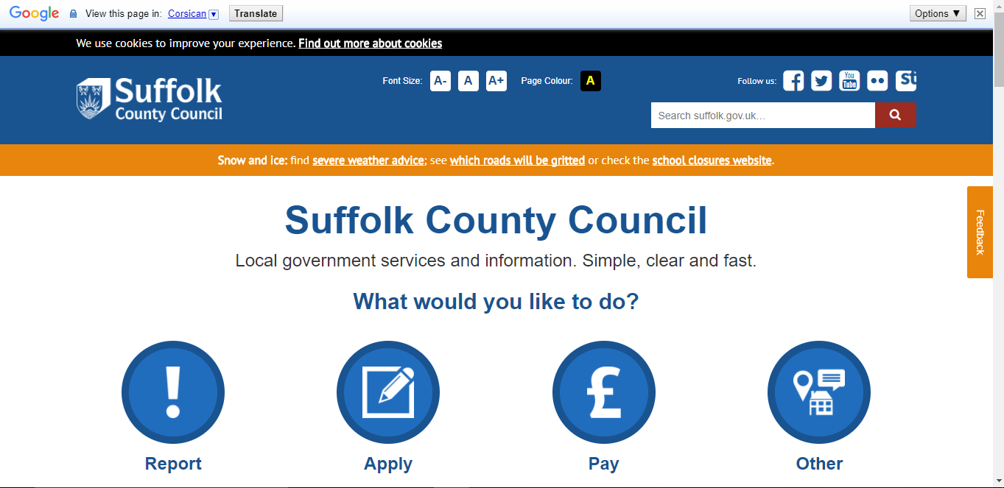The website I have chosen to review has a fully responsive design, it incorporates breakpoints within media queries to determine what should be displayed on the device. For example, below is a screenshot of what the website displays when browsing on a device with a screen width of 1748px.

It has a classic layout with branding and navigation along the top of the page. Notice the transaction buttons Report, Apply, Pay and Other are all displayed as inline elements when the display area has a large resolution. It makes for a professional looking design, clear and easily understandable for any user. This makes for a good user interface as it displays information in such a way that it does not overwhelm the individual viewing the webpage.

However, the layout changes alongside the display resolution in two ways. It uses what are called media queries to detect what styles it should use for any given element judged upon the display. For example, the below screenshot shows the version of the page that would be displayed on the iPhone 6.

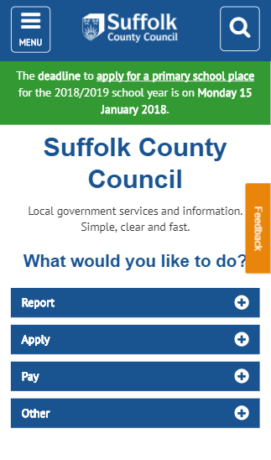

Notice how the layout differs, the transactions section containing Report, Apply, Pay and Other are no longer inline elements, this is because of the media queries within the CSS. There are breakpoints around 375px and 500px which cause major style changes for the contents on the website. Other changes include a dropdown navigation button appearing using JavaScript functionality with an ‘on click’ event listener to display a series of navigation options to the user.

However, when the display reaches around 2000px it no longer resizes. This is because the container which is wrapped around the content has a max-width of 2000px. Meaning it will get no larger than 2000px. At this point the padding of the body is set to auto which centres the content the large display.

# Accessibility

## **“Web accessibility means that people with disabilities can use the Web.** More specifically, Web accessibility means that people with disabilities can perceive, understand, navigate, and interact with the Web, and that they can contribute to the Web. Web accessibility also benefits others, including [older people](https://www.w3.org/WAI/bcase/soc.html#of) with changing abilities due to aging.”

(w3.org, 2017)

## Can you use the site with a screen-reader?

Although the website should have been designed for blind users also, it does not work very well with windows narrator. This may be down to the website not representing the content correctly therefore the screen reader did not know what content to read. Or windows narrator does not understand the layout of the website and the structure of the content.

This makes for a poor user experience If you rely on this type of tool to navigate websites, this is because the screen reader is only as good as the information it has been given so if the content is poorly organised the screen reader will just read gibberish that means nothing to the end user.

## What other accessibility considerations are there?

My selected website has two main accessibility features which allow users to change how text on the website is displayed for example the first feature allows the user to adjust the font size to ensure they can see it clearly. This is a good feature because it allows people who have degenerative sight conditions to read the content.

The second feature my website uses is a high contrast mode, this changes the background of the text to black and the font colour to yellow, as seen below this enables the users to better distinguish between what is text and what is not, this is also helpful with for people with poor vision.

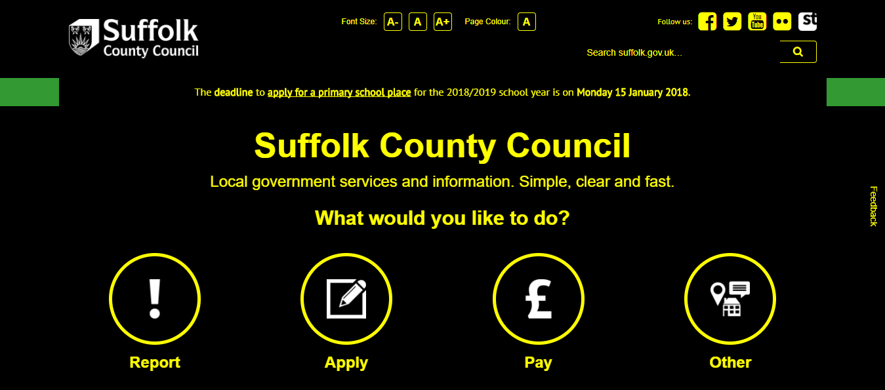

# Scripted functionality

Scripted functionality is the ability to perform an action based upon the users input. Examples include drop down menus, image slideshows and animations.

## Does the site make use of any JavaScript?

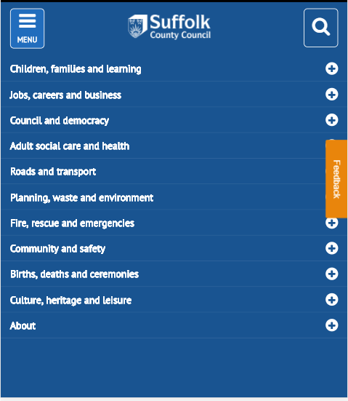My website used JavaScript to display drop down menus. Below is a screenshot of a burger menu button which is an event listener. This means the when a specific set of requirements are met it will run a certain script. Hence the term scripted functionality.

In my case the button is an ‘On Click’ event listener. This means that when the element is clicked it changes the code in such a way that it displays the drop-down menu.

An additional feature is animation, often used to make transitions between sections of content or other elements such as drop-down menus. They are implemented so when you activate an event such as a drop-down menu it appears slowly instead of a box appearing. this gives the website a very nice feel as it is very visually appealing.

Furthermore, JavaScript animations such as the bounce effect used on my website can be used to draw the user’s attention. For example, much of the home screen for my website is taken up by a navigation menu. Therefore, they cannot see the content sitting below it. Using a bouncing arrow informs the user that they have not seen all the content on that page.

# Site style

## Multiple pages vs one page (does the URL change? How is information presented?) •

As this is a very large website which has multiple sections with large amounts of data on each. It would be very impractical to make this a single page design. Therefore, the content is divided in such a way that it is organised into relevant sections that are easy for the end user to navigate through.

The home page is basically a way of locating what you are looking for within the page, for example it asks, ‘What would you like to do?’ and gives you the following options; Report, Apply, Pay and Other. This allows users to efficiently search through the content of the website.

The benefit to having displayed the content as separate pages is that when providing information on a specific topic for example roads. They can give a specific link to a user which will display the relevant content immediately in comparison to giving them a single link and asking them to look through the content themselves.

On the other hand, single page websites are much easier to maintain and edit as all the information is displayed in a single area, you could change it very easily if need be. Having a multiple page design makes that very difficult.

## Does the HTML and CSS validate?

Having a website which validates is fundamentally a website free of errors. This must be tested across browsers as each different browser has different functions and features. So, when you write code you must ensure that is works across on the most common browsers.

Although this website has some errors they are not large enough to cause problems for the user for example errors include not defining the language used within the head of the page.

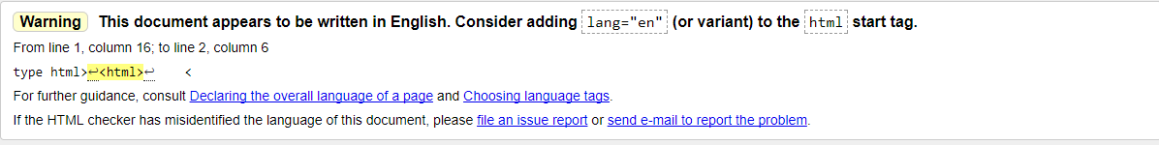

The second error being that the type attribute is unnecessary for JavaScript resources. Meaning that the user does not need to define what type of resource this is.



Having a website that validates completely is good because it ensures that it is error free and all the intended functions and features of the website are compatible with modern browsers.

## Conclusion

Over all I believe the website I have chosen to review had some good features such as a consistent responsive design, appropriate JavaScript functionality and above average accessibility. It has a good user interface which keeps the user engaged which is also continued onto mobile versions of the site. Furthermore, the sites layout is by far the best feature of this website.

With well over 100 pages this website has been planned out meticulously for searching for content to be as efficient as it is whilst maintain a visually appealing design.

# Bibliography

w3.org. (2017, 7 23). *Introduction to Web Accessibility*. Retrieved from Accessibility Initiative: https://www.w3.org/WAI/intro/accessibility.php