Data Exploration: Simple TEM Tutorial

# Upload past student data

To synthesize student usage in the past, execute the IPython (Jupyter) Notebook “TEM-Tutorial-Setup”:  
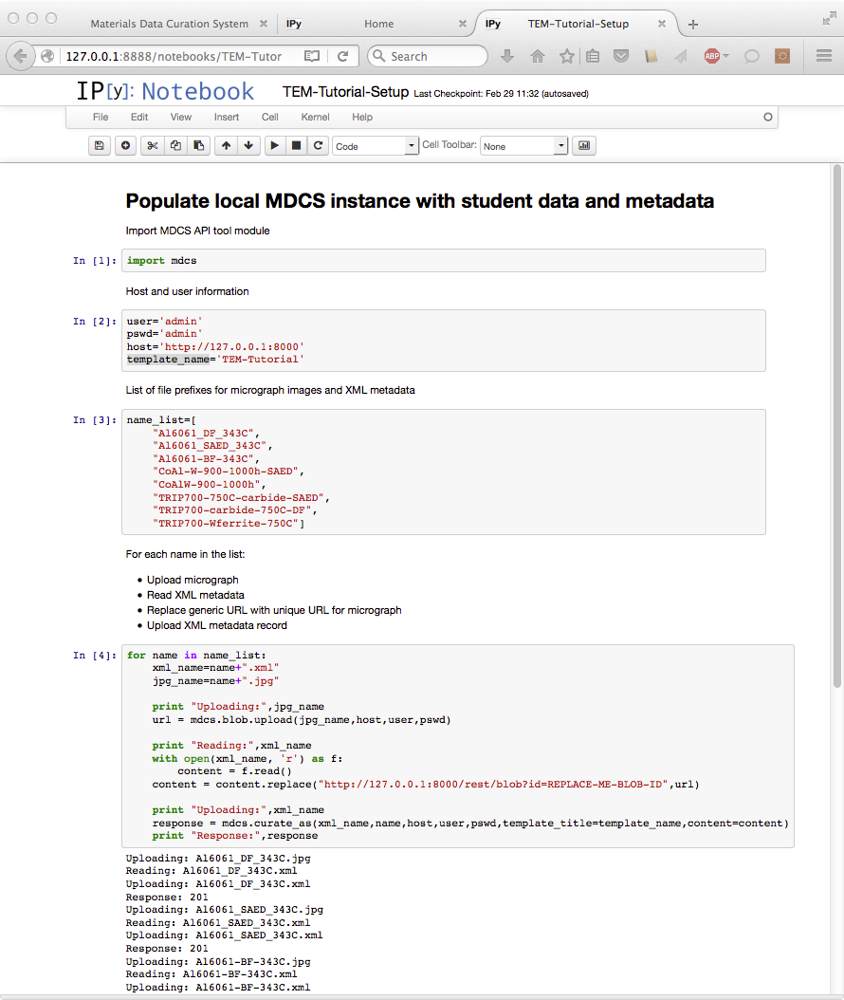

# Explore Student TEM Data by Student Name

1: From the MDCS homepage, click on “Data Exploration” then click on “Search by Keyword”:   
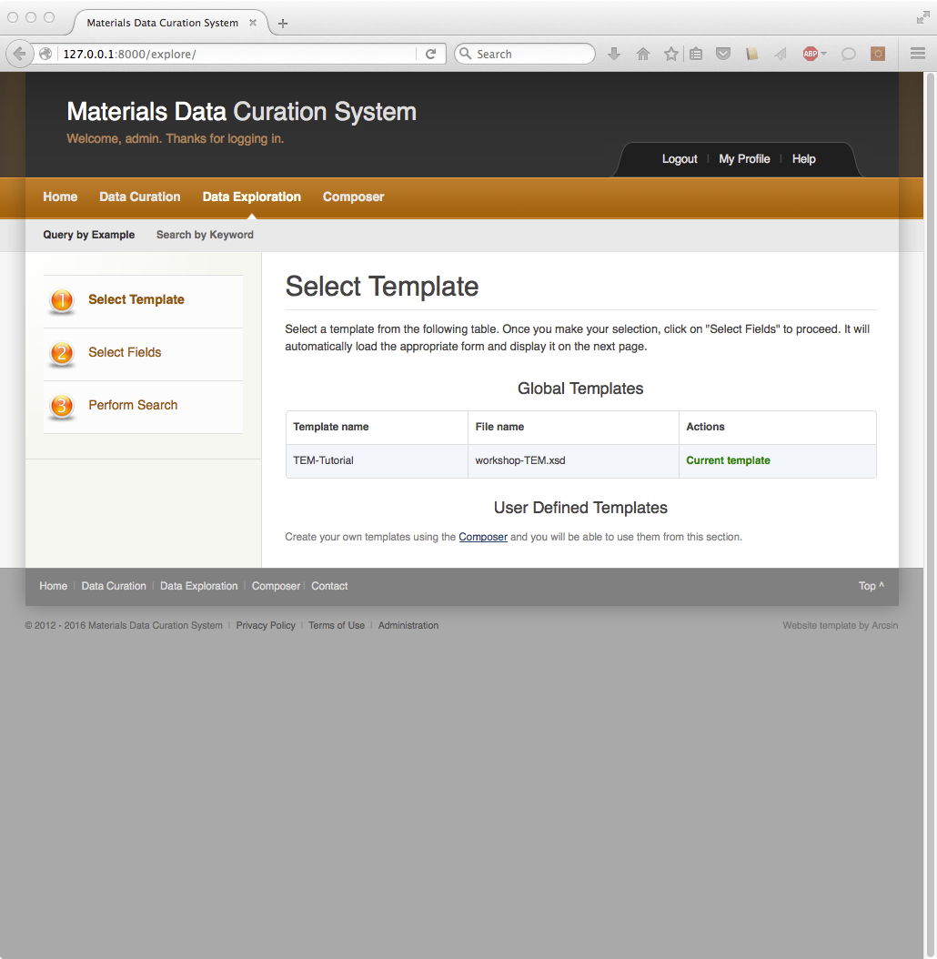

2: Search for all records under student name “Smith”:  
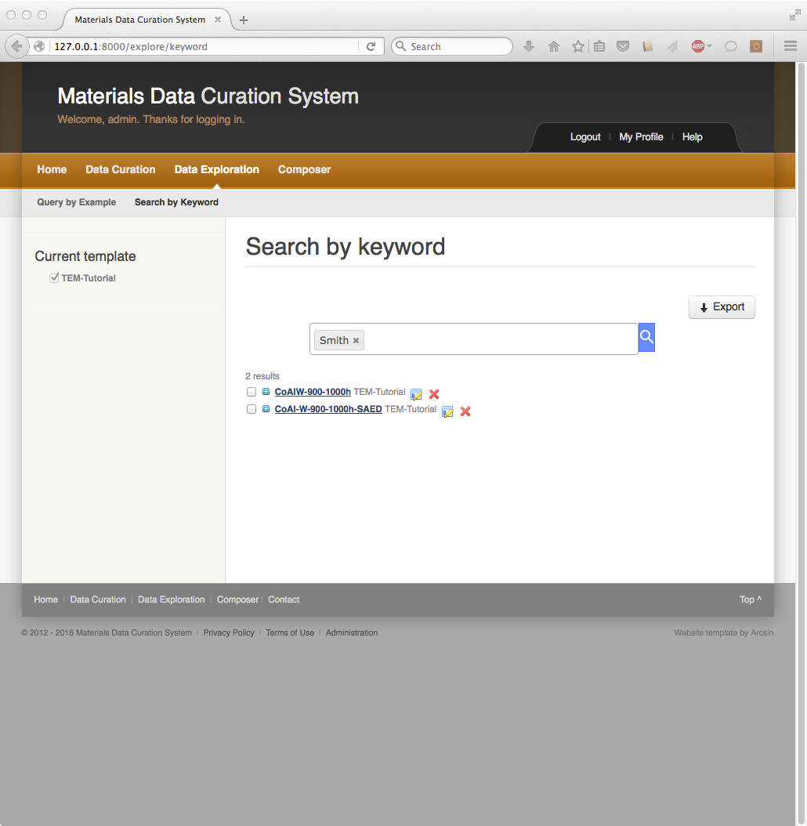

3: Expand “CoAlW-900-1000h”:  
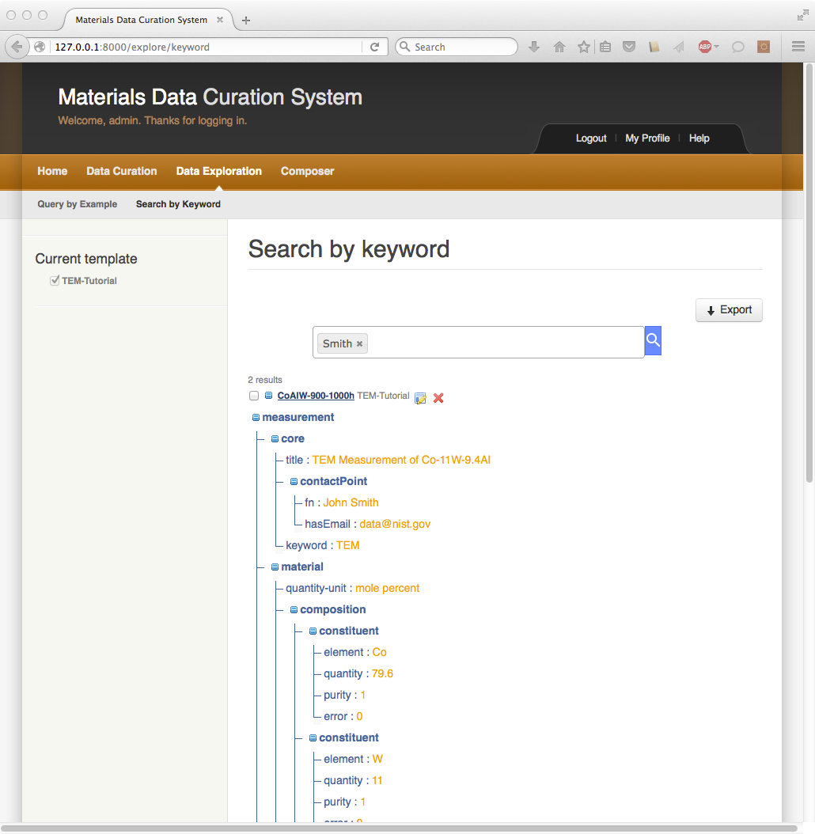

4: Scroll to bottom of metadata record, highlight the download URL of supporting file, right-click and select “Open Link”:  
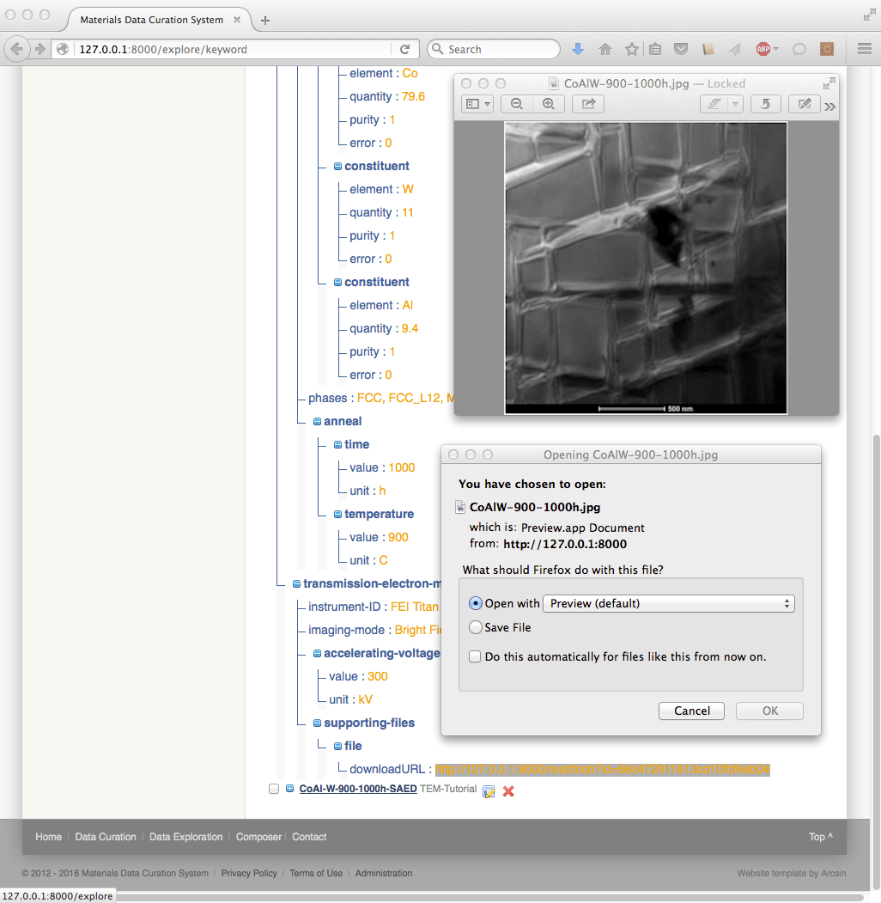

# Explore all TEM records containing Silicon and narrow by Bright Field

1: Search by keyword “Si”  
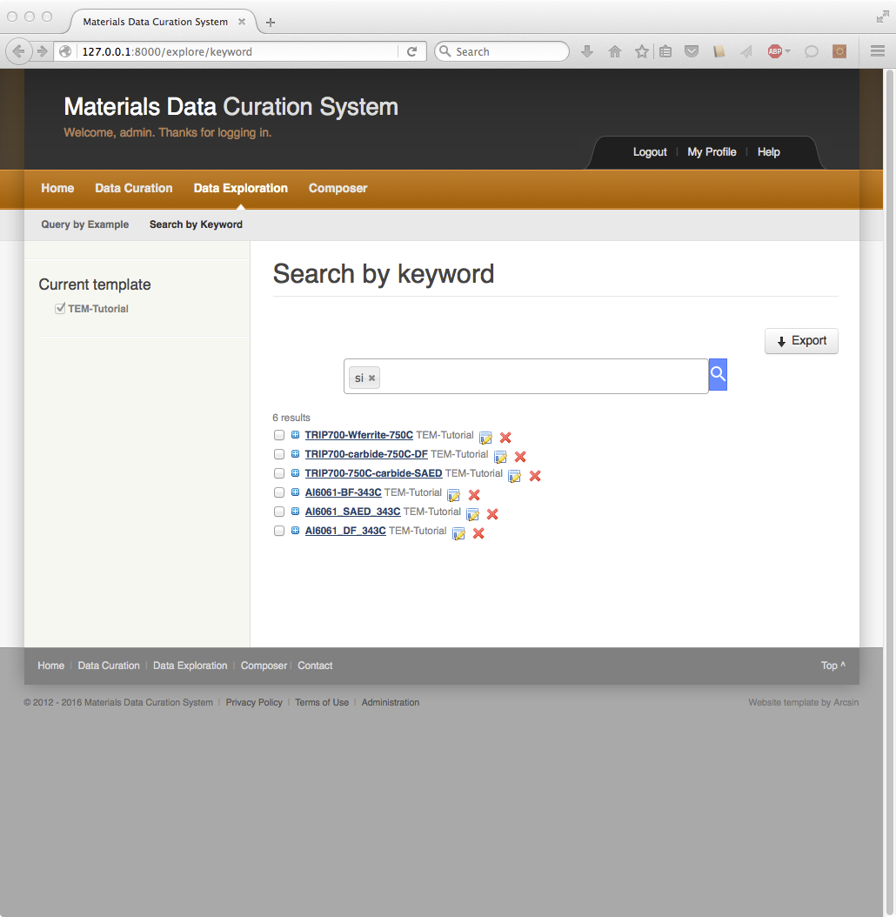

2: Add keyword of “bright field”  
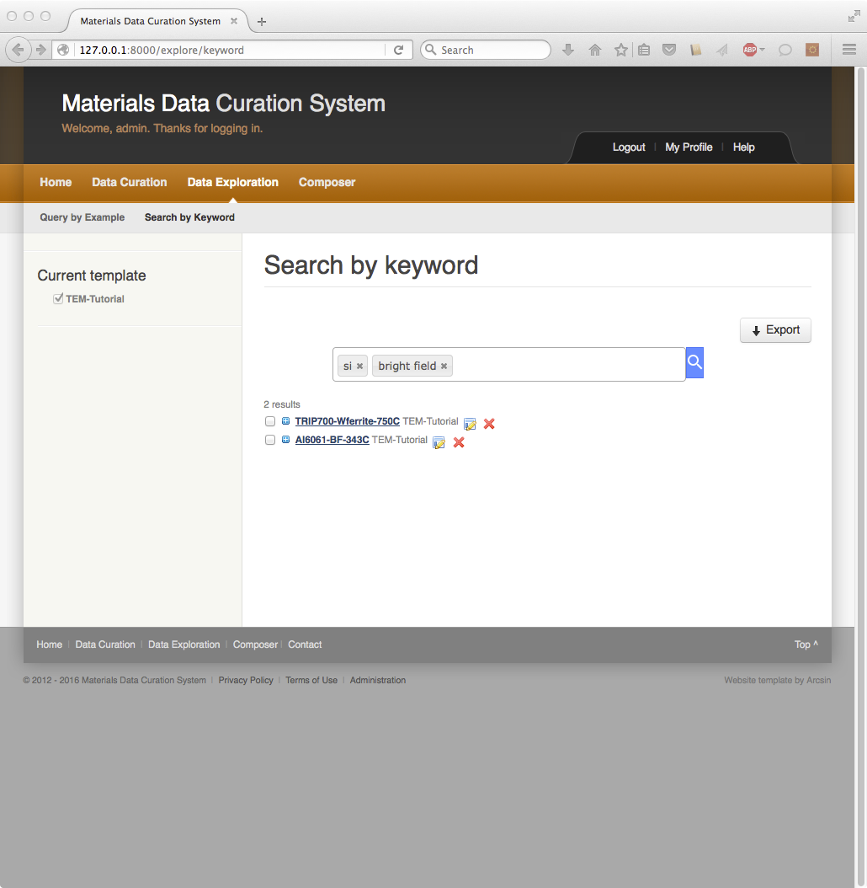

3: Expand “TRIP700-Wferrite-750C” and download micrograph  
